Altera Excalibur (ARM 922T Core) Port for uCOS-II v2.81

Who & When
Harry Gunnarsson, 2/28/06. Email: mrharryg@yahoo.com.

Introduction
The Altera Excalibur chip contains an ARM 922T core and a PLD area (programmable hardware), which makes the processor environment, in terms of memory maps etc, very configurable. In order to have a working chip, the processor (the stripe) and the PLD must have a valid configuration and the process of building the PLD/stripe will generate a C header file containing the current memory map.
See http://www.altera.com/literature/lit-exc.jsp for more Excalibur information.

Environment
The following hardware and software is required for building and running the port.
- Excalibur EPXA10 chip with a configured stripe.
- uCOS-II version 2.81.
- ARM Realview Developer Suite version 2.2 with any patch level, running on a MS Windows XP workstation. More specifically, the port was developed using
  - RVCT (compiler tools) 2.2.1 build 559
  - RVD (debugger) 1.8.1 build 497
  - Multi-ICE JTAG software version 2.2.6.
- The Excalibur port, i.e. excalibur_ucos-II_v2.81.zip. This port has been tested in both ARM and Thumb mode.

Port overview
This port is based upon the source provided in the AN-1014.zip. The relevant directories are
- MICRIUM\SOFTWARE\Excalibur. Contains the bsp and application files.
- MICRIUM\SOFTWARE\uCOS-II\Ports\ARM\Generic\rvct221. Contains the os_cpu.* and os_dbg.c files. These files are derived from the files in AN-1014.zip.
Note that the port only provides support for the OS timer tick. It should be fairly simple to add support for the UART.

Details
Below follow some detailed information on the files in the two directories mentioned above. Let’s start with the Excalibur directory.
- Altera_Excalibur_Port_uCOS-II_v2.81.doc. This document.
- app.c. The ucos test application.
- app_cfg.h. Required by uCOS.
- bsp.c. Interrupt handlers.
- bsp.h. Header file for app.c
- create_ucos_image.bat. Batch file for building everything. Assumes that Realview 2.2 is installed on the workstation.
- exc_init.s. The entry point for the application.
- includes.h.
- os_cfg.h. Same as Micrium\Software\uCOS-II\Source\os_cfg_r.h.
- stripe.h. Generated header file for the Excalibur processor stripe. It contains address locations of all internal registers.
- ucos.lcf. Realview linkage script.
- ucos_arm_swi.c. Realview compiler requires dummy implementations of certain I/O related functions in the C library.
And now we continue with the rvct221 directory. Again, the files are based on the IAR versions in AN-1014.zip. Below the differences between the IAR and the RVCT versions are described.
- os_cpu.h. The __arm keyword in IAR compiler does not exist in RVCT. It is believed that the RVCT compiler doesn’t need a hint that the functions are to be executed in ARM mode. It should be automatically handled.
- os_cpu_a.s. A couple of things are different between the IAR and RVCT assemblers
  - EXTERN is replaced with IMPORT.
  - PUBLIC is replaced with EXPORT.
  - RSEG is replaced with AREA.
  - Labels prefixed with ‘??’ are now prefixed with ‘LBL_’.
  - DC32 is replaced with DCD.
  - Some non-ascii characters were removed.
- os_cpu_c.c. No difference.
- os_dbg.c. The __root keyword doesn’t exist in RVCT. Replace this with the standard ‘volatile’ keyword.

Building
The sample application is simply build by running the batch file create_ucos_image.bat. Below follow a few things worth noticing.
- It will force usage of any existing RVDS 2.2 installation.
- It will print the relevant environment variables to the compiler.
- It will assemble 2 .s files and six .c files and finally link the application.
- One can easily compile the C files in Thumb mode by adding the –thumb flag to the CPPFLAGS variable. Expect roughly a 30% reduction in code size.
The following screen shot captures the entire build log.
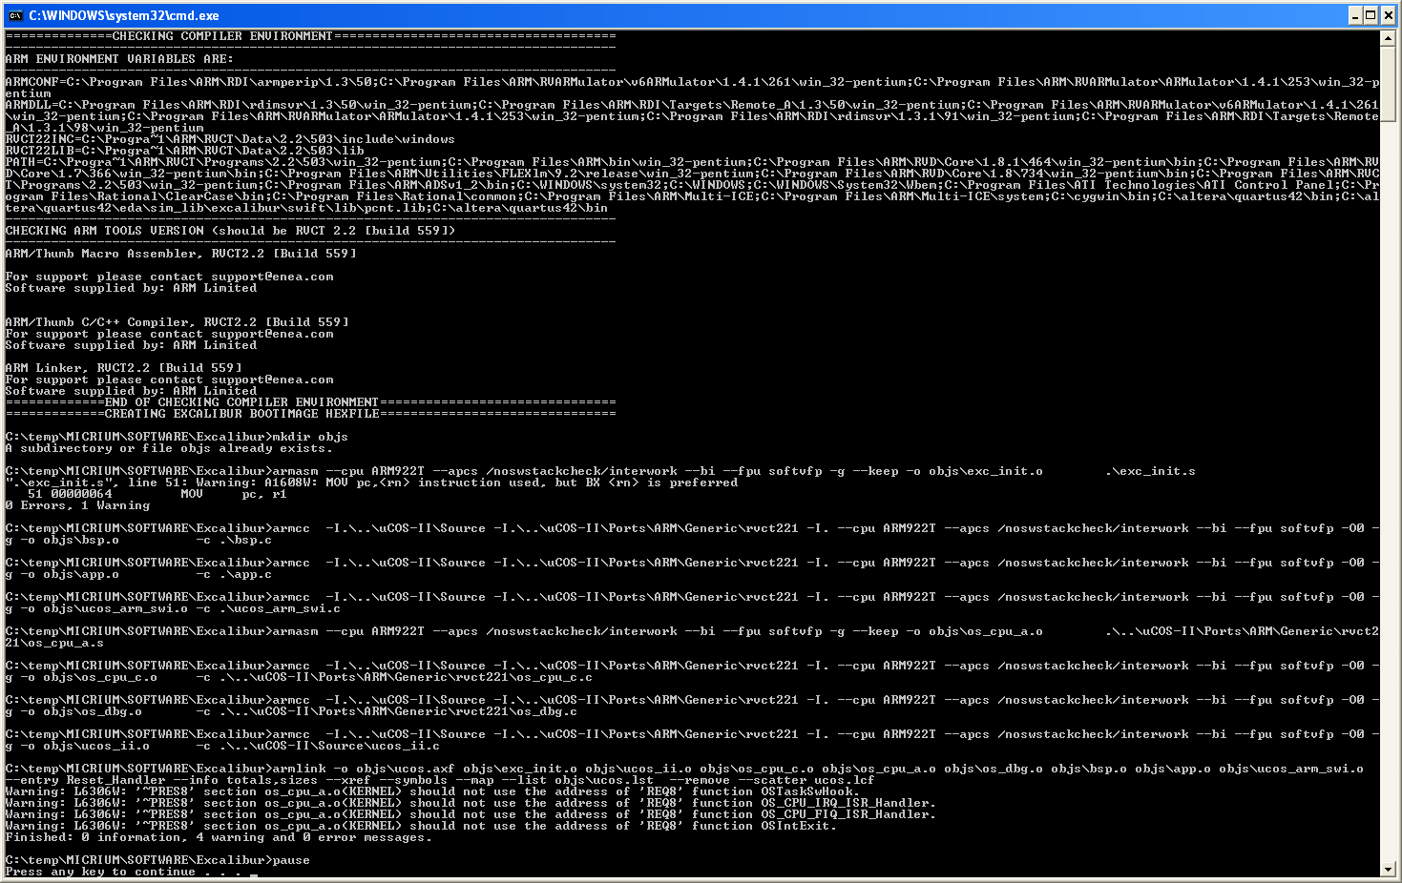
Figure 1 Build log

