문서종류 | 기술문서
작성일자 | 2007년 4월 20일
작성자 | 강 남 궐
e-mail | kwoly@shmt.co.kr
Component video output Workbook

HISTORY

Ver | Date | 변 경 내 용 | 기 타
0.1 | APR,20,2007 | 생 성
FEATURES

This output format is for supporting the HDTV(Hight-definition television). In using RGB 24bit format to support for 480p / 720p / 1080i format component video output

- 480p / 720p /1080i component video timing generation function
- Y / Pb /Pr amplitude control
- Video sync timing control
- On-chip color bar generation
BLOCK DIAGRAM
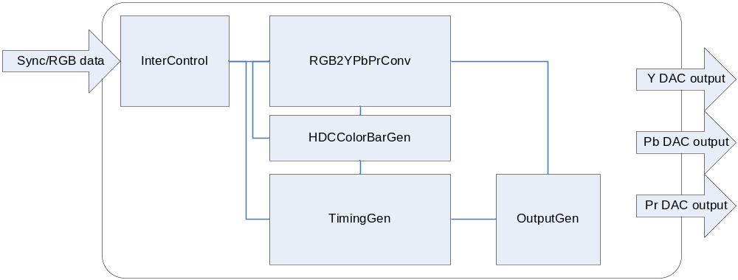
INDEX

1. Spce 분석 5
1. 480p timing (483p) 5
1. YPbPb conversion 5
2. Timing 5
3. Level 10
2. 720p timing 13
1. YPbPb conversion 13
2. Timing 14
3. Level 18
3. 1080i timing 20
1. YPbPb conversion 20
2. Timing 21
3. Level 25
2. Function Description 27
A. Video input timing 27
3. Register Description 28
4. H/W Description 36
1. RGBtoYPbPr interface Block 37
2. Timing Generation Block 39
3. ColorBar Generation Block 42
4. Output Generation Block 43

Spec 분석

480p timing (483p)

YPbPb conversion

Y’ = 0.299R’ + 0.587G’ + 0.114B’
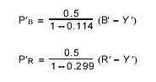
Pb = -0.169R' - 0.331G' + 0.500B'
Pr = 0.500R' - 0.419G' - 0.081B'
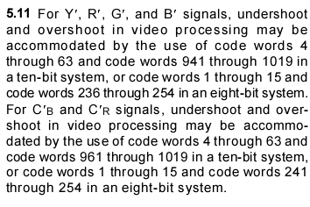

Timing
Active line :: 720 x 483
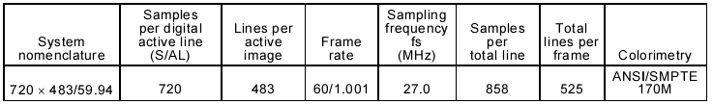
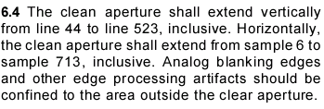
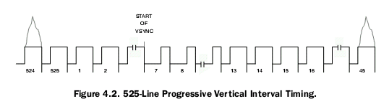
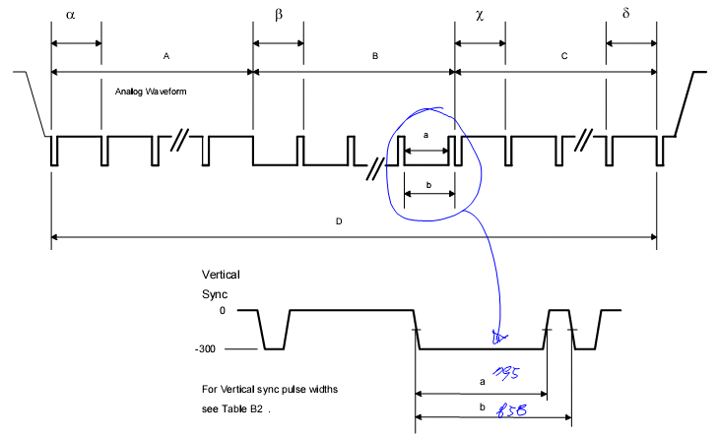
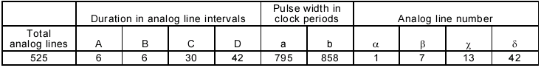
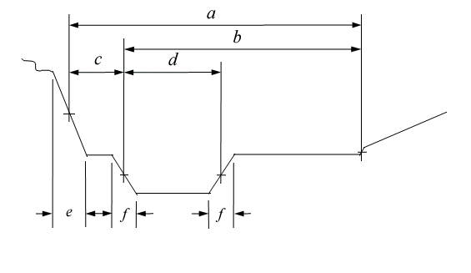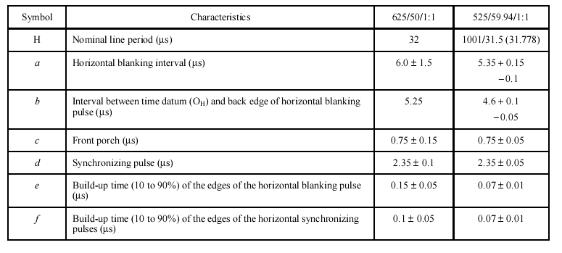
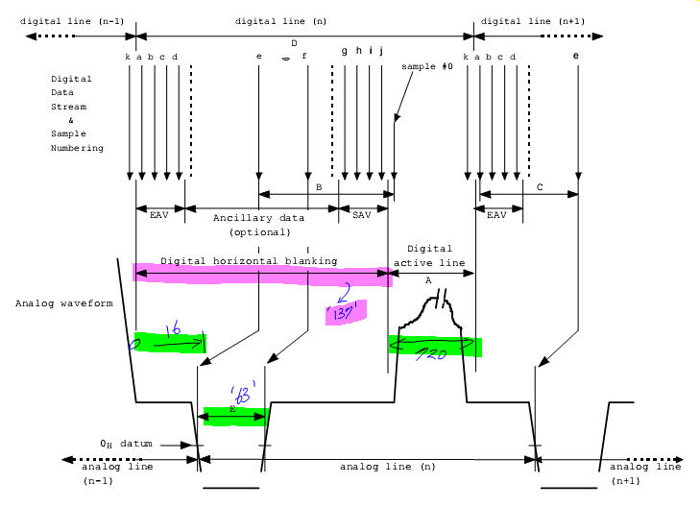
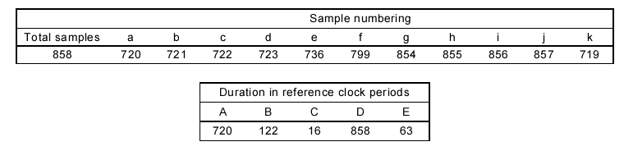
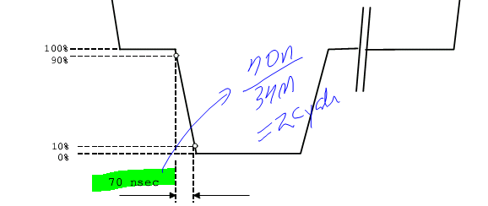

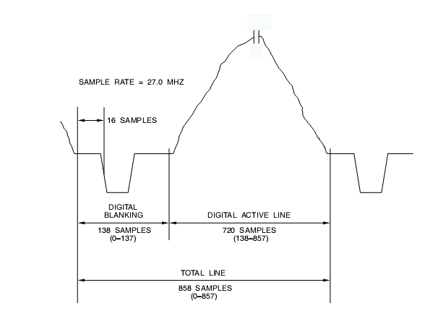
27Mhz sampling frequency / 720 x 480 p interface signal

Level

    - Input range
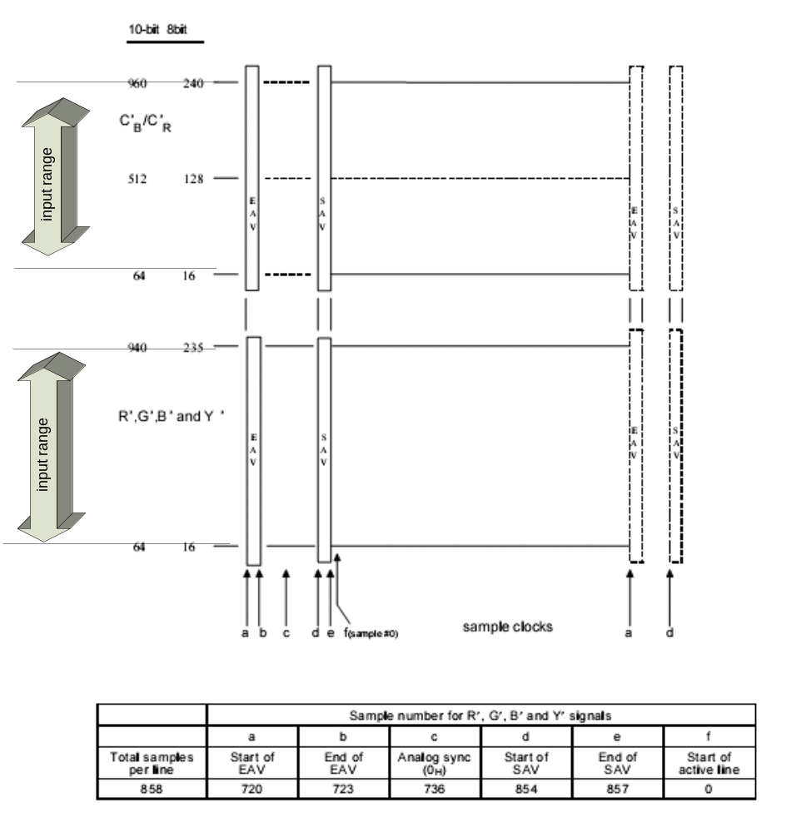

    - Output range
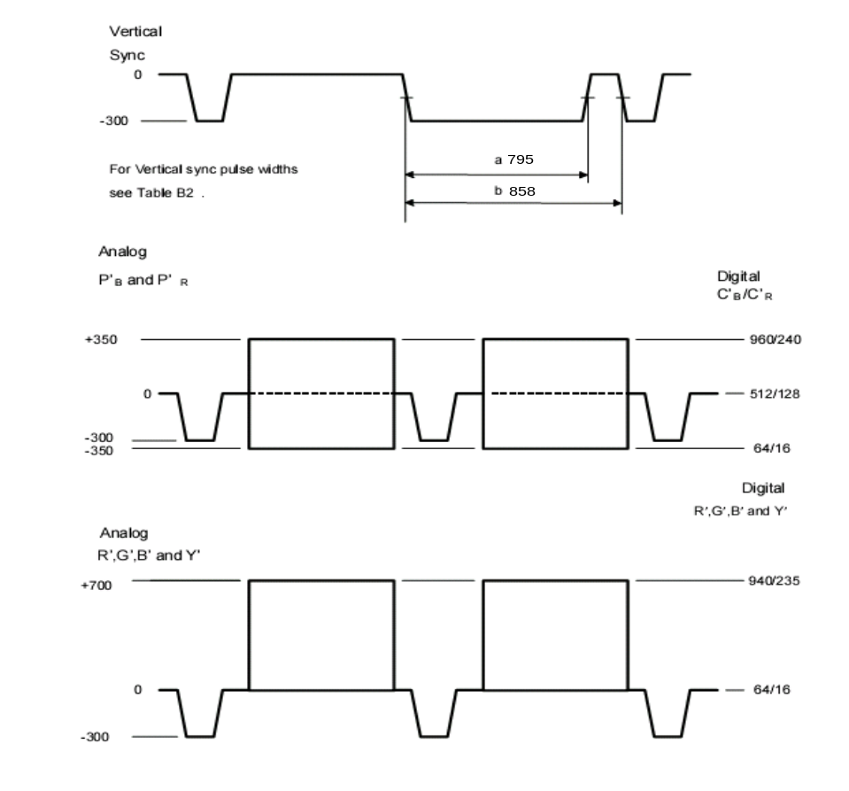
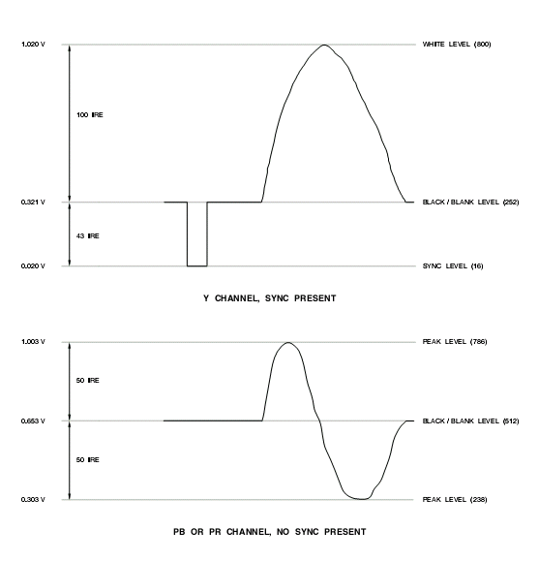
With sync in Y signal for consumer market

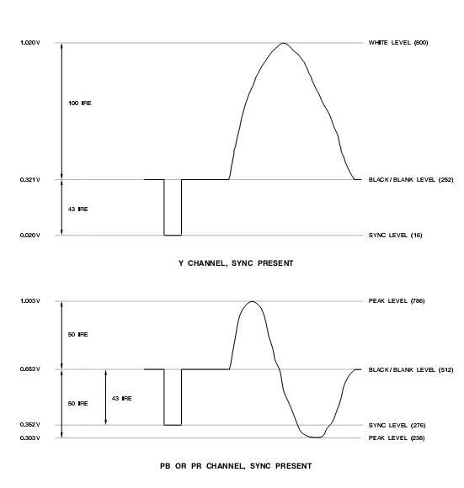
With sync in all signal for pro-video market

720p timing

YPbPb conversion
Y′ = 0.2126R′ + 0.7152G′ + 0.0722B′
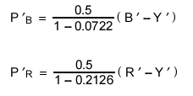
0.5 / ( 1- 0.0722) = 0.53890924768269023496443198965294
0.5 / ( 1- 0.2126) = 0.63500127000254000508001016002032
Pb = 0.5389 * (-0.2126R′- 0.7152G′+ 0.9278B′)
Pb = -0.11457014R' - 0.38542128G' + 0.49999142B'
Pb = -0.115R' - 0.385G' + 0.500B'

Pr = 0.6350 * (0.7874R′ -0.7152G′ - 0.0722B′)
Pr = 0.499999R′-0.454152G′-0.045847B′
Pr = 0.500 R′ - 0.454G′ - 0.0458B′

Timing

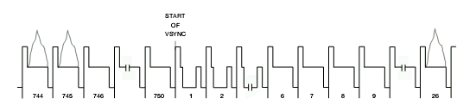
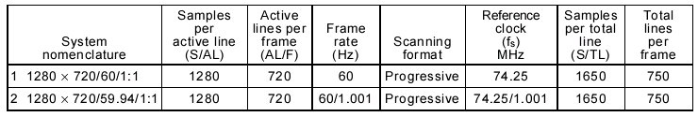
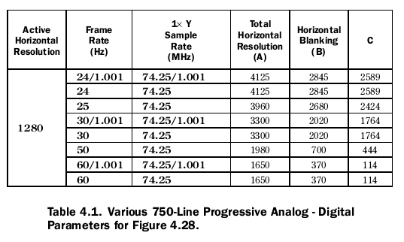
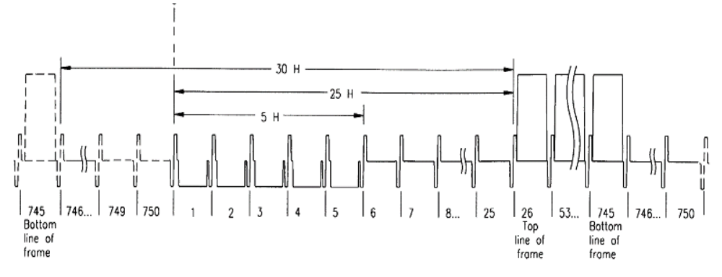

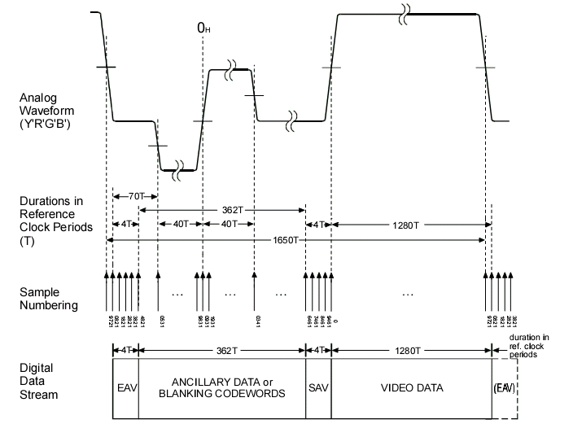

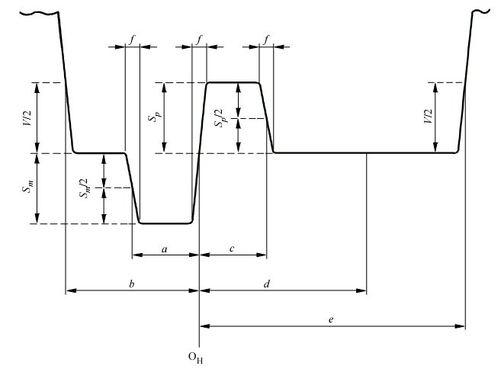
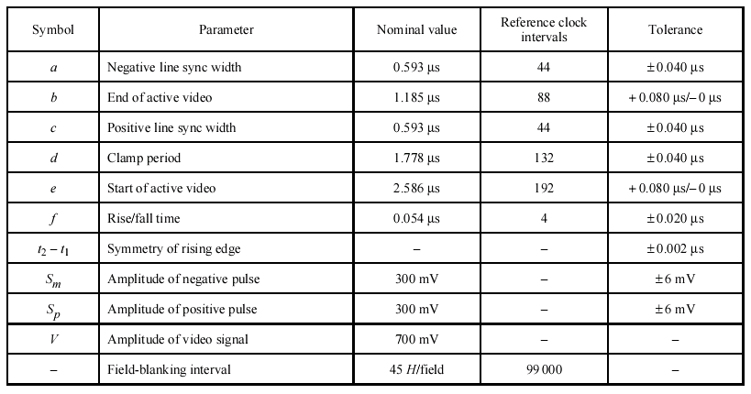

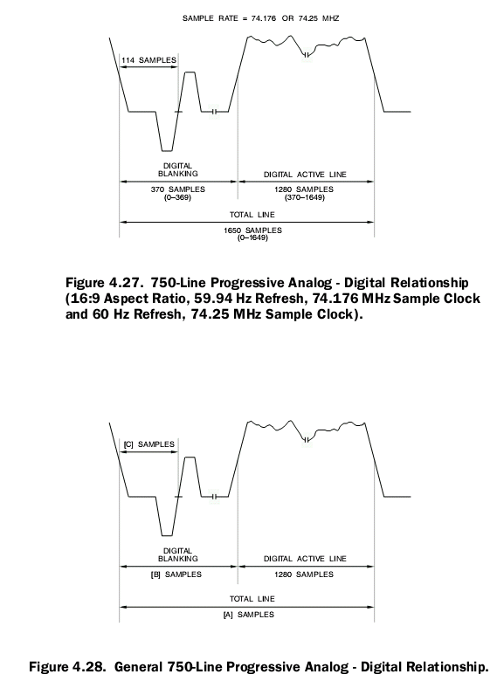

Level
    - Input range
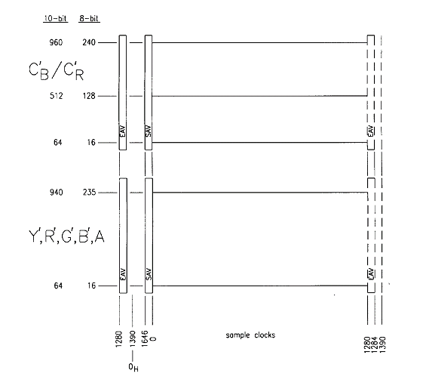

    - Output range
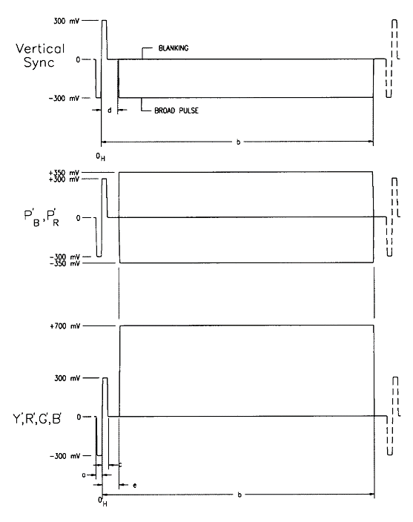
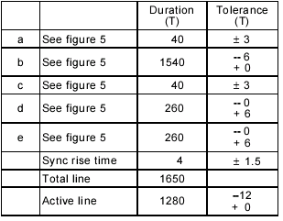

1080i timing

YPbPb conversion
Y′ = 0.2126R′ + 0.7152G′ + 0.0722B′
0.5 / ( 1- 0.0722) = 0.53890924768269023496443198965294
0.5 / ( 1- 0.2126) = 0.63500127000254000508001016002032
Pb = 0.5389 * (-0.2126R′- 0.7152G′+ 0.9278B′)
Pb = -0.11457014R' - 0.38542128G' + 0.49999142B'
Pb = -0.115R' - 0.385G' + 0.500B'

Pr = 0.6350 * (0.7874R′ -0.7152G′ - 0.0722B′)
Pr = 0.499999R′-0.454152G′-0.045847B′
Pr = 0.500 R′ - 0.454G′ - 0.0458B′
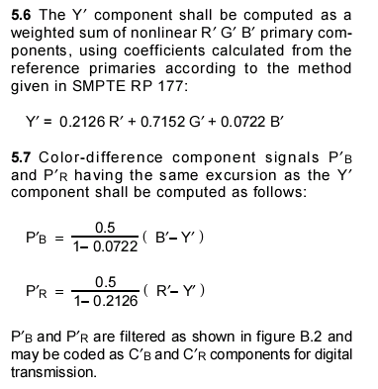

Timing

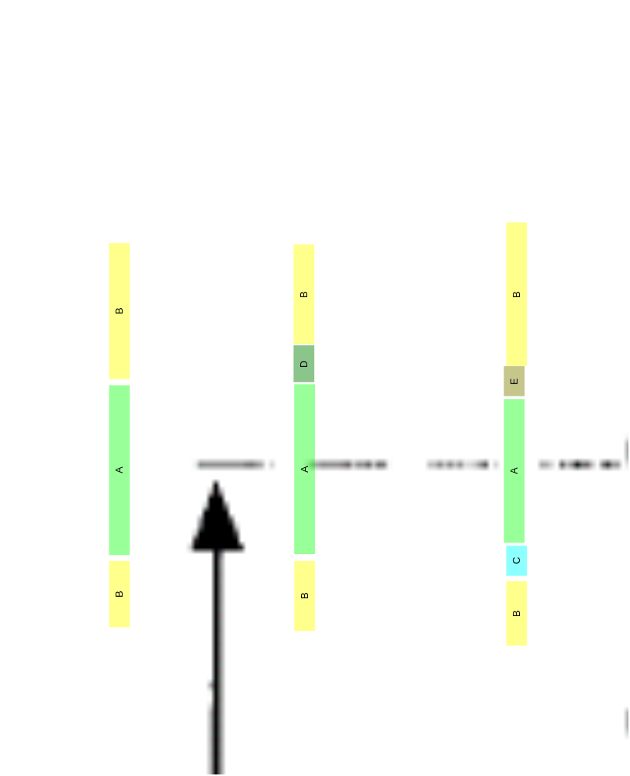
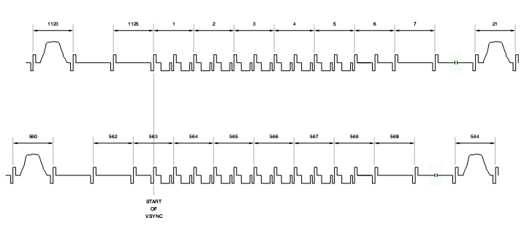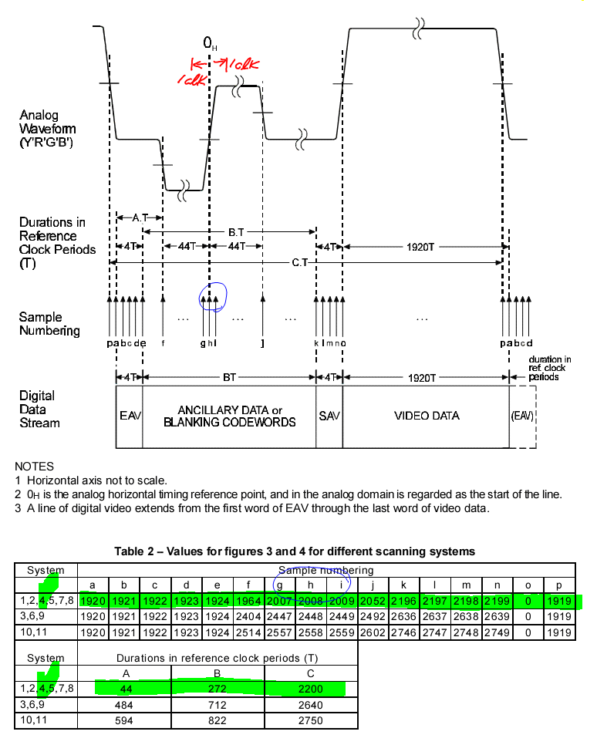

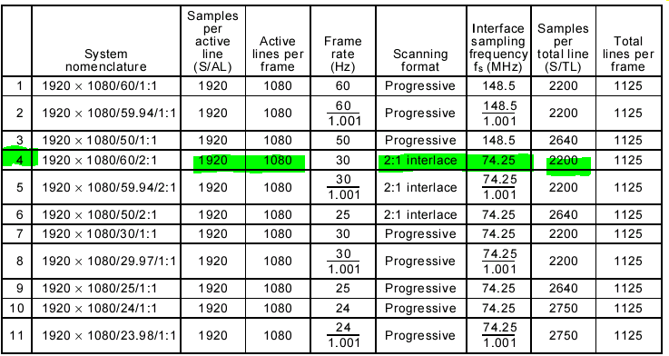

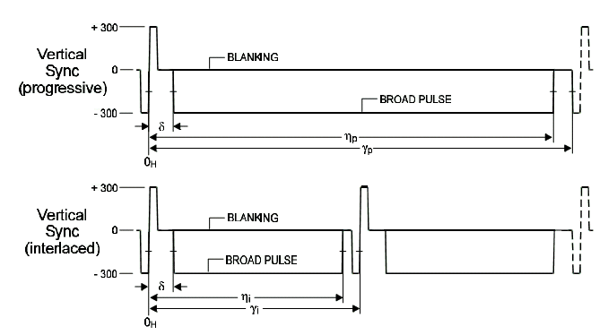
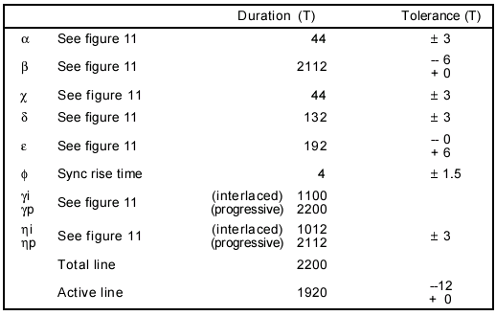

Level

- Input range
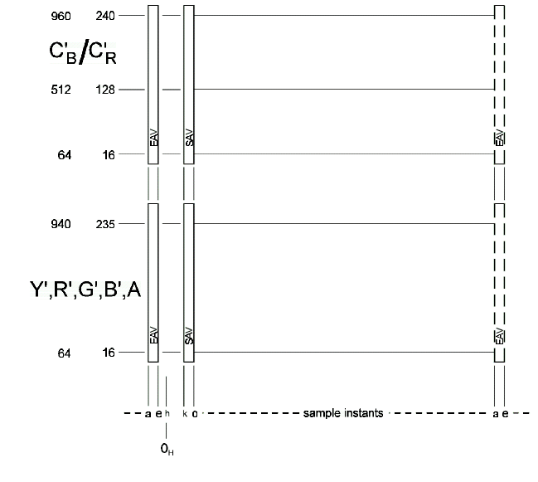

- Output range

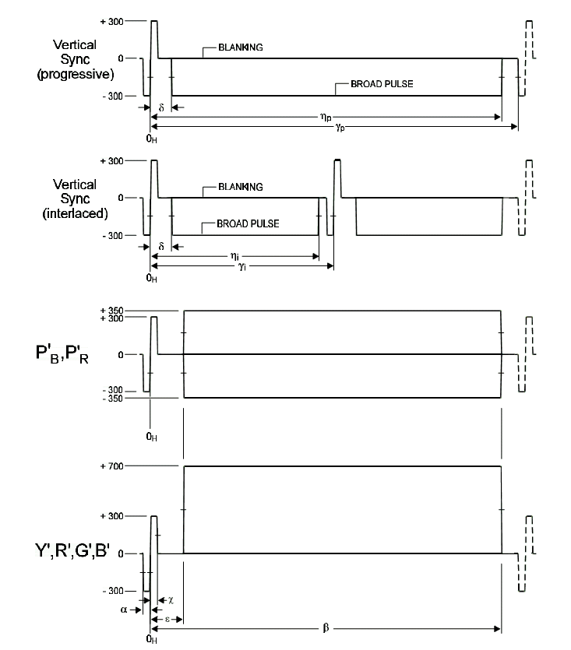

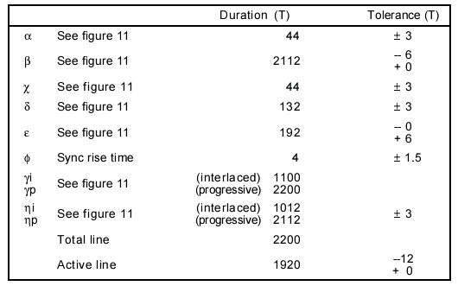

Function Description

Video input timing

Register Description

Figure 1-1 HD Control Register Bits
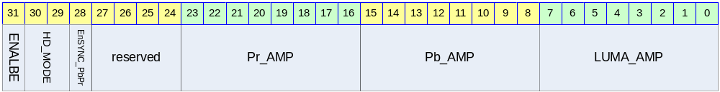
Table 1-1 HD Control Register Description(Offset : 0000 0030h)

Bits | Name | R/W | Description | Init. value
[31] | HD_ENABLE | RW | Enable
[29:30] | HD_MODE | RW | Setting for components mode  2’b00 :: 480P mode  2’b01 :: 720P mode  2’b10 :: 1800i mode | 0b
[28] | EnSYNC_PbPr | RW | Sync generation on Pb/Pr signal
[16:23] | Pr_AMP | RW | Pr amplitude 1.99 ~ 0
[8:15] | Pb_AMP | RW | Pb amplitude 1.99 ~ 0
[0:7] | LUMA_AMP | RW | Y amplitude 1.99 ~ 0

Figure 1-2 HD Output Level 0 Register Bits
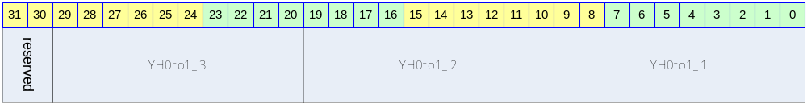

Table 1-2 HD Output Level 0 Register Description(Offset : 0000 0034h)
Bits | Name | R/W | Description | Init. value
[0:9] | YH0to1_1 | RW | Sync step value
[10:19] | YH0to1_2 | RW | Sync step value
[20:29] | YH0to1_3 | RW | Sync step value

Figure 1-3 HD Output Level 1 Register Bits
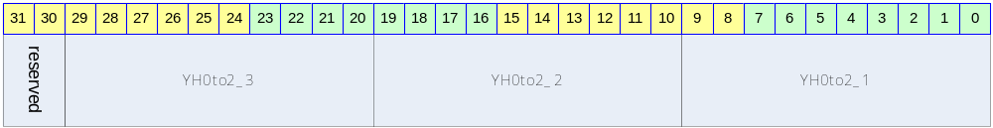

Table 1-3 HD Output Level 1 Register Description(Offset : 0000 0038h)
Bits | Name | R/W | Description | Init. value
[0:9] | YH0to2_1 | RW | Sync step value
[10:19] | YH0to2_2 | RW | Sync step value
[20:29] | YH0to2_3 | RW | Sync step value

Figure 1-4 HD Output Level 2 Register Bits
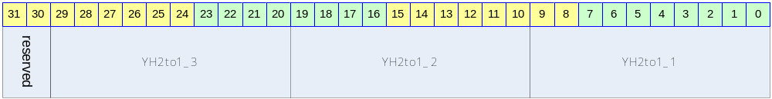

Table 1-4 HD Output Level 2 Register Description(Offset : 0000 003Ch)
Bits | Name | R/W | Description | Init. value
[0:9] | YH2to1_1 | RW | Sync step value
[10:19] | YH2to1_2 | RW | Sync step value
[20:29] | YH2to1_3 | RW | Sync step value

Figure 1-5 HD Output Level 3 Register Bits
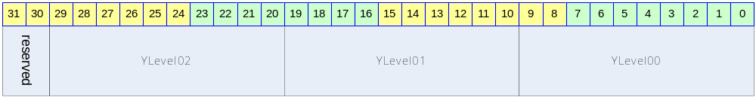

Table 1-5 HD Output Level 3 Register Description(Offset : 0000 0040h)
Bits | Name | R/W | Description | Init. value
[0:9] | YLevel00 | RW | Output level define
[10:19] | YLevel01 | RW | Output level define
[20:29] | YLevel02 | RW | Output level define

Figure 1-6 HD Output Level 4 Register Bits
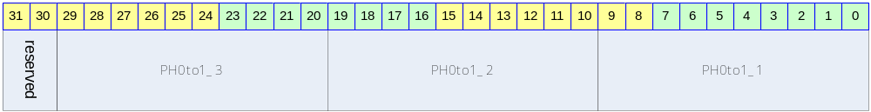

Table 1-6 HD Output Level 4 Register Description(Offset : 0000 0044h)
Bits | Name | R/W | Description | Init. value
[0:9] | PH0to1_1 | RW | Sync step value
[10:19] | PH0to1_2 | RW | Sync step value
[20:29] | PH0to1_3 | RW | Sync step value

Figure 1-7 HD Output Level 5 Register Bits
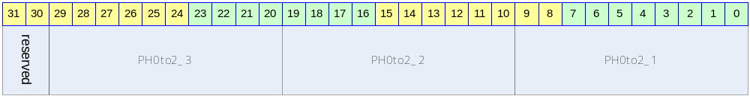

Table 1-7 HD Output Level 5 Register Description(Offset : 0000 0048h)
Bits | Name | R/W | Description | Init. value
[0:9] | PH0to2_1 | RW | Sync step value
[10:19] | PH0to2_2 | RW | Sync step value
[20:29] | PH0to2_3 | RW | Sync step value

Figure 1-8 HD Output Level 6 Register Bits
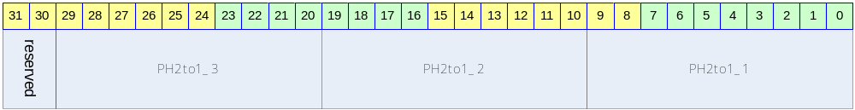

Table 1-8 HD Output Level 6 Register Description(Offset : 0000 004Ch)
Bits | Name | R/W | Description | Init. value
[0:9] | PH2to1_1 | RW | Sync step value
[10:19] | PH2to1_2 | RW | Sync step value
[20:29] | PH2to1_3 | RW | Sync step value

Figure 1-9 HD Output Level 7 Register Bits
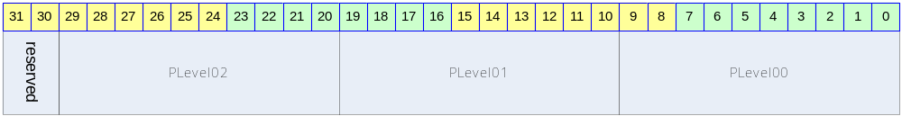

Table 1-9 HD Output Level 7 Register Description(Offset : 0000 0050h)
Bits | Name | R/W | Description | Init. value
[0:9] | PLevel00 | RW | Output level define
[10:19] | PLevel01 | RW | Output level define
[20:29] | PLevel02 | RW | Output level define

Figure 1-10 HD Timing Control 0 Register Bits
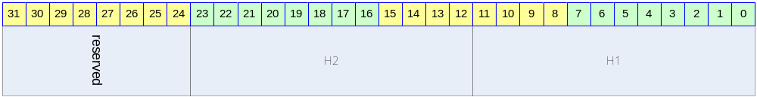

Table 1-10 HD Timing Control 0 Register Description(Offset : 0000 0054h)
Bits | Name | R/W | Description | Init. value
[0:11] | H1 | RW | Horizontal point 1
[12:23] | H2 | RW | Horizontal point 2

Figure 1-11 HD Timing Control 1 Register Bits
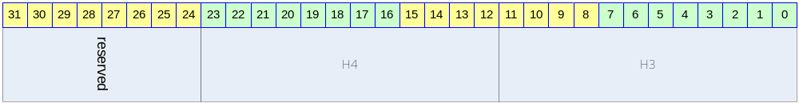

Table 1-11 HD Timing Control 1 Register Description(Offset : 0000 0058h)
Bits | Name | R/W | Description | Init. value
[0:11] | H3 | RW | Horizontal point 3
[12:23] | H4 | RW | Horizontal point 4

Figure 1-12 HD Timing Control 2 Register Bits
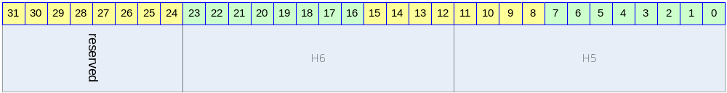

Table 1-12 HD Timing Control 2 Register Description(Offset : 0000 005Ch)
Bits | Name | R/W | Description | Init. value
[0:11] | H5 | RW | Horizontal point 5
[12:23] | H6 | RW | Horizontal point 6

Figure 1-13 HD Timing Control 3 Register Bits
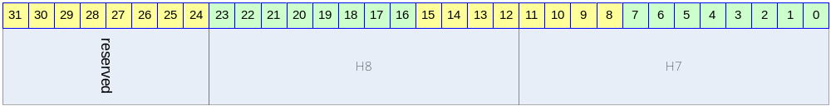

Table 1-13 HD Timing Control 3 Register Description(Offset : 0000 0060h)
Bits | Name | R/W | Description | Init. value
[0:11] | H7 | RW | Horizontal point 7
[12:23] | H8 | RW | Horizontal point 8

Figure 1-14 HD Timing Control 4 Register Bits
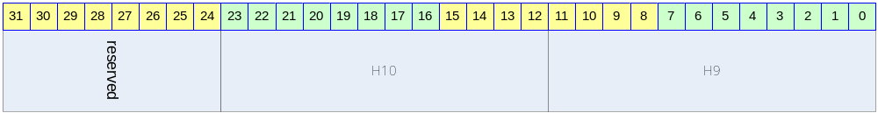

Table 1-14 HD Timing Control 4 Register Description(Offset : 0000 0064h)
Bits | Name | R/W | Description | Init. value
[0:11] | H9 | RW | Horizontal point 9
[12:23] | H10 | RW | Horizontal point 10

Figure 1-15 HD Timing Control 5 Register Bits
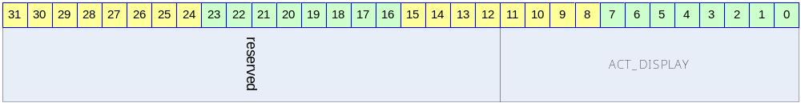

Table 1-15 HD Timing Control 5 Register Description(Offset : 0000 0068h)
Bits | Name | R/W | Description | Init. value
[0:11] | ACT_DISPLAY | RW | Active display area define

Figure 1-16 HD convert parameter 0 Register Bits
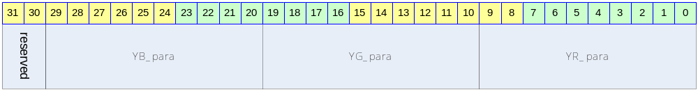

Table 1-16 HD convert parameter 0 Register Description(Offset : 0000 006Ch)
Bits | Name | R/W | Description | Init. value
[0:9] | YR_para | RW
[10:19] | YG_para | RW
[20:29] | YB_para | RW

Figure 1-17 HD convert parameter 0 Register Bits
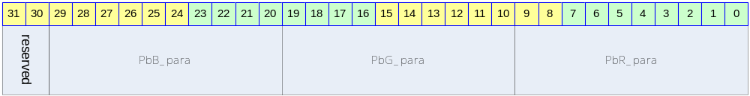

Table 1-17 HD convert parameter 0 Register Description(Offset : 0000 0070h)
Bits | Name | R/W | Description | Init. value
[0:9] | PbR_para | RW
[10:19] | PbG_para | RW
[20:29] | PbB_para | RW

Figure 1-18 HD convert parameter 0 Register Bits
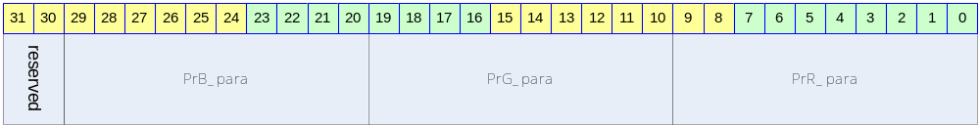

Table 1-18 HD convert parameter 0 Register Description(Offset : 0000 0074h)
Bits | Name | R/W | Description | Init. value
[0:9] | PrR_para | RW
[10:19] | PrG_para | RW
[20:29] | PrB_para | RW

H/W Description

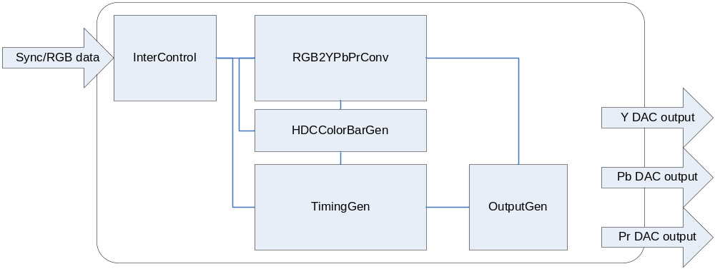

RGBtoYPbPr interface Block
Input range를 Limit 하여 사용하며, 720p와 1080i는 공용으로 사용한다.
→ 480p
Y’ = 0.299R’ + 0.587 G’ + 0.114B’
Pb = -0.169R' - 0.331G' + 0.500B'
Pr = 0.500R' - 0.419G' - 0.081B'
➔ X1024__________________________
Y’ = 306R’ + 601G’ + 117B’
Pb = -173R' - 334G' + 512B'
Pr = 512R' - 429G' - 83B'
___________________________________

→ 720p/1080i
Y′ = 0.2126R′ + 0.7152G′ + 0.0722B′
Pb = -0.115R' - 0.385G' + 0.500B'
Pr = 0.500 R′ - 0.454G′ - 0.0458B′

➔ X1024__________________________
Y′ = 218R′ + 732G′ + 74B′
Pb = -118R' - 394G' + 512B'
Pr = 512R′ - 465G′ - 47B′
___________________________________

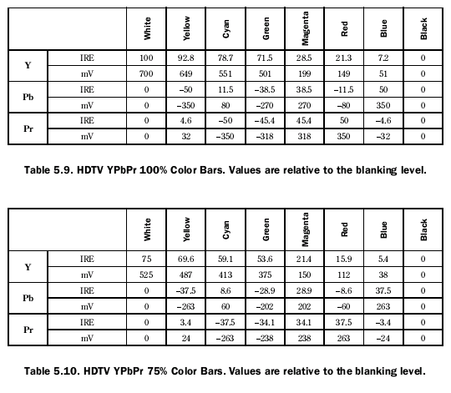

Timing Generation Block
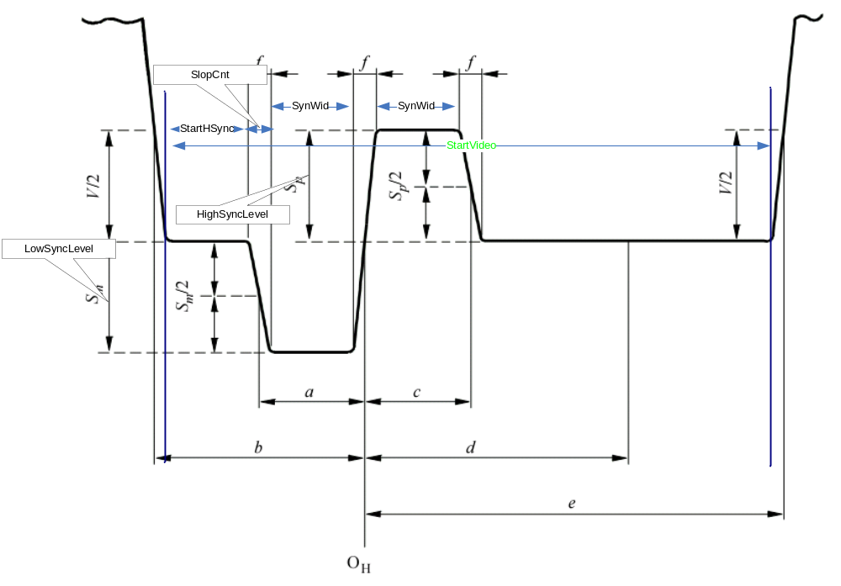

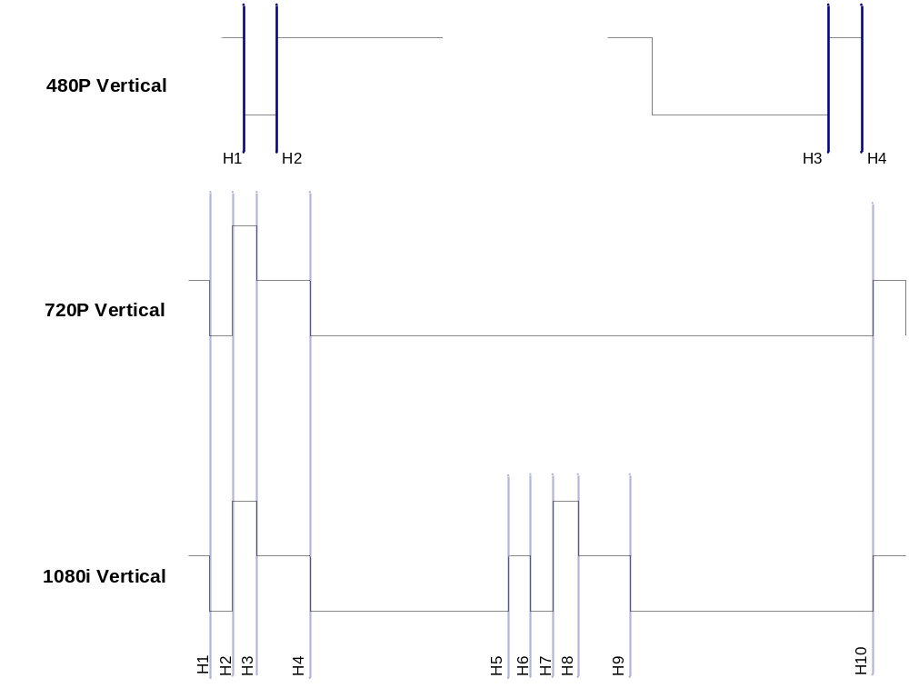
480P
H1/H2 는 Vertical 480p A영역에 값을 표시합니다.
H1 :: 30 H2 :: 156
H3/H4 는 Vertical 480p B영역에 값을 표시합니다.
H3 :: 1588 H4 :: 1714
ACT_DISPLAY :: 275
720P
H1 :: 68T H2 :: 108T H3 :: 148T H4 :: 368 H10 :: End-2
ACT_DISPLAY :: 370

1080i
H1 :: 42T H2 :: 86T H3 :: 130T H4 :: 218(132+88-2)
H5 :: 1098T(1012+88-2)
H6 :: 1142T H7 :: 1186T
H8 :: 1230T
H9 :: 1318T (1100+88+132-2)
H10 :: End-2
ACT_DISPLAY :: 280

ColorBar Generation Block
ColoarBar 는 Encoder와 동일한 정도로 출력 된다.

➔ 480p
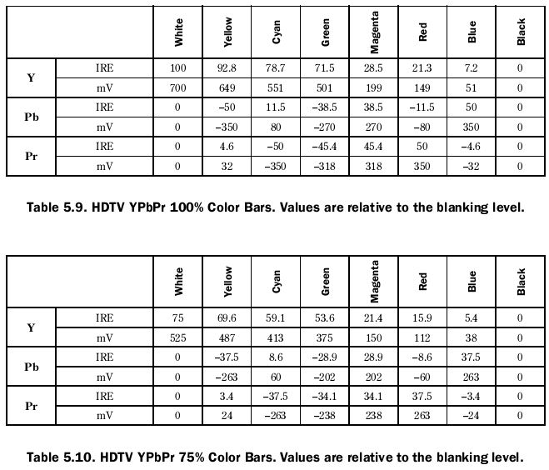
➔ 720p/1080i
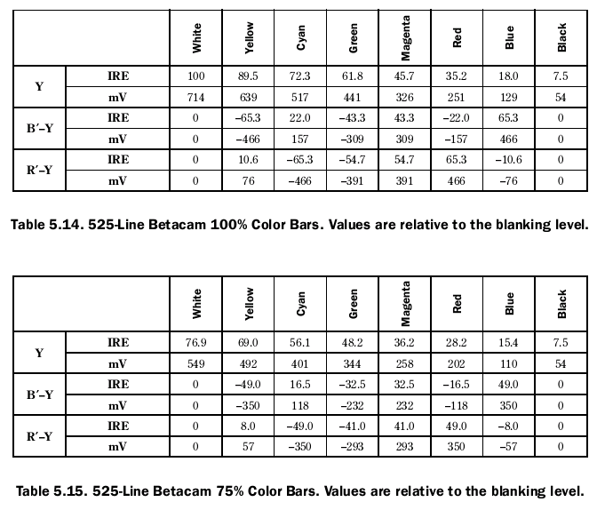

Output Generation Block
Timing에서 입력을 받아서 각 output 에 맞는 Level을 생성 합니다.
Luminance amplitude :: 564/960 ➔ 0.5875 * 128 = 75.2

Test Display module

