Component video output

Version 1.0

SHMT Co., Ltd.(Verdana 18pt bold)

REVISION HISTORY (굴림/Verdana 12pt bold)
Version | Detail(굴림/Verdana 10pt bold) | Name | Date
V1.0 | 생 성 | 강 남궐 | 07/5/28

Technical documents
Copyright © 2006 Shmt Limited. All rights reserved.

Confidentiality Status
This document is NOT OPEN ACCESS. The distribution is restricted to certified company.
This document is CONFIDENTIAL.

Feedback on this document
If you have any comments on this document, please contact your channel to our company.

Shmt Web address
http://www.shmt.com

Contents

1. Component video output 8
1.1. Overview 8
1.1.1. Feature 8
1.1.2. Block Diagram 8
1.2. Operation 9
1.2.1. Video input timing 9
1.2.2. Video output timing 13
1.2.3. Control Setting 19
1.3. Signal Description 20
1.3.1. InOutput Signal 20
1.4. Register Description 23
1.4.1. Registers 23
1.4.2. HD control Register 24
1.4.3. HD output level 0 Register 25
1.4.4. HD output level 1 Register 25
1.4.5. HD output level 2 Register 26
1.4.6. HD output level 3 Register 26
1.4.7. HD output level 4 Register 27
1.4.8. HD output level 5 Register 27
1.4.9. HD output level 6 Register 28
1.4.10. HD output level 7 Register 28
1.4.11. HD Timing Control 0 Register 29
1.4.12. HD Timing Control 1 Register 29
1.4.13. HD Timing Control 2 Register 30
1.4.14. HD Timing Control 3 Register 30
1.4.15. HD Timing Control 4 Register 31
1.4.16. HD Timing Control 5 Register 31
1.4.17. HD convert parameter 0 Register 32
1.4.18. HD convert parameter 1 Register 32
1.4.19. HD convert parameter 2 Register 33

Figures

Figure 1-1 Component video output block diagram 8
Figure 1-2 480P Video input timing chart 9
Figure 1-3 480P Video clock timing chart 9
Figure 1-4 720P Video input timing chart 10
Figure 1-5 720P Video clock input timing chart 10
Figure 1-6 1080i Video input timing chart 11
Figure 1-7 1080i Video clock input timing chart 12
Figure 1-7 480p Video output timing/level chart 13
Figure 1-7 720p Video output timing/level chart 15
Figure 1-10 720p Video output timing/level chart 17
Figure 1-11 HD Control Register Bits 24
Figure 1-12 HD Output Level 0 Register Bits 25
Figure 1-13 HD Output Level 1 Register Bits 25
Figure 1-14 HD Output Level 2 Register Bits 26
Figure 1-15 HD Output Level 3 Register Bits 26
Figure 1-16 HD Output Level 4 Register Bits 27
Figure 1-17 HD Output Level 5 Register Bits 27
Figure 1-18 HD Output Level 6 Register Bits 28
Figure 1-19 HD Output Level 7 Register Bits 28
Figure 1-20 HD Timing Control 0 Register Bits 29
Figure 1-21 HD Timing Control 1 Register Bits 29
Figure 1-22 HD Timing Control 2 Register Bits 30
Figure 1-23 HD Timing Control 3 Register Bits 30
Figure 1-24 HD Timing Control 4 Register Bits 31
Figure 1-25 HD Timing Control 5 Register Bits 31
Figure 1-26 HD convert parameter 0 Register Bits 32
Figure 1-27 HD convert parameter 1 Register Bits 32
Figure 1-28 HD convert parameter 2 Register Bits 33

Tables
Table 1-1 480p recommend setting 14
Table 1-2 720p recommend setting 16
Table 1-3 1080i recommend setting 18
Table 1-4 parameter recommend setting 19
Table 1-5 Component video output core Signal 20
Table 1-6 Registers(Base Address : 5000 B000h) 23
Table 1-7 HD Control Register Description(Offset : 0000 0030h) 24
Table 1-8 HD Output Level 0 Register Description(Offset : 0000 0034h) 25
Table 1-9 HD Output Level 1 Register Description(Offset : 0000 0038h) 25
Table 1-10 HD Output Level 2 Register Description(Offset : 0000 003Ch) 26
Table 1-11 HD Output Level 3 Register Description(Offset : 0000 0040h) 26
Table 1-12 HD Output Level 4 Register Description(Offset : 0000 0044h) 27
Table 1-13 HD Output Level 5 Register Description(Offset : 0000 0048h) 27
Table 1-14 HD Output Level 6 Register Description(Offset : 0000 004Ch) 28
Table 1-15 HD Output Level 7 Register Description(Offset : 0000 0050h) 28
Table 1-16 HD Timing Control 0 Register Description(Offset : 0000 0054h) 29
Table 1-17 HD Timing Control 1 Register Description(Offset : 0000 0058h) 29
Table 1-18 HD Timing Control 2 Register Description(Offset : 0000 005Ch) 30
Table 1-19 HD Timing Control 3 Register Description(Offset : 0000 0060h) 30
Table 1-20 HD Timing Control 4 Register Description(Offset : 0000 0064h) 31
Table 1-21 HD Timing Control 5 Register Description(Offset : 0000 0068h) 31
Table 1-22 HD convert parameter 0 Register Description(Offset : 0000 006Ch) 32
Table 1-23 HD convert parameter 1 Register Description(Offset : 0000 0070h) 32
Table 1-24 HD convert parameter 2 Register Description(Offset : 0000 0074h) 33

Component video output

Overview

This output format is for supporting the HDTV(Hight-definition television). In using RGB 24bit format to support for 480p / 720p / 1080i format component video output

Feature

- 480p / 720p /1080i component video timing generation function
- Y / Pb /Pr amplitude control
- Video sync timing control
- On-chip color bar generation

Block Diagram

Figure 1-1 Component video output block diagram
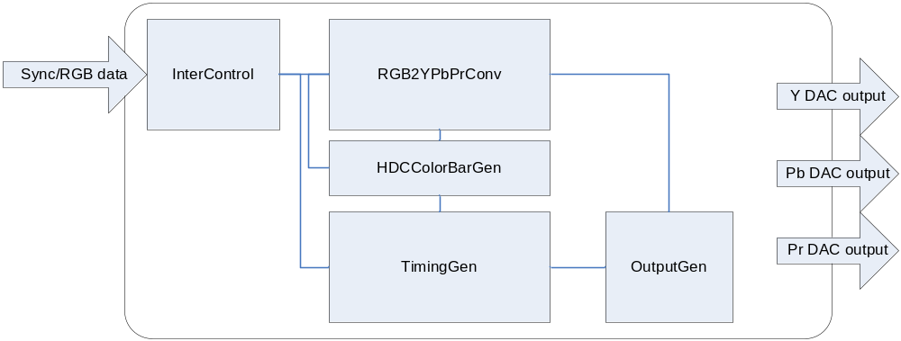

Operation

Video input timing

480P Data input timing

Video input 은 24bits RGB Slave를 지원하도록 되어 있으며, BLANKn = “High” 일 경우, 유효한 정보를 입력 받습니다. 입력 되는 image 는 720x480 size 입니다.

Figure 1-2 480P Video input timing chart
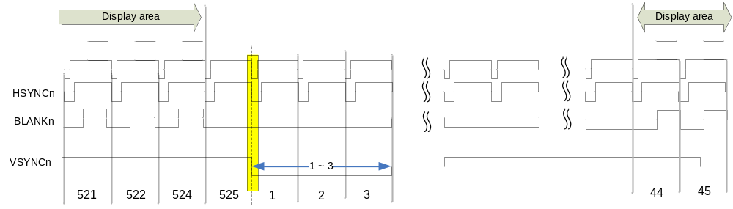
Vertical Line은 525 이며, 유효한 Display 구간은 44 ~ 524(480 Line)으로 구성되어 있습니다.
기본적으로 적용되는 Display clock은 27Mhz 입니다.

Figure 1-3 480P Video clock timing chart
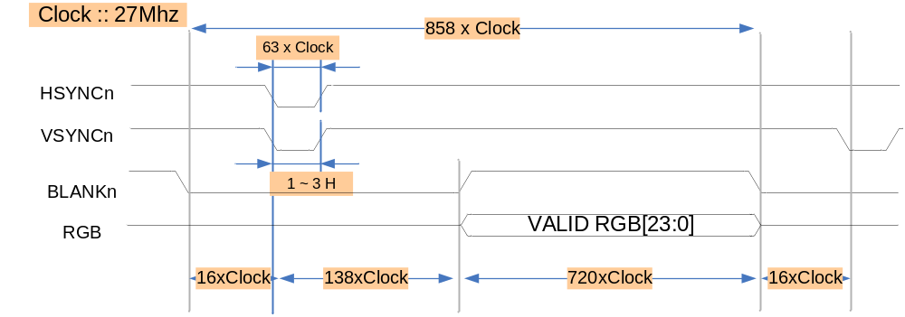
새로운 Frame이 시작될 때, HSYNCn 와 VSYNCn과 동기를 같게 하여 입력하여야 Sync를 맞출 수 있습니다.
VSYNCn 에 Width 는 1~3 Horizontal size 만큼으로 설정 하셔서 사용 가능 합니다. ( **1H ::858 clock)

720P Data input timing

Clock은 74.25Mhz를 사용하며, 1280x720 30frame 입니다. RGB 24bit format을 input 받습니다.

Figure 1-4 720P Video input timing chart
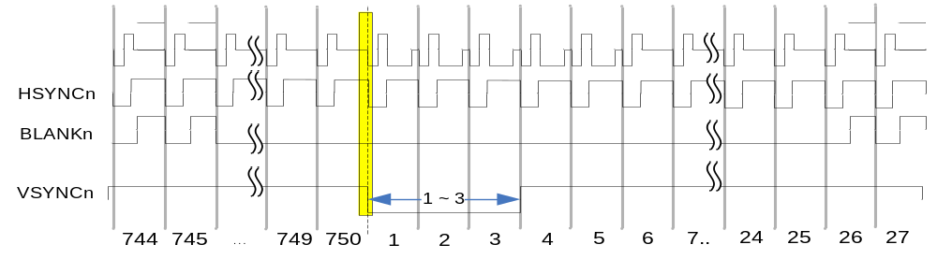

Figure 1-5 720P Video clock input timing chart
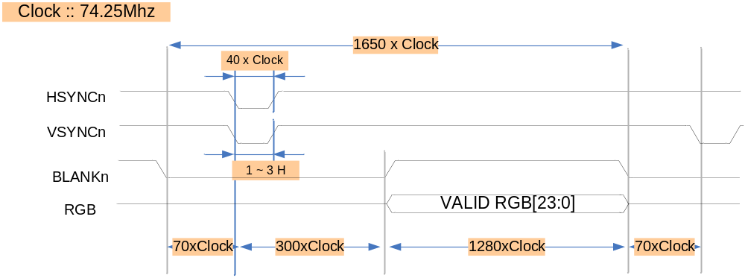
1H ( 1650 clock) 적용되며, VSYNCn에 크기는 최소 1H 이상입니다.

1080i Data input timing

Figure 1-6 1080i Video input timing chart
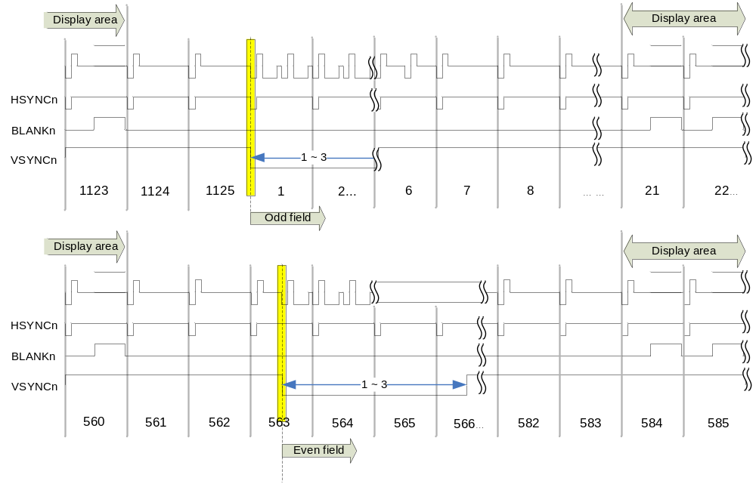

Figure 1-7 1080i Video clock input timing chart
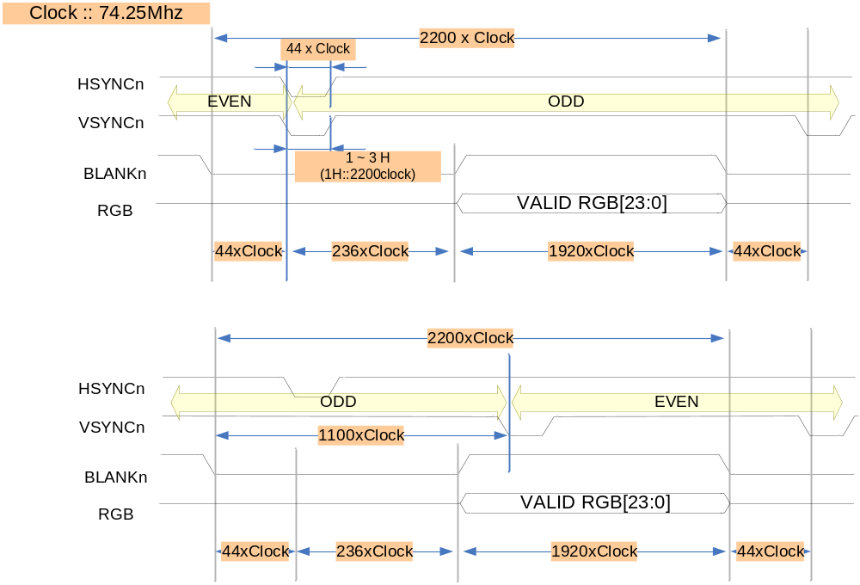
Odd ➔ Even field에 구분은 위와 같이 VSYNC를 1/2 H delay 시키는 시점을 기준으로 EVEN field 로 인식하게 됩니다.

Video output timing

480P Data output timing

Figure 1-8 480p Video output timing/level chart
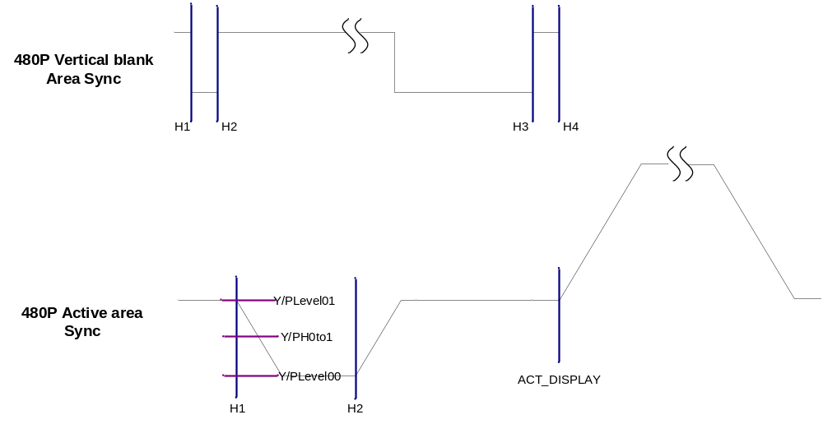
480p로 설정할 경우, H1~H4 register를 사용하여 Timing을 설정하며 ACT_DISPLAY는 출력 Display 영역에 시작 Timing을 설정 합니다. Luminance는 YLevel 로 설정하며, Pb/Pr level은 PLevel로 설정 됩니다.

Table 1-1 480p recommend setting
Bits | Reg. Name | Description | Setting value
[0:11] | H1 | Horizontal point 1 | 15
[0:11] | H2 | Horizontal point 2 | 78
[0:11] | H3 | Horizontal point 3 | 794
[0:11] | H4 | Horizontal point 4 | 857
[0:9] | YLevel00 | Output Level (Y level) | 16
[0:9] | YLevel01 | Output Level (Y level) | 252
[0:9] | YLevel02 | Output Level (Y level) | 0
[0:11] | ACT_DISPLAY | Horizontal point for Display point | 137
[0:9] | PLevel00 | Output Level (Pb/Pr level) | 276
[0:9] | PLevel01 | Output Level (Pb/Pr level) | 512
[0:9] | PLevel02 | Output Level (Pb/Pr level) | 0
[0:9] | YH0to1_1 | Slope 1 level from 0 to 1(Y level) | 134
[0:9] | YH0to1_2 | Slope 2 level from 0 to 1(Y level) | 134
[0:9] | YH0to1_3 | Slope 3 level from 0 to 1(Y level) | 134
[0:9] | PH0to1_1 | Slope 1 level from 0 to 1(PbPr) | 394
[0:9] | PH0to1_2 | Slope 1 level from 0 to 2(PbPr) | 394
[0:9] | PH0to1_3 | Slope 1 level from 0 to 3(PbPr) | 394

720P Data output timing

Figure 1-9 720p Video output timing/level chart
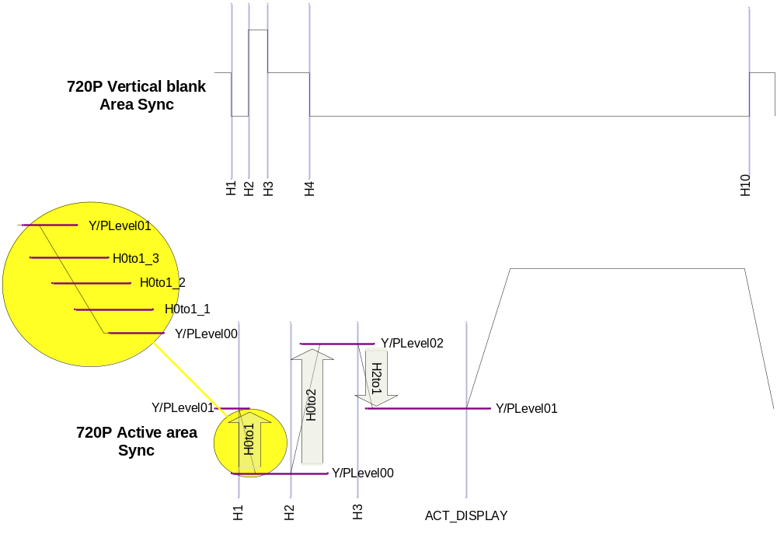
720p Level 설정은 4step으로 설정 하고, H0to1_1 ~ H0to1_3 까지 4단계로 설정 할 수 있도록 설정합니다.

Table 1-2 720p recommend setting
Bits | Reg. Name | Description | Setting value
[0:11] | H1 | Horizontal point 1 | 68
[0:11] | H2 | Horizontal point 2 | 108
[0:11] | H3 | Horizontal point 3 | 148
[0:11] | H4 | Horizontal point 4 | 368
[0:11] | H10 | Horizontal point 10 | 1648
[0:9] | YLevel00 | Output Level (Y level) | 16
[0:9] | YLevel01 | Output Level (Y level) | 242
[0:9] | YLevel02 | Output Level (Y level) | 484
[0:11] | ACT_DISPLAY | Horizontal point for Display point | 369
[0:9] | PLevel00 | Output Level (Pb/Pr level) | 270
[0:9] | PLevel01 | Output Level (Pb/Pr level) | 512
[0:9] | PLevel02 | Output Level (Pb/Pr level) | 782
[0:9] | YH0to1_1 | Slope 1 level from 0 to 1(Y level) | 57
[0:9] | YH0to1_2 | Slope 2 level from 0 to 1(Y level) | 129
[0:9] | YH0to1_3 | Slope 3 level from 0 to 1(Y level) | 186
[0:9] | YH0to2_1 | Slope 1 level from 0 to 2(Y level) | 129
[0:9] | YH0to2_2 | Slope 2 level from 0 to 2(Y level) | 242
[0:9] | YH0to2_3 | Slope 3 level from 0 to 2(Y level) | 369
[0:9] | YH2to1_1 | Slope 1 level from 2 to 1(Y level) | 424
[0:9] | YH2to1_2 | Slope 2 level from 2 to 1(Y level) | 363
[0:9] | YH2to1_3 | Slope 3 level from 2 to 1(Y level) | 303
[0:9] | PH0to1_1 | Slope 1 level from 0 to 1(PbPr) | 331
[0:9] | PH0to1_2 | Slope 1 level from 0 to 1(PbPr) | 391
[0:9] | PH0to1_3 | Slope 1 level from 0 to 1(PbPr) | 452
[0:9] | PH0to2_1 | Slope 1 level from 0 to 2(PbPr) | 391
[0:9] | PH0to2_2 | Slope 1 level from 0 to 2(PbPr) | 512
[0:9] | PH0to2_3 | Slope 1 level from 0 to 2(PbPr) | 647
[0:9] | PH2to1_1 | Slope 1 level from 2 to 1(PbPr) | 715
[0:9] | PH2to1_2 | Slope 1 level from 2 to 1(PbPr) | 647
[0:9] | PH2to1_3 | Slope 1 level from 2 to 1(PbPr) | 580

1080i Data output timing

Figure 1-10 720p Video output timing/level chart
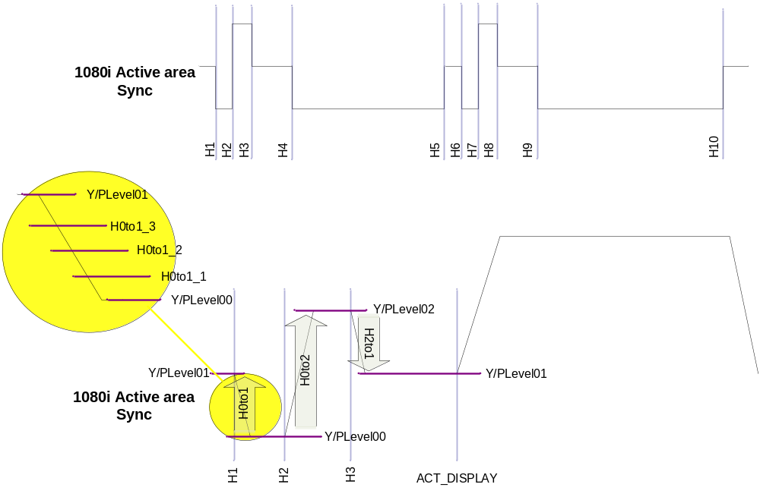

Table 1-3 1080i recommend setting
Bits | Reg. Name | Description | Setting value
[0:11] | H1 | Horizontal point 1 | 42
[0:11] | H2 | Horizontal point 2 | 86
[0:11] | H3 | Horizontal point 3 | 130
[0:11] | H4 | Horizontal point 4 | 218
[0:11] | H10 | Horizontal point 10 | 2198
[0:9] | YLevel00 | Output Level (Y level) | 16
[0:9] | YLevel01 | Output Level (Y level) | 242
[0:9] | YLevel02 | Output Level (Y level) | 484
[0:11] | ACT_DISPLAY | Horizontal point for Display point | 279
[0:9] | PLevel00 | Output Level (Pb/Pr level) | 270
[0:9] | PLevel01 | Output Level (Pb/Pr level) | 512
[0:9] | PLevel02 | Output Level (Pb/Pr level) | 782
[0:9] | YH0to1_1 | Slope 1 level from 0 to 1(Y level) | 57
[0:9] | YH0to1_2 | Slope 2 level from 0 to 1(Y level) | 129
[0:9] | YH0to1_3 | Slope 3 level from 0 to 1(Y level) | 186
[0:9] | YH0to2_1 | Slope 1 level from 0 to 2(Y level) | 129
[0:9] | YH0to2_2 | Slope 2 level from 0 to 2(Y level) | 242
[0:9] | YH0to2_3 | Slope 3 level from 0 to 2(Y level) | 363
[0:9] | YH2to1_1 | Slope 1 level from 2 to 1(Y level) | 424
[0:9] | YH2to1_2 | Slope 2 level from 2 to 1(Y level) | 363
[0:9] | YH2to1_3 | Slope 3 level from 2 to 1(Y level) | 303
[0:9] | PH0to1_1 | Slope 1 level from 0 to 1(PbPr) | 331
[0:9] | PH0to1_2 | Slope 1 level from 0 to 1(PbPr) | 391
[0:9] | PH0to1_3 | Slope 1 level from 0 to 1(PbPr) | 452
[0:9] | PH0to2_1 | Slope 1 level from 0 to 2(PbPr) | 391
[0:9] | PH0to2_2 | Slope 1 level from 0 to 2(PbPr) | 512
[0:9] | PH0to2_3 | Slope 1 level from 0 to 2(PbPr) | 647
[0:9] | PH2to1_1 | Slope 1 level from 2 to 1(PbPr) | 715
[0:9] | PH2to1_2 | Slope 1 level from 2 to 1(PbPr) | 647
[0:9] | PH2to1_3 | Slope 1 level from 2 to 1(PbPr) | 580

Control Setting

Color space conversion parameter setting

Table 1-4 parameter recommend setting
 | Reg. Name | 480p | 720p | 1080i
[0:9] | YR_para | 306 | 218 | 218
[0:9] | YG_para | 601 | 732 | 732
[0:9] | YB_para | 117 | 74 | 74
[0:9] | PbR_para | 173 | 118 | 118
[0:9] | PbG_para | 334 | 394 | 394
[0:9] | PbB_para | 512 | 512 | 512
[0:9] | PrR_para | 512 | 512 | 512
[0:9] | PrG_para | 429 | 465 | 465
[0:9] | PrB_para | 83 | 47 | 47

Amplitude setting

LUMA_AMP /Pr_AMP / Pb_AMP register를 통하여 0~1.99 까지 값을 설정 하도록 되어 있으며, 추천되는 값은 480p :: 75 / 720p :: 77 / 1080i :: 77 설정 합니다.

Signal Description

InOutput Signal

Table 1-5 Component video output core Signal
Signal Name | Direction | Description | Init. value
CLK | input | Input clock (27Mhz/74.25Mhz)
RESETn | Input | Reset
HSYNCn | Input | Horizontal sync signal
VSYNCn | Input | Vertical sync signal
BLANKn | Input | Blank sync signal
Rin | Input | R[7:0] Red color
Gin | Input | G[7:0] Green color
Bin | Input | B[7:0] Blue color
HD_ENABLE | Input | Enable signal
EnDAC0 | Input | Luminance DAC enable signal
EnDAC1 | Input | Pb DAC enable signal
EnDAC2 | Input | Pr DAC enable signal
LUMA_AMP | input | Luminance amplitude
Pb_AMP | input | Pb amplitude
Pr_AMP | input | Pr amplitude
HD_MODE | input | Output mode setting
EN_INTERNAL_PATTERN | input | Internal pattern enable
EnSYNC_PbPr | input | PbPr sync signal enable
YRpara | input | Color space conversion parameter
YGpara | input | Color space conversion parameter
YBpara | input | Color space conversion parameter
PbRpara | input | Color space conversion parameter
PbGpara | input | Color space conversion parameter
PbBpara | input | Color space conversion parameter
PrRpara | input | Color space conversion parameter
PrGpara | input | Color space conversion parameter
PrBpara | input | Color space conversion parameter

Signal Name | Direction | Description | Init. value
H1 | input | Horizontal point 1
H2 | Input | Horizontal point 2
H3 | Input | Horizontal point 3
H4 | Input | Horizontal point 4
H5 | Input | Horizontal point 5
H6 | Input | Horizontal point 6
H7 | Input | Horizontal point 7
H8 | Input | Horizontal point 8
H9 | Input | Horizontal point 9
H10 | Input | Horizontal point 10
ACT_DISPLAY | Input | Active display area define
YH0to1_1 | Input | Luminance level control value
YH0to1_2 | input | Luminance level control value
YH0to1_3 | input | Luminance level control value
YH0to2_1 | input | Luminance level control value
YH0to2_2 | input | Luminance level control value
YH0to2_3 | input | Luminance level control value
YH2to1_1 | input | Luminance level control value
YH2to1_2 | input | Luminance level control value
YH2to1_3 | input | Luminance level control value
YLevel00 | input | Luminance level control value
YLevel01 | input | Luminance level control value
YLevel02 | input | Luminance level control value
PH0to1_1 | input | Pr/Pb level control value
PH0to1_2 | input | Pr/Pb level control value
PH0to1_3 | input | Pr/Pb level control value
PH0to2_1 | input | Pr/Pb level control value
PH0to2_2 | Input | Pr/Pb level control value
PH0to2_3 | Input | Pr/Pb level control value
PH2to1_1 | Input | Pr/Pb level control value
PH2to1_2 | Input | Pr/Pb level control value
PH2to1_3 | Input | Pr/Pb level control value
PLevel00 | Input | Pr/Pb level control value
PLevel01 | Input | Pr/Pb level control value
PLevel02 | Input | Pr/Pb level control value

Signal Name | Direction | Description | Init. value
DAC0_Luminace | Output | Luminance DAC output
DAC1_Pb | Output | Pb DAC output
DAC2_Pr | Output | Pr DAC output

Register Description

Registers

Table 1-6 Registers(Base Address : 5000 B000h)
Offset | Name | R/W | Description | Init. Value
0000h | HD Control Reg. | R/W | Control register | 0000 0000h
0004h | HD output level 0 Reg. | RW | Output level control register | 0000 0000h
0008h | HD output level 1 Reg. | RW | Output level control register | 0000 0000h
000Ch | HD output level 2 Reg. | RW | Output level control register | 0000 0000h
0010h | HD output level 3 Reg. | RW | Output level control register | 0000 0000h
0014h | HD output level 4 Reg. | RW | Output level control register | 0000 0000h
0018h | HD output level 5 Reg. | RW | Output level control register | 0000 0000h
001Ch | HD output level 6 Reg. | RW | Output level control register | 0000 0000h
0020h | HD output level 7 Reg. | RW | Output level control register | 0000 0000h
0024h | HD Timing control 0 Reg. | RW | Timing control register | 0000 0000h
0028h | HD Timing control 1 Reg. | RW | Timing control register | 0000 0000h
002Ch | HD Timing control 2 Reg. | RW | Timing control register | 0000 0000h
0030h | HD Timing control 3 Reg. | RW | Timing control register | 0000 0000h
0034h | HD Timing control 4 Reg. | RW | Timing control register | 0000 0000h
0038h | HD Timing control 5 Reg. | RW | Timing control register | 0000 0000h
003Ch | HD convert para. 0 Reg. | RW | Color space conversion parameter | 0000 0000h
0040h | HD convert para. 1 Reg. | RW | Color space conversion parameter | 0000 0000h
0044h | HD convert para. 2 Reg. | RW | Color space conversion parameter | 0000 0000h

HD control Register

Figure 1-11 HD Control Register Bits
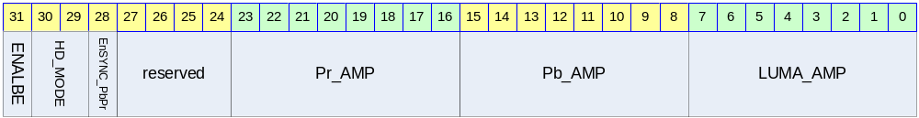

Table 1-7 HD Control Register Description(Offset : 0000 0030h)

Bits | Name | R/W | Description | Init. value
[31] | HD_ENABLE | RW | Enable
[29:30] | HD_MODE | RW | Setting for components mode  2’b00 :: 480P mode  2’b01 :: 720P mode  2’b10 :: 1800i mode | 0b
[28] | EnSYNC_PbPr | RW | Sync generation on Pb/Pr signal
[16:23] | Pr_AMP | RW | Pr amplitude 1.99 ~ 0
[8:15] | Pb_AMP | RW | Pb amplitude 1.99 ~ 0
[0:7] | LUMA_AMP | RW | Y amplitude 1.99 ~ 0

HD output level 0 Register

Figure 1-12 HD Output Level 0 Register Bits
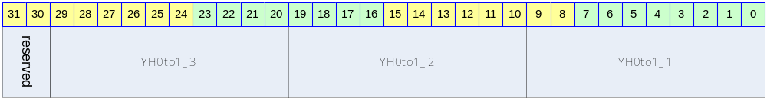

Table 1-8 HD Output Level 0 Register Description(Offset : 0000 0034h)
Bits | Name | R/W | Description | Init. value
[0:9] | YH0to1_1 | RW | Sync step value
[10:19] | YH0to1_2 | RW | Sync step value
[20:29] | YH0to1_3 | RW | Sync step value

HD output level 1 Register

Figure 1-13 HD Output Level 1 Register Bits
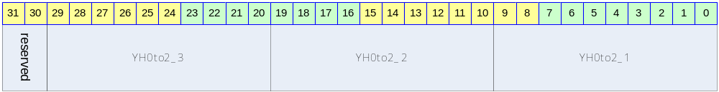

Table 1-9 HD Output Level 1 Register Description(Offset : 0000 0038h)
Bits | Name | R/W | Description | Init. value
[0:9] | YH0to2_1 | RW | Sync step value
[10:19] | YH0to2_2 | RW | Sync step value
[20:29] | YH0to2_3 | RW | Sync step value

HD output level 2 Register

Figure 1-14 HD Output Level 2 Register Bits
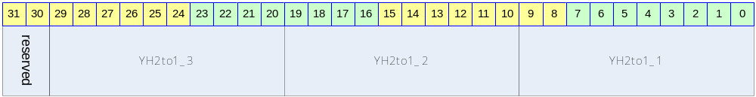

Table 1-10 HD Output Level 2 Register Description(Offset : 0000 003Ch)
Bits | Name | R/W | Description | Init. value
[0:9] | YH2to1_1 | RW | Sync step value
[10:19] | YH2to1_2 | RW | Sync step value
[20:29] | YH2to1_3 | RW | Sync step value

HD output level 3 Register

Figure 1-15 HD Output Level 3 Register Bits
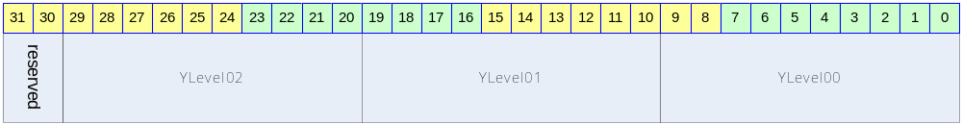

Table 1-11 HD Output Level 3 Register Description(Offset : 0000 0040h)
Bits | Name | R/W | Description | Init. value
[0:9] | YLevel00 | RW | Output level define
[10:19] | YLevel01 | RW | Output level define
[20:29] | YLevel02 | RW | Output level define

HD output level 4 Register

Figure 1-16 HD Output Level 4 Register Bits
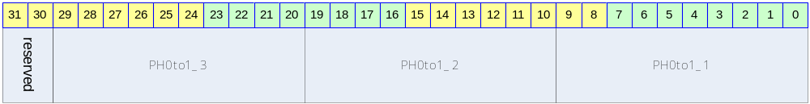

Table 1-12 HD Output Level 4 Register Description(Offset : 0000 0044h)
Bits | Name | R/W | Description | Init. value
[0:9] | PH0to1_1 | RW | Sync step value
[10:19] | PH0to1_2 | RW | Sync step value
[20:29] | PH0to1_3 | RW | Sync step value

HD output level 5 Register

Figure 1-17 HD Output Level 5 Register Bits
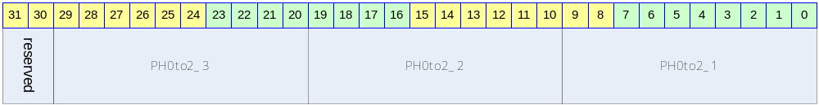

Table 1-13 HD Output Level 5 Register Description(Offset : 0000 0048h)
Bits | Name | R/W | Description | Init. value
[0:9] | PH0to2_1 | RW | Sync step value
[10:19] | PH0to2_2 | RW | Sync step value
[20:29] | PH0to2_3 | RW | Sync step value

HD output level 6 Register

Figure 1-18 HD Output Level 6 Register Bits
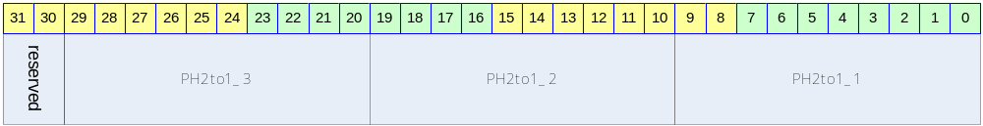

Table 1-14 HD Output Level 6 Register Description(Offset : 0000 004Ch)
Bits | Name | R/W | Description | Init. value
[0:9] | PH2to1_1 | RW | Sync step value
[10:19] | PH2to1_2 | RW | Sync step value
[20:29] | PH2to1_3 | RW | Sync step value

HD output level 7 Register

Figure 1-19 HD Output Level 7 Register Bits
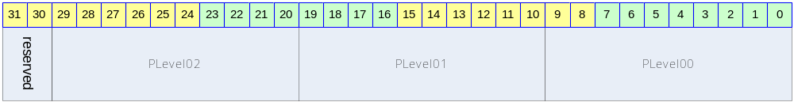

Table 1-15 HD Output Level 7 Register Description(Offset : 0000 0050h)
Bits | Name | R/W | Description | Init. value
[0:9] | PLevel00 | RW | Output level define
[10:19] | PLevel01 | RW | Output level define
[20:29] | PLevel02 | RW | Output level define

HD Timing Control 0 Register

Figure 1-20 HD Timing Control 0 Register Bits
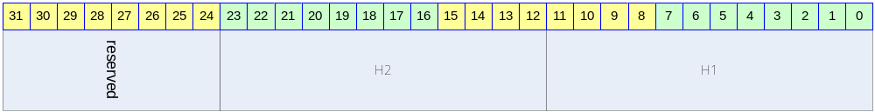

Table 1-16 HD Timing Control 0 Register Description(Offset : 0000 0054h)
Bits | Name | R/W | Description | Init. value
[0:11] | H1 | RW | Horizontal point 1
[12:23] | H2 | RW | Horizontal point 2

HD Timing Control 1 Register

Figure 1-21 HD Timing Control 1 Register Bits
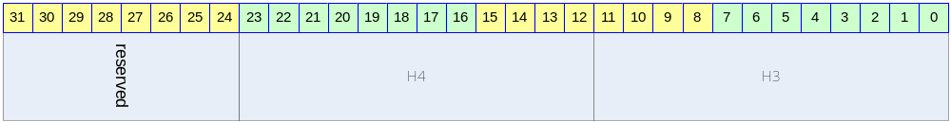

Table 1-17 HD Timing Control 1 Register Description(Offset : 0000 0058h)
Bits | Name | R/W | Description | Init. value
[0:11] | H3 | RW | Horizontal point 3
[12:23] | H4 | RW | Horizontal point 4

HD Timing Control 2 Register

Figure 1-22 HD Timing Control 2 Register Bits
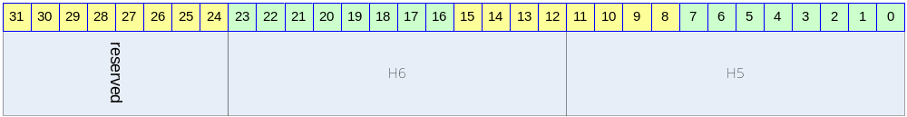

Table 1-18 HD Timing Control 2 Register Description(Offset : 0000 005Ch)
Bits | Name | R/W | Description | Init. value
[0:11] | H5 | RW | Horizontal point 5
[12:23] | H6 | RW | Horizontal point 6

HD Timing Control 3 Register

Figure 1-23 HD Timing Control 3 Register Bits
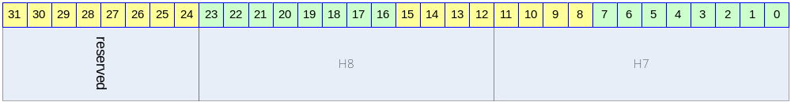

Table 1-19 HD Timing Control 3 Register Description(Offset : 0000 0060h)
Bits | Name | R/W | Description | Init. value
[0:11] | H7 | RW | Horizontal point 7
[12:23] | H8 | RW | Horizontal point 8

HD Timing Control 4 Register

Figure 1-24 HD Timing Control 4 Register Bits
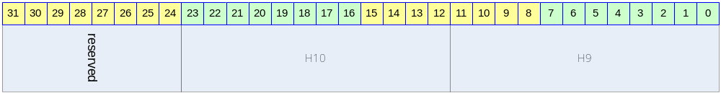

Table 1-20 HD Timing Control 4 Register Description(Offset : 0000 0064h)
Bits | Name | R/W | Description | Init. value
[0:11] | H9 | RW | Horizontal point 9
[12:23] | H10 | RW | Horizontal point 10

HD Timing Control 5 Register

Figure 1-25 HD Timing Control 5 Register Bits
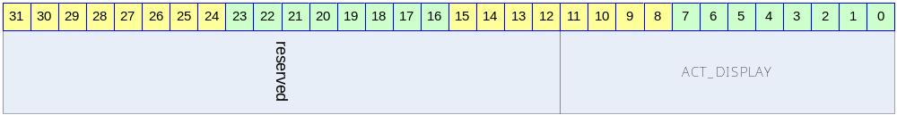

Table 1-21 HD Timing Control 5 Register Description(Offset : 0000 0068h)
Bits | Name | R/W | Description | Init. value
[0:11] | ACT_DISPLAY | RW | Active display area define

HD convert parameter 0 Register

Figure 1-26 HD convert parameter 0 Register Bits
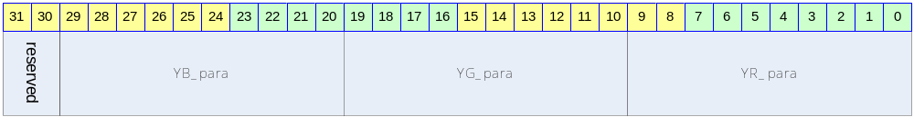

Table 1-22 HD convert parameter 0 Register Description(Offset : 0000 006Ch)
Bits | Name | R/W | Description | Init. value
[0:9] | YR_para | RW
[10:19] | YG_para | RW
[20:29] | YB_para | RW

HD convert parameter 1 Register

Figure 1-27 HD convert parameter 1 Register Bits
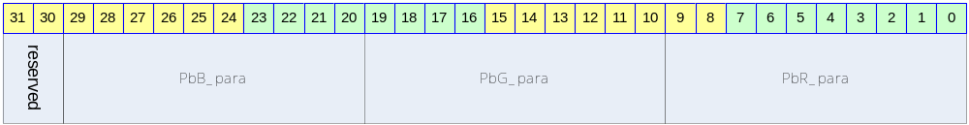

Table 1-23 HD convert parameter 1 Register Description(Offset : 0000 0070h)
Bits | Name | R/W | Description | Init. value
[0:9] | PbR_para | RW
[10:19] | PbG_para | RW
[20:29] | PbB_para | RW

HD convert parameter 2 Register

Figure 1-28 HD convert parameter 2 Register Bits
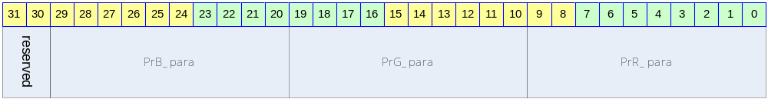

Table 1-24 HD convert parameter 2 Register Description(Offset : 0000 0074h)
Bits | Name | R/W | Description | Init. value
[0:9] | PrR_para | RW
[10:19] | PrG_para | RW
[20:29] | PrB_para | RW

