NTSC PAL Video Encoder

Version 1.0

SHMT Co., Ltd.

REVISION HISTORY (굴림/Verdana 12pt bold)
Version | Detail(굴림/Verdana 10pt bold) | Name | Date
V.0

Technical documents(굴림/Verdana 12pt, bold)
Copyright © 2006 Shmt Limited. All rights reserved.(굴림, Verdana 10pt, 기울임)

Confidentiality Status(굴림/Verdana 12pt, bold)
This document is NOT OPEN ACCESS. The distribution is restricted to certified company.(굴림/Verdana 10pt)
This document is CONFIDENTIAL.(굴림/Verdana 10pt)

Feedback on this document(굴림/Verdana 12pt, bold)
If you have any comments on this document, please contact your channel to our company.(굴림/Verdana 10pt)

Shmt Web address (굴림/Verdana, 12pt, bold)
http://www.shmt.com (굴림/Verdana 10pt)

Contents
1. NTSC PAL Video encoder 7
1.1. Overview 7
1.1.1. Feature 7
1.1.2. Block diagram 8
1.2. Operation 9
1.3. Signal Description 10
1.3.1. InOutput Signal 10
1.4. Register Description 11
1.4.1. Registers 11
1.4.2. Status Register 11
1.4.3. Control Register 12
1.4.4. Internal Register 13
1.4.5. Interface register 15
1.4.6. Subcarrier phase register 16
1.4.7. Subcarrier register 16

Figures

Figure 1-1 Video Encoder Block Diagram 8

Tables
Table 1-1 VideoEncoder Signal 10
Table 1-2 Registers(Base Address : xxxxxh) 11
Table 1-3 Status Register Description(Offset : 0000 0000h) 11

NTSC PAL Video encoder

Overview
High performance video encoder supports for NTSC M, NTSC-J, NTSC4.32, PAL B/D/G/H/I and PAL M. By using RGB/BT.656/BT.601 format, it outputs analog composite and analog S-video. This encoder drives the 10bits DAC

Feature
- ITU-R1 BT601/BT656 YCrCb or RGB to PAL/NTSC video encoder
- NTSC M, NTSC J, NTSC 4.43, PAL Nc, PAL B/D/G/H/I, PAL-M
- 27Mhz clock required (x2 oversampling)
- Video input data port supports:
  - CCIR-656/601 4:2:2 8bit parallel input format
  - RGB 24bit Parallel input format
- Video output supports:
  - Composite / S-Video signal output
  - 10bits high quality DAC output
- Gamma correction function
- Programmable luma / chroma filters
- Programmable subcarrier frequency and phase
- Programmable LUMA delay
- Individual on/off control of each DAC
- CCIR and square pixel operation
- Integrated subcarrier locking to external video source
- Color signal control/burst signal control
- Complete on-chip video timing generator
- Programmable multimode master/slave operation
- On-chip color bar generation

Block diagram

Figure 1-1 Video Encoder Block Diagram
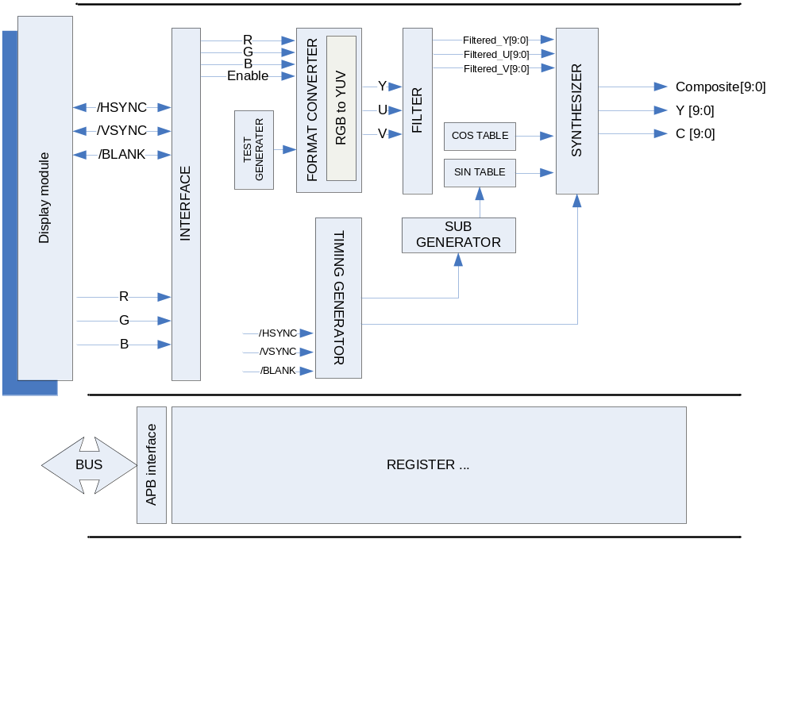

Operation

동작 설명…

Signal Description

InOutput Signal

Table 1-1 VideoEncoder Signal
Signal Name | Direction | Description | Init. value

Register Description

Registers

Table 1-2 Registers(Base Address : xxxxxh)
Offset | Name | R/W | Description | Init. value
0000h | Status Reg. | R | Status register | 0000 0000h
0004h | Control Reg. | RW | Output Control register | 0000 0000h
0008h | Internal Reg. | RW | Internal control register | 0000 0000h
000Ch | Interface Reg. | RW | Input interface control register | 0000 0000h
0010h | Subcarrier phase Reg. | RW | Subcarrier adjust phase register | 0000 0000h
0014h | Subcarrier Reg. | RW | Subcarriter frequency setup register | 0000 0000h
0018h
001Ch
0020h

Status Register
Figure 1-2 Status Register Bits
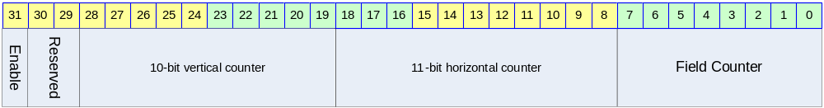

Table 1-3 Status Register Description(Offset : 0000 0000h)
Bits | Name | R/W | Description | Init. value
[00:07] | FIELD_CNT | R | Field counter | 0b
[08:18] | H_CNT | R | Horizontal counter | 0b
[19:28] | V_CNT | R | Vertical counter | 0b
[31] | Enable | R | Enable status | 0b

Control Register
Figure 1-3 Control Register Bits
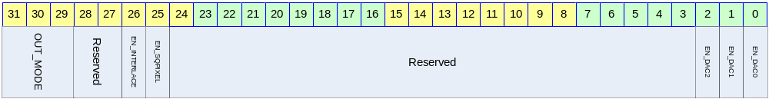

Table 1-4 Control Register Description(Offset : 0000 0000h)
Bits | Name | R/W | Description | Init. value
[00] | EN_DAC0 | R/W | This bit can be used to power down the DAC0  0 :: Off DAC / 1 :: On DAC | 0b
[01] | EN_DAC1 | R/W | This bit can be used to power down the DAC1  0 :: Off DAC / 1 :: On DAC | 0b
[02] | EN_DAC2 | R/W | This bit can be used to power down the DAC2  0 :: Off DAC / 1 :: On DAC | 0b
[25] | EN_SQPIXEL | R/W | This bit is used for square pixel mode  0 :: normal mode  1 :: Square pixel mode  for the square pixel mode, change the frequency.  - NTSC square pixel mode :: 24.5454MHz  - PAL square pixel mode :: 29.5MHz | 0b
[26] | EN_INTERLACE | R/W | To choice the mode of interlace or non-interlace  0 :: interlace  1 :: non-interlace | 0b
[31:29] | OUT_MODE | R/W | For setting up the ENCODE mode  000 :: NTSC M  001 :: NTSC J  010 :: NTSC 4.43  011 :: M PAL  100 :: PAL(B, D, G, H and I)  101 :: PAL Nc  110 :: PAL N | 000b

Internal Register
Figure 1-4 Internal Register Bits
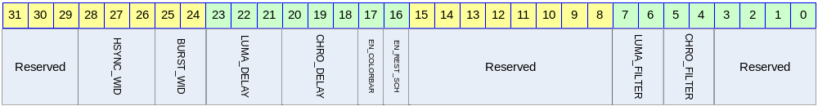

Table 1-5 Internal Register Description(Offset : 0000 0000h)
Bits | Name | R/W | Description | Init. Value
[04:05] | LUMA_FILTER_SEL | R/W | Select of the luminance filter | 00b
[06:07] | CHRO_FILTER_SEL | R/W | Select of the chrominance filter | 00b
[16] | EN_REST_SCH | R/W | This bit can be auto reset SCH  0 :: disable  1 :: Enable auto reset  Resetting the SCH phase every four or eight fields. This function is to avoid the accumulation of SCH phase error | 0b
[17] | EN_COLORBAR | R/W | Internal color bar generation setting  0 :: disable  1 :: color bar generation | 0b
[18:20] | CHRO_DELAY |  | For setting the delay of chrominance  000 :: none  001 :: 1 Ts delay  010 :: 2 Ts delay  011 :: 3 Ts delay  100 :: 4 Ts delay  (1Ts – 1clock period :: 27Mhz → about 37ns) | 000b
[21:23] | LUMA_DELAY |  | For setting the delay of luminance  000 :: none  001 :: 1 Ts delay  010 :: 2 Ts delay  011 :: 3 Ts delay  100 :: 4 Ts delay  (1Ts – 1clock period :: 27Mhz → about 37ns) | 000b

Bits | Name | R/W | Description | Init. Value
[24:25] | BURST_WID | R/W | For setting burst falling to rising and rising to falling edge time  00 :: 1 Ts reduce from normal  01 :: normal  10 :: 1 Ts expanded | 01b
[26:28] | HSYNC_WID | R/W | For setting the delay of luminance  000 :: 2 Ts reduce from normal mode  001 :: 1 Ts reduce from normal mode  010 :: normal mode  011 :: 1 Ts expanded  100 :: 2 Ts expanded  (1Ts – 1clock period :: 27Mhz → about 37ns) | 010b

Interface register
Figure 1-5 Interface Register Bits
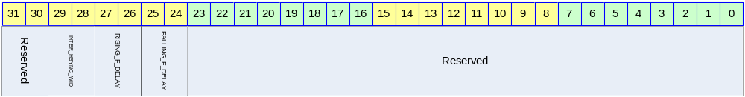

Table 1-6 Internal Register Description(Offset : 0000 0000h)
Bits | Name | R/W | Description | Init. Value
[24:25] | INTER_HSYNC_WIDTH | R/W | When interface mode 1, /HSYNC width  00 :: 1 x Ts  01 :: 4 x Ts  10 :: 16 x Ts  11 :: 128 x Ts
[26:27] | RISING_F_DELAY | R/W | The rising or falling of /HSYNC edge to Field,/VSYNC rising edge delay  00 :: 0 x Ts  01 :: 4 x Ts  10 :: 8 x Ts  11 :: 16 x Ts
[28:29] | INTER_HSYNC_WIDTH | R/W | When interface mode 1, /HSYNC width  00 :: 1 x Ts  01 :: 4 x Ts  10 :: 16 x Ts  11 :: 128 x Ts

Subcarrier phase register
Figure 1-6 subcarrier phase Register Bits
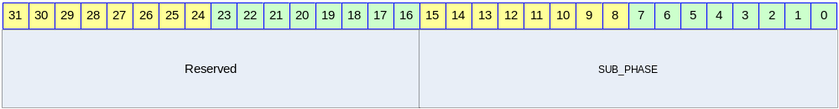

Table 1-7 Internal Register Description(Offset : 0000 0000h)
Bits | Name | R/W | Description | Init. Value
[00:15] | SUB_PHASE | R/W | Subcarrier phase register  [0 ~ 2048]  Each bit represents 0.17578125˚

Subcarrier register
Figure 1-7 subcarrier Register Bits
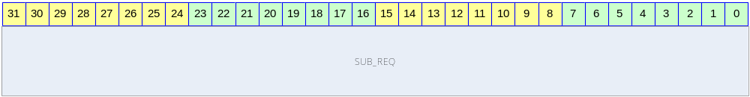

Table 1-8 Internal Register Description(Offset : 0000 0000h)
Bits | Name | R/W | Description | Init. Value
[00:31] | SUB_REQ | R/W | Subcarrier frequency setting

