NTSC PAL Video Encoder

Version 1.08

SHMT Co., Ltd.

REVISION HISTORY
Version | Detail(굴림/Verdana 10pt bold) | Name | Date
V.00 | Core block specification | NamKwol Kang | Jan .1st.2007
V.01 | 오류 수정 / 내용 첨가 | NamKwol Kang | Jan .30th.2007
V.02 | Video Output control 추가 | NamKwol Kang | Feb .14th.2007
V.03 | 오류수정 그림 HSYNC← → VSYNC / Valid area 영역 | NamKwol Kang | Feb.21th.2007
V.04 | Video output control 내용 추가 | NamKwol Kang | Feb.22th.2007
V.05 | BT601 내용 제거 함 (spec. 변경) | NamKwol Kang | Feb.28th.2007
V.06 | Hue/Saturation/Brightness 추가 | NamKwol Kang | Mar. 15th.2007
V.07 | 오류 및 BUST_STEP /HSYNC_STEP 변경 추가. |  | Mar. 25th.2007
V.08 | 일부 내용 수정/삭제 |  | June 4, 2007

Technical documents
Copyright © 2006 Shmt Limited. All rights reserved

Confidentiality Status
This document is NOT OPEN ACCESS. The distribution is restricted to certified companyThis document is CONFIDENTIAL

Feedback on this document
If you have any comments on this document, please contact your channel to our company

Shmt Web address
http://www.shmt.com

Contents
1. NTSC PAL Video encoder 7
1.1. Overview 7
1.1.1. Feature 7
1.1.2. Block diagram 8
1.2. Operation 9
1.2.1. Control setting 9
1.2.2. Video Output BT656 13
1.3. Signal Description 16
1.3.1. InOutput Signal 16
1.4. Register Description 18
1.4.1. Registers 18
1.4.2. Status Register 18
1.4.3. Control Register 19
1.4.4. Internal Register 21
1.4.5. Subcarrier phase register 23
1.4.6. Subcarrier register 23
1.4.7. Image Control register 24
1.4.8. Output level register 0 25
1.4.9. Output level register 1 26

Figures

Figure 17-1 Video Encoder Block Diagram 8
Figure 17-2 Internal pattern 9
Figure 17-3 NTSC / PAL setting 11
Figure 17-4 BT656 Display module Timing setting 13
Figure 17-5 INV_CbCr register setting 13
Figure 17-6 BT656 NTSC mode Timing 14
Figure 17-7 BT656 PAL mode Timing 14
Figure 17-8 BT656 mode register setting example (decimal value) 15
Figure 17-9 Status Register Bits 18
Figure 17-10 Control Register Bits 19
Figure 17-11 Internal Register Bits 21
Figure 17-12 subcarrier phase Register Bits 23
Figure 17-13 Subcarrier Register Bits 23
Figure 17-14 Image control Register Bits 24
Figure 17-15 Output level Register 0 Bits 25
Figure 17-16 Output level Register 1 Bits 26

Tables

Table 17-1 Subcarrier frequnce table 10
Table 17-2 Display module LCD setting example table 12
Table 17-3 VideoEncoder core Signal 16
Table 17-4 Registers(Base Address : 5000 B000h) 18
Table 17-5 Status Register Description(Offset : 0000h) 18
Table 17-6 Control Register Description(Offset : 0004h) 19
Table 17-7 Internal Register Description(Offset : 0008h) 21
Table 17-8 subcarrier phase Register (Offset : 000Ch) 23
Table 17-9 subcarrier Register (Offset : 0010h) 23
Table 17-10 Image control Register (Offset : 0014h) 24
Table 17-11 Output level Register 0 (Offset : 0018h) 25
Table 17-12 Output level Register 1 (Offset : 001Ch) 26

NTSC PAL Video encoder

Overview

High performance video encoder supports for NTSC M, NTSC-J, NTSC4.32, PAL B/D/G/H/I and PAL M. By using RGB format, it outputs analog composite This encoder drives the 10bits DAC

Feature

- RGB to PAL/NTSC video encoder
- NTSC M, NTSC J, NTSC 4.43, PAL Nc, PAL B/D/G/H/I, PAL-M
- 27Mhz clock required (x2 oversampling)
- Video input data port supports:
  - RGB 24bit Parallel input format
- Video output supports:
  - Composite
  - 10bits high quality DAC output
- Programmable luma / chroma filters
- Programmable subcarrier frequency and phase
- Programmable LUMA delay
- Individual on/off control of each DAC
- Color signal control/burst signal control
- Complete on-chip video timing generator
- On-chip color bar / color ramp generation

Block diagram

Figure 17-1 Video Encoder Block Diagram

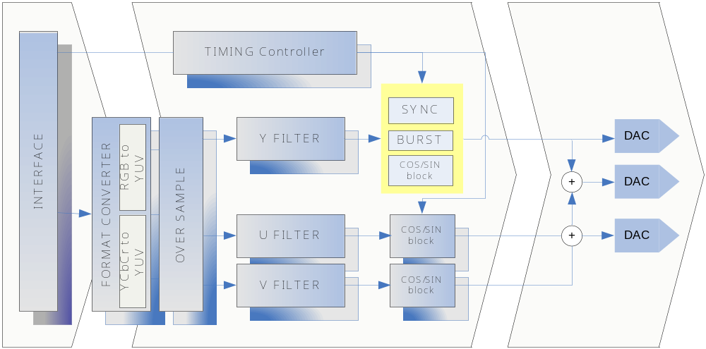

Operation

Control setting

Video Encoder 동작을 위하여 각 설정 정보를 설정한 후 Enable을 설정 하는 순서로 이루 워 지며, NTSC Video Encoder는 720x480 image를 기본 영역으로 하는 image를 NTSC(M)을 기본으로 제공하는 TV및 영상 장치에 출력 할 수 있도록 되어 있습니다.

Internal Pattern generation

Figure 17-2 Internal pattern

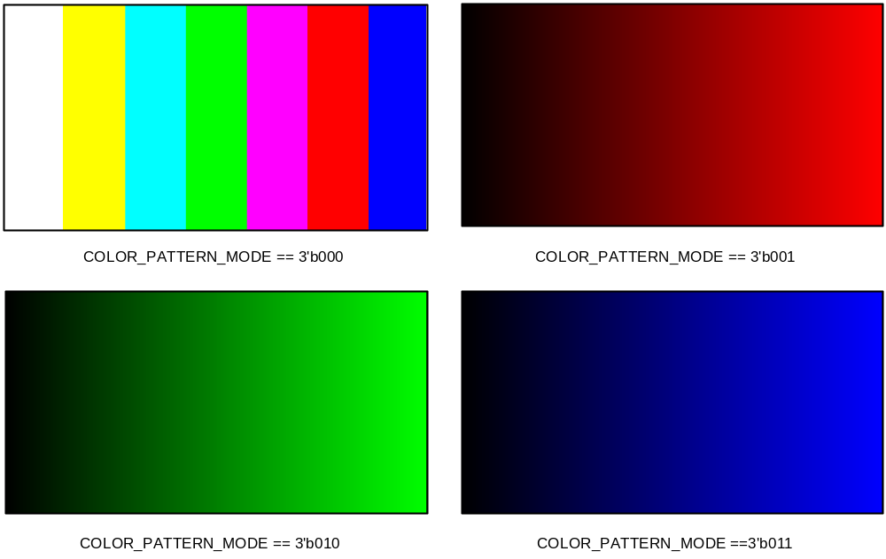

COLOR_PATTERN_MODE를 선택 하고, EN_INTERNAL_PATTERN을 Enable 하게 되면 외부에 입력신호 없이 자체 SYNC 신호 및 RGB 신호를 생성하여, MODE에 따라 출력 하게 됩니다.

Subcarrier frequency setting

Table 17-1 Subcarrier frequnce table
MODE | Name | Setting value (SUB_REQ) | Frequency
3’b000 | NTSC M | 21F0 78BB h | 3.579545 Mhz
3’b001 | NTSC J | 21F0 78BB h | 3.579545 Mhz
3’b010 | NTSC 4.43 | 2A09 8ACB h | 4.43361875 Mhz
3’b011 | M PAL | 21E6 EFA4 h | 3.57561149 Mhz
3’b100 | PAL(B, D, G, H and I) | 2A09 8ACB h | 4.43361875 Mhz
3’b101 | PAL Nc | 21F6 9446 h | 3.58205625 Mhz
3’b110 | PAL N | 2A09 8ACB h | 4.43361875 Mhz
SUB_REQ를 각 MODE에 따라서 설정 하여야 합니다. Subcarrier 설정을 위하여 각 값들을 설정 하게 됩니다.

Register 계산방법은 아래와 같습니다.
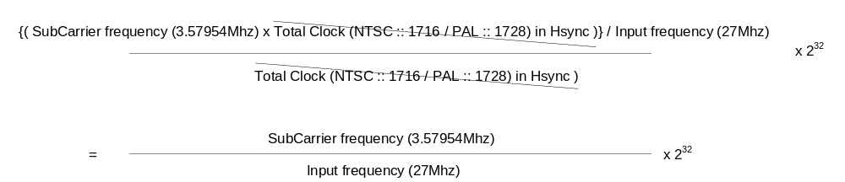

예를 들어, 3.57954Mhz에 Subcarrier를 사용하고, 입력 주파수가 27Mhz 일 경우,
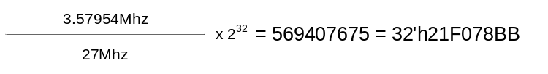
MODE를 설정 하면, MODE에 맞는 설정 값을 갖게 되며, 만약 사용자가 다른 값을 설정 하고 싶을 경우에는 MODE 설정 후에 값을 설정 하면 됩니다.

Video Encoder recommend setting

Figure 17-3 NTSC / PAL setting

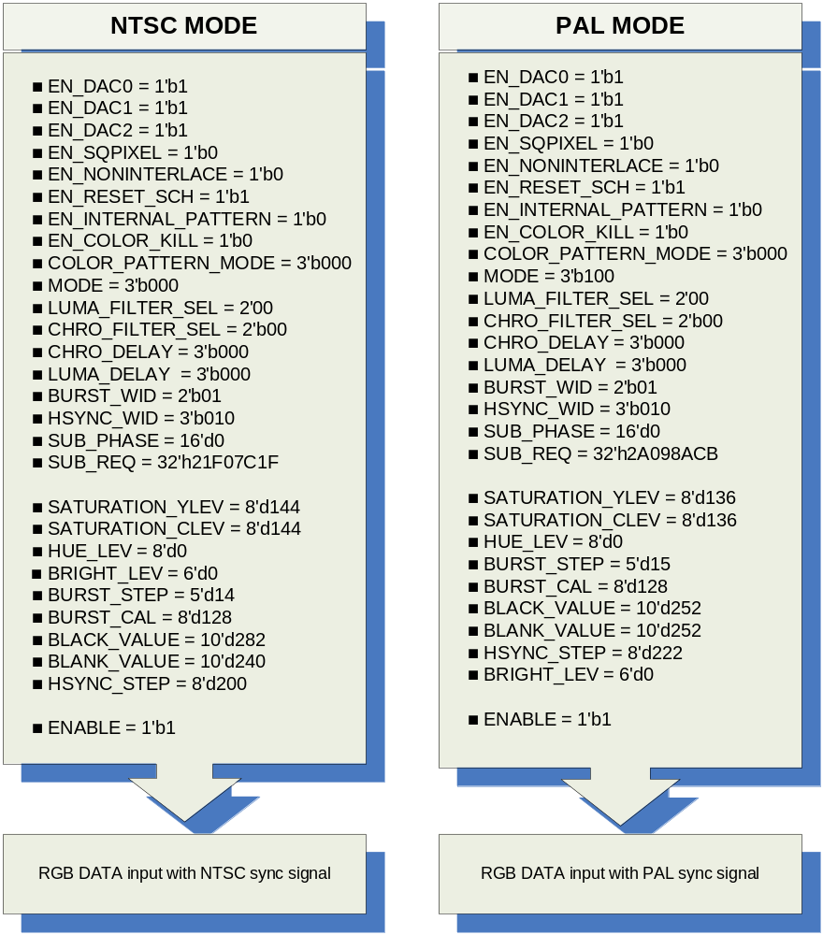

NTSC / PAL mode에 기본적인 Setting 값들 이며, SUB_REQ 값은 특정한 Setting을 원하지 않는 이상 설정 하지 않도록 합니다.
Setting 순서는 Video Encoder register 설정 후에, Display module을 설정 하도록 합니다. Display module은 사용자가 원하는 Plane을 설정합니다. LCD 출력 관련한 값들은 아래 Table을 참조 합니다.

Table 17-2 Display module LCD setting example table
Name | Register | NTSC mode (decimal) | PAL mode (decimal)
LCDHFP | HSYNCCON0 | 31 | 23
LCDHSW | HSYNCCON1 | 122 | 132
LCDHBP | HSYNCCON0 | 123 | 133
LCDCPL | HSYNCCON1 | 1440 | 1440
LCDVSW | VSYNCCON1 | 3 | 2
LCDLPS | VSYNCCON1 | 240 | 288
LCDVBP | VSYNCCON0 | 16 | 20
LCDVFP | VSYNCCON0 | 3 | 3
LCDIVS | LCDCON | 1 | 1
LCDIHS | LCDCON | 1 | 1
LCDIPS | LCDCON | 1 | 1
LCDBPP | LCDCON | 2 | 2

Video Output BT656

Video Output 과 동시에 Video Encoder 기능은 제공 되지 않습니다. 즉, Display module 측에서 Video Encoder에 맞게 설정된 LCD 설정과 BT656용 설정은 다른 값을 갖기 때문에 동시에 지원할 수 없습니다.

BT.656 Timing & setting

Figure 17-4 BT656 Display module Timing setting
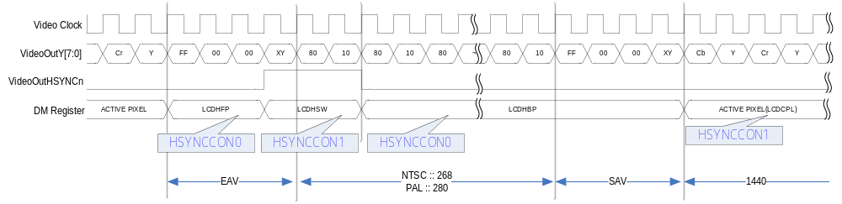
Video output 은 BT.656 과 BT.601 형식을 지원합니다. BT.656은 위와 같이 EAV와 SAV 영역으로 sync를 구분하게 됩니다. LCDHFP를 설정을 하려면, Display module에서 HSYNCCON0에서 LCDHFP를 설정 합니다. 주의 사항은 LCDHFP/LCDHSW/LCDHBP 는 1이상에 값을 설정 하여야 하며, 총 합은 기본 적으로 정의된 수를 지켜야 합니다.
즉, NTSC에 경우에는 LCDHFP + LCDHSW + LCDHBP = 276 되어야 합니다.
BT.601로 Display module 설정 방법은 동일 합니다.

Figure 17-5 INV_CbCr register setting
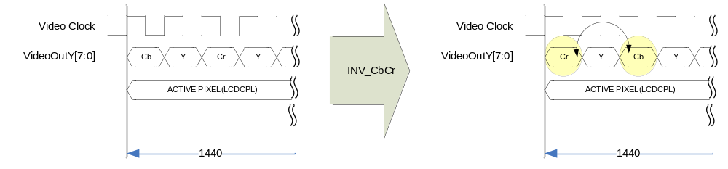
INV_CbCr Register를 설정 하면, Cr 과 Cb 가 서로 위치가 변경됩니다. BT601에서도 서로 위치가 변경 적용 됩니다.

Figure 17-6 BT656 NTSC mode Timing
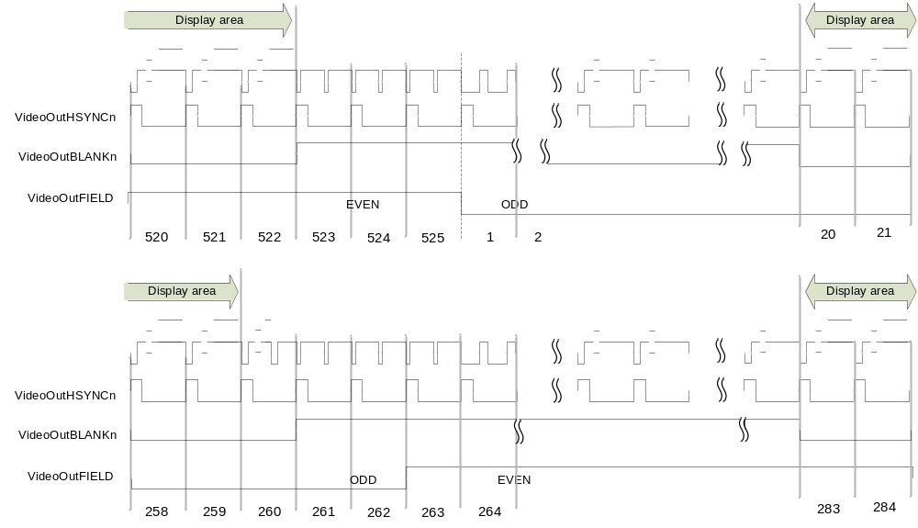

Figure 17-7 BT656 PAL mode Timing
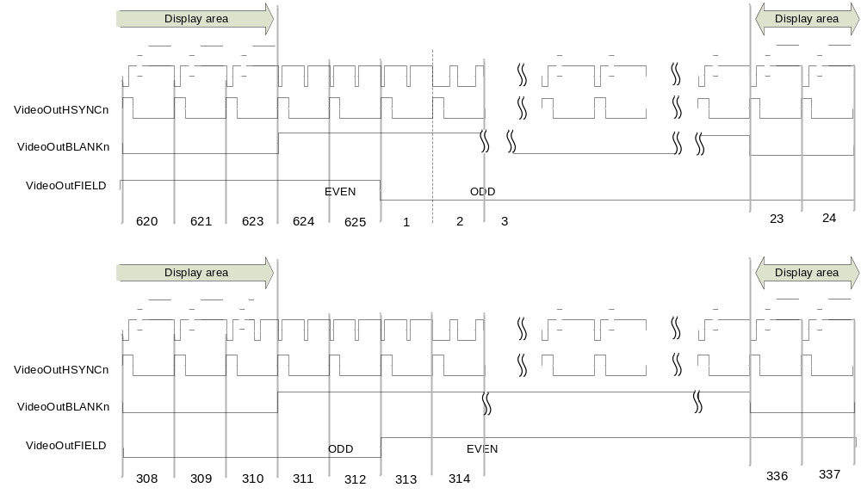

BT656 output recommend setting

Figure 17-8 BT656 mode register setting example (decimal value)
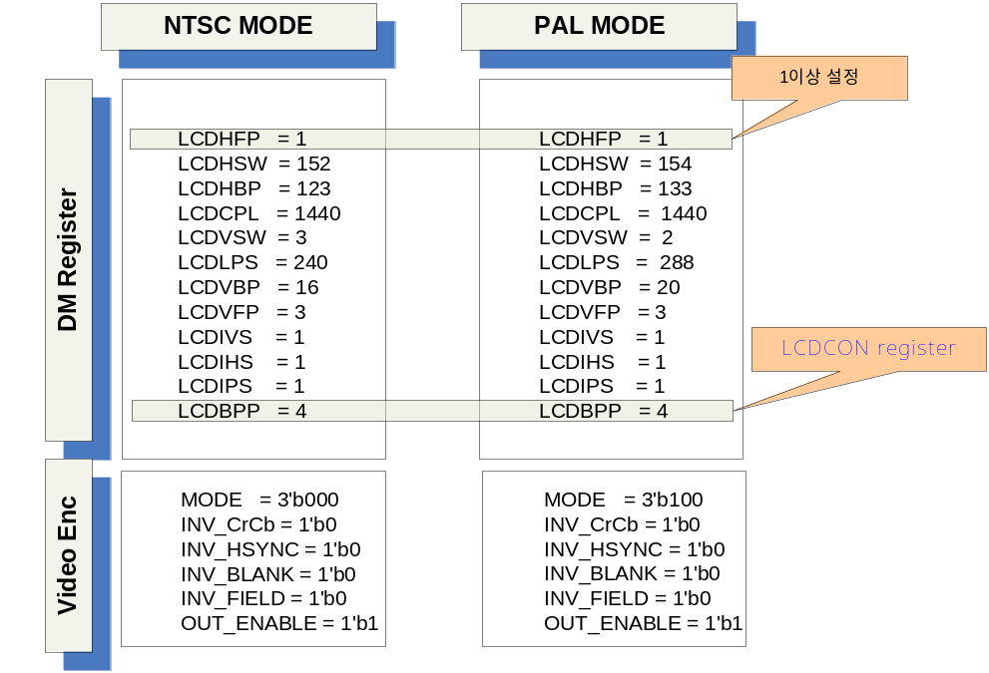

Signal Description

InOutput Signal

Table 17-3 VideoEncoder core Signal

Signal Name | Direction | Description | Init. value
CLK | input | Input clock (27Mhz)
RESETn | Input | Reset
HSYNCn | Input | Horizontal sync signal
VSYNCn | Input | Vertical sync signal
BLANKn | Input | Blank sync signal
Rin | Input | R[7:0] Red color
Gin | Input | G[7:0] Green color
Bin | Input | B[7:0] Blue color
ENABLE | Input | Enable signal
EN_DAC0 | Input | Composite enable signal
EN_DAC1 | Input | Luminance enable signal
EN_DAC2 | Input | Chrominance enable signal
EN_SQPIXEL | Input | Square pixel enable signal
EN_NONINTERLACE | Input | Non-interlace mode signal
EN_INTERNAL_PATTERN | Input | Internal color generation
EN_COLOR_KILL | Input | Composite color remove signal
COLOR_PATTERN_MODE | Input | Internal Color pattern selection
MODE | Input | Output encoder format selection
LUMA_FILTER_SEL | Input | Luminance filter selection
CHRO_FILTER_SEL | Input | Chrominance filter selection
CHRO_DELAY | Input | Chrominance delay
LUMA_DELAY | Input | Luminance delay
BURST_WID | Input | Burst width setting
HSYNC_WID | Input | Hsync width setting
SUB_PHASE | Input | Subcarrier phase setting
SUB_REQ | Input | Subcarrier frequency setting
SATURATION_YLEV | Input | Saturation luminance level setting
SATURATION_CLEV | Input | Saturation chrominance level setting
BLANK_VALUE | Input | Blank value setting

Signal Name | Direction | Description | Init. value
HUE_LEV | Input | Hue level setting
BRIGHT_LEV | Input | Brightness level setting
BURST_STEP | Input | Burst step setting
HSYNC_STEP | Input | Hsync step setting
BURST_CAL | Input | Burst level setting
BLACK_VALUE | Input | Black value setting
DAC0_ENABLE | Output | DAC enable signal
DAC1_ENABLE | Output | DAC enable signal
DAC2_ENABLE | Output | DAC enable signal
DAC0_DATA | Output | Composite signal data
DAC1_DATA | Output | Luminance signal data
DAC2_DATA | Output | Chrominance signal data
F_COUNTER_INTER | Output | Field counter
H_COUNTER_INTER | Output | Horizontal counter
V_COUNTER_INTER | Output | Vertical counter

Register Description

Registers

Table 17-4 Registers(Base Address : 5000 B000h)
Offset | Name | R/W | Description | Init. Value
0000h | Status Reg. | R/W | Status register | 0000 0000h
0004h | Control Reg. | RW | Output Control register | 0000 0000h
0008h | Internal Reg. | RW | Internal control register | 0900 0000h
000Ch | Subcarrier phase Reg. | RW | Subcarrier adjust phase register | 0000 0000h
0010h | Subcarrier Reg. | RW | Subcarriter frequency setup register | 0000 0000h
0014h | Image Control Reg. | RW | Hue/Saturation/Brightness register | 0000 8080h
0018h | Output level Reg. 0 | RW | BLANK / BLACK register
001Ch | Output level Reg. 1 | RW | Burst level / Hsync Low level register

Status Register

Figure 17-9 Status Register Bits
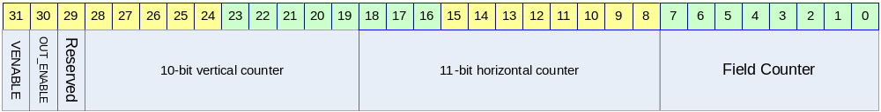

Table 17-5 Status Register Description(Offset : 0000h)
Bits | Name | R/W | Description | Init. Value
[00:07] | FIELD_CNT | R | Field counter | 0b
[08:18] | H_CNT | R | Horizontal counter | 0b
[19:28] | V_CNT | R | Vertical counter | 0b
[30] | OUT_ENABLE | R/W | Video output enable (BT.656) | 0b
[31] | VENABLE | R/W | Video Encoder enable | 0b

Control Register

Figure 17-10 Control Register Bits
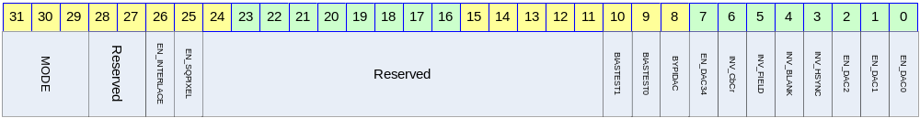

Table 17-6 Control Register Description(Offset : 0004h)
Bits | Name | R/W | Description | Init. Value
[00] | EN_DAC0 | R/W | This bit can be used to power down the DAC0  0 :: Off DAC / 1 :: On DAC (composite) | 0b
[01] | EN_DAC1 | R/W | This bit can be used to power down the DAC1  0 :: Off DAC / 1 :: On DAC (luminance)  For S-Video luminance output | 0b
[02] | EN_DAC2 | R/W | This bit can be used to power down the DAC2  0 :: Off DAC / 1 :: On DAC (chrominance)  For S-Video chrominance output | 0b
[03] | INV_HSYNC | R/W | This bit is used for inverting output HSYNC signal (BT656/BT601 output) | 0b
[04] | INV_BLANK | R/W | This bit is used for inverting output BLANK signal (BT656/BT601 output) | 0b
[05] | INV_FIELD | R/W | This bit is used for inverting output FIELD signal (BT656/BT601 output) | 0b
[06] | INV_CbCr | R/W | To swap Cb and Cr value in Video output function (BT656/BT601) | 0b
[07] | EN_DAC0_34 | R/W | 34mA output full-scale enable | 1b
[08] | BYPIDAC | R/W | External reference current enable | 0b
[09:10] | BIASTEST0  BIASTEST1 | R/W | Analog bias test 0/1 | 00b

Bits | Name | R/W | Description | Init. value
[25] | EN_SQPIXEL | R/W | This bit is used for square pixel mode  0 :: normal mode  1 :: Square pixel mode  for the square pixel mode, change the frequency.  - NTSC square pixel mode :: 24.5454MHz  - PAL square pixel mode :: 29.5MHz | 0b
[26] | EN_NONINTERLACE | R/W | To choice the mode of interlace or non-interlace  0 :: interlace  1 :: non-interlace | 0b
[29:31] | MODE | R/W | For setting up the ENCODE mode  000 :: NTSC M  001 :: NTSC J  010 :: NTSC 4.43  011 :: M PAL  100 :: PAL(B, D, G, H and I)  101 :: PAL Nc  110 :: PAL N | 000b

Internal Register

Figure 17-11 Internal Register Bits
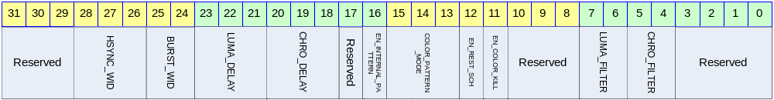

Table 17-7 Internal Register Description(Offset : 0008h)
Bits | Name | R/W | Description | Init. Value
[04:05] | CHRO_FILTER_SEL | R/W | Select of the chrominance filter  00 :: 1.35 Mhz  10 :: 0.67 Mhz | 00b
[06:07] | LUMA_FILTER_SEL | R/W | Select of the luminance filter  00 :: 6MHz  01 :: NTSC notch  10 :: PAL notch  11 :: By pass | 00b
[11] | EN_COLOR_KILL | R/W | Color information is not output to composite DAC (only luminance output)  0 :: disable  1 :: enable | 0b
[12] | EN_RESET_SCH | R/W | This bit can be auto reset SCH  0 :: disable  1 :: Enable auto reset  Resetting the SCH phase every four or eight fields. This function is to avoid the accumulation of SCH phase error | 0b
[15:13] | COLOR_PATTERN_MODE | R/W | 000 :: Colorbar 001 :: Red Ramp  010 :: Green Ramp 011 :: Blue Ramp | 00b
[16] | EN_INTERNAL_PATTERN | R/W | Internal pattern generation setting  0 :: disable  1 :: pattern generation | 0b

Bits | Name | R/W | Description | Init. Value
[18:20] | CHRO_DELAY | R/W | For setting the delay of chrominance  000 :: none  001 :: 1 Ts delay  010 :: 2 Ts delay  ……..  110 :: 6 Ts delay  111 :: 7 Ts delay  (1Ts – 1clock period :: 27Mhz → about 37ns) | 000b
[21:23] | LUMA_DELAY | R/W | For setting the delay of luminance  000 :: none  001 :: 1 Ts delay  010 :: 2 Ts delay  ……..  110 :: 6 Ts delay  111 :: 7 Ts delay  (1Ts – 1clock period :: 27Mhz → about 37ns) | 000b
[24:25] | BURST_WIDTH | R/W | For setting burst falling to rising and rising to falling edge time  00 :: 1 Ts reduce from normal  01 :: normal  10 :: 1 Ts expanded | 01b
[26:28] | HSYNC_WIDTH | R/W | For setting the width of HSYNC  000 :: 2 Ts reduce from normal mode  001 :: 1 Ts reduce from normal mode  010 :: normal mode  011 :: 1 Ts expanded  100 :: 2 Ts expanded  (1Ts – 1clock period :: 27Mhz → about 37ns) | 010b

Subcarrier phase register

Figure 17-12 subcarrier phase Register Bits
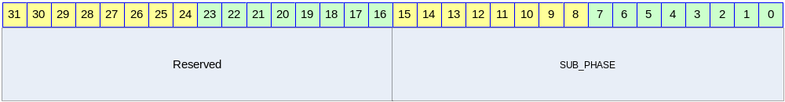

Table 17-8 subcarrier phase Register (Offset : 000Ch)
Bits | Name | R/W | Description | Init. Value
[00:15] | SUB_PHASE | R/W | Subcarrier phase register  Each bit represents 0.0055˚ | 0000h

Subcarrier register

Figure 17-13 Subcarrier Register Bits
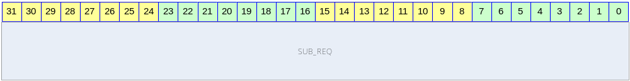

Table 17-9 subcarrier Register (Offset : 0010h)
Bits | Name | R/W | Description | Init. Value
[00:31] | SUB_REQ | R/W | Subcarrier frequency setting  Automatically, setting SUB_REQ value, If you set MODE register. | 0000 0000h

Image Control register

Figure 17-14 Image control Register Bits
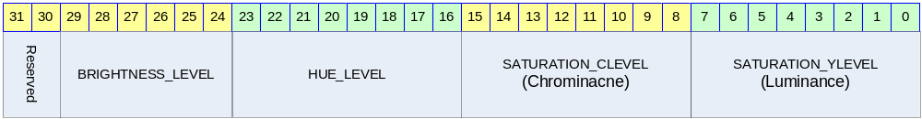

Table 17-10 Image control Register (Offset : 0014h)
Bits | Name | R/W | Description | Init. Value
[00:07] | SATURATION_YLEV | R/W | Luminance Saturation level control register.  This level range 0 to 1.99x. the setting level 128 is the range value 1  If you not use saturation effect, you setting 80h(128)  NTSC recommend value :: 144  PAL recommend value :: 136 | 80h
[08:15] | SATURATION_CLEV | R/W | Chrominance Saturation level control register.(0 ~ 1.99x)  NTSC recommend value :: 144  PAL recommend value :: 136 | 80h
[16:23] | HUE_LEV | R/W | Hue level control(0 ~ 255). Each bit has 1.41 degree value  Setting 0, which is 0° shift  Setting 1, which is 1.41° shift | 00h
[24:29] | BRIGHTHNESS_LEV | R/W | Brightness level control(-32 ~ 31) | 00h

Output level register 0

Figure 17-15 Output level Register 0 Bits
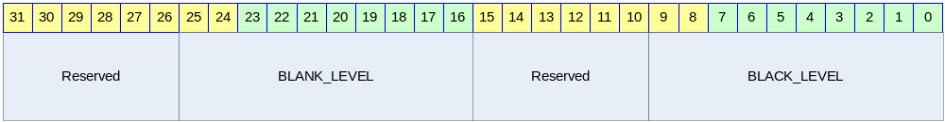

Table 17-11 Output level Register 0 (Offset : 0018h)
Bits | Name | R/W | Description | Init. Value
[00:09] | BLACK_LEV | R/W | BLACK level control register.  Automatically, setting after setting mode  Recommend setting value ::  NTSC→ 282 / PAL → 252 | 00h
[16:25] | BLANK_LEV | R/W | BLANK Level control register.  Automatically, setting after setting mode  Recommend setting value ::  NTSC→ 240 / PAL → 252 | 00h

Output level register 1

Figure 17-16 Output level Register 1 Bits
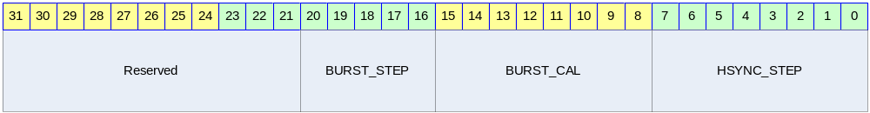

Table 17-12 Output level Register 1 (Offset : 001Ch)
Bits | Name | R/W | Description | Init. Value
[00:07] | HSYNC_STEP | R/W | 2’s complement value  NTSC :: 8’hC8  PAL :: 8’hDE | 0b
[15:08] | BURST_CAL | R/W | This bit is for calibration of Burst level.  This level range 0 to 1.99x. the setting level 128 is the range value 1 | 10000000b
[16:20] | BURST_STEP | R/W | For burst level setting,  NTSC :: 14  PAL :: 15 | 0b

