NTSC PAL Video Encoder

Version 1.04

SHMT Co., Ltd.

REVISION HISTORY
Version | Detail(굴림/Verdana 10pt bold) | Name | Date
V.00 | Core block specification | NamKwol Kang | Jan .1st.2007
V.01 | 오류 수정 / 내용 첨가 | NamKwol Kang | Jan .30th.2007
V.02 | Video Output control 추가 | NamKwol Kang | Feb .14th.2007
V.03 | 오류수정 그림 HSYNC← → VSYNC / Valid area 영역 | NamKwol Kang | Feb.21th.2007
V.04 | Video output control 내용 추가 | NamKwol Kang | Feb.22th.2007

Technical documents
Copyright © 2006 Shmt Limited. All rights reserved

Confidentiality Status
This document is NOT OPEN ACCESS. The distribution is restricted to certified companyThis document is CONFIDENTIAL

Feedback on this document
If you have any comments on this document, please contact your channel to our company

Shmt Web address
http://www.shmt.com

Contents
1. NTSC PAL Video encoder 7
1.1. Overview 7
1.1.1. Feature 7
1.1.2. Block diagram 8
1.2. Operation 9
1.2.1. Video timing 9
1.2.2. Control setting 17
1.2.3. Video Output (BT656 / BT601) 21
1.3. Signal Description 27
1.3.1. InOutput Signal 27
1.4. Register Description 29
1.4.1. Registers 29
1.4.2. Status Register 29
1.4.3. Control Register 30
1.4.4. Internal Register 32
1.4.5. Subcarrier phase register 34
1.4.6. Subcarrier register 34

Figures

Figure 1-1 Video Encoder Block Diagram 8
Figure 1-2 Interlaced NTSC Video input timing chart 9
Figure 1-3 NTSC Even and Odd timing chart 10
Figure 1-4 Square NTSC Even and Odd timing chart 10
Figure 1-5 RGB input timing 11
Figure 1-6 PAL Video input timing chart 12
Figure 1-7 PAL Even and Odd timing chart 13
Figure 1-8 Square PAL Even and Odd timing chart 13
Figure 1-9 output HSYNC / BURST timing chart 14
Figure 1-10 DAC output timing chart 14
Figure 1-11 display module timing chart 15
Figure 1-12 Internal pattern 17
Figure 1-13 NTSC / PAL setting 19
Figure 1-14 BT656 Display module Timing setting 21
Figure 1-15 INV_CbCr register setting 21
Figure 1-16 BT656 NTSC mode Timing 22
Figure 1-17 BT656 PAL mode Timing 22
Figure 1-18 BT601 Display module Timing setting 23
Figure 1-19 OUT_16BIT register setting 23
Figure 1-20 BT601 mode 0 NTSC Timing 24
Figure 1-21 BT601 mode 0 PAL Timing 24
Figure 1-22 BT601 mode 1 NTSC Timing 25
Figure 1-23 BT601 mode 1 PAL Timing 25
Figure 1-24 BT656 mode register setting example (decimal value) 26
Figure 1-25 BT601 mode 0 and mode 1 register setting example (decimal value) 26
Figure 1-26 Status Register Bits 29
Figure 1-27 Control Register Bits 30
Figure 1-28 Internal Register Bits 32
Figure 1-29 subcarrier phase Register Bits 34
Figure 1-30 Subcarrier Register Bits 34

Tables

Table 1-1 Subcarrier frequnce table 18
Table 1-2 Display module LCD setting example table 20
Table 1-3 VideoEncoder Signal 27
Table 1-4 Registers(Base Address : 5000 B000h) 29
Table 1-5 Status Register Description(Offset : 0000h) 29
Table 1-6 Control Register Description(Offset : 0004h) 30
Table 1-7 Internal Register Description(Offset : 0008h) 32
Table 1-8 subcarrier phase Register (Offset : 000Ch) 34
Table 1-9 subcarrier Register (Offset : 0010h) 34

NTSC PAL Video encoder

Overview

High performance video encoder supports for NTSC M, NTSC-J, NTSC4.32, PAL B/D/G/H/I and PAL M. By using RGB/BT.656/BT.601 format, it outputs analog composite and analog S-video. This encoder drives the 10bits DAC

Feature

- RGB to PAL/NTSC video encoder
- NTSC M, NTSC J, NTSC 4.43, PAL Nc, PAL B/D/G/H/I, PAL-M
- 27Mhz clock required (x2 oversampling)
- Video input data port supports:
  - CCIR-656/601 4:2:2 8bit parallel input format ( next version )
  - RGB 24bit Parallel input format
- Video output supports:
  - Composite / S-Video signal output
  - 10bits high quality DAC output
- Programmable luma / chroma filters
- Programmable subcarrier frequency and phase
- Programmable LUMA delay
- Individual on/off control of each DAC
- Color signal control/burst signal control
- Complete on-chip video timing generator
- On-chip color bar / color ramp generation

Block diagram

Figure 1-1 Video Encoder Block Diagram

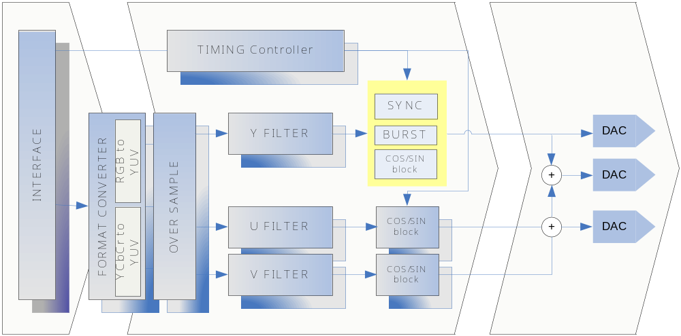

Operation

Video timing

Data input timing

Video input 은 24bits RGB Slave를 지원하도록 되어 있으며, BLANKn = “High” 일 경우, 유효한 정보를 입력 받습니다.

Figure 1-2 Interlaced NTSC Video input timing chart
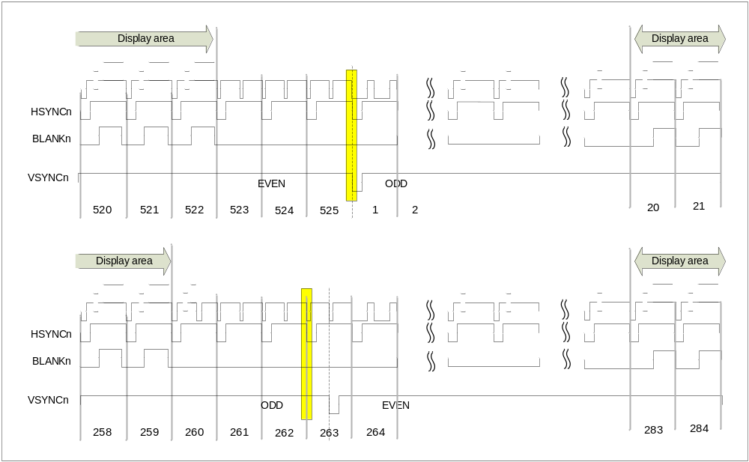

NTSC format 일 경우 Data Active 영역 은 odd field 20~259 / even field 283~522 입니다. Data Active 영역에서 720x480 format에 RGB 신호를 받습니다. Odd와 Even으로 입력 구분은 HSYNCn = “LOW” 와 VSYNC = “LOW” 인 경우를 기준으로 Even → Odd로 변경 됩니다. 263번째 HSYNCn = “LOW” 이면서, VSYNCn = “HIGH” 일정 지연 후 VSYNCn = “LOW”일 때, Odd→ Even으로 변경 됩니다. 자세한 사항은 Even and Odd timing chart 참조.

Figure 1-3 NTSC Even and Odd timing chart
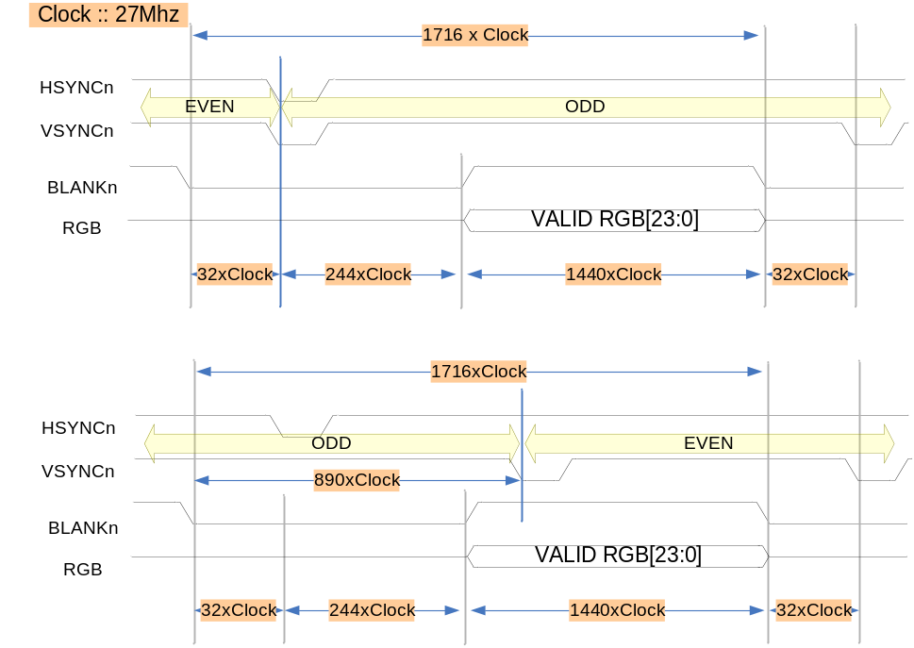
NTSC mode 일 경우 1Line 당 27Mhz sample x 1716 입니다. 출력되는 화상은 720x480 크기를 가지며, Interlaced로 출력 됩니다.

Figure 1-4 Square NTSC Even and Odd timing chart
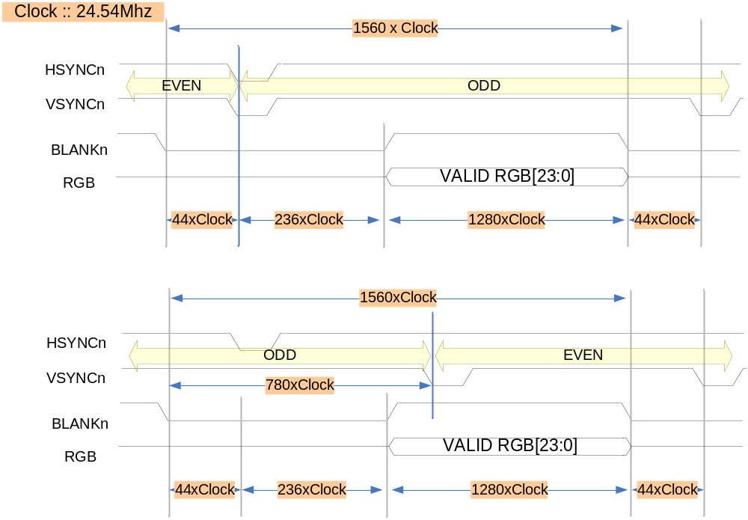
Square mode 일 경우, 24.54Mhz를 공급하며 640x480화상을 출력합니다.

Figure 1-5 RGB input timing
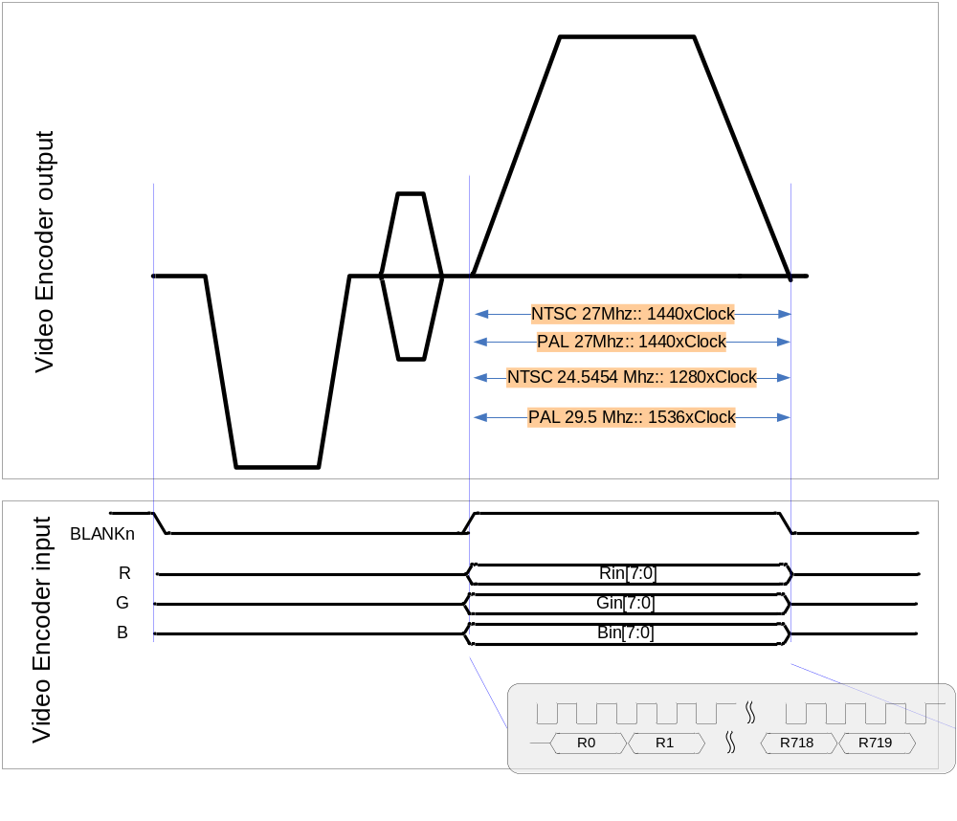
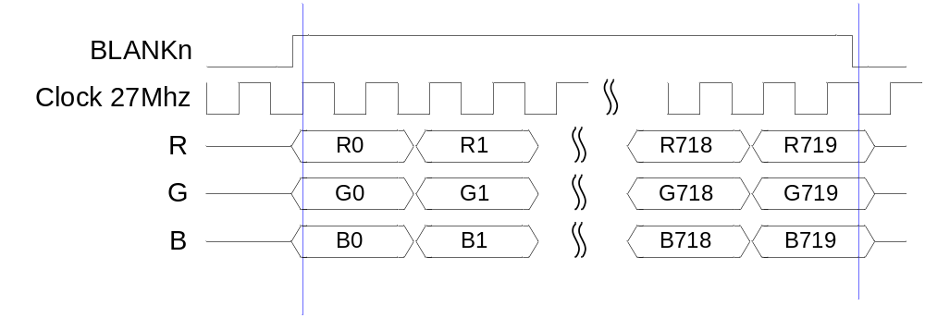
PAL/NTSC 27Mhz 에서 BLANKn 구간은 1440Clock 동안에 총 720 sample를 입력 받도록 되어있으며, Clock에 positive edge 에서 data를 가져 가도록 구성 되어있습니다.

Figure 1-6 PAL Video input timing chart
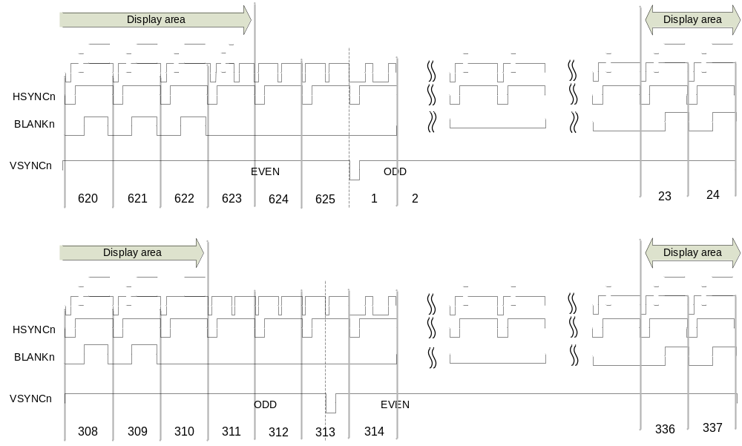
BLANKn = “HIGH” 에서 RGB 입력을 받으며, Data active 영역은 Odd field에서 23~310 총 288 Line Even field에서 336~623 총 288 Line으로 PAL은 720x576 RGB format을 지원합니다.

Figure 1-7 PAL Even and Odd timing chart
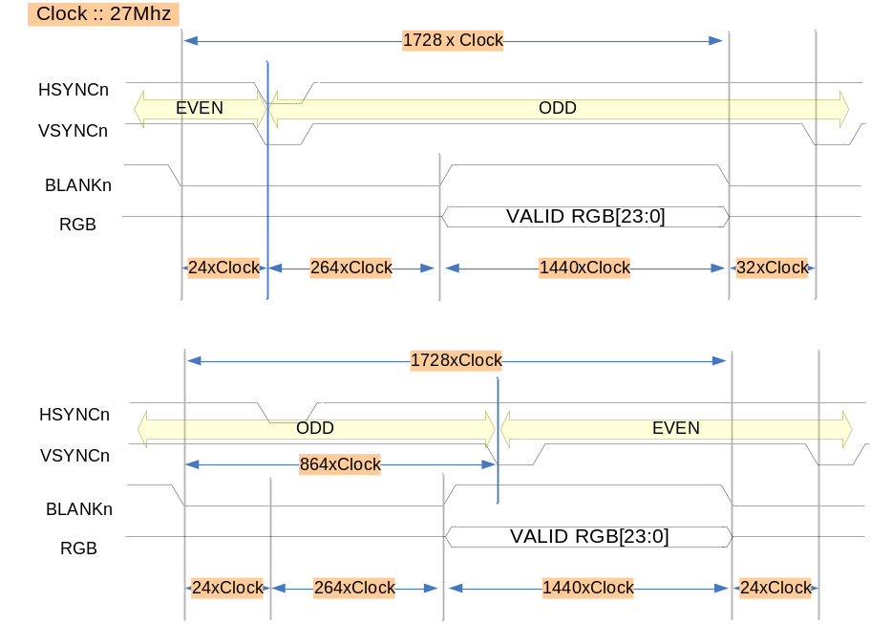
입력 주파수는 27Mhz 를 공급하고, image 720x576 입력합니다.

Figure 1-8 Square PAL Even and Odd timing chart
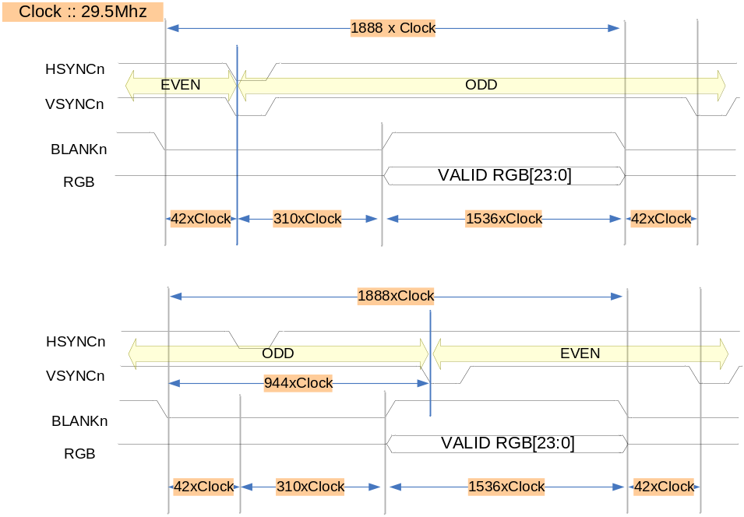

Data output timing

Figure 1-9 output HSYNC / BURST timing chart
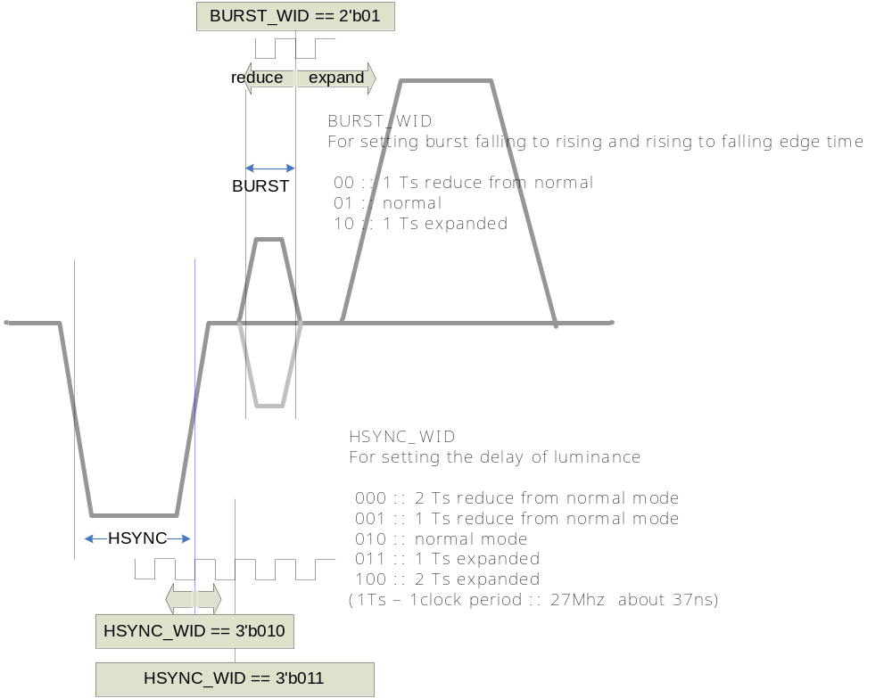
사용되는 기준 Clock (27Mhz) 를 기준으로 HSYNC width와 BURST width를 조절 할 수 있습니다. Normal 값보다 1clock 또는 2clock 내외에서 설정 가능 합니다.

Figure 1-10 DAC output timing chart
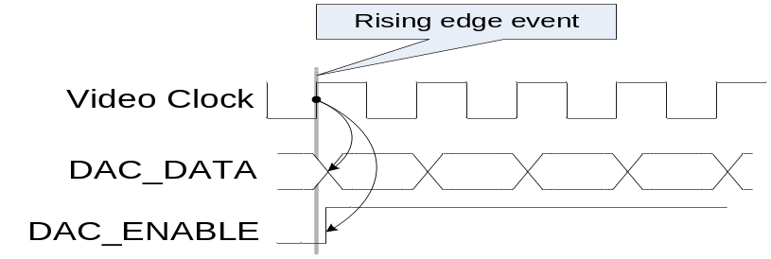
DAC data output 은 Video Clock에 Rising edge 에서 Data가 변환 되도록 되어있습니다. 외부 DAC 사용할 경우, Timing을 고려 하여야 합니다.

Display module timing

Figure 1-11 display module timing chart
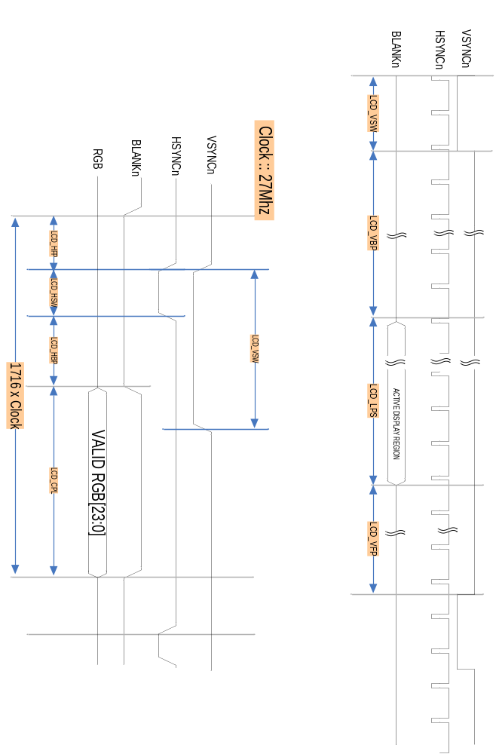

NTSC 일 경우,
LCD_HFP = 31
LCD_HSW = 122
LCD_HBP = 123
LCD_CPL = 1440
LCD_VSW = 3
LCD_LPS = 240
LCD_VBP = 16
LCD_VFP = 3
LCD_IVS = 1
LCD_IHS = 1
LCD_IPS = 1

PAL 일 경우,
LCD_HFP = 23
LCD_HSW = 132
LCD_HBP = 133
LCD_CPL = 1440
LCD_VSW = 2
LCD_LPS = 288
LCD_VBP = 20
LCD_VFP = 3
LCD_IVS = 1
LCD_IHS = 1
LCD_IPS = 1

Graphic plan 또는 Display 할 수 있는 plan에 영역은 Even과 Odd를 구분하여 사용 하며, Display module 에서 interrupt가 발생시, Address 영역을 변환 합니다. 자세한 사항은 Display module spec. 참조.
NTSC 사용할 경우 Display Area는 720x240 Even/Odd를 구분 하여 가져야 하며, PAL 경우에는 720x288 Even/Odd를 구분 하여야 합니다

Control setting

Video Encoder 동작을 위하여 각 설정 정보를 설정한 후 Enable을 설정 하는 순서로 이루 워 지며, NTSC Video Encoder는 720x480 image를 기본 영역으로 하는 image를 NTSC(M)을 기본으로 제공하는 TV및 영상 장치에 출력 할 수 있도록 되어 있습니다.

Internal Pattern generation

Figure 1-12 Internal pattern

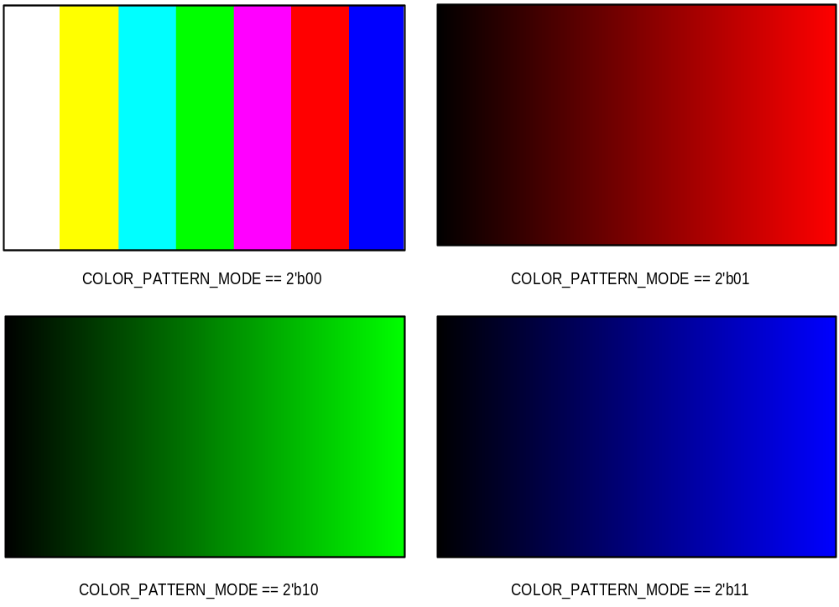

COLOR_PATTERN_MODE를 선택 하고, EN_INTERNAL_PATTERN을 Enable 하게 되면 외부에 입력신호 없이 자체 SYNC 신호 및 RGB 신호를 생성하여, MODE에 따라 출력 하게 됩니다.

Subcarrier frequency setting

Table 1-1 Subcarrier frequnce table
MODE | Name | Setting value (SUB_REQ) | Frequency
3’b000 | NTSC M | 21F0 78BB h | 3.579545 Mhz
3’b001 | NTSC J | 21F0 78BB h | 3.579545 Mhz
3’b010 | NTSC 4.43 | 2A09 8ACB h | 4.43361875 Mhz
3’b011 | M PAL | 21E6 EFA4 h | 3.57561149 Mhz
3’b100 | PAL(B, D, G, H and I) | 2A09 8ACB h | 4.43361875 Mhz
3’b101 | PAL Nc | 21F6 9446 h | 3.58205625 Mhz
3’b110 | PAL N | 2A09 8ACB h | 4.43361875 Mhz
SUB_REQ를 각 MODE에 따라서 설정 하여야 합니다. Subcarrier 설정을 위하여 각 값들을 설정 하게 됩니다.

Register 계산방법은 아래와 같습니다.
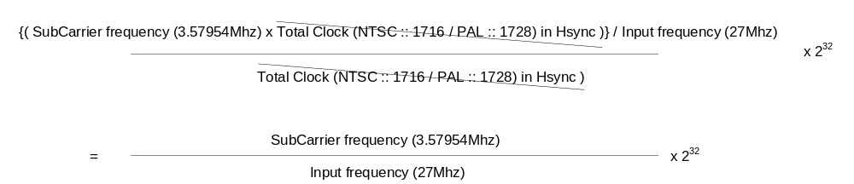

예를 들어, 3.57954Mhz에 Subcarrier를 사용하고, 입력 주파수가 27Mhz 일 경우,
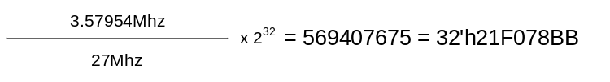
MODE를 설정 하면, MODE에 맞는 설정 값을 갖게 되며, 만약 사용자가 다른 값을 설정 하고 싶을 경우에는 MODE 설정 후에 값을 설정 하면 됩니다.

Video Encoder recommend setting

Figure 1-13 NTSC / PAL setting

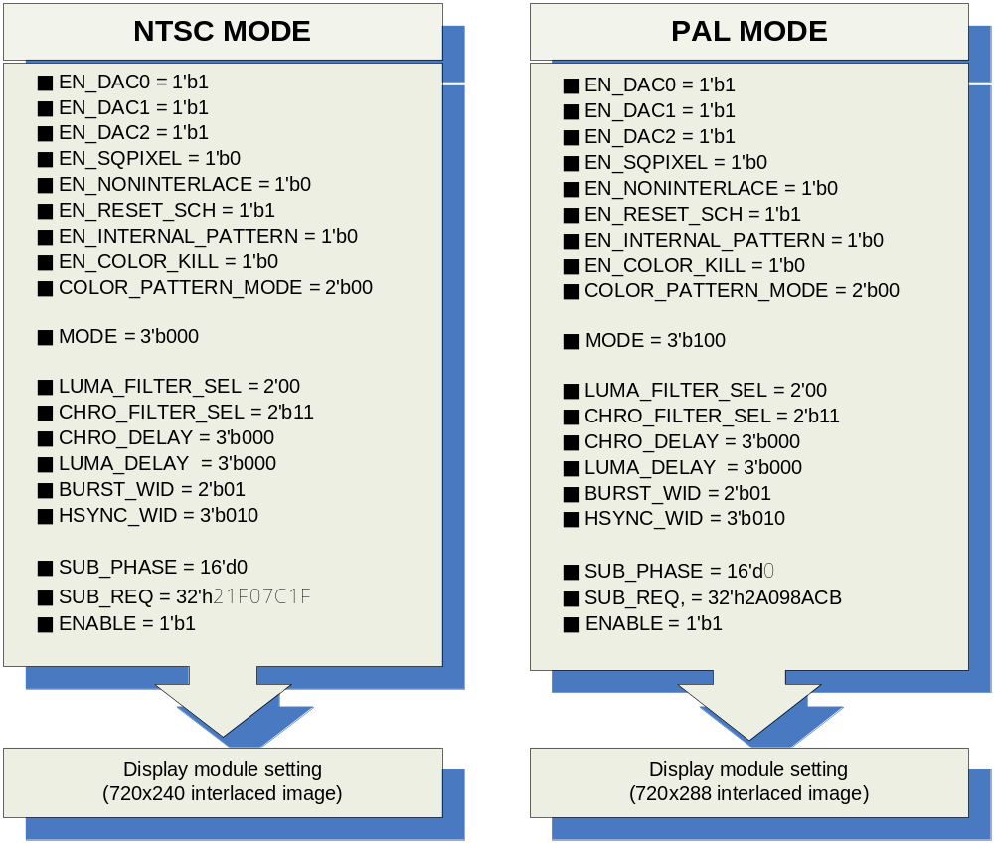

NTSC / PAL mode에 기본적인 Setting 값들 이며, SUB_REQ 값은 특정한 Setting을 원하지 않는 이상 설정 하지 않도록 합니다.
Setting 순서는 Video Encoder register 설정 후에, Display module을 설정 하도록 합니다. Display module은 사용자가 원하는 Plane을 설정합니다. LCD 출력 관련한 값들은 아래 Table을 참조 합니다.

Table 1-2 Display module LCD setting example table
Name | Register | NTSC mode (decimal) | PAL mode (decimal)
LCDHFP | HSYNCCON0 | 31 | 23
LCDHSW | HSYNCCON1 | 122 | 132
LCDHBP | HSYNCCON0 | 123 | 133
LCDCPL | HSYNCCON1 | 1440 | 1440
LCDVSW | VSYNCCON1 | 3 | 2
LCDLPS | VSYNCCON1 | 240 | 288
LCDVBP | VSYNCCON0 | 16 | 20
LCDVFP | VSYNCCON0 | 3 | 3
LCDIVS | LCDCON | 1 | 1
LCDIHS | LCDCON | 1 | 1
LCDIPS | LCDCON | 1 | 1
LCDBPP | LCDCON | 2 | 2

Video Output (BT656 / BT601)

BT.656 Timing & setting

Figure 1-14 BT656 Display module Timing setting
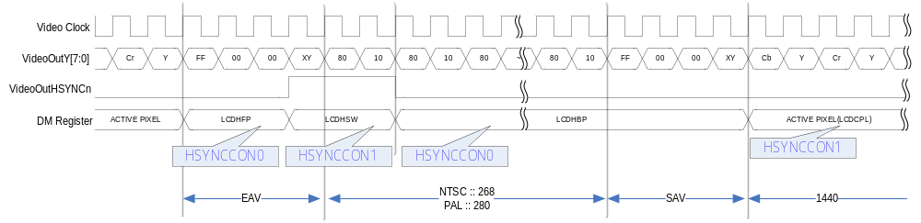
Video output 은 BT.656 과 BT.601 형식을 지원합니다. BT.656은 위와 같이 EAV와 SAV 영역으로 sync를 구분하게 됩니다. LCDHFP를 설정을 하려면, Display module에서 HSYNCCON0에서 LCDHFP를 설정 합니다. 주의 사항은 LCDHFP/LCDHSW/LCDHBP 는 1이상에 값을 설정 하여야 하며, 총 합은 기본 적으로 정의된 수를 지켜야 합니다.
즉, NTSC에 경우에는 LCDHFP + LCDHSW + LCDHBP = 276 되어야 합니다.
BT.601로 Display module 설정 방법은 동일 합니다.

Figure 1-15 INV_CbCr register setting
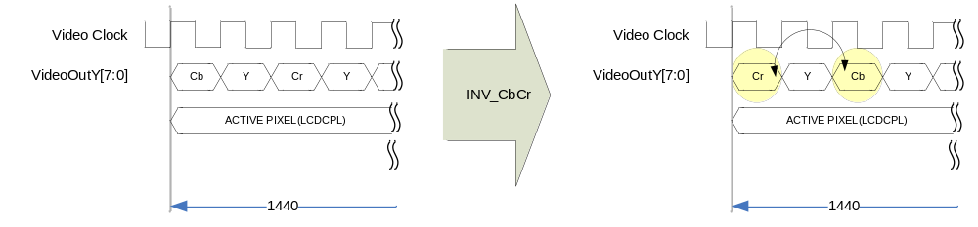
INV_CbCr Register를 설정 하면, Cr 과 Cb 가 서로 위치가 변경됩니다. BT601에서도 서로 위치가 변경 적용 됩니다.

Figure 1-16 BT656 NTSC mode Timing
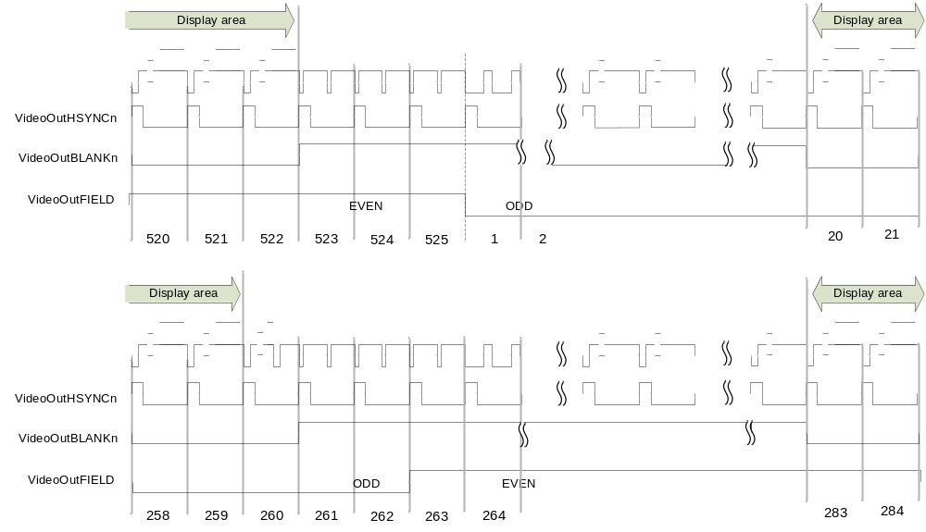

Figure 1-17 BT656 PAL mode Timing
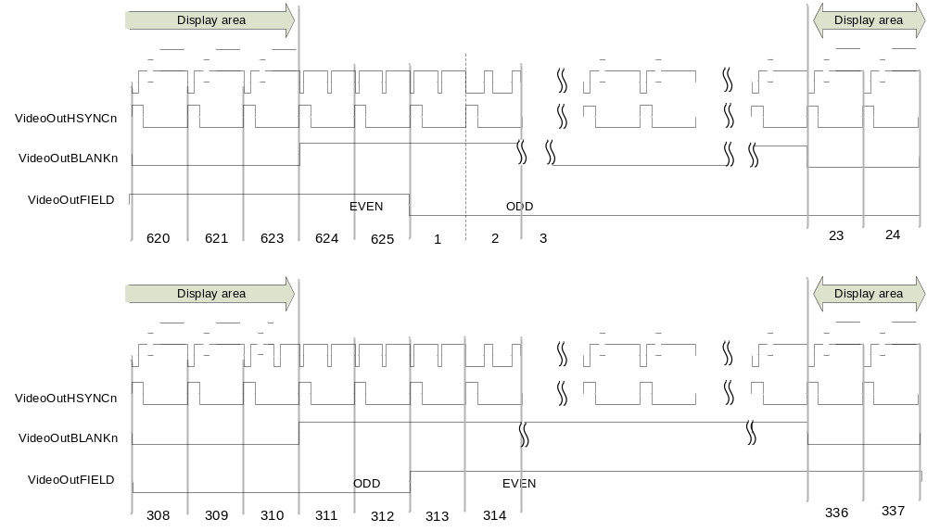

BT.601 Timing & setting

Figure 1-18 BT601 Display module Timing setting
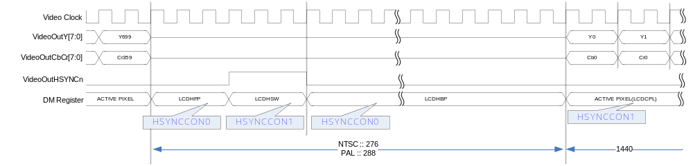
NTSC :: LCDHFP + LCDHSW + LCDHBP = 276
PAL :: LCDHFP + LCDHSW + LCDHBP = 288
Display module 측에 위와 같이 각 모드에 따라 설정되어야 할 값들이며, 총합이 위배되지 않도록 주의 하여야 합니다.

Figure 1-19 OUT_16BIT register setting
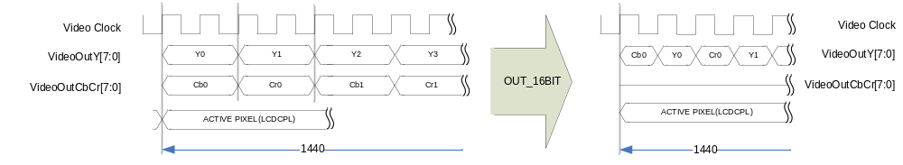
OUT_16BIT값을 사용하여 BT601에서 16bit로 출력되는 것을 8bit로 VideoOutY에 출력 되도록 합니다. BT.601로 설정하였을 때 유효합니다.
각 VideoOutHSYNCn / VideoOutBLANKn / VideoOutFIELD 신호들은 INV_HSYNC / INV_BLANK / INV_FIELD register를 이용 하여 필요에 따라 역상을 만들 수 있습니다.

Figure 1-20 BT601 mode 0 NTSC Timing
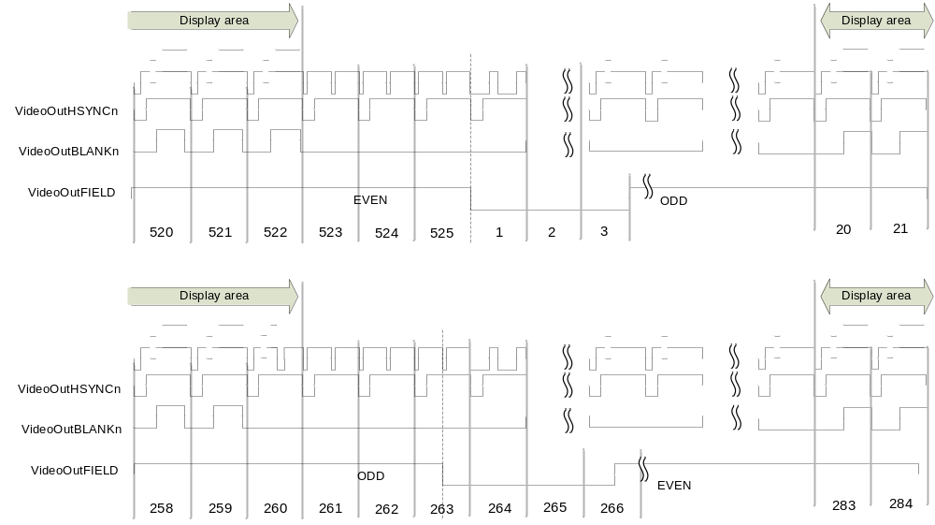

Figure 1-21 BT601 mode 0 PAL Timing
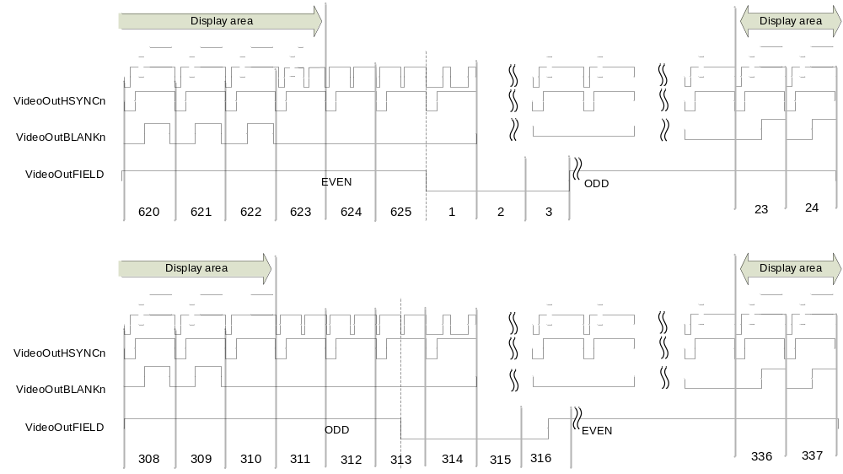

Figure 1-22 BT601 mode 1 NTSC Timing
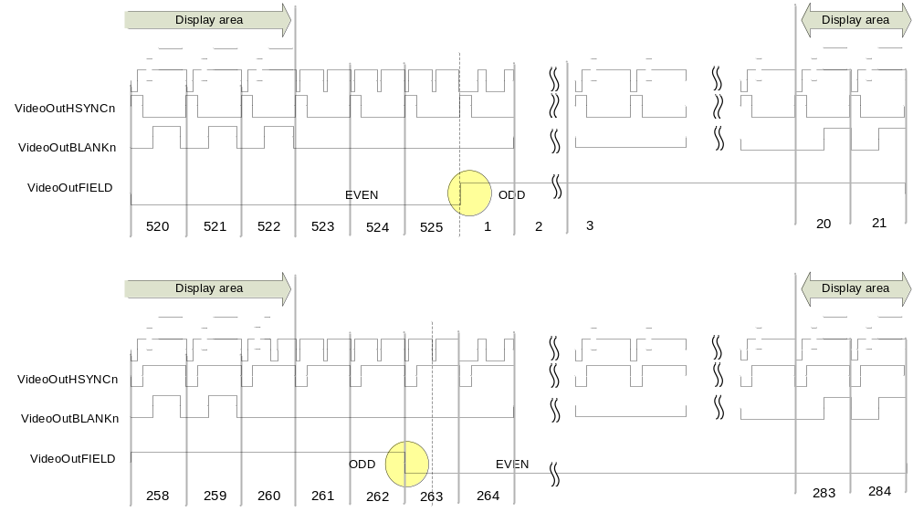

Figure 1-23 BT601 mode 1 PAL Timing
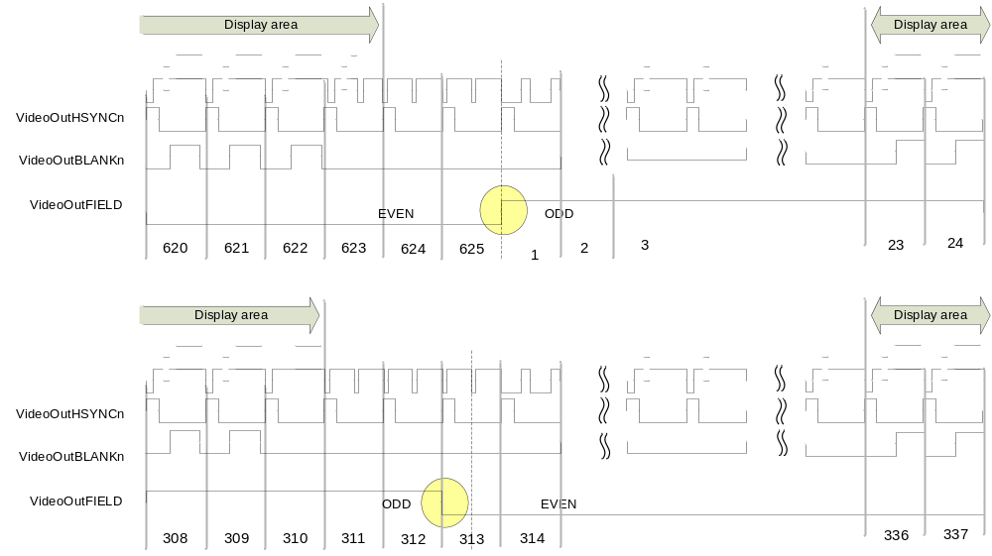

BT656/BT601 output recommend setting

Figure 1-24 BT656 mode register setting example (decimal value)
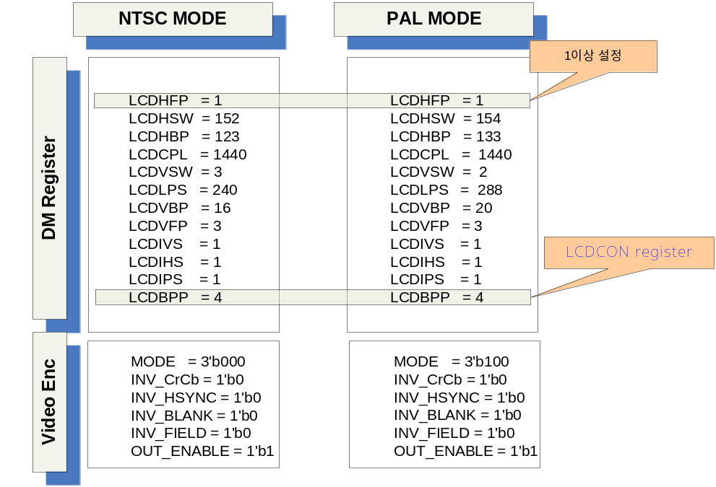

Figure 1-25 BT601 mode 0 and mode 1 register setting example (decimal value)
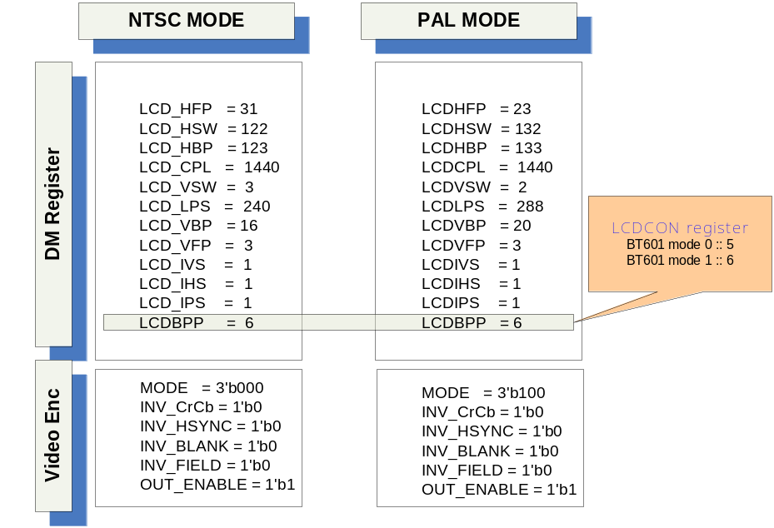

Signal Description

InOutput Signal

Table 1-3 VideoEncoder Signal
Signal Name | Direction | Description | Init. Value
CLK | input | Input frequency ( 27 Mhz )
RESETn | Input | Reset
HSYNCn | Input | Horizontal sync signal
VSYNCn | Input | Vertical sync signal
BLANKn | Input | Blank sync signal
Rin | Input | R[7:0] Red color
Gin | Input | G[7:0] Green color
Bin | Input | B[7:0] Blue color
ENABLE | Input | Enable signal
EN_DAC0 | Input | Composite enable signal
EN_DAC1 | Input | Luminance enable signal
EN_DAC2 | Input | Chrominance enable signal
EN_SQPIXEL | Input | Square pixel enable signal
EN_NONINTERLACE | Input | Non-interlace mode signal
EN_INTERNAL_PATTERN | Input | Internal color generation
EN_COLOR_KILL | Input | Composite color remove signal
COLOR_PATTERN_MODE | Input | Internal Color pattern selection
MODE | Input | Output encoder format selection
LUMA_FILTER_SEL | Input | Luminance filter selection
CHRO_FILTER_SEL | Input | Chrominance filter selection
CHRO_DELAY | Input | Chrominance delay
LUMA_DELAY | Input | Luminance delay
BURST_WID | Input | Burst width setting
HSYNC_WID | Input | Hsync width setting
SUB_PHASE | Input | Subcarrier phase setting
DAC0_ENABLE | Output | DAC enable signal
DAC1_ENABLE | Output | DAC enable signal
DAC2_ENABLE | Output | DAC enable signal
DAC0_DATA | Output | Composite signal data
DAC1_DATA | Output | Luminance signal data

Signal Name | Direction | Description | Init. Value
DAC2_DATA | Output | Chrominance signal data
F_COUNTER_INTER | Output | Field counter
H_COUNTER_INTER | Output | Horizontal counter
V_COUNTER_INTER | Output | Vertical counter
VideoOutHSYNCn | Output | BT601 output format Hsync signal
VideoOutFIELD | Output | BT601 output format Field/Vsync signal
VideoOutBLANKn | Output | BT601 output format Blank signal
VideoOutY | Output | BT656/BT601 signal output
VideoOutCbCr | Output | BT601 chrominance signal output

Register Description

Registers

Table 1-4 Registers(Base Address : 5000 B000h)
Offset | Name | R/W | Description | Init. Value
0000h | Status Reg. | R/W | Status register | 0000 0000h
0004h | Control Reg. | RW | Output Control register | 0000 0000h
0008h | Internal Reg. | RW | Internal control register | 0900 0000h
000Ch | Subcarrier phase Reg. | RW | Subcarrier adjust phase register | 0000 0000h
0010h | Subcarrier Reg. | RW | Subcarriter frequency setup register | 0000 0000h
0014h
0018h
001Ch

Status Register

Figure 1-26 Status Register Bits
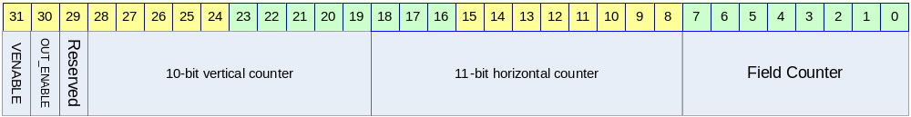

Table 1-5 Status Register Description(Offset : 0000h)
Bits | Name | R/W | Description | Init. Value
[00:07] | FIELD_CNT | R | Field counter | 0b
[08:18] | H_CNT | R | Horizontal counter | 0b
[19:28] | V_CNT | R | Vertical counter | 0b
[30] | OUT_ENABLE | R/W | Video output enable (BT.656/BT.601) | 0b
[31] | VENABLE | R/W | Enable status | 0b

Control Register

Figure 1-27 Control Register Bits
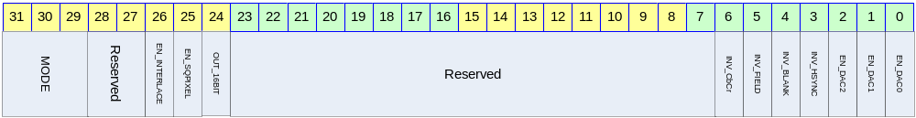

Table 1-6 Control Register Description(Offset : 0004h)
Bits | Name | R/W | Description | Init. Value
[00] | EN_DAC0 | R/W | This bit can be used to power down the DAC0  0 :: Off DAC / 1 :: On DAC (composite) | 0b
[01] | EN_DAC1 | R/W | This bit can be used to power down the DAC1  0 :: Off DAC / 1 :: On DAC (luminance)  For S-Video luminance output | 0b
[02] | EN_DAC2 | R/W | This bit can be used to power down the DAC2  0 :: Off DAC / 1 :: On DAC (chrominance)  For S-Video chrominance output | 0b
[03] | INV_HSYNC | R/W | This bit is used for inverting output HSYNC signal (BT656/BT601 output) | 0b
[04] | INV_BLANK | R/W | This bit is used for inverting output BLANK signal (BT656/BT601 output) | 0b
[05] | INV_FIELD | R/W | This bit is used for inverting output FIELD signal (BT656/BT601 output) | 0b
[06] | INV_CbCr | R/W | To swap Cb and Cr value in Video output function (BT656/BT601) | 0b
[24] | OUT_16BIT | R/W | This bit if used for 8bit data output in BT.601 format | 0b
[25] | EN_SQPIXEL | R/W | This bit is used for square pixel mode  0 :: normal mode  1 :: Square pixel mode  for the square pixel mode, change the frequency.  - NTSC square pixel mode :: 24.5454MHz  - PAL square pixel mode :: 29.5MHz | 0b

Bits | Name | R/W | Description | Init. value
[26] | EN_NONINTERLACE | R/W | To choice the mode of interlace or non-interlace  0 :: interlace  1 :: non-interlace | 0b
[29:31] | MODE | R/W | For setting up the ENCODE mode  000 :: NTSC M  001 :: NTSC J  010 :: NTSC 4.43  011 :: M PAL  100 :: PAL(B, D, G, H and I)  101 :: PAL Nc  110 :: PAL N | 000b

Internal Register

Figure 1-28 Internal Register Bits
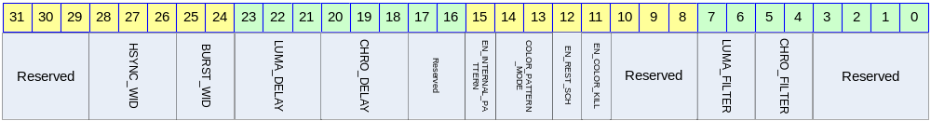

Table 1-7 Internal Register Description(Offset : 0008h)
Bits | Name | R/W | Description | Init. Value
[04:05] | LUMA_FILTER_SEL | R/W | Select of the luminance filter  00 :: 6Mhz  01 :: 2.5Mhz  10 :: NTSC notch  11 :: PAL notch | 00b
[06:07] | CHRO_FILTER_SEL | R/W | Select of the chrominance filter  00 :: 0.61 Mhz  01 :: 0.85 Mhz  10 :: 1.24 Mhz  11 :: 1.45 Mhz | 00b
[11] | EN_COLOR_KILL | R/W | Color information is not output to composite DAC (only luminance output)  0 :: disable  1 :: enable | 0b
[12] | EN_RESET_SCH | R/W | This bit can be auto reset SCH  0 :: disable  1 :: Enable auto reset  Resetting the SCH phase every four or eight fields. This function is to avoid the accumulation of SCH phase error | 0b
[15] | EN_INTERNAL_PATTERN | R/W | Internal pattern generation setting  0 :: disable  1 :: pattern generation | 0b

Bits | Name | R/W | Description | Init. Value
[14:13] | COLOR_PATTERN_MODE | R/W | 00 :: Colorbar 01 :: Red Ramp  10 :: Green Ramp 11 :: Blue Ramp | 00b
[18:20] | CHRO_DELAY | R/W | For setting the delay of chrominance  000 :: none  001 :: 1 Ts delay  010 :: 2 Ts delay  011 :: 3 Ts delay  100 :: 4 Ts delay  (1Ts – 1clock period :: 27Mhz → about 37ns) | 000b
[21:23] | LUMA_DELAY | R/W | For setting the delay of luminance  000 :: none  001 :: 1 Ts delay  010 :: 2 Ts delay  011 :: 3 Ts delay  100 :: 4 Ts delay  (1Ts – 1clock period :: 27Mhz → about 37ns) | 000b
[24:25] | BURST_WIDTH | R/W | For setting burst falling to rising and rising to falling edge time  00 :: 1 Ts reduce from normal  01 :: normal  10 :: 1 Ts expanded | 01b
[26:28] | HSYNC_WIDTH | R/W | For setting the delay of luminance  000 :: 2 Ts reduce from normal mode  001 :: 1 Ts reduce from normal mode  010 :: normal mode  011 :: 1 Ts expanded  100 :: 2 Ts expanded  (1Ts – 1clock period :: 27Mhz → about 37ns) | 010b

Subcarrier phase register

Figure 1-29 subcarrier phase Register Bits
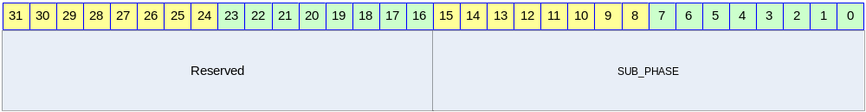

Table 1-8 subcarrier phase Register (Offset : 000Ch)
Bits | Name | R/W | Description | Init. Value
[00:15] | SUB_PHASE | R/W | Subcarrier phase register  Each bit represents 0.0055˚ | 0000h

Subcarrier register

Figure 1-30 Subcarrier Register Bits
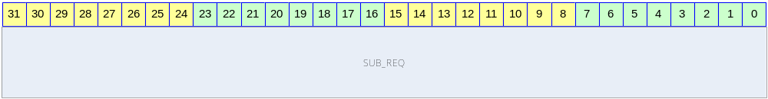

Table 1-9 subcarrier Register (Offset : 0010h)
Bits | Name | R/W | Description | Init. Value
[00:31] | SUB_REQ | R/W | Subcarrier frequency setting  Automatically, setting SUB_REQ value, If you set MODE register. | 0000 0000h

