NTSC PAL Video Encoder

Version 1.0

SHMT Co., Ltd.

REVISION HISTORY
Version | Detail(굴림/Verdana 10pt bold) | Name | Date
V.01 | Core block specification | NamKwol Kang | Jan .1st. 2007

Technical documents(굴림/Verdana 12pt, bold)
Copyright © 2006 Shmt Limited. All rights reserved.(굴림, Verdana 10pt, 기울임)

Confidentiality Status(굴림/Verdana 12pt, bold)
This document is NOT OPEN ACCESS. The distribution is restricted to certified company.(굴림/Verdana 10pt)
This document is CONFIDENTIAL.(굴림/Verdana 10pt)

Feedback on this document(굴림/Verdana 12pt, bold)
If you have any comments on this document, please contact your channel to our company.(굴림/Verdana 10pt)

Shmt Web address (굴림/Verdana, 12pt, bold)
http://www.shmt.com (굴림/Verdana 10pt)

Contents
1. NTSC PAL Video encoder 7
1.1. Overview 7
1.1.1. Feature 7
1.1.2. Block diagram 8
1.2. Operation 9
1.3. Signal Description 10
1.3.1. InOutput Signal 10
1.4. Register Description 11
1.4.1. Registers 11
1.4.2. Status Register 11
1.4.3. Control Register 12
1.4.4. Internal Register 13
1.4.5. Interface register 15
1.4.6. Subcarrier phase register 16
1.4.7. Subcarrier register 16

Figures

Figure 1-1 Video Encoder Block Diagram 8

Tables
Table 1-1 VideoEncoder Signal 10
Table 1-2 Registers(Base Address : xxxxxh) 11
Table 1-3 Status Register Description(Offset : 0000 0000h) 11

NTSC PAL Video encoder

Overview
High performance video encoder supports for NTSC M, NTSC-J, NTSC4.32, PAL B/D/G/H/I and PAL M. By using RGB/BT.656/BT.601 format, it outputs analog composite and analog S-video. This encoder drives the 10bits DAC

Feature
- ITU-R1 BT601/BT656 YCrCb or RGB to PAL/NTSC video encoder
- NTSC M, NTSC J, NTSC 4.43, PAL Nc, PAL B/D/G/H/I, PAL-M
- 27Mhz clock required (x2 oversampling)
- Video input data port supports:
  - CCIR-656/601 4:2:2 8bit parallel input format
  - RGB 24bit Parallel input format
- Video output supports:
  - Composite / S-Video signal output
  - 10bits high quality DAC output
- Gamma correction function
- Programmable luma / chroma filters
- Programmable subcarrier frequency and phase
- Programmable LUMA delay
- Individual on/off control of each DAC
- CCIR and square pixel operation
- Integrated subcarrier locking to external video source
- Color signal control/burst signal control
- Complete on-chip video timing generator
- On-chip color bar generation

Block diagram

Figure 1-1 Video Encoder Block Diagram
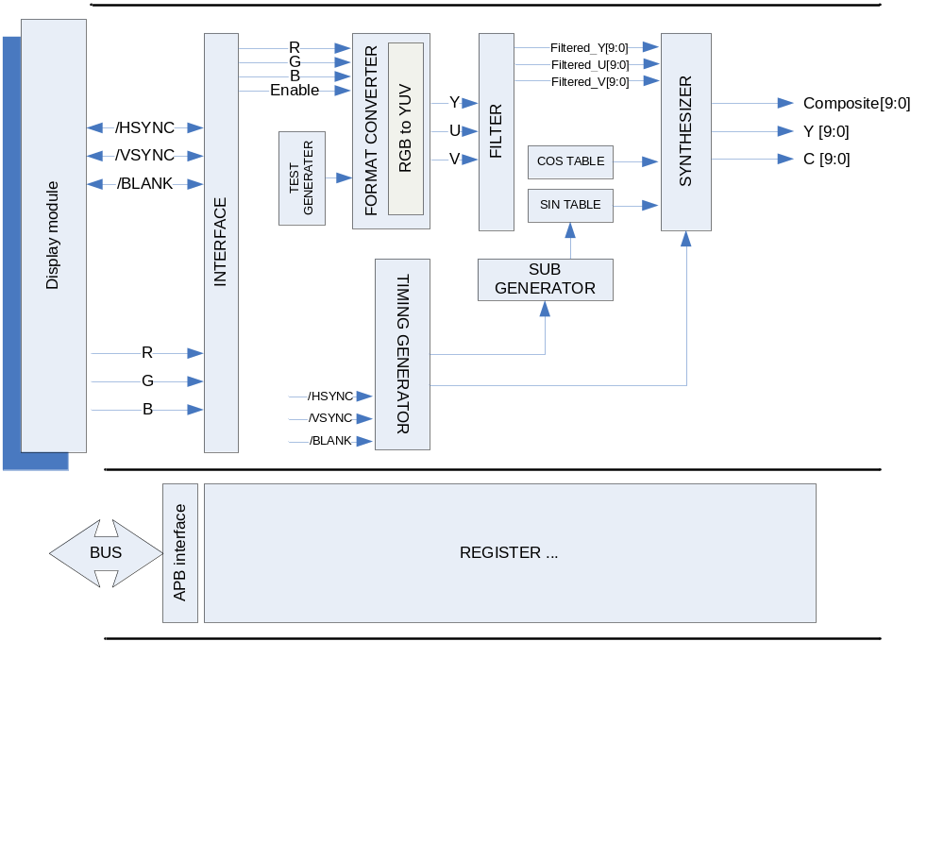

Operation

Video timing

Data input timing
Video input 은 24bits RGB Slave를 지원하도록 되어 있으며, BLANKn = “High” 일 경우, 유효한 정보를 입력 받습니다.

Figure 1-2 Interlaced NTSC Video input timing chart
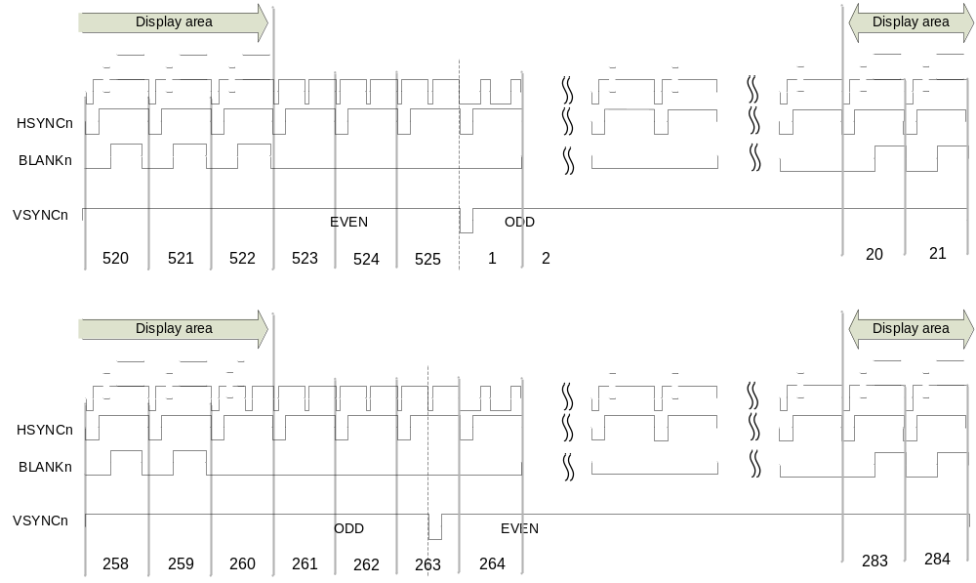

NTSC format 일 경우 Data Active 영역 은 odd field 20~259 / even field 283~522 입니다. Data Active 영역에서 720x480 format에 RGB 신호를 받습니다. Odd와 Even으로 입력 구분은 HSYNCn = “LOW” 와 VSYNC = “LOW” 인 경우를 기준으로 Even → Odd로 변경 됩니다. Even 에서 Odd로 변경 될 경우는 VSYNC= “LOW”인 경우를 기준으로 합니다. 자세한 Timing 은 Figure 1-2 참조

Figure 1-2 NTSC Even and Odd timing chart
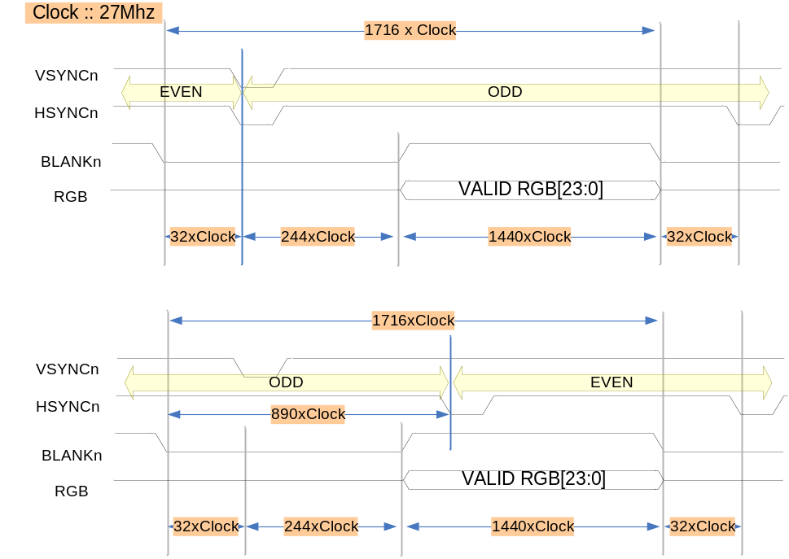
NTSC mode 일 경우 1Line 당 27Mhz sample x 1716 입니다. 출력되는 화상은 720x480 크기를 가지며, Interlaced로 출력 됩니다.

Figure 1-3 Square NTSC Even and Odd timing chart
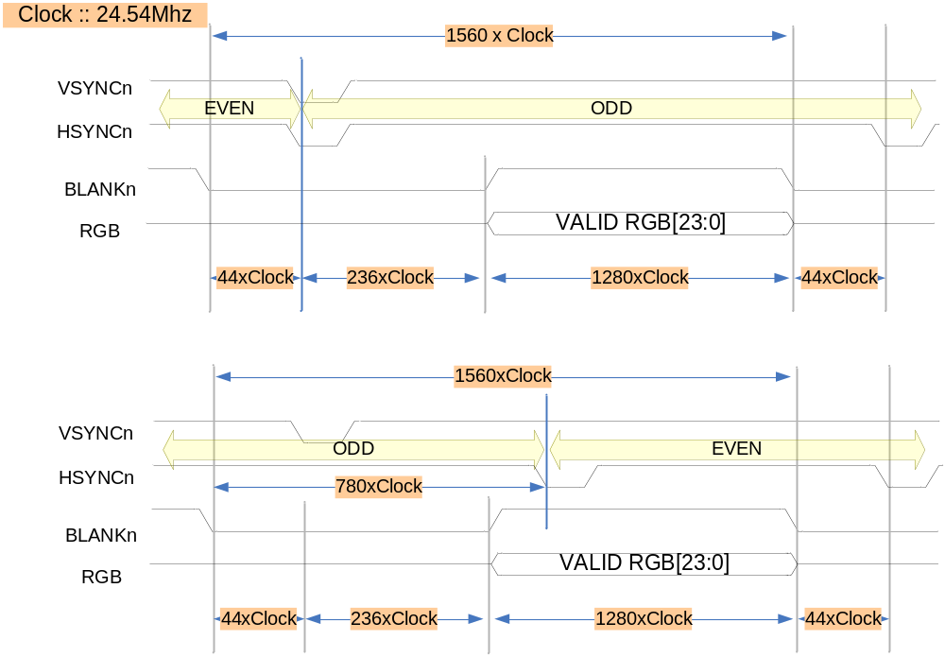
Square mode 일 경우, 24.54Mhz를 공급하며 640x480화상을 출력합니다.

Figure 1-4 RGB input timing

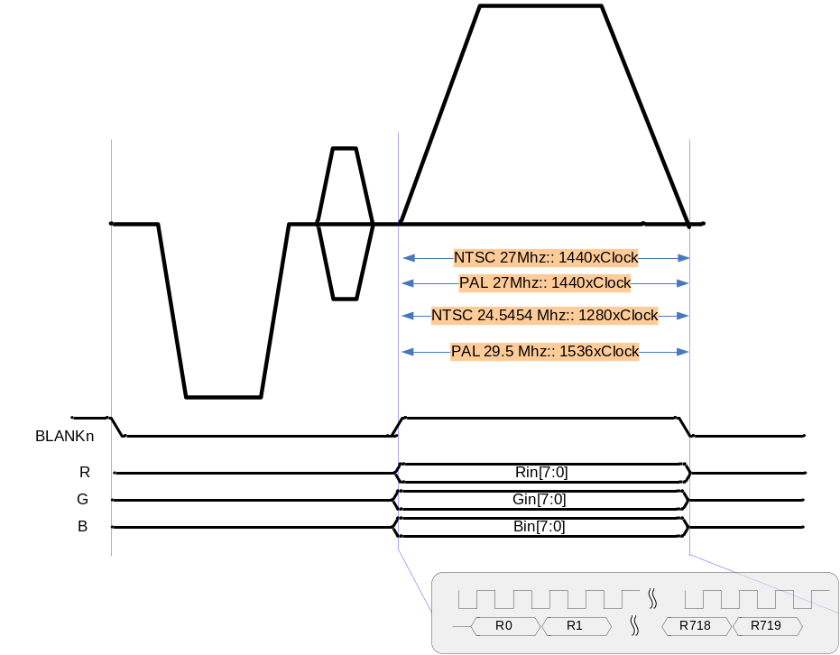
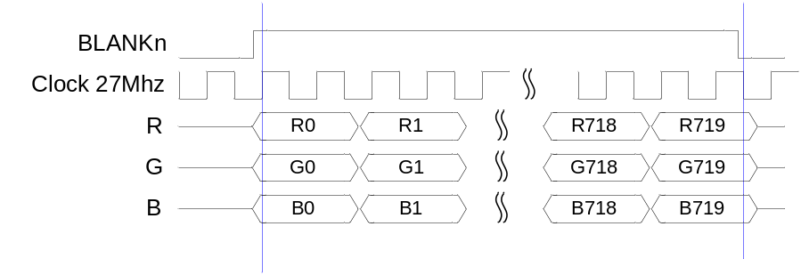
PAL/NTSC 27Mhz 에서 BLANKn 구간은 1440Clock 동안에 총 720 sample를 입력 받도록 되어있으며, Clock에 positive edge 에서 data를 가져 가도록 구성 되어있습니다.

Figure 1-5 PAL Video input timing chart
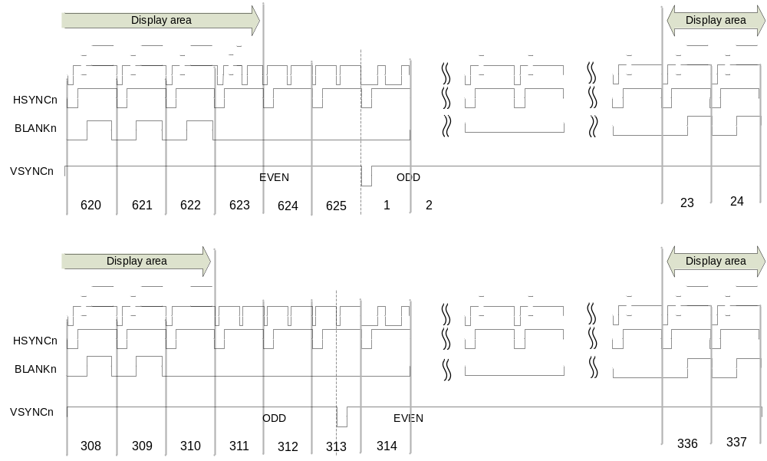

BLANKn = “HIGH” 에서 RGB 입력을 받으며, Data active 영역은 Odd field에서 23~310 총 288 Line Even field에서 336~623 총 288 Line으로 PAL은 720x576 RGB format을 지원합니다.

Figure 1-6 PAL Even and Odd timing chart
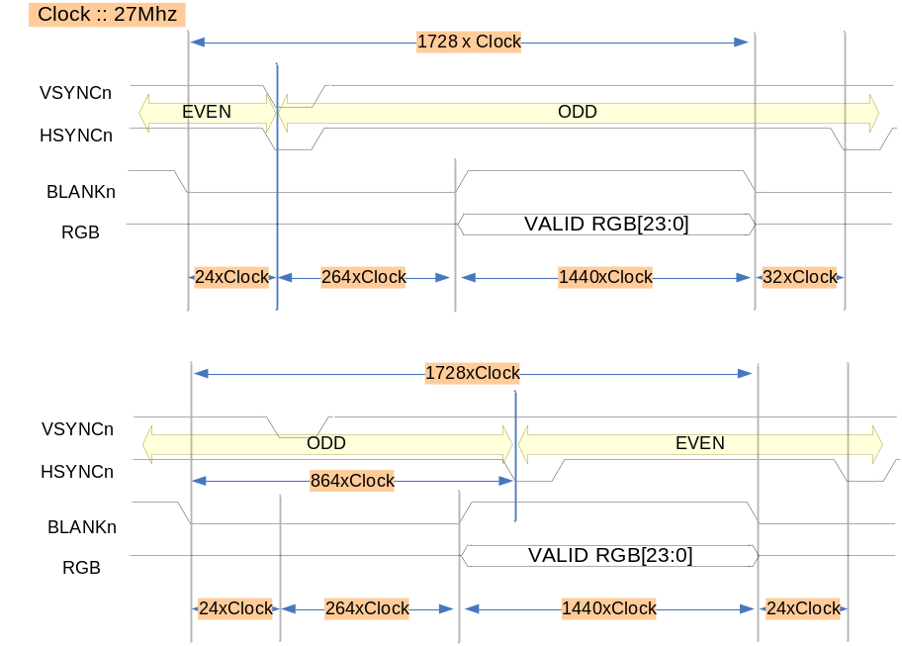
입력 주파수는 27Mhz 를 공급하고, image 576x720 입력합니다. Timing은 Figure 1-6 과 같이 합니다.

Figure 1-7 Square PAL Even and Odd timing chart
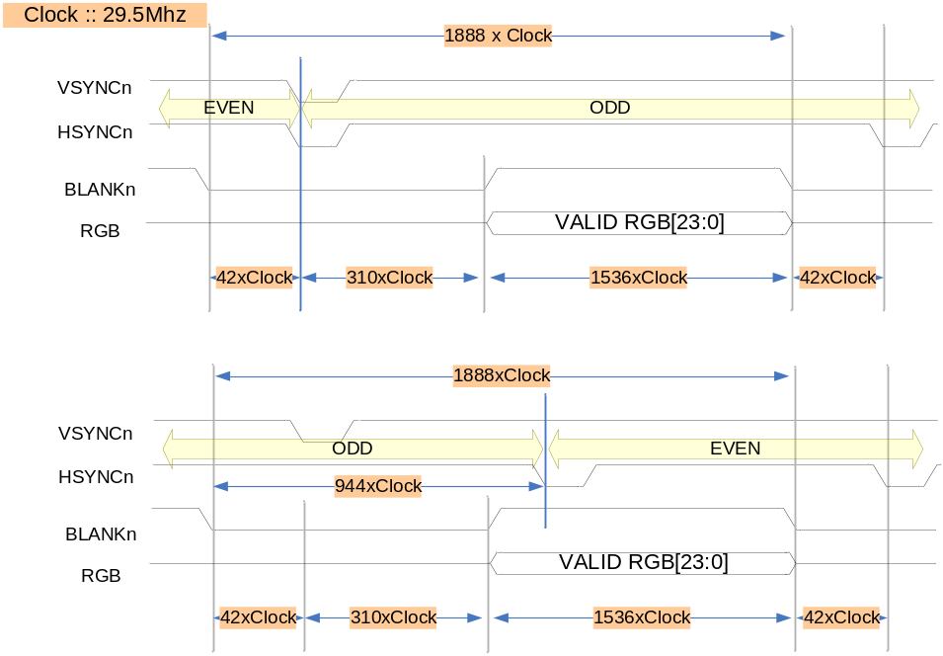

Data output timing

Figure 1-6 output HSYNC / BURST timing chart

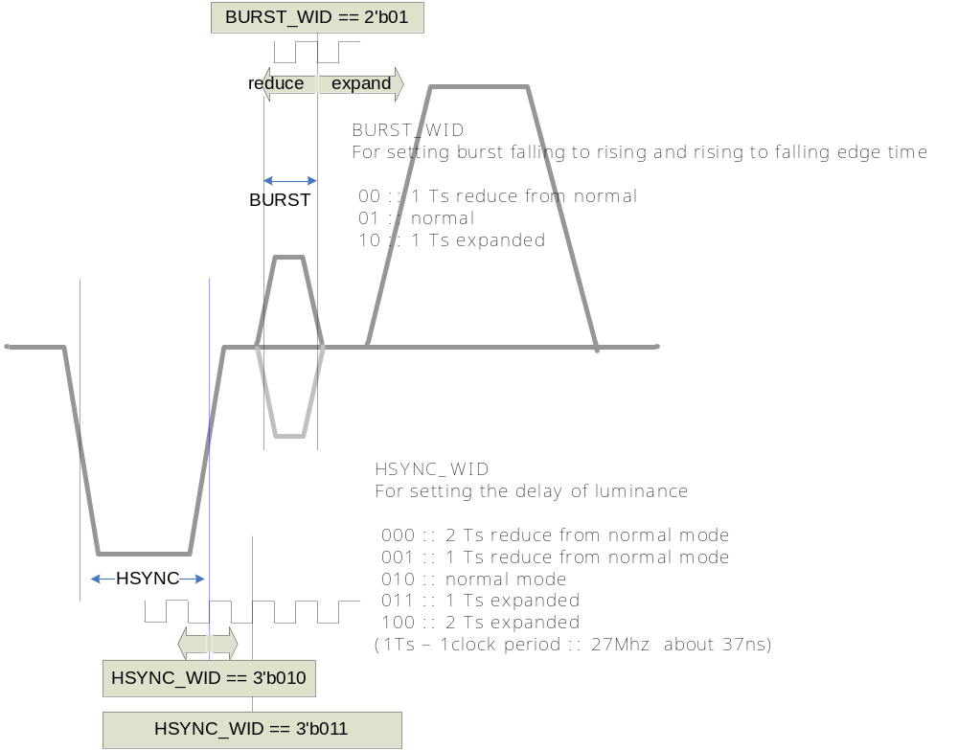

사용되는 기준 Clock (27Mhz) 를 기준으로 HSYNC width와 BURST width를 조절 할 수 있습니다. Normal 값보다 1clock 또는 2clock 내외에서 설정 가능 합니다.

Control setting
Video Encoder 동작을 위하여 각 설정 정보를 설정한 후 Enable을 설정 하는 순서로 이루 워 지며, NTSC Video Encoder는 720x480 image를 기본 영역으로 하는 image를 NTSC(M)을 기본으로 제공하는 TV및 영상 장치에 출력 할 수 있도록 되어 있습니다.

Internal Pattern generation
Figure 1-8 Internal pattern

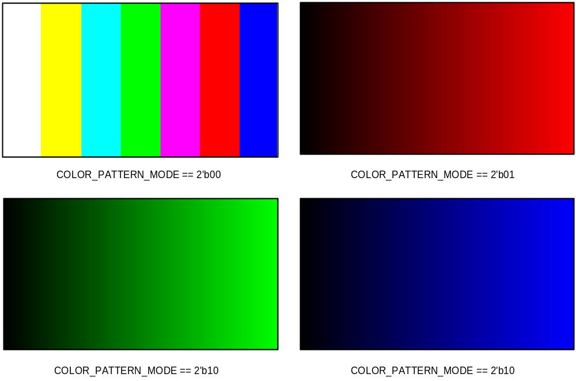
COLOR_PATTERN_MODE를 선택 하고, EN_INTERNAL_PATTERN== 1’b1로 설정 하게 되면 외부에 입력신호 없이 자체 SYNC 신호 및 RGB 신호를 생성하여, MODE에 따라 출력 하게 됩니다.

Subcarrier frequency setting
Table 1-1 Subcarrier frequnce table
MODE | Name | Setting value (SUB_REQ) | Frequency
3’b000 | NTSC M | 21F0 7C1F h | 3.57954 Mhz
3’b001 | NTSC J | 21F0 7C1F h | 3.57954 Mhz
3’b010 | NTSC 4.43 | 2A09 8ACB h | 4.43361875 Mhz
3’b011 | M PAL | 21E6 EFE3 h | 3.57561149 Mhz
3’b100 | PAL(B, D, G, H and I) | 2A09 8ACB h | 4.43361875 Mhz
3’b101 | PAL Nc | 21F6_9446 h | 3.58205625 Mhz
3’b110 | PAL N | 2A09 8ACB h | 4.43361875 Mhz
SUB_REQ를 각 MODE에 따라서 설정 하여야 합니다. Subcarrier 설정을 위하여 각 값들을 설정 하게 됩니다.

Mode setting value
Figure 1-9 NTSC / PAL setting
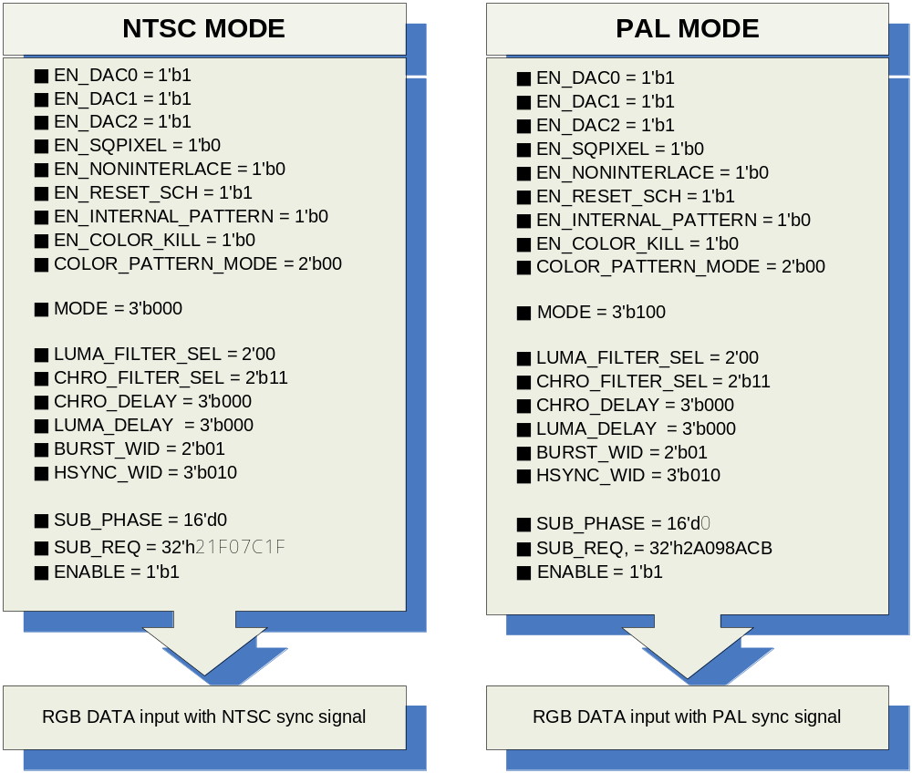

Signal Description

InOutput Signal
Table 1-2 VideoEncoder Signal
Signal Name | Direction | Description | Init. value
CLK | input | 입력 주파수 ( 27 Mhz )
RESETn | Input | Reset
HSYNCn | Input | Horizontal sync signal
VSYNCn | Input | Vertical sync signal
BLANKn | Input | Blank sync signal
Rin | Input | R[7:0] Red color
Gin | Input | G[7:0] Green color
Bin | Input | B[7:0] Blue color
ENABLE | Input | Enable signal
EN_DAC0 | Input | Composite enable signal
EN_DAC1 | Input | Luminance enable signal
EN_DAC2 | Input | Chrominance enable signal
EN_SQPIXEL | Input | Square pixel enable signal
EN_NONINTERLACE | Input | Non-interlace mode signal
EN_INTERNAL_PATTERN | Input | Internal color generation
EN_COLOR_KILL | Input | Composite color remove signal
COLOR_PATTERN_MODE | Input | Internal Color pattern selection
MODE | Input | Output encoder format selection
LUMA_FILTER_SEL | Input | Luminance filter selection
CHRO_FILTER_SEL | Input | Chrominance filter selection
CHRO_DELAY | Input | Chrominance delay
LUMA_DELAY | Input | Luminance delay
BURST_WID | Input | Burst width setting
HSYNC_WID | Input | Hsync width setting
SUB_PHASE | Input | Subcarrier phase setting
DAC0_ENABLE | Output | DAC enable signal
DAC1_ENABLE | Output | DAC enable signal
DAC2_ENABLE | Output | DAC enable signal
DAC0_DATA | Output | Composite signal data
DAC1_DATA | Output | Luminance signal data
DAC2_DATA | Output | Chrominance signal data

Signal Name | Direction | Description | Init. value
F_COUNTER_INTER | Output | Field counter
H_COUNTER_INTER | Output | Horizontal counter
V_COUNTER_INTER | Output | Vertical counter

Register Description

Registers

Table 1-3 Registers(Base Address : xxxxxh)
Offset | Name | R/W | Description | Init. value
0000h | Status Reg. | R | Status register | 0000 0000h
0004h | Control Reg. | RW | Output Control register | 0000 0000h
0008h | Internal Reg. | RW | Internal control register | 0000 0000h
000Ch | Interface Reg. | RW | Input interface control register | 0000 0000h
0010h | Subcarrier phase Reg. | RW | Subcarrier adjust phase register | 0000 0000h
0014h | Subcarrier Reg. | RW | Subcarriter frequency setup register | 0000 0000h
0018h
001Ch
0020h

Status Register
Figure 1-2 Status Register Bits
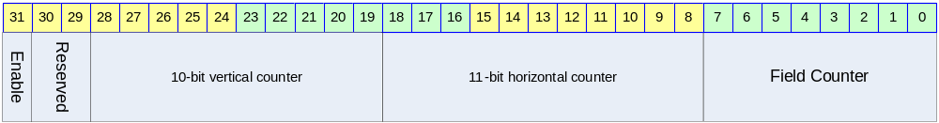

Table 1-4 Status Register Description(Offset : 0000 0000h)
Bits | Name | R/W | Description | Init. value
[00:07] | FIELD_CNT | R | Field counter | 0b
[08:18] | H_CNT | R | Horizontal counter | 0b
[19:28] | V_CNT | R | Vertical counter | 0b
[31] | Enable | R | Enable status | 0b

Control Register
Figure 1-3 Control Register Bits
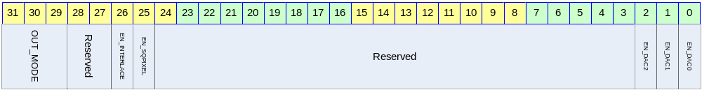

Table 1-4 Control Register Description(Offset : 0000 0000h)
Bits | Name | R/W | Description | Init. value
[00] | EN_DAC0 | R/W | This bit can be used to power down the DAC0  0 :: Off DAC / 1 :: On DAC | 0b
[01] | EN_DAC1 | R/W | This bit can be used to power down the DAC1  0 :: Off DAC / 1 :: On DAC | 0b
[02] | EN_DAC2 | R/W | This bit can be used to power down the DAC2  0 :: Off DAC / 1 :: On DAC | 0b
[25] | EN_SQPIXEL | R/W | This bit is used for square pixel mode  0 :: normal mode  1 :: Square pixel mode  for the square pixel mode, change the frequency.  - NTSC square pixel mode :: 24.5454MHz  - PAL square pixel mode :: 29.5MHz | 0b
[26] | EN_INTERLACE | R/W | To choice the mode of interlace or non-interlace  0 :: interlace  1 :: non-interlace | 0b
[31:29] | OUT_MODE | R/W | For setting up the ENCODE mode  000 :: NTSC M  001 :: NTSC J  010 :: NTSC 4.43  011 :: M PAL  100 :: PAL(B, D, G, H and I)  101 :: PAL Nc  110 :: PAL N | 000b

Internal Register
Figure 1-4 Internal Register Bits
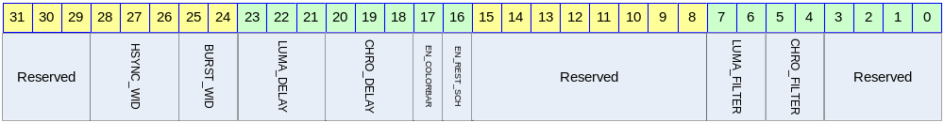

Table 1-5 Internal Register Description(Offset : 0000 0000h)
Bits | Name | R/W | Description | Init. Value
[04:05] | LUMA_FILTER_SEL | R/W | Select of the luminance filter | 00b
[06:07] | CHRO_FILTER_SEL | R/W | Select of the chrominance filter | 00b
[16] | EN_REST_SCH | R/W | This bit can be auto reset SCH  0 :: disable  1 :: Enable auto reset  Resetting the SCH phase every four or eight fields. This function is to avoid the accumulation of SCH phase error | 0b
[17] | EN_INTERNAL_TEST | R/W | Internal pattern generation setting  0 :: disable  1 :: pattern generation | 0b
[18:20] | CHRO_DELAY |  | For setting the delay of chrominance  000 :: none  001 :: 1 Ts delay  010 :: 2 Ts delay  011 :: 3 Ts delay  100 :: 4 Ts delay  (1Ts – 1clock period :: 27Mhz → about 37ns) | 000b
[21:23] | LUMA_DELAY |  | For setting the delay of luminance  000 :: none  001 :: 1 Ts delay  010 :: 2 Ts delay  011 :: 3 Ts delay  100 :: 4 Ts delay  (1Ts – 1clock period :: 27Mhz → about 37ns) | 000b

Bits | Name | R/W | Description | Init. Value
[24:25] | BURST_WID | R/W | For setting burst falling to rising and rising to falling edge time  00 :: 1 Ts reduce from normal  01 :: normal  10 :: 1 Ts expanded | 01b
[26:28] | HSYNC_WID | R/W | For setting the delay of luminance  000 :: 2 Ts reduce from normal mode  001 :: 1 Ts reduce from normal mode  010 :: normal mode  011 :: 1 Ts expanded  100 :: 2 Ts expanded  (1Ts – 1clock period :: 27Mhz → about 37ns) | 010b

Interface register
Figure 1-5 Interface Register Bits
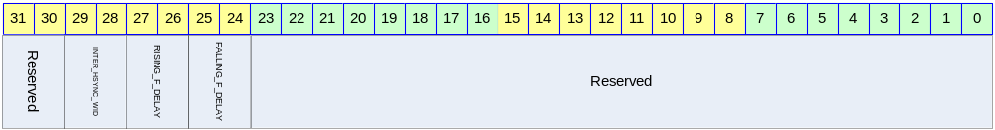

Table 1-6 Internal Register Description(Offset : 0000 0000h)
Bits | Name | R/W | Description | Init. Value
[24:25] | INTER_HSYNC_WIDTH | R/W | When interface mode 1, /HSYNC width  00 :: 1 x Ts  01 :: 4 x Ts  10 :: 16 x Ts  11 :: 128 x Ts
[26:27] | RISING_F_DELAY | R/W | The rising or falling of /HSYNC edge to Field,/VSYNC rising edge delay  00 :: 0 x Ts  01 :: 4 x Ts  10 :: 8 x Ts  11 :: 16 x Ts
[28:29] | INTER_HSYNC_WIDTH | R/W | When interface mode 1, /HSYNC width  00 :: 1 x Ts  01 :: 4 x Ts  10 :: 16 x Ts  11 :: 128 x Ts

Subcarrier phase register
Figure 1-6 subcarrier phase Register Bits
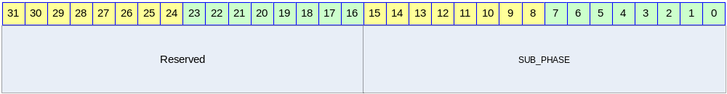

Table 1-7 Internal Register Description(Offset : 0000 0000h)
Bits | Name | R/W | Description | Init. Value
[00:15] | SUB_PHASE | R/W | Subcarrier phase register  [0 ~ 2048]  Each bit represents 0.17578125˚

Subcarrier register
Figure 1-7 subcarrier Register Bits
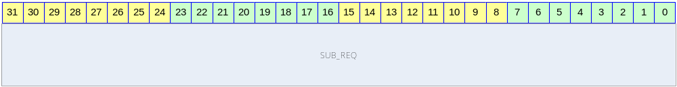

Table 1-8 Internal Register Description(Offset : 0000 0000h)
Bits | Name | R/W | Description | Init. Value
[00:31] | SUB_REQ | R/W | Subcarrier frequency setting

