NTSC PAL Video Encoder

Version 1.0

SHMT Co., Ltd.

REVISION HISTORY
Version | Detail(굴림/Verdana 10pt bold) | Name | Date
V.01 | Core block specification | NamKwol Kang | Jan .1st. 2007

Technical documents
Copyright © 2006 Shmt Limited. All rights reserved

Confidentiality Status
This document is NOT OPEN ACCESS. The distribution is restricted to certified companyThis document is CONFIDENTIAL

Feedback on this document
If you have any comments on this document, please contact your channel to our company

Shmt Web address
http://www.shmt.com

Contents
1. NTSC PAL Video encoder 7
1.1. Overview 7
1.1.1. Feature 7
1.1.2. Block diagram 8
1.2. Operation 9
1.2.1. Video timing 9
1.2.2. Control setting 17
1.3. Signal Description 20
1.3.1. InOutput Signal 20
1.4. Setting Input/Output Description 22
1.4.1. Status input/output 22
1.4.2. Control input 22
1.4.3. Internal control input 24
1.4.4. Subcarrier phase input 26
1.4.5. Subcarrier input 26
1.4.6. Image Control register 26
1.4.7. Output level register 0 27
1.4.8. Output level register 1 27

Figures

Figure 1-1 Video Encoder Block Diagram 8
Figure 1-2 Interlaced NTSC Video input timing chart 9
Figure 1-3 NTSC Even and Odd timing chart 10
Figure 1-4 Square NTSC Even and Odd timing chart 10
Figure 1-5 RGB input timing 11
Figure 1-6 PAL Video input timing chart 12
Figure 1-7 PAL Even and Odd timing chart 13
Figure 1-8 Square PAL Even and Odd timing chart 13
Figure 1-9 output HSYNC / BURST timing chart 14
Figure 1-10 Output level control chart 15
Figure 1-11 Hue level control chart 16
Figure 1-12 Internal pattern 17
Figure 1-13 NTSC / PAL setting 19

Tables
Table 1-1 Subcarrier frequnce table 18
Table 1-2 VideoEncoder Signal 20
Table 1-3 Status input/output Description 22
Table 1-4 Control input Description 22
Table 1-5 Internal control input Description 24
Table 1-6 subcarrier phase Register 26
Table 1-7 subcarrier input 26
Table 1-8 Image control Register 26
Table 17-9 Output level Register 0 (Offset : 0018h) 27
Table 17-10 Output level Register 1 (Offset : 001Ch) 27

NTSC PAL Video encoder

Overview
High performance video encoder supports for NTSC M, NTSC-J, NTSC4.32, PAL B/D/G/H/I and PAL M. By using RGB format, it outputs analog composite and analog S-video. This encoder drives the 10bits DAC

Feature
- RGB to PAL/NTSC video encoder
- NTSC M, NTSC J, NTSC 4.43, PAL Nc, PAL B/D/G/H/I, PAL-M
- 27Mhz clock required (x2 oversampling)
- Video input data port supports:
  - RGB 24bit Parallel input format
- Video output supports:
  - Composite / S-Video signal output
  - 10bits high quality DAC output
- Programmable luma / chroma filters
- Programmable subcarrier frequency and phase
- Programmable LUMA delay
- Individual on/off control of each DAC
- CCIR and square pixel operation
- Color signal control/burst signal control
- Complete on-chip video timing generator
- On-chip color bar / color lamp generation

Block diagram

Figure 1-1 Video Encoder Block Diagram

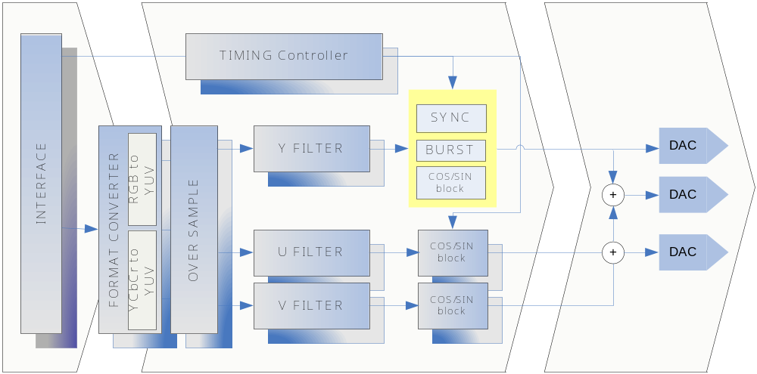

Operation

Video timing

Data input timing

Video input 은 24bits RGB Slave를 지원하도록 되어 있으며, BLANKn = “High” 일 경우, 유효한 정보를 입력 받습니다.

Figure 1-2 Interlaced NTSC Video input timing chart
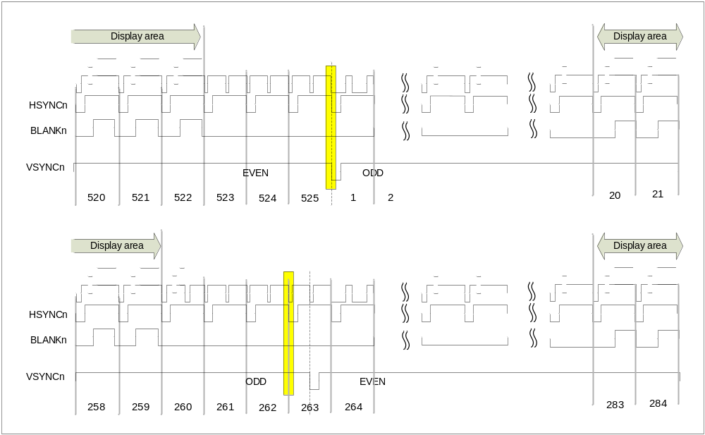

NTSC format 일 경우 Data Active 영역 은 odd field 20~259 / even field 283~522 입니다. Data Active 영역에서 720x480 format에 RGB 신호를 받습니다. Odd와 Even으로 입력 구분은 HSYNCn = “LOW” 와 VSYNC = “LOW” 인 경우를 기준으로 Even → Odd로 변경 됩니다. Even 에서 Odd로 변경 될 경우는 VSYNC= “LOW”인 경우를 기준으로 합니다. 자세한 Timing 은 Figure 1-3 참조

Figure 1-3 NTSC Even and Odd timing chart
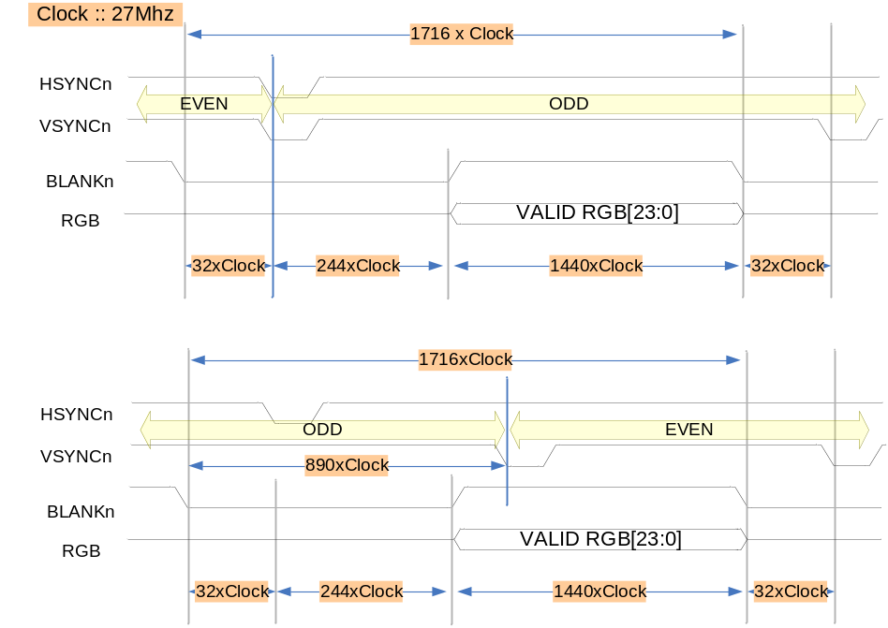
NTSC mode 일 경우 1Line 당 27Mhz sample x 1716 입니다. 출력되는 화상은 720x480 크기를 가지며, Interlaced로 출력 됩니다.

Figure 1-4 Square NTSC Even and Odd timing chart
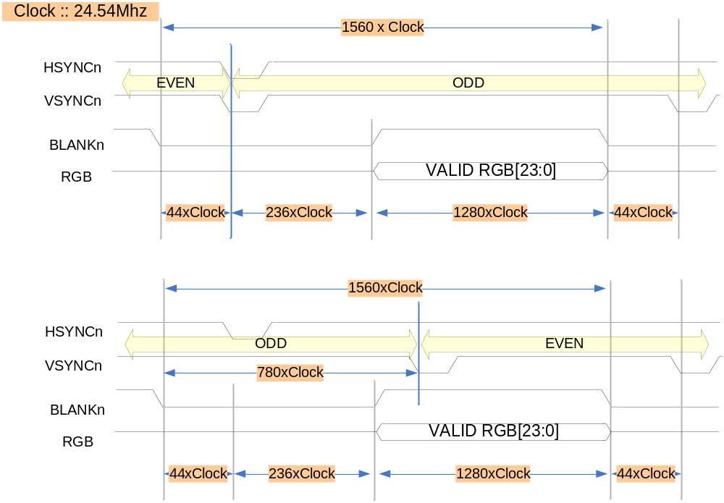
Square mode 일 경우, 24.54Mhz를 공급하며 640x480화상을 출력합니다.

Figure 1-5 RGB input timing
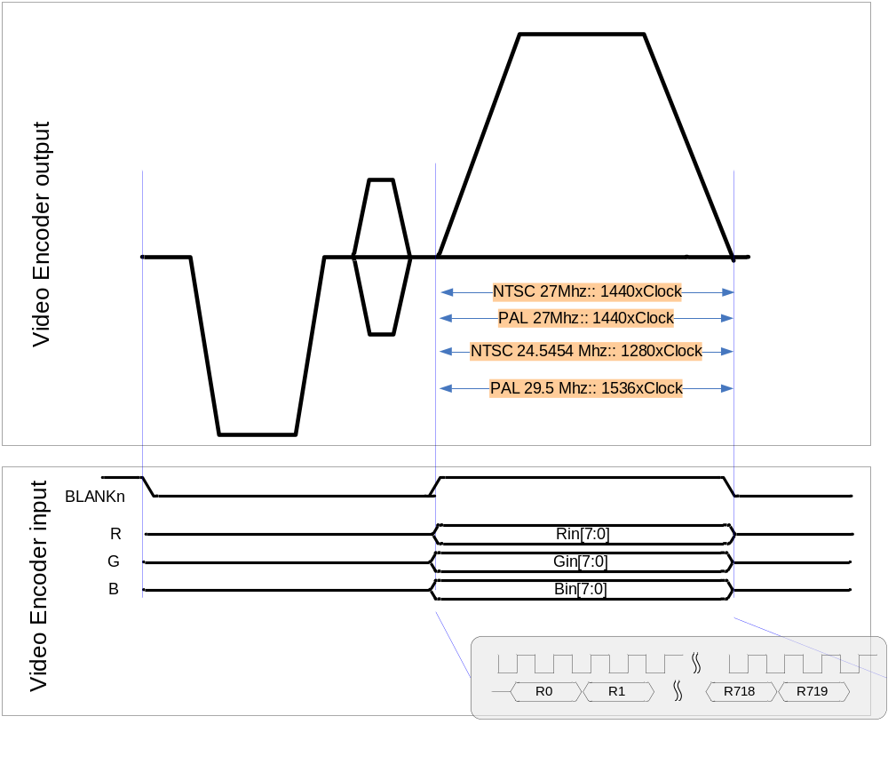
PAL/NTSC 27Mhz 에서 BLANKn 구간은 1440Clock 동안에 총 720 sample를 입력 받도록 되어있으며, Clock에 positive edge 에서 data를 가져 가도록 구성 되어있습니다.

Figure 1-6 PAL Video input timing chart
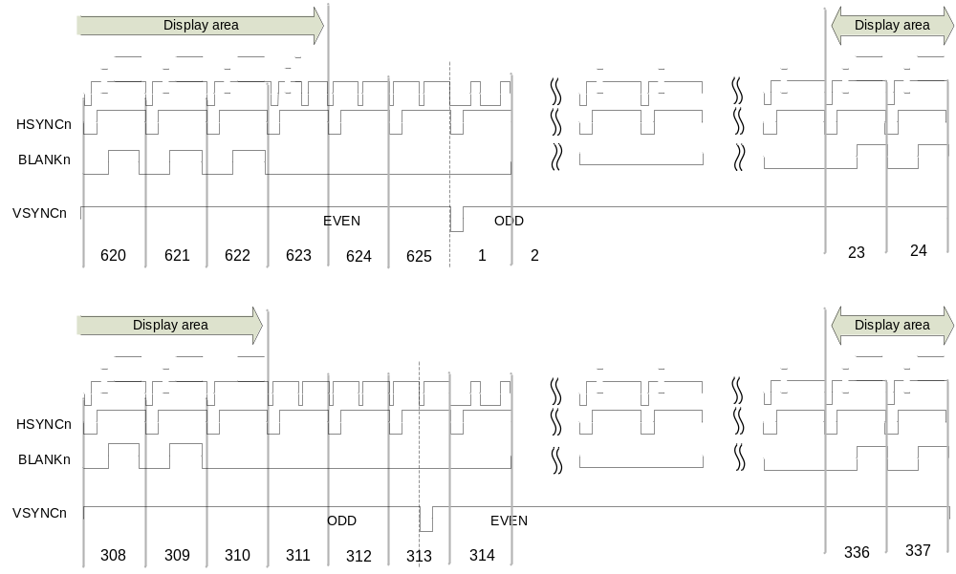

BLANKn = “HIGH” 에서 RGB 입력을 받으며, Data active 영역은 Odd field에서 23~310 총 288 Line Even field에서 336~623 총 288 Line으로 PAL은 720x576 RGB format을 지원합니다.

Figure 1-7 PAL Even and Odd timing chart
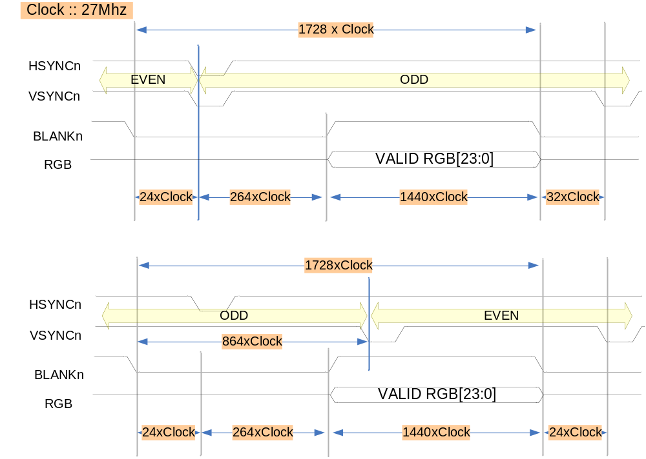
입력 주파수는 27Mhz 를 공급하고, image 576x720 입력합니다. Timing은 Figure 1-6 과 같이 합니다.

Figure 1-8 Square PAL Even and Odd timing chart
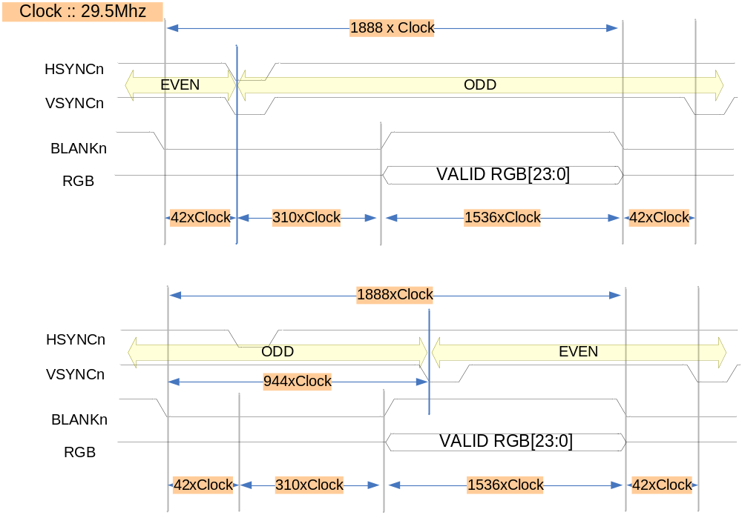

Data output timing

Figure 1-9 output HSYNC / BURST timing chart

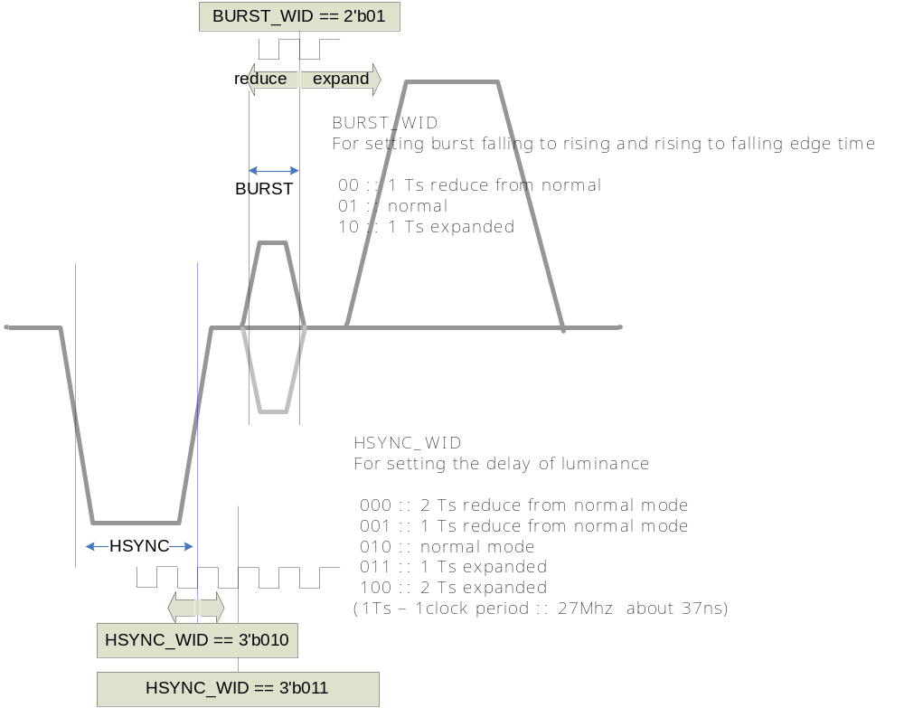

사용되는 기준 Clock (27Mhz) 를 기준으로 HSYNC width와 BURST width를 조절 할 수 있습니다. Normal 값보다 1clock 또는 2clock 내외에서 설정 가능 합니다.

Figure 1-10 Output level control chart
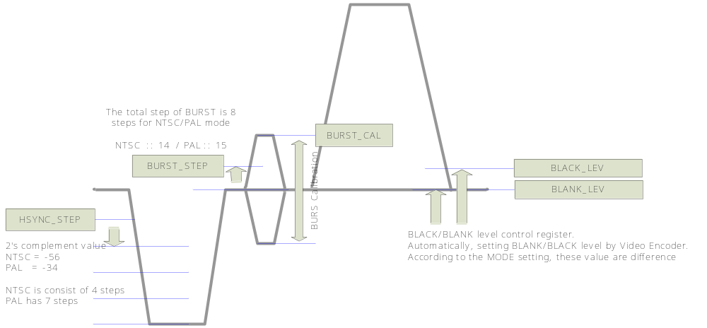
BLACK_LEV 은 NTSC에 경우 7.5IRE가 적용된 값인 282를 적용합니다. PAL 에 경우 252를 사용합니다.
BLANK_LEV 도 NTSC와 PAL경우가 다르며, NTSC → 240 / PAL →252 가 적용됩니다.
BURST_STEP 은 총 8 step으로 구성되며, 한 Step당 크기를 설정할 수 있도록 되어있습니다.
이와 마찬가지로 HSYNC_STEP 또한 step 당 설정 가능합니다.

Figure 1-11 Hue level control chart
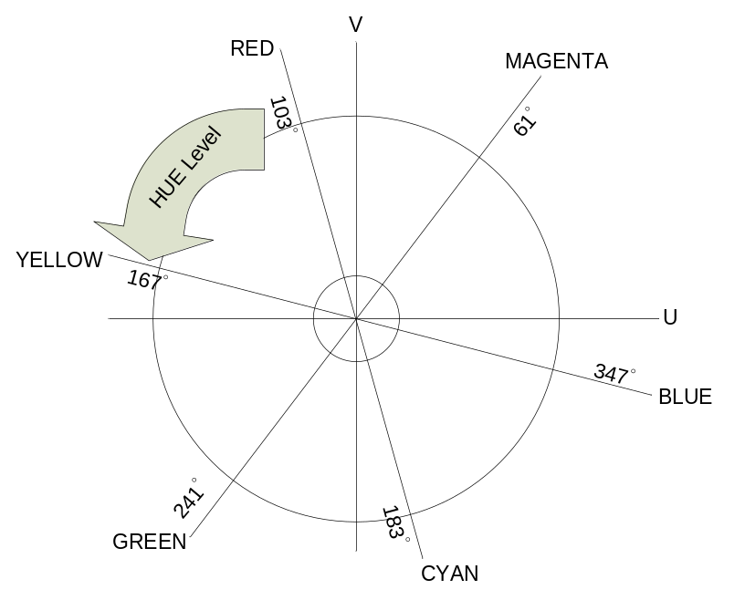
RED 신호를 YELLOW 출력으로 변경할 경우, HUE_LEV 을 이용하여 변경 가능합니다. RED와 YELLOW에 차는 167 ˚ – 103 ˚ = 64 ˚ 위상 차가 발생합니다. HEL_LEV이 255일 경우 360 ˚ 이므로,
(64 / 360) X 255 = 45 입니다. 따라서 HUE_LEV = 45를 설정하면, RED Level에 신호들은 Yellow값을 갖습니다. Hue 정보만 수정되기 때문에 Saturation/Luminance 정보는 본래 값을 갖게 됩니다.

Control setting
Video Encoder 동작을 위하여 각 설정 정보를 설정한 후 Enable을 설정 하는 순서로 이루 워 지며, NTSC Video Encoder는 720x480 image를 기본 영역으로 하는 image를 NTSC(M)을 기본으로 제공하는 TV및 영상 장치에 출력 할 수 있도록 되어 있습니다.

Internal Pattern generation

Figure 1-12 Internal pattern
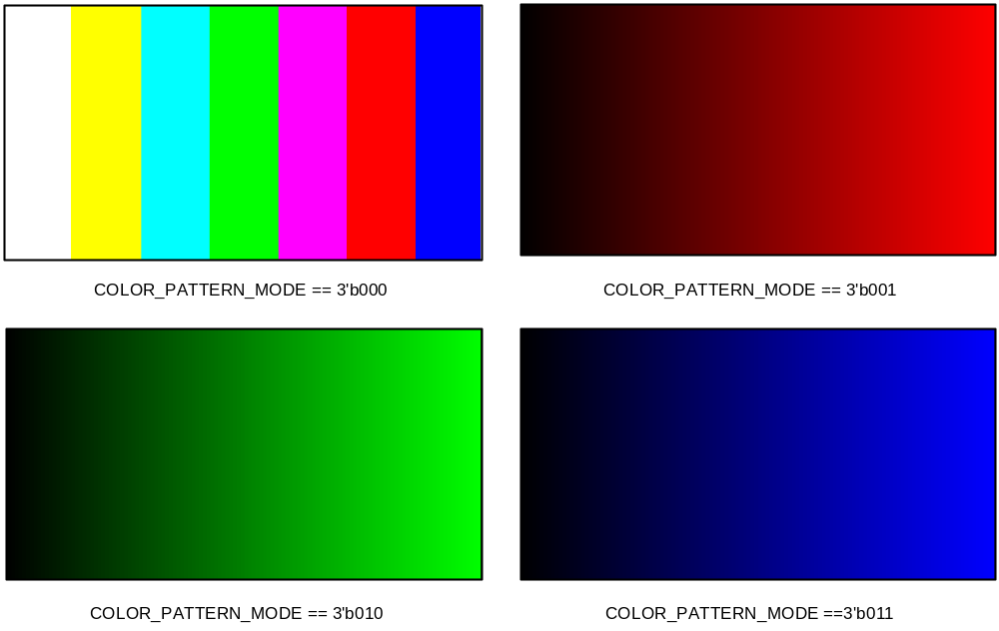
COLOR_PATTERN_MODE를 선택 하고, EN_INTERNAL_PATTERN== 1’b1로 설정 하게 되면 외부에 입력신호 없이 자체 SYNC 신호 및 RGB 신호를 생성하여, MODE에 따라 출력 하게 됩니다.

Subcarrier frequency setting

Table 1-1 Subcarrier frequnce table
MODE | Name | Setting value (SUB_REQ) | Frequency
3’b000 | NTSC M | 21F0 78BB h | 3.579545 Mhz
3’b001 | NTSC J | 21F0 78BB h | 3.579545 Mhz
3’b010 | NTSC 4.43 | 2A09 8ACB h | 4.43361875 Mhz
3’b011 | M PAL | 21E6 EFA4 h | 3.57561149 Mhz
3’b100 | PAL(B, D, G, H and I) | 2A09 8ACB h | 4.43361875 Mhz
3’b101 | PAL Nc | 21F6 9446 h | 3.58205625 Mhz
3’b110 | PAL N | 2A09 8ACB h | 4.43361875 Mhz
SUB_REQ를 각 MODE에 따라서 설정 하여야 합니다. Subcarrier 설정을 위하여 각 값들을 설정 하게 됩니다.

Register 계산방법은 아래와 같습니다.
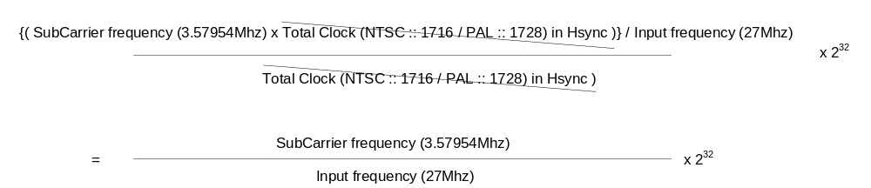

예를 들어, 3.57954Mhz에 Subcarrier를 사용하고, 입력 주파수가 27Mhz 일 경우,
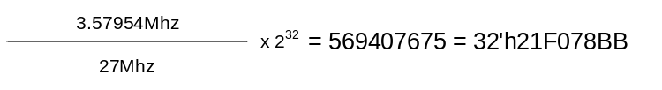

Mode setting value

Figure 1-13 NTSC / PAL setting

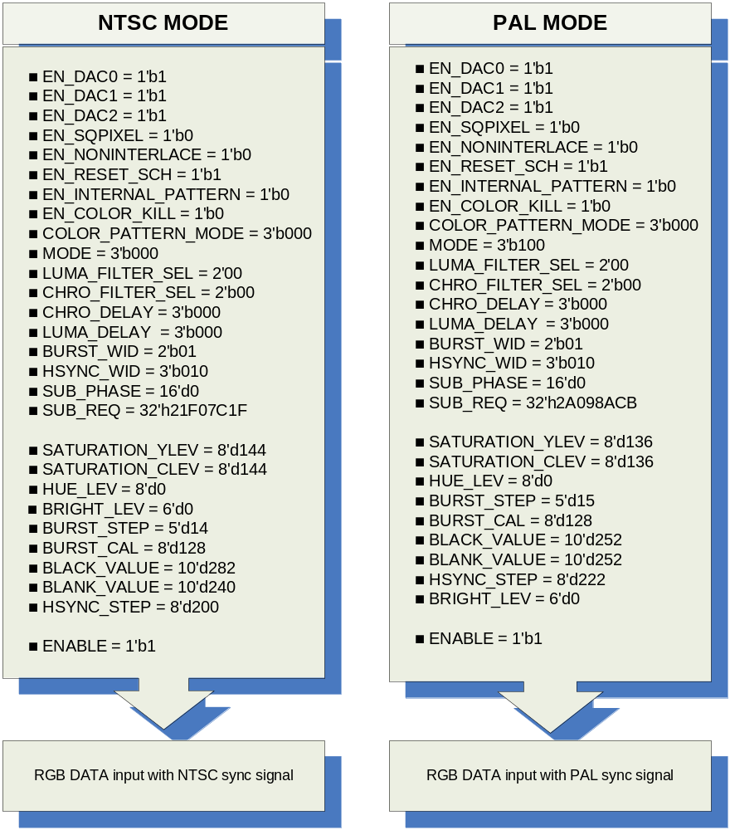

Signal Description

InOutput Signal
Table 1-2 VideoEncoder Signal
Signal Name | Direction | Description | Init. value
CLK | input | Input clock (27Mhz)
RESETn | Input | Reset
HSYNCn | Input | Horizontal sync signal
VSYNCn | Input | Vertical sync signal
BLANKn | Input | Blank sync signal
Rin | Input | R[7:0] Red color
Gin | Input | G[7:0] Green color
Bin | Input | B[7:0] Blue color
ENABLE | Input | Enable signal
EN_DAC0 | Input | Composite enable signal
EN_DAC1 | Input | Luminance enable signal
EN_DAC2 | Input | Chrominance enable signal
EN_SQPIXEL | Input | Square pixel enable signal
EN_NONINTERLACE | Input | Non-interlace mode signal
EN_INTERNAL_PATTERN | Input | Internal color generation
EN_COLOR_KILL | Input | Composite color remove signal
COLOR_PATTERN_MODE | Input | Internal Color pattern selection
MODE | Input | Output encoder format selection
LUMA_FILTER_SEL | Input | Luminance filter selection
CHRO_FILTER_SEL | Input | Chrominance filter selection
CHRO_DELAY | Input | Chrominance delay
LUMA_DELAY | Input | Luminance delay
BURST_WID | Input | Burst width setting
HSYNC_WID | Input | Hsync width setting
SUB_PHASE | Input | Subcarrier phase setting
SUB_REQ | Input | Subcarrier frequency setting
SATURATION_YLEV | Input | Saturation luminance level setting
SATURATION_CLEV | Input | Saturation chrominance level setting
BLANK_VALUE | Input | Blank value setting
HUE_LEV | Input | Hue level setting
BRIGHT_LEV | Input | Brightness level setting

Signal Name | Direction | Description | Init. value
BURST_STEP | Input | Burst step setting
HSYNC_STEP | Input | Hsync step setting
BURST_CAL | Input | Burst level setting
BLACK_VALUE | Input | Black value setting
DAC0_ENABLE | Output | DAC enable signal
DAC1_ENABLE | Output | DAC enable signal
DAC2_ENABLE | Output | DAC enable signal
DAC0_DATA | Output | Composite signal data
DAC1_DATA | Output | Luminance signal data
DAC2_DATA | Output | Chrominance signal data
F_COUNTER_INTER | Output | Field counter
H_COUNTER_INTER | Output | Horizontal counter
V_COUNTER_INTER | Output | Vertical counter

Setting Input/Output Description

Status input/output

Table 1-3 Status input/output Description
Bits | Name | I/O | Description | Init. value
[7:0] | FIELD_CNT | output | Field counter | 0b
[10:0] | H_CNT | Output | Horizontal counter | 0b
[9:0] | V_CNT | Output | Vertical counter | 0b
[00] | Enable | Input | Enable status | 0b

Control input

Table 1-4 Control input Description
Bits | Name | I/O | Description | Init. value
[00] | EN_DAC0 | Input | This bit can be used to power down the DAC0  0 :: Off DAC / 1 :: On DAC | 0b
[00] | EN_DAC1 | Input | This bit can be used to power down the DAC1  0 :: Off DAC / 1 :: On DAC | 0b
[00] | EN_DAC2 | Input | This bit can be used to power down the DAC2  0 :: Off DAC / 1 :: On DAC | 0b
[00] | EN_SQPIXEL | Input | This bit is used for square pixel mode  0 :: normal mode  1 :: Square pixel mode  for the square pixel mode, change the frequency.  - NTSC square pixel mode :: 24.5454MHz  - PAL square pixel mode :: 29.5MHz | 0b
[00] | EN_NONINTERLACE | input | To choice the mode of interlace or non-interlace  0 :: interlace  1 :: non-interlace | 0b

Bits | Name | I/O | Description | Init. value
[00] | EN_NONINTERLACE | Input | To choice the mode of interlace or non-interlace  0 :: interlace  1 :: non-interlace | 0b
[2:0] | MODE | Input | For setting up the ENCODE mode  000 :: NTSC M  001 :: NTSC J  010 :: NTSC 4.43  011 :: M PAL  100 :: PAL(B, D, G, H and I)  101 :: PAL Nc  110 :: PAL N | 000b

Internal control input

Table 1-5 Internal control input Description
Bits | Name | R/W | Description | Init. Value
[1:0] | LUMA_FILTER_SEL | input | Select of the luminance filter  00 :: 6MHz  01 :: NTSC notch  10 :: PAL notch  11 :: By pass | 00b
[1:0] | CHRO_FILTER_SEL | Input | Select of the chrominance filter  00 :: 1.35 Mhz  10 :: 0.67 Mhz | 00b
[0] | EN_COLOR_KILL | Input | Color information is not output to composite DAC (only luminance output)  0 :: disable  1 :: enable | 0b
[0] | EN_REST_SCH | Input | This bit can be auto reset SCH  0 :: disable  1 :: Enable auto reset  Resetting the SCH phase every four or eight fields. This function is to avoid the accumulation of SCH phase error | 0b
[0] | EN_INTERNAL_PATTERN | Input | Internal pattern generation setting  0 :: disable  1 :: pattern generation | 0b

Bits | Name | R/W | Description | Init. Value
[2:0] | COLOR_PATTERN_MODE | Input | 000 :: Colorbar 001 :: Red lamp  010 :: Green lamp 011 :: Blue lamp | 000b
[2:0] | CHRO_DELAY | Input | For setting the delay of chrominance  000 :: none  001 :: 1 Ts delay  010 :: 2 Ts delay  ……..  110 :: 6 Ts delay  111 :: 7 Ts delay  (1Ts – 1clock period :: 27Mhz → about 37ns) | 000b
[2:0] | LUMA_DELAY | Input | For setting the delay of luminance  000 :: none  001 :: 1 Ts delay  010 :: 2 Ts delay  ……..  110 :: 6 Ts delay  111 :: 7 Ts delay  (1Ts – 1clock period :: 27Mhz → about 37ns) | 000b
[1:0] | BURST_WID | Input | For setting burst falling to rising and rising to falling edge time  00 :: 1 Ts reduce from normal  01 :: normal  10 :: 1 Ts expanded | 01b
[2:0] | HSYNC_WID | Input | For setting the delay of luminance  000 :: 2 Ts reduce from normal mode  001 :: 1 Ts reduce from normal mode  010 :: normal mode  011 :: 1 Ts expanded  100 :: 2 Ts expanded  (1Ts – 1clock period :: 27Mhz → about 37ns) | 010b

Subcarrier phase input
Table 1-6 subcarrier phase Register
Bits | Name | R/W | Description | Init. Value
[15:0] | SUB_PHASE | R/W | Subcarrier phase register  Each bit represents 0.0055˚ | 0000h

Subcarrier input
Table 1-7 subcarrier input
Bits | Name | I/O | Description | Init. Value
[31:0] | SUB_REQ | Input | Subcarrier frequency setting | 0000h

Image Control register
Table 1-8 Image control Register
Bits | Name | R/W | Description | Init. Value
[7:0] | SATURATION_YLEV | R/W | Luminance Saturation level control register.  If you not use saturation effect, you setting 80h(128)  NTSC recommend value :: 144  PAL recommend value :: 136 | 00h
[7:0] | SATURATION_CLEV | R/W | Chrominance Saturation level control register.  If you not use saturation effect, you setting 80h(128)  NTSC recommend value :: 144  PAL recommend value :: 136 | 00h
[7:0] | HUE_LEV | R/W | Hue level control(0 ~ 255). Each bit has 1.41 degree value  Setting 0, which is 0° shift  Setting 1, which is 1.41° shift | 00h
[4:0] | BRIGHTHNESS_LEV | R/W | Brightness level control(-32 ~ 31) | 00h

Output level register 0
Table 17-9 Output level Register 0 (Offset : 0018h)
Bits | Name | R/W | Description | Init. Value
[9:0] | BLACK_LEV | R/W | BLACK level control register.  Recommend setting value ::  NTSC→ 282 / PAL → 252 | 00h
[9:0] | BLANK_LEV | R/W | BLANK Level control register.  Recommend setting value :  NTSC→ 240 / PAL → 252 | 00h

Output level register 1

Table 17-10 Output level Register 1 (Offset : 001Ch)
Bits | Name | R/W | Description | Init. Value
[7:0] | HSYNC_STEP | R/W | 2’s complement value  NTSC :: 8’hC8  PAL :: 8’hDE | 0b
[7:0] | BURST_CAL | R/W | This bit is for calibration of Burst level.  This level range 0 to 1.99x. the setting level 128 is the range value 1 | 10000000b
[4:0] | BURST_STEP | R/W | For burst level setting,  NTSC :: 14  PAL :: 15 | 0b

