Real-Time Clock

Version 1.0

SHMT Co., Ltd.(Verdana 18pt bold)

REVISION HISTORY
Version | Detail | Name | Date
1.0 | 생 성 | kwoly | May 30, 2007

Technical documents
Copyright © 2006 Shmt Limited. All rights reserved.

Confidentiality Status
This document is NOT OPEN ACCESS. The distribution is restricted to certified company. This document is CONFIDENTIAL.

Feedback on this document
If you have any comments on this document, please contact your channel to our company.(굴림/Verdana 10pt)

Shmt Web address
http://www.shmt.com

Contents

1. 제목1 7
1.1. 제목2 7
1.1.1. 제목3 8
2. ARM926EJ-S 9
2.1. Overview 9
2.1.1. Feature 9
2.1.2. Block Diagram 9
2.2. Operation 10
2.3. Signal Description 10
2.3.1. JTAG Signal 10
2.3.2. Debug Signal 10
2.3.3. ETM Signal 10
2.4. Register Description 11
2.4.1. Registers 11
2.4.2. Status Register 11

Figures

Figure 1-1 figure (왼쪽 맞춤 굴림/Verdana 10pt Bold Blue) 7
Figure 2-1 ARM926EJ-S Block Diagram 9
Figure 2-2 Status Register Bits 11

Tables
Table 1-1 table (왼쪽 맞춤 굴림/Verdana 10pt Bold Blue) 7
Table 2-1 JTAG Signal 10
Table 2-2 Registers(Base Address : 1FFF 0000h) 11
Table 2-3 Status Register Description 11

Real-Time Clock

Overview

Feature

- Alarm function
  - Period alarm (second / minute / hour / day)
  - Setting alarm
- BCD counter
- Leap year counter

Block Diagram

Figure 1-1 RTC block diagram
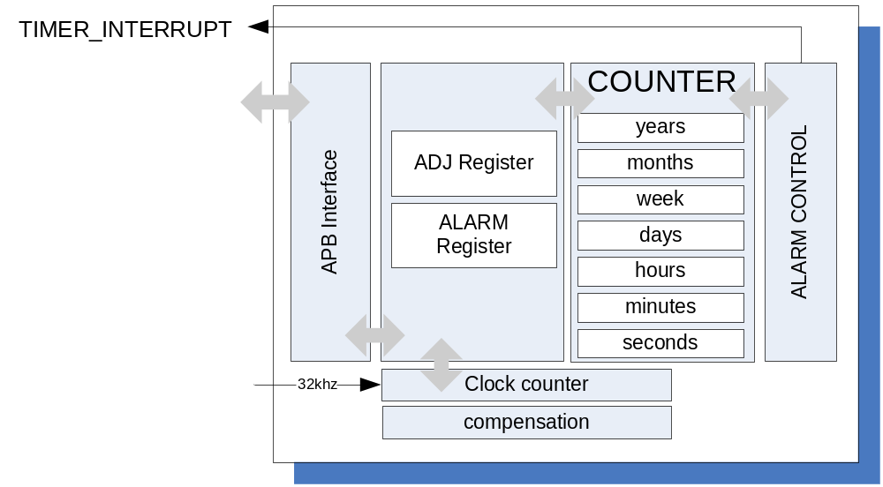

Operation

Setting RTC

RTC(Real-time clock)은 32Khz를 기본 Clock으로 설정하여 동작하며, 오차를 고려하여 Clock Counter 에 Maximum 값을 설정 하수 있도록 하였습니다. 상태에서 BUSY 신호는 Clock이 update 되는 구간을 표시한 것입니다. Register는 BCD 형태를 기본으로 하여 사용합니다.

MODE_APM register를 통하여, 12시/24시 mode를 지원하다. 24시 mode 설정할 경우 시간영역에 맞게 AMPM을 설정 하여야 합니다. 즉, 24시 mode에서 15시를 설정할 때, AMPM은 ‘HIGH’가 되어야 한다. Alarm을 설정 경우에도 MODE_APM에 맞게 설정하여 합니다. 잘못된 설정을 할 경우 기능상 오류를 발생 할 수 있습니다.

Figure 1-2 Busy timing Diagram
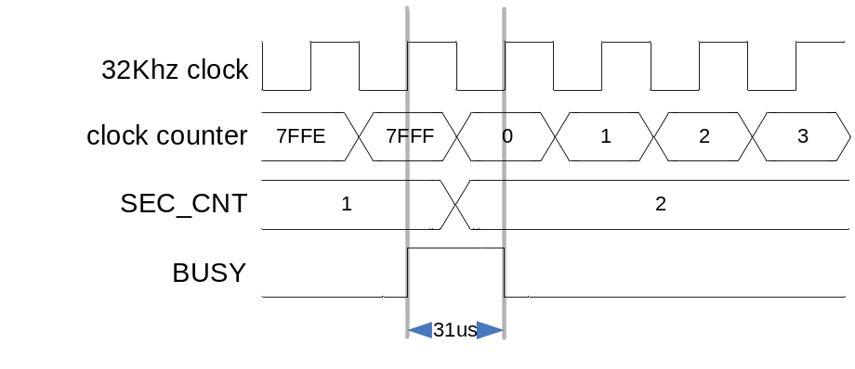

SET_32_CNT를 Enable 하면, Clock counter를 RTC_COMP 값이 적용 되게 됩니다. RTC_COMP값이 적용됩니다. 적용하기 위해선 Counter 동작을 Hold 시킨 다음 적용하여야 합니다.
- STOP_RTC == 1’b0 :: 동작 정지
- SET_32_CNT == 1’b1 :: 값 적용
- STOP_RTC == 1’b1 :: 동작
- SET_32_CNT == 1’b0 :: counter 동작 시작점

Figure 1-3 SET_32_CNT setting timing Diagram
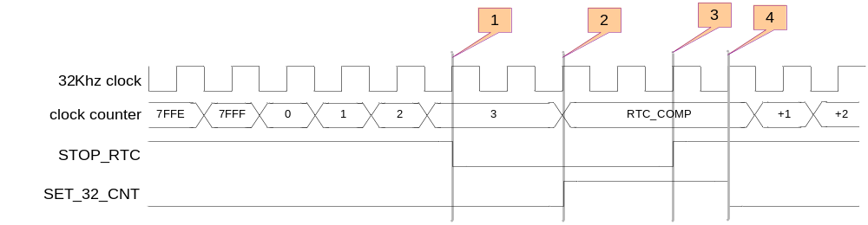

Table 1-1 Register setting value range
Register | Description | Etc
Year | 00~99 윤년 은 4로 나눠지는 수
Month | 01~12
Day | 01~31 :: 1/3/5/7/8/10/12 월  01~30 :: 4/6/9/11 월  01~29 :: 2월 윤년  01~28 :: 2월
Week | 00~06
Hour | 00~23 :: 24시 mode  01~12 :: 12시 mode
Minutes | 00~59
Seconds | 00~59

Alarm interrupt

RTC에는 2가지 alarm 존재합니다.
- period alarm
- setting alarm
period alarm은 초/분/시/날짜 별 주기를 갖도록 하여 주기적인 특성을 갖습니다. Interrupt는 EN_INT_TIMER로 설정하며, IntTimer = ‘HIGH’ 로 설정됩니다. MODE_APM에 맞게 Alarm register를 설정 하여야 합니다. 24시 mode를 사용할 경우 24시 맞게 시간을 설정하고, PMAM도 설정 합니다. 잘못 설정할 경우 기능상 오류가 발생할 수 있습니다.

Figure 1-4 Period interrupt timing diagram
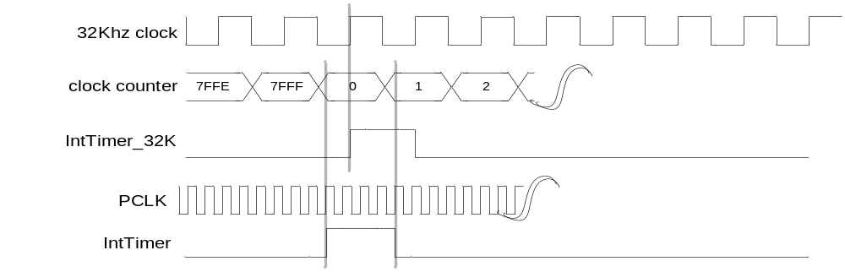

Figure 1-5 Alarm interrupt timing diagram without setting ALARM register212
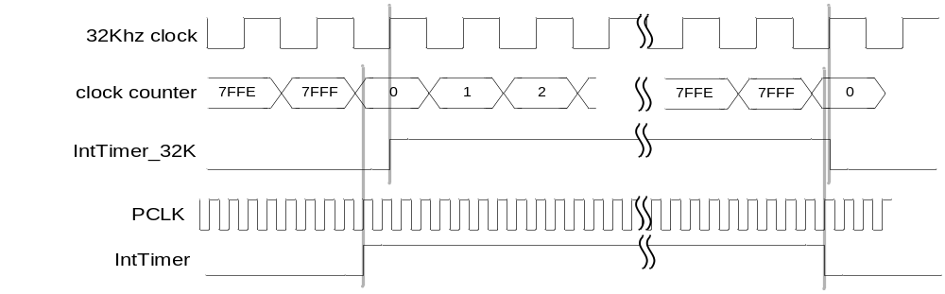
Interrupt가 발생하고, 발생에 따른 ALARM setting을 하지 않았을 경우, interrupt는 1초간 지속됩니다. Interrupt domain은 32Khz와 APB clock 2가지가 존재합니다. ALARM은 status reg. setting으로 설정 합니다.

Figure 1-6 Alarm interrupt timing diagram and ALARM signal setting
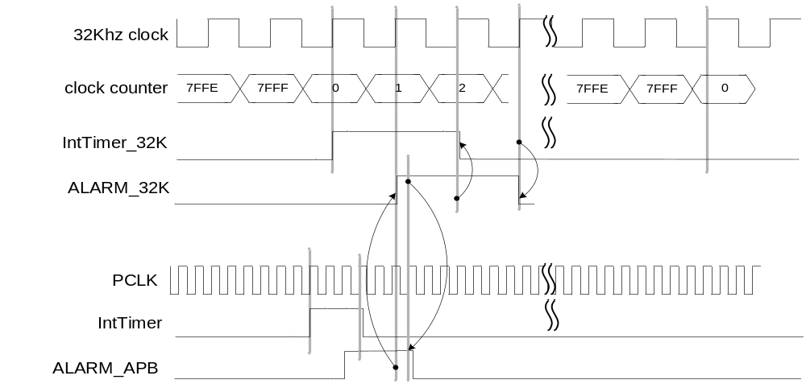
APB를 통하여 ALARM을 설정할 경우, 위와 같이 interrupt가 clear 됩니다.

Table 1-2 Timer interrupts generation
Timer interrupt | Sec | Min | Hour | Day
DAY | ? | ? | ? | O
HOUR | ? | ? | O | O
MIN | ? | O | O | O
SEC | O | O | O | O
Timer interrupt를 초로 설정 할 경우, 분/시/일 모든 경우에 timer interrupt가 포함되지만, 만약 DAY로 설정되면 날짜가 변경 될 경우에 해당 되는 초/분/시 에 포함되는 신호가 발생되고 다른 경우에는 interrupt가 발생 되지 않습니다.

Compensation function

누적되는 오차를 보정하기 위한 기능으로 1시간 주기로 Counter 값에 오차를 보상합니다. 보상방법은 RTC_COMP register를 setting하여 그것으로 하여금 보상됩니다.
RTC_COMP는 +/- 값을 가질 수 있습니다.

Figure 1-7 compensation setting timing char
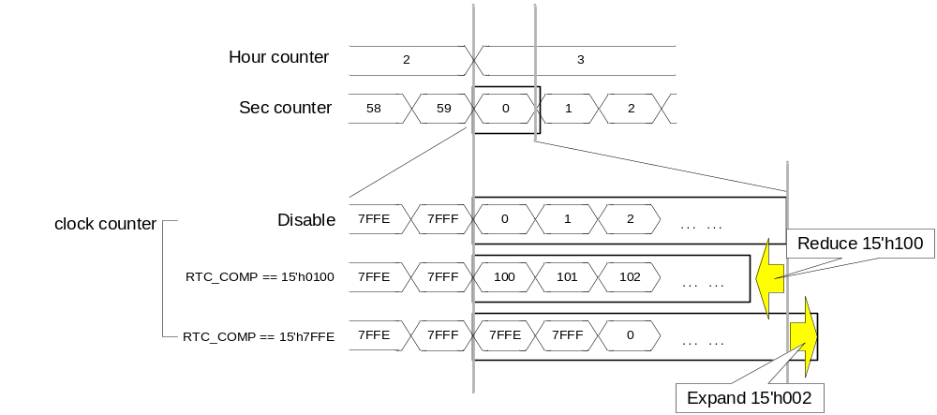
Compensation 기능을 enable 하고, RTC_COMP 값을 양수로 setting 할 경우 시간 보정은 줄이는 방향으로 결정 됩니다. 음수로 setting 할 때는 반대로 Clock counter 값이 증가 되는 효과를 볼 수 있습니다.

Signal Description

InOutput Signal

Table 1-3 Component video output core Signal
Signal Name | Direction | Description | Init. value
PCLK | Input | APB bus clock
PRESETn | Input | APB bus reset
PENABLE | Input | APB interface signal
PSEL , | Input | APB interface signal
PWRITE , | Input | APB interface signal
PADDR , | Input | APB interface signal
PWDATA | Input | APB interface signal
PRDATA | Input | APB interface signal
INT_TIMER | Output | Interrupt signal sync with APB clock
INT_ALARM | Output | Interrupt signal sync with APB clock
IntTimer_32K | Output | Interrupt signal sync with CLK clock
IntAlarm_32K | Output | Interrupt signal sync with CLK clock
CLK | Input | Timer clock

Register Description

Registers

Table 3-4 Registers(Base Address : XXXX 0000h)
Offset | Name | R/W | Description | Init. value
0000h | RTC_CTRL | RW | RTC control register | 0000 0000h
0004h | RTC_STATUS | RW | RTC status register
0008h | RTC_INT | RW | RTC interrupt register
000Ch | RTC_COMP | RW | RTC compensation
0020h | SECS | RW | Seconds setting register
0024h | MINUTES | RW | Minutes setting register
0028h | HOURS | RW | Hours setting register
002Ch | DAYS | RW | Days setting register
0030h | MONTHS | RW | Months setting register
0034h | YEARS | RW | Years setting register
0038h | WEEK | RW | Week setting register
0040h | ALSET_SECS | RW | Alarm seconds
0044h | ALSET_MINUTES | RW | Alarm minutes
0048h | ALSET_HOURS | RW | Alarm hours
004Ch | ALSET_DAYS | RW | Alarm days
0050h | ALSET_MONTHS | RW | Alarm months
0054h | ALSET_YEARS | RW | Alarm years

RTC control Register

Figure 3-8 RTC_CTRL Register Bits
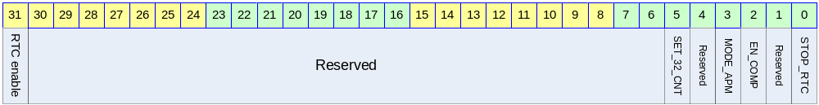
Table 3-5 RTC_CTRL Register Description (Offset : 0000 0000h)
Bits | Name | R/W | Description | Init. value
[0] | STOP_RTC | RW | 0 :: RTC is stop  1 :: RTC is running | 0b
[1] | Reserved
[2] | EN_COMP | RW | 0 :: compensation disabled  1 :: compensation enabled | 0b
[3] | MODE_APM | RW | 0 :: 24 hour mode  1 :: PM/AM mode (12 hour mode) | 0b
[4] | Reserved
[5] | SET_32_CNT | RW | 0 :: normal option  1 :: set the RTC counter with compensation register  * note :: SET_32_CNT is only set in STOP_RTC mode.  STOP_RTC(1’b0) → SET_32_CNT(1’b1)  → STOP_RTC(1’b1) → SET_32_CNT(1’b0) | 0b
[6:30] | Reserved
[31] | RTC enable | RW | RTC enable bit | 0b

RTC status Register

Figure 3-9 RTC_STATUS Register Bits
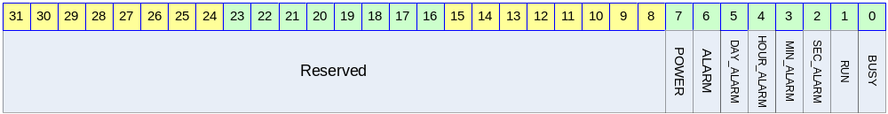
Table 3-6 RTC_STATUS Register Description (Offset : 0000 0004h)
Bits | Name | R/W | Description | Init. value
[0] | BUSY | R | 0 :: RTC normal status  1 :: RTC is busy | 0b
[1] | RUN | R | RUN running status | 0b
[2] | SEC_ALARM | R | One second periodic alarm | 0b
[3] | MIN_ALARM | R | One minute periodic alarm | 0b
[4] | HOUR_ALARM | R | One hour periodic alarm | 0b
[5] | DAY_ALARM | R | One day periodic alarm | 0b
[6] | ALARM | RW | Alarm from setting value | 0b
[7] | CLEAR | RW | Reset indication  - after reset, setting “HIGH”  - write “HIGH”(POWER), reset RTC | 1b
[8:31] | Reserved

RTC interrupt Register

Figure 3-10 RTC_INT Register Bits
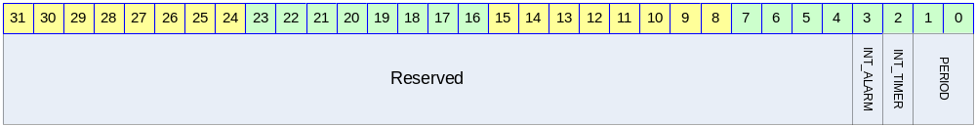
Table 3-7 RTC_INT Register Description (Offset : 0000 0008h)
Bits | Name | R/W | Description | Init. value
[0:1] | PERIOD | RW | 0 : every seconds  1 : every minutes  2 : every hour  3 : every day | 00b
[2] | EN_INT_TIMER | RW | Enable periodic interrupt | 0b
[3] | EN_INT_ALARM | RW | Enable setting value interrupt | 0b
[4:31] | Reserved

RTC compensation Register

Figure 3-11 RTC_COMP Register Bits
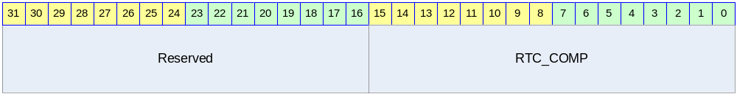
Table 3-8 RTC_COMP Register Description (Offset : 0000 000Ch)
Bits | Name | R/W | Description | Init. value
[0:15] | RTC_COMP | RW | The Counter is generated by 32Khz OSC, which is added RTC_COMP every hour. | 18’h0
[16:31] | Reserved

RTC Seconds setting Register

Figure 3-12 SECS Register Bits
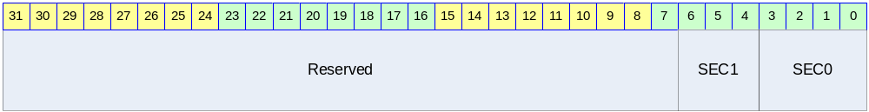
Table 3-9 SECS Register Description (Offset : 0000 0020h)
Bits | Name | R/W | Description | Init. value
[0:3] | SEC0 | RW | The first digit of seconds(0~9) | 0000b
[4:6] | SEC1 | RW | The second digit of seconds(0~5) | 000b
[7:31] | Reserved

RTC Minutes setting Register

Figure 3-13 MINUTES Register Bits
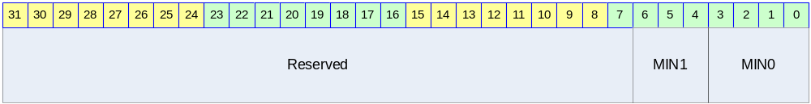
Table 3-10 MINUTES Register Description (Offset : 0000 0024h)
Bits | Name | R/W | Description | Init. value
[0:3] | MIN0 | RW | The first digit of minutes(0~9) | 0000b
[4:6] | MIN1 | RW | The second digit of minutes(0~5) | 000b
[7:31] | Reserved

RTC Hours setting Register

Figure 3-14 HOURS Register Bits
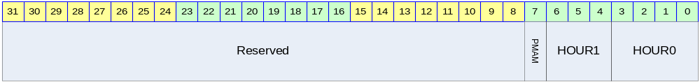
Table 3-11 HOURS Register Description (Offset : 0000 0028h)
Bits | Name | R/W | Description | Init. value
[0:3] | HOUR0 | RW | The first digit of hour(0~9) | 0000b
[4:6] | HOUR1 | RW | The second digit of hour(0~2) | 000b
[7] | PMAM | RW | 0 :: AM  1 :: PM
[8:31] | Reserved

RTC Days setting Register

Figure 3-15 DAYS Register Bits
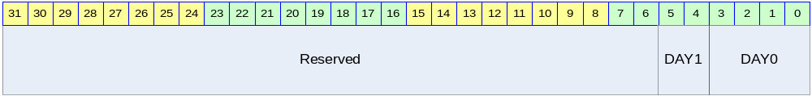
Table 3-12 DAYS Register Description (Offset : 0000 002Ch)
Bits | Name | R/W | Description | Init. value
[0:3] | DAY0 | RW | The first digit of days(0~9) | 0000b
[4:5] | DAY1 | RW | The second digit of days(0~3) | 00b
[6:31] | Reserved

RTC Months setting Register

Figure 3-16 MONTHS Register Bits
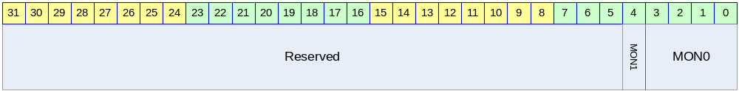
Table 3-13 MONTHS Register Description (Offset : 0000 0030h)
Bits | Name | R/W | Description | Init. value
[0:3] | MON0 | RW | The first digit of months(0~9) | 0000b
[4] | MON1 | RW | The second digit of months(0~1) | 0b
[5:31] | Reserved

RTC Years setting Register

Figure 3-17 YEARS Register Bits
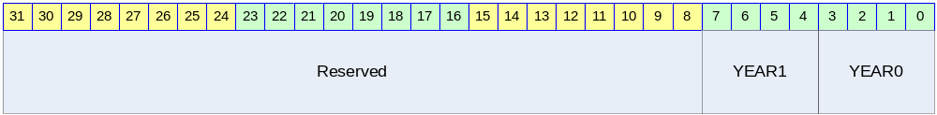
Table 3-14 YEARS Register Description (Offset : 0000 0034h)
Bits | Name | R/W | Description | Init. value
[0:3] | YEAR0 | RW | The first digit of years(0~9) | 0000b
[4:7] | YEAR1 | RW | The second digit of years(0~9) | 0000b
[8:31] | Reserved

RTC Week setting Register

Figure 3-18 WEEK Register Bits
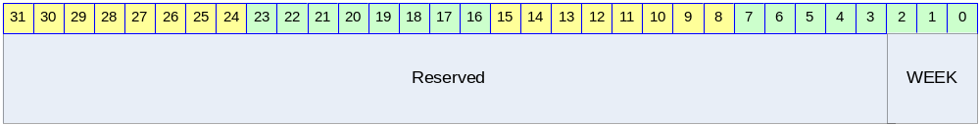
Table 3-15 WEEK Register Description (Offset : 0000 0038h)
Bits | Name | R/W | Description | Init. value
[0:2] | WEEK | RW | The first digit of years(0~6) | 000b
[3:31] | Reserved

RTC Alarm Seconds setting Register

Figure 3-19 ALSET_SECS Register Bits
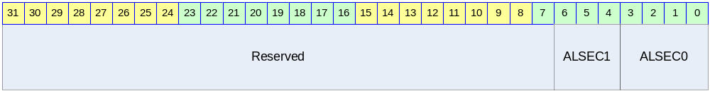
Table 3-16 ALSET_SECS Register Description (Offset : 0000 0040h)
Bits | Name | R/W | Description | Init. value
[0:3] | ALSEC0 | RW | The first digit of seconds(0~9) | 0000b
[4:6] | ALSEC1 | RW | The second digit of seconds(0~5) | 000b
[7:31] | Reserved

RTC Alarm Minutes setting Register

Figure 3-20 ALSET_MINUTES Register Bits
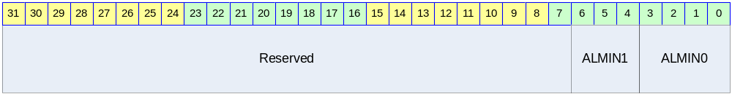
Table 3-17 ALSET_MINUTES Register Description (Offset : 0000 0044h)
Bits | Name | R/W | Description | Init. value
[0:3] | ALMIN0 | RW | The first digit of minutes(0~9) | 0000b
[4:6] | ALMIN1 | RW | The second digit of minutes(0~5) | 000b
[7:31] | Reserved

RTC Alarm Hours setting Register

Figure 3-21 ALSET_HOURS Register Bits
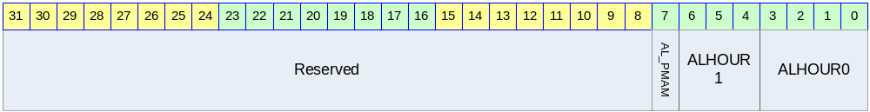
Table 3-18 ALSET_MINUTES Register Description (Offset : 0000 0048h)
Bits | Name | R/W | Description | Init. value
[0:3] | ALHOUR0 | RW | The first digit of hour(0~9) | 0000b
[4:6] | ALHOUR1 | RW | The second digit of hour(0~2) | 000b
[7] | AL_PMAM | RW | 0 :: AM  1 :: PM | 0b
[8:31] | Reserved

RTC Alarm Days setting Register

Figure 3-22 ALSET_DAYS Register Bits
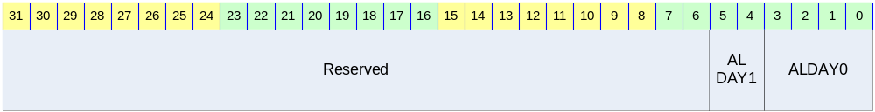
Table 3-19 ALSET_DAYS Register Description (Offset : 0000 004Ch)
Bits | Name | R/W | Description | Init. value
[0:3] | ALDAY0 | RW | The first digit of days(0~9) | 0000b
[4:5] | ALDAY1 | RW | The second digit of days(0~3) | 000b
[6:31] | Reserved

RTC Alarm Months setting Register

Figure 3-23 ALSET_MONTHS Register Bits
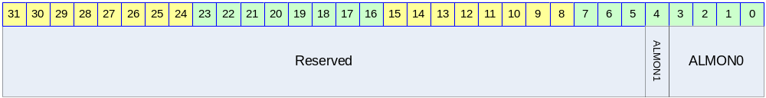
Table 3-20 ALSET_MONTHS Register Description (Offset : 0000 0050h)
Bits | Name | R/W | Description | Init. value
[0:3] | ALMON0 | RW | The first digit of months(0~9) | 0000b
[4] | ALMON1 | RW | The second digit of months(0~1) | 0b
[5:31] | Reserved

RTC Alarm Years setting Register

Figure 3-24 ALSET_YEARS Register Bits
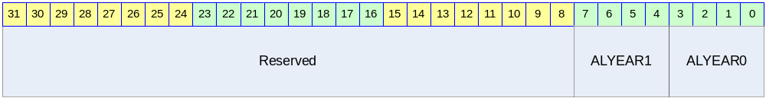
Table 3-21 ALSET_YEARS Register Description (Offset : 0000 0054h)
Bits | Name | R/W | Description | Init. value
[0:3] | ALYEAR0 | RW | The first digit of years(0~9) | 0000b
[4:7] | ALsYEAR1 | RW | The second digit of years(0~9) | 0000b
[8:31] | Reserved

