
UBUNTU 10.04
User Guide

Table of Contents

I. How to Use this Manual 2

II. Getting Started 3

III. A Brief Overview of the Desktop 5

IV. Connecting to the Internet 7

V. Browsing the Web 12

VI. Email 14

VII. Audio & Video 15

VIII. Managing Updates 16

IX. Installing New Software 16

X. Getting Help 17

For information regarding your warranty please visit: http://freegeek.org/warranty

This document is licensed under:
Creative Commons Attribution-NonCommercial-ShareAlike 3.0

The most current version of this document can be found online at: http://freegeek.org/manual

I. How to Use this Manual

Welcome to your new Free Geek system. Your computer uses Ubuntu version 10.04. Ubuntu is a free operating system written by volunteers and paid professionals all over the world. It's open source, meaning the way the operating system works is not hidden from a person who is interested and able to look more deeply into it.

This guide is intended for those who've adopted or bought a computer from Free Geek, and who fall into one of the following three categories:

1. People who have never used computers before. These folks will want to read everything in this manual, and make use of the Internet and Free Geek Tech Support when they get stuck.

2. People who have used computers but are used to Windows. This manual will teach these users to do the things they already know how to do, but in a way that is a little different because they're using a different operating system.

3. People who are pretty good with computers and just need a quick start. These users probably just need the username: Default User, and the password: "freegeek" (without the quotes).

And now, on to the fun stuff...we hope you love your new computer!

II. Getting Started
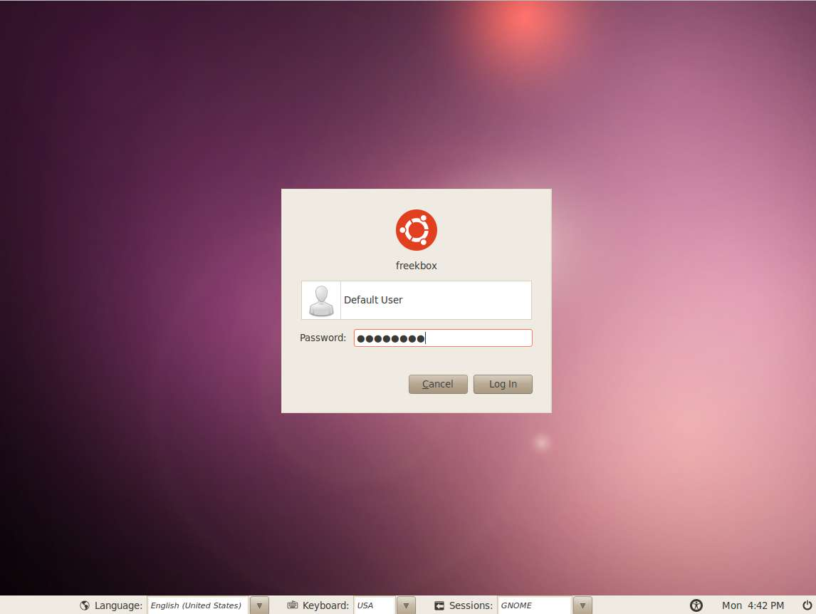
The first time you turn on your Free Geek computer, it will boot to to a login screen. The username for this account is Default User and the password is "freegeek" (without quotes). Every computer that Free Geek builds has Default User account installed so we can test its hardware and software. If you can't log in, make sure that the password, "freegeek", is also all lower-case letters. The password is all one word. There is no space between "free" and "geek".

When you type letters into the password field they won't appear as letters, they'll appear as dots. The computer does this so that someone looking over your shoulder can't see you typing your password.

While the Default User account could serve your needs, it's not very secure, as hundreds of people use the same password. One of your first jobs will be to create a new account and delete the Default User account. Fortunately, there's a simple way of doing that, but be warned that this will destroy all files you have created or downloaded to the computer so far.

To create a new, primary user, log in to the Default User account, then go to System>Administration>Prepare for shipping to end user. Then restart your computer. As it boots up, it will prompt you to create a new account. Be aware that usernames should not have any capital letters or spaces, and that some users like "admin," "root," and "oem" are already used by the operating system, and should not be chosen.

The Administrator (You) and Users on Ubuntu
If you wish to have more than one user account on your machine, you can do so using the users and groups application (System>Administration>Users and Groups). Please note that you'll need to click Unlock and enter your password to make changes once you've opened the users and groups application.

You may have had a computer before that had multiple users. When you create a user on a computer you are doing a few things. You're creating some folders on the computer that only specific users can access with their password. Users can save their preferences, too. They can make permanent changes to the way everything looks and behaves and it won't affect the preferences of the other users. But there are things that some users can't do, only the root user or administrator can do them. The administrator can do anything, look at anything, change anything. By default the first user you create (that's you!) is the administrator. On a Windows computer, it's easier for anyone to do anything, for example install software. Consequently, it's easier for mistakes to happen on that kind of computer. On this computer, you won't be able to do certain things, for example install software, unless you are the administrator and you enter your password. This makes it harder to mess things up.

What if There's a Problem?
If you can't get the username and password to work, try calling Free Geek Tech Support during their open hours. It's possible something went wrong when we put it together and that it's not your fault. Don't give up hope, there's a way to make it work! Go to section X. Getting Help in this manual for Free Geek Tech Support contact information.

III. A Brief Overview of the Desktop
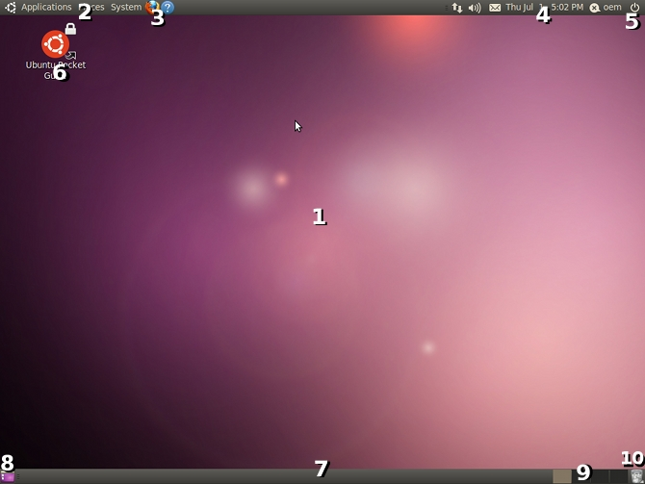
Once logged in, you'll be presented with the Gnome Desktop Environment. A desktop environment is a collection of programs that help you operate your computer on a day-to-day basis. This section of the user guide will briefly explain each part of the environment.

1. Desktop Wallpaper: A background image which you can choose. To set a new wallpaper, right-click on the desktop and choose "Change Desktop Background"
2. Menu Bar: Contains menus for Applications, Places, and System
- Applications - A categorized list of all the programs currently installed and available for use on your system.
- Places - A list of commonly-used places on your computer, like your home folder or desktop folder. This is where documents and other files can be stored. Selecting any of the items in this menu will open a file browser.
- System — The System menu contains the user preferences, administration, and help menus.
3. Launch Icons: Gnome allows you to create shortcuts to any frequently-used application and place them on the Panel/Task Bar. Simply click-and-drag the icon of your chosen application from the Applications Menu to the Panel.
4. The Notification Area: This area contains icons from various applications to indicate activity in those applications. Pictured above:
- Network manager (the up/down arrows or radio icon) - An applet/widget designed to help simplify connecting to the Internet
- Volume Manager - Quick access to your speaker volume, as well as some more advanced audio options
(Note: this area may include Battery and Blue-tooth notifications for laptops as well as other running applications.)
5. Exit Menu: Used to log out, restart, power off, or otherwise exit the system.
6. Desktop Icons: Shortcuts to commonly used programs. Icons representing files can be placed on your desktop for quick access.
7. Task Bar: Contains a list of any currently running applications, and allows you to switch between them by clicking on your chosen running application.
- Show Desktop Button: Use this button to hide all currently open windows and show only your desktop.
9. Virtual Desktops: A configurable set of 4 virtual desktops, each of which can contain a separate set of running application windows.
10. Trash Can: When you want to throw a file away, you can drag and drop its icon onto the trash can icon. Files will stay in your trash can until you empty it. To do this, click on the trash can icon at the bottom-right of your desktop, then click Empty Trash on the window that appears.

The Ubuntu Menu System
Windows users are probably used to the Start button. The Start button is like everything in the Applications Menu, the Places Menu and the System Menu all jammed into one menu. Pretty much everything that you're used to in Windows has an equivalent here, you just have to find out where it is or what it's called.

Take a look around. Make yourself at home. You'll discover lots of useful menus by right-clicking on icons. Try dragging applications from the Applications Menu to the Desktop or top Menu Bar. If you're not sure about something, though, don't change it, especially if it requires your password. Remember, if it ain't broke, don't fix it!

What if There's a Problem?
One of the most common problems new users have is simply not being able to find something, or not knowing what it's called on their new system. Some of these questions may be answered later in this manual.

IV. Connecting to the Internet

The Internet is a pretty nebulous thing - it's a world wide network of interconnected computers which share information. Most people who adopt or buy computers from Free Geek want access to the Internet so they can check their email, browse the Web, listen to music, or watch movies.

Ways to Connect to the Internet
There are 4 ways to connect to the Internet: Dialup, Wired Broadband, Wireless Broadband, and Mobile Broadband.

Dialup
This is Internet that is delivered through a phone line. Compared to other methods of connecting to the Internet, dialup is very slow, but if all you want to do is check your email, and you can only afford to spend a small amount of money each month, it may be all you need. A dialup connection is generally used for only one computer.

If you wish to connect to the Internet using dialup, you should contact Free Geek Tech Support for more information (go to the last section of this manual for contact info). You will likely need to bring your system in to Free Geek, as using dialup requires additional hardware and software to be installed on your computer. Additionally, Free Geek has a relationship with a Portland company called Whiz To Coho (http://whiz.to) that allows your tech support for connection issues to be handled through Free Geek.

Wired Broadband
Broadband is a lot faster than dialup. This is what you need if you want to play games online, download or stream music and movies, and move around the Internet quickly. It is more expensive than dialup. Your Free Geek computer already has all the hardware it needs for broadband Internet. Wired broadband is one of the most stable and secure ways to connect to the Internet.

Wired broadband will almost never be free to you. To receive this type of connection, you'll most likely need to pay for broadband Internet and transmit your Internet connection through ethernet cables by way of a modem and possibly router. See the section entitled "Creating a Home Network" below for instructions on how to do that.

Ready, Set...Connect
Once you've set up your wired home network, you should be able to plug an ethernet cable directly into your computer's ethernet port from either a modem or a router and be automatically connected to the Internet. If your system doesn't automatically connect, please check your connections and ensure that the modem and router are on. If you still can't connect, please contact Free Geek Technical Support.

Wireless Broadband
This type of broadband has all the benefits of wired broadband: faster speed and performance. The difference is that, instead of sending the signal over wires, wireless broadband sends the signal through the air, at a certain frequency that can be picked up by your computer.

Free Wireless Broadband Internet
Since this type of signal travels wirelessly, you can often pick it up for free. You may be able to share a wireless connection with a neighbor, and if you have a laptop, you'll likely be able to go to a local coffee shop to connect to the Internet. In both cases, you may need to know a passphrase or password in order to gain access to the wireless network. It can be hard to access a consistent, strong wireless connection this way.

Wireless Adapters
Most people use wireless broadband by paying for the broadband connection and then purchasing hardware to transmit their Internet connection wirelessly. The "transmitter" is a wireless router. The "receiver" is a wireless adapter, or wireless card. Whether or not you pay for your wireless broadband connection, you'll need a wireless adapter.

What the wireless adapter on your computer looks like depends on whether you've got a desktop computer or a laptop computer. A desktop will usually take a card that is installed internally (a PCI wireless adapter). If you bought a wireless card from Free Geek's Thrift Store, and you have a Free Geek computer, our Tech Support department would be happy to install it at no cost to you.

A laptop uses either an internal card or one that plugs into the side. Alternatively, both laptops and desktops can use wireless adapters that plug into a USB port. These are handy because they're easy to use with more than one computer.

Will My Wireless Adapter Work with Ubuntu?
Some wireless adapters work with Ubuntu and others don't. Tested wireless adapters from Free Geek's Thrift Store will work with Ubuntu. Some tested wireless adapters require software to work. You can usually get this software by connecting to the Internet with an ethernet cable and then going to System>Hardware Drivers and selecting the circle next to the driver to enable it. If you do not see this option, or you still have issues, please contact Free Geek Technical Support. Once the software is installed, you will not usually need to do anything else to make it work.

Ready, Set...Connect
Once you have a wireless adapter and have found a place to connect to the Internet wirelessly, you'll need to tell your computer to connect to the wireless signal. Ubuntu includes an applet called the Network Manager to help with this. The Network Manager Applet is an icon that changes depending on whether you're connected to the Internet and whether you're connected wirelessly or with a wire. In the picture below, the Network Manager Applet is the cone-shaped icon in the upper left corner.
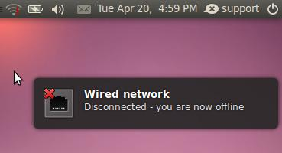
The Network Manager will display a "!" on top of its icon if it's disconnected from any network.
To connect to a wireless network, click on the Network Manager Applet and click on your chosen wireless network.

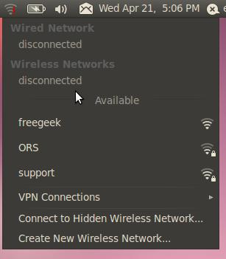
Pictured to the left is a list of available wireless networks. A lock icon means the network requires a password or passphrase. Password-protected networks require you to enter the password or passphrase manually.

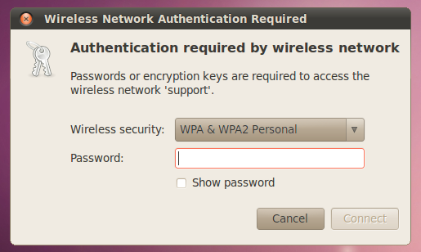
If you select a network with a lock icon, you'll be presented with a window that resembles the one pictured to the left. Enter the required password in the appropriate text box. If you click on the Show Password box near the bottom of the window, you'll see the password you are typing instead of generic dots, so you can be sure you're entering the correct characters.

Once you're connected to a wireless network, the Network Manager Applet will indicate wireless signal strength.

Mobile Broadband (WiMax/3G/4G and Others)
Mobile broadband is a reasonably fast Internet connection that works by using a cell phone network. Its cost and speed are between dial-up and traditional broadband. Most mobile broadband devices should be recognized automatically when you connect them to your computer. Ubuntu will prompt you to configure the device.
The New Mobile Broadband Connection Wizard will open automatically when you connect the device. Here's what to enter:

- Click Forward and insert your details, including the country where you bought your device (probably the United States), your network provider's name (Sprint, Verizon, Cricket, etc.), and type of connection (Contract or Pre-pay).
- Give your connection a name (it's up to you what name you choose) and click Apply.
- Your connection is now ready to use. To connect, click the Network Manager Applet in the top right of your screen and select your new connection.
- To disconnect, click the Network Manager Applet in the top right of the screen and click Disconnect.

If you are not prompted to configure the device when you connect it, you may still be able to add the connection manually.

- Right-click the Network Manager Applet in the system notification area and click Edit Connections.
- Select the Mobile Broadband tab.
- Click Add.
- This will open the New Mobile Broadband Connection Wizard. From here, you can start from the first item in the list above: "Click Forward and insert your details...".

If you're still having problems after you've tried the steps above, please contact Free Geek Tech Support.

Creating a Home Broadband Network
You've taken the plunge and paid for broadband Internet. You'll need a cable or DSL modem to receive the signal from your Internet provider and, if you want to share your broadband connection with more than one computer, you'll need a router.

Setting Up a Modem and Router for a Wired Home Network
This is how the hardware is generally set up for sharing wired broadband Internet at home:
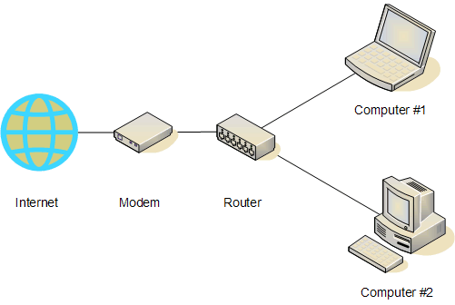

The physical wire that connects the wall to the modem depends on what type of Internet connection you bought. You may have a coaxial cable (a thick cable with a round end and a pin sticking out of it, like what you'd use if you paid for cable TV), or a DSL cable (which is like a phone cable, and connects to your phone jack). If you're trying to buy a modem from Free Geek, the type of modem you need depends on whether you will use a coaxial cable or a DSL line. Your best bet is to get a modem from your provider as they only provide phone support for certain models.

The modem's job is to turn whatever signal you're getting from your Internet provider into one that your computer can understand and respond to. From there on, everything is connected together with ethernet cable: the modem to the router, the router to the computers, etc. You can get cheap ethernet cables from the Free Geek Thrift Store.

What if There Are Problems?
Usually this kind of setup is plug-and-play, in other words: you plug everything in, turn everything on and it should work. Please wait a minute or so after hooking everything up for it work. If all the pieces are connected correctly, but you still can't connect to the Internet, try unplugging your router from the wall for 10 seconds, and then plugging it back in. If you are still experiencing issues, please contact Technical Support.

Setting Up a Modem and Router for a Wireless Home Network
Setting up a wireless network can be a little tricky. Because all wireless routers are a bit different, we can't give precise instructions. What follows is a general overview explaining how to set up a wireless network.

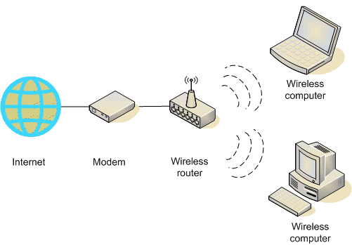
The connection going from the wall (in the picture above, "Internet") to your router are the same as if you were using a wired connection. You connect an ethernet cable from your cable or DSL modem to your wireless router. The wireless router is a special kind of router that sends radio signals to computers that have wireless adapters that can receive and translate the signal. Most wireless routers look like little boxes with one or two antennae on them. One nice thing about wireless routers is that they usually also have extra ethernet ports to allow you to connect with a wire. You can also configure your wireless router through these ports. This is a nice option if you get frustrated with setting up the wireless network, and need to get on the Internet for some answers.

Configuring a Wireless Router
Configuring a wireless router is slightly different for each model. For this reason, your best bet is to read the manufacturer's instruction manual for your router. If you do not have this manual, you can usually find it by going to www.google.com, and searching for your router's make and model number (usually on a sticker on the bottom or the device) and the word "configure." For example, "configure linksys wrt54g." The instructions from manufacturers are written for beginners, so they should help most users configure their routers.

V. Browsing the Web
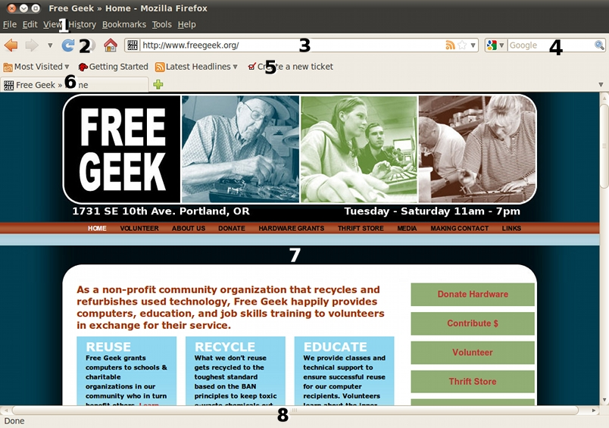
1. Firefox Menu Bar: A place to print web pages and adjust Firefox's settings. Click on Edit>Preferences to change your home page, edit online password preferences, edit popup preferences, and more.
2. Navigation: go Back, go Forward, Refresh the page, Stop loading, take me to my Homepage
3. Address Bar: If you want to visit a specific website, such as www.freegeek.org, you would enter it here.
4. Search: For searching the web. Type the terms you'd like to use in your search, and then press Enter.
5. Bookmark Toolbar: A place to keep frequently visited sites. To add a bookmark to the toolbar, simply visit your chosen site, then drag the site's tab to the toolbar. To edit this toolbar, go to Bookmarks>Organize Bookmarks.
6. Tabs: Tabs can be used to browse multiple web pages at the same time. To open a new tab, click on the plus sign to the right of your right-most open tab, or press Ctrl and T on your keyboard.
7. Page Content: The contents (text, images and other media) of the web site you are visiting will be displayed here.
8. Status Bar: Shows what Firefox is currently doing. For example, you might see messages such as "waiting for...", "connecting to...", "stopped", or "done".

Being Safe Online
One common question new users ask is «what about virus protection»? Currently viruses and spyware are limited to Microsoft's Windows operating system. This is partly because Ubuntu is designed to be less vulnerable to these types of attacks. While there are no viruses that work on Ubuntu, You should still be aware of a few basic steps to take while browsing the web to ensure your personal information stays safe and your computer remains secure.

- It is best to visit websites directly rather then clicking on a link from an email or other webpage. For example, if you receive an email from Myspace.com asking you to log in by clicking on a link, type "Myspace.com" into your web browser instead of clicking on the link.
- NEVER submit serious personal information such as tax or bank account information to a web page that does not start with "https://".
- Never open email attachments from people or organizations you do not know (no matter how tempting).
- On occasion, you may receive emails or Facebook messages offering free ipods/ipads/laptops/etc in exchange for your time filling out surveys. These offers are scams. Do not click on these links.
- Update your software regularly (see section VIII. Managing Updates for information on how to do this).
- Occasionally, a website will present you with a popup window that insists that you have a virus on your computer. Remember, though, that there are no viruses for Ubuntu! These are scams that will attempt to obtain your personal information if you click on them. Exit out of these windows.

Improving Readability
To make text larger while using your web browser, press Ctrl, then + on your keyboard. To make text smaller, press Ctrl, then -.

Web Media
Some web media (usually music and video) requires the installation of software in order to make it work. Please see section VIII. Installing New Software for more information on getting this software.

VI. Email

Email is now a standard communication tool. The email messages you receive in your inbox actually "live" on a computer that belongs to someone else. If you use a web browser to check email, you are using webmail (e.g., gmail, yahoo), and your email "lives" on the computers belonging to your email provider (e.g., gmail, yahoo). If you use a program on your computer to fetch and organize your email, you are using a mail client. In both cases, you must be connected to the Internet to get new mail.

When surfing the web, you may at some point click on a link to send someone an email. The first time this happens, you should see the window below:
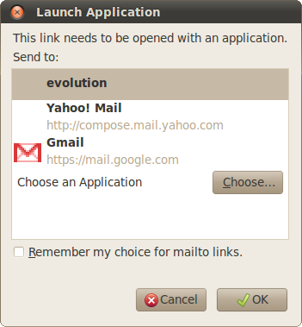
When you click on a link containing an email address in Firefox, you will be asked to select the email service you prefer. Free Geek recommends that you use the email service that you're already comfortable with.

If you're new to email, we recommend Yahoo or Gmail. If you've used primarily a mail client like Outlook or Thunderbird, and want to connect to your work email account at home, Evolution should work for you. If you've only used email in a work environment, but want a new email account for personal use, we recommend Yahoo or Gmail. Please contact technical support if you require a mail client and are unable to configure it.

For more information on email visit:
Google(gmail) Help: http://mail.google.com/support/
Yahoo!Mail Help: http://help.yahoo.com/l/us/yahoo/mail/
Evolution User Guide: http://library.gnome.org/users/evolution/stable/

VII. Audio & Video

Ubuntu comes with software for playing videos and managing a digital music collection. Unfortunately, many of the most popular media formats, including commercially-available DVDs, require software that isn't possible for Free Geek to distribute. Don't fear, though: there's hope! You can individually install this special software onto your computer. To learn how to do this, go to the section labeled "Ubuntu Restricted Extras" in section IX. Installing New Software in this manual.

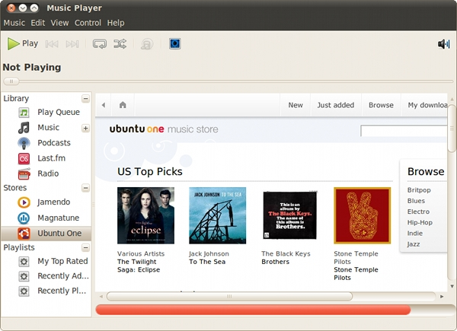
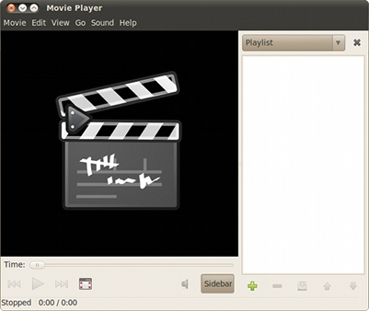

Audio
You can use Rhythmbox (Applications>Sound & Video>Rhythmbox Music Player) and Totem Movie Player (Applications>Sound & Video>Movie Player) to listen to music on your computer. Audio files will be opened in Totem Movie Player when double-clicked, but Rhythmbox is better at handling large music collections. Rhythmbox is also able to play audio CDs and connect to many MP3 players. It should open automatically when you insert a CD. See the Rhythmbox manual for more information. The Rythmbox manual can be accessed by opening Rythmbox, then clicking Help>Contents.

Video
You can watch movies, DVDs, and video clips with the Totem Movie Player (Applications>Sound & Video>Movie Player).

A Note About Speakers
If you can't hear any sound, check that your speakers are:

- Plugged into the green port on the back of your computer (or the headphone jack if you have a laptop),
- Plugged into the wall, and
- Turned on with the volume up.

VIII. Managing Updates
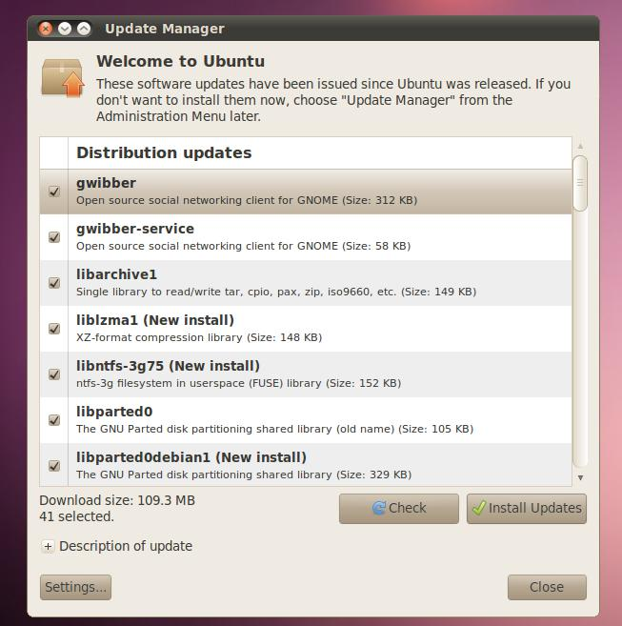
When important updates are available for your system, an Update Manager window will pop up on your desktop. This is a good thing! Installing these updates eliminates security flaws and keeps applications installed on your system current.

IX. Installing New Software
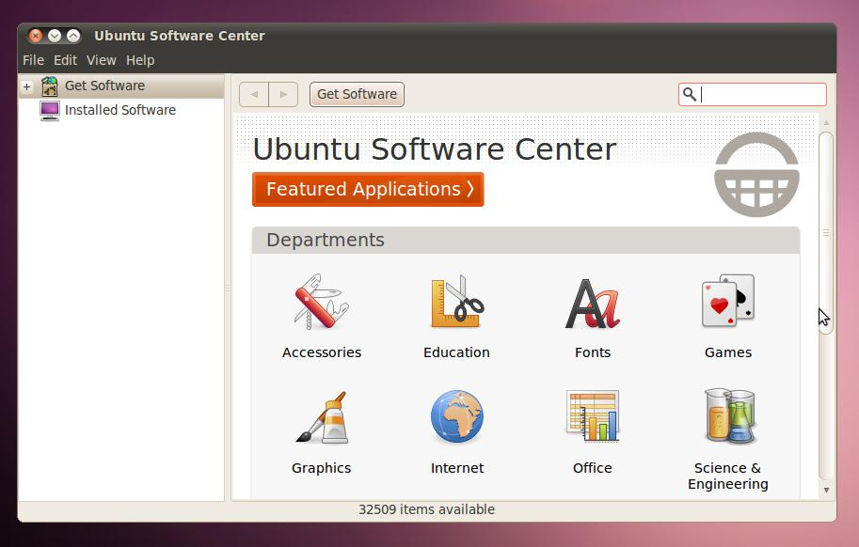
Ubuntu includes the Ubuntu Software Center to make installation and removal of software easier. You can browse the categories to discover new applications, or use the search feature. Remember that you need to have a working Internet connection to download software.

Ubuntu Restricted Extras
Just like Windows and Mac computers, some media formats won't automatically play on your Free Geek computer. Thankfully, Ubuntu has created an easy way of installing the software necessary to enable playback of flash videos, MP3s, and many more commonly-used media formats. To install this software, follow these steps:

- First you must tell Ubuntu Software Center to download software with restricted licenses (please refer to the individual licenses for greater detail). Go to Applications>Ubuntu Software Center.
- After the Ubuntu Software Center window opens, select Edit>Software Sources.
- Enter your password.
- Check the box next to Software Restricted by Legal or Copyright Issues (multiverse), then click on the Close button in the bottom right corner of the window.
- Type "restricted" (without the quotes) into the white search box in the upper right corner of the Ubuntu Software Center window.
- Click on Ubuntu Restricted Extras, then click on the Install button.

X. Getting Help
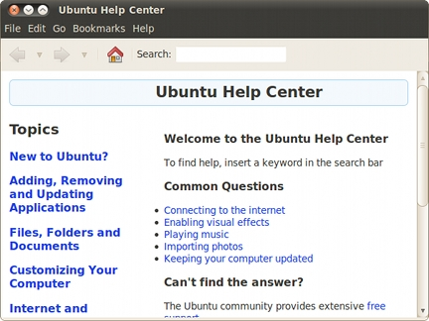

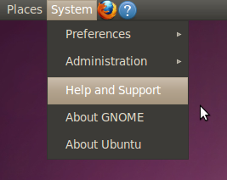
The Ubuntu community has created many resources to help both new and experienced users learn more. Use the built-in help features by clicking on the blue ? icon or going to System>Help and Support.

Official Ubuntu Documentation
Ubuntu provides and maintains an up-to-date set of how-tos and manuals. They can be found by going to help.ubuntu.com and clicking on the link Ubuntu 10.04 LTS.

Taking Classes at Free Geek
Free Geek offers a range of classes for beginners and intermediate users alike. The classes are free for active volunteers and $10 for everyone else. If you learn well in a classroom environment and are interested in taking a class at Free Geek, please call 503-232-9350.

Contacting Technical Support
Free Geek offers technical support services for users of our products. The purpose of technical support is to repair or replace hardware that breaks and provide basic end-user support of Ubuntu and the included applications.

Free Geek Technical Support
12 to 6 pm, Tuesday through Saturday
Telephone: 503-232-9350.
support@freegeek.org.

In order the get the best help from our technicians, be sure to write down what is not working (for example, "I can't get to Facebook" or "I can't log in"). If an error message appears and you do not understand its meaning, you can take a screenshot of it to ensure that tech support has specific information about your issue. You can take a screenshot by going to Applications>Accessories>Take Screenshot.

Finally, if your computer freezes (whether or not you can still move the mouse pointer) please note the time this occurs. Please use the system time in the upper right corner (instead of your phone or watch). This allows our technicians to use very detailed logs to determine the source of the problem.

About this Manual
This manual was written and edited by:

Ian Young
Luiz Sudbrack
Shawn Furst
Joe Sapienza
Evie Strohmeyer

While blood, sweat, and tears were shed in the creation of this manual, we want it to be as useful as possible to Free Geek adopters, volunteers, and Thrift Store customers. For this reason, we welcome any and all comments, opinions, or suggestions you may have regarding this manual. If you'd like to tell us your thoughts, please send an email to manual@freegeek.org.

