
Xubuntu 12.04
User Guide

Table of Contents

I. How to Use this manual __________________________________________________ 2
II. Getting Started _________________________________________________________ 3
III. A Brief Overview of the Desktop ___________________________________________ 5
IV. Connecting to the Internet ________________________________________________ 7
V. Browsing the Web_______________________________________________________ 13
VI. Email_________________________________________________________________ 15
VII. Audio & Video ________________________________________________________ 16
VIII. Managing Updates_____________________________________________________ 17
IX. Installing New Software _________________________________________________ 18
X. Getting Help ___________________________________________________________ 19

For information regarding your warranty please visit: http://freegeek.org/thrift-store/system-warranty

This document is licensed under:
Creative Commons Attribution-NonCommercial-ShareAlike 3.0

I. How to Use this Manual

Welcome to your new Free Geek system. Your computer uses a modified version of Ubuntu called Xubuntu version 12.04. Xubuntu is a free Linux operating system written by volunteers and paid professionals all over the world. It is open source, meaning Xubuntu is free, and the code that built and runs it is available for everyone to see and modify.

This guide is intended for those who have adopted or bought a computer from Free Geek, who fall into one of the following three categories:

1. People who have never used computers before. These individuals will want to read everything in this manual, make use of troubleshooting on the Internet (ex. searching your problem on Google), and contact Free Geek Tech Support if they get stuck.

2. People who have used computers and are familiar with Windows, but not Linux. This manual will teach these users how to do what they already know how to do in Windows, but in Xubuntu.
3. People who are already moderately skilled with computers, but need a quick start guide for Xubuntu.

One piece of information that is often requested is the default Xubuntu login credentials, which are as follows:
username: Default User
password: freegeek
*password is one word, all lowercase*

And now, on to the fun stuff. We hope you love your new computer!

II. Getting Started

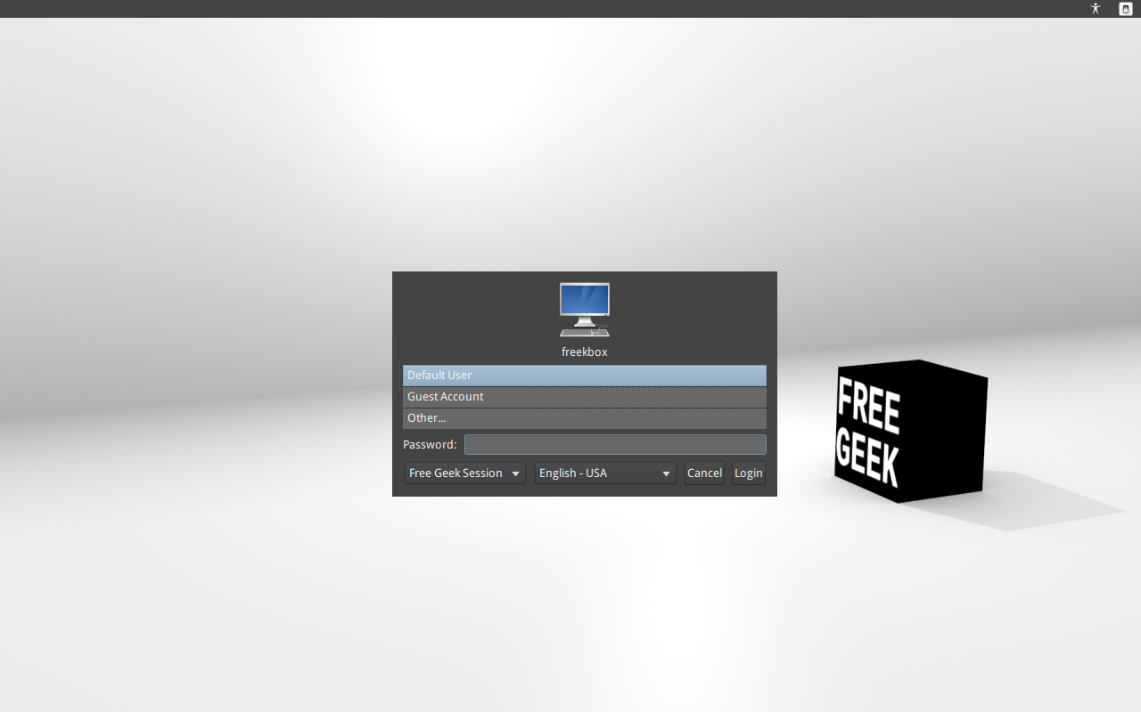

The first time you turn on your Free Geek computer, it will boot to to a login screen. The username for this account is Default User and the password is freegeek. Every computer that Free Geek builds has the Default User account installed, so we can test its hardware and software. If you can't log in, make sure that the password, freegeek, is in all lower-case letters, with no spaces.

When you type characters into the password field they'll appear as dots. The computer does this so that someone looking over your shoulder can’t see your password on the screen as you type it.
While the Default User account could serve your needs, it is not very secure, as hundreds of people use this same default password. One of your first jobs will thus be to create a new account and delete the Default User account. Fortunately, there is a simple way of doing this, but be warned, this will destroy all files you have created or downloaded to the computer so far.

To create a new primary user:
1. Log in to the Default User account.
2. Go to Menu>System>Prepare for shipping to end user. When it asks for your Password, type in freegeek.
3. The next dialog box will ask you to verify that you want to do an oem-config-prepare. Click the “OK” button, then “Reboot” your computer.
4. As your computer boots up, Xubuntu will prompt you to select a language (English is the default). Select your language, then click “Continue.”
5. Next you will be asked your location, which will set the timezone on your computer’s clock (Los Angeles PST is the default). After selecting your timezone, click “Continue.”
6. You will now be asked to choose your Keyboard layout. The default is English (US). Select your keyboard type and click “Continue.”
7. The following dialog box asks you to create a new account. Be aware that your username should not have any capital letters or spaces, and that some users like "admin," "root," and "oem" are already in use by Xubuntu. These usernames should not be chosen. You must now type in your name, your computer’s name (it will create one for you), and your password in the “Choose a password” box. As you type the password in, the system will tell you how strong the password you typed is. Make sure you choose a strong password. Write your password down and save it somewhere safe and secure (not taped to your computer), so if you forget it, you will have a location to look it up in. After typing in your password, click “Continue.”

The Administrator (You) and Users on Xubuntu
If you wish to have more than one user account on your machine, you can do this using the Users and Groups application (Menu>System>Users and Groups). To add a new user, click on “Add “(green plus sign). Enter your current password when it asks you to Authenticate, then click “Authenticate.” You will be asked for the name and the username of the user you wish to create. Enter this information, then click “OK.” A dialog box will now ask you for a “New password” for the user. Enter the password you wish to use for this account in the New Password box and again in the Confirmation box, then click “OK.”

When you create a user on a computer you are doing a few things. For one, you're creating the user’s home folder. Each user has their own home folder and uses it to store their private data and preferences. Each user can make permanent changes in their home folder to the way everything on Xubuntu looks and behaves. This won't affect the preferences of the other users. Still, there are tasks that some users can't do and that only the root user or administrator can do. The administrator can do anything, look at everything, and change everything. By default the first user you create (that's you!) is the administrator.
On this computer you won't be able to do certain things, for example, install software, unless you are the administrator and you enter your password before doing some tasks. This makes it harder to mess up your computer.

What if There's a Problem?
If you can't get the username and password to work, try calling Free Geek Tech Support during their open hours. It is possible something went wrong when we set up your computer and the error isn’t your fault. Don't give up hope; there's a way to make it work! Go to section X. in this manual, Getting Help, for Free Geek Tech Support contact information.

III. A Brief Overview of the Desktop

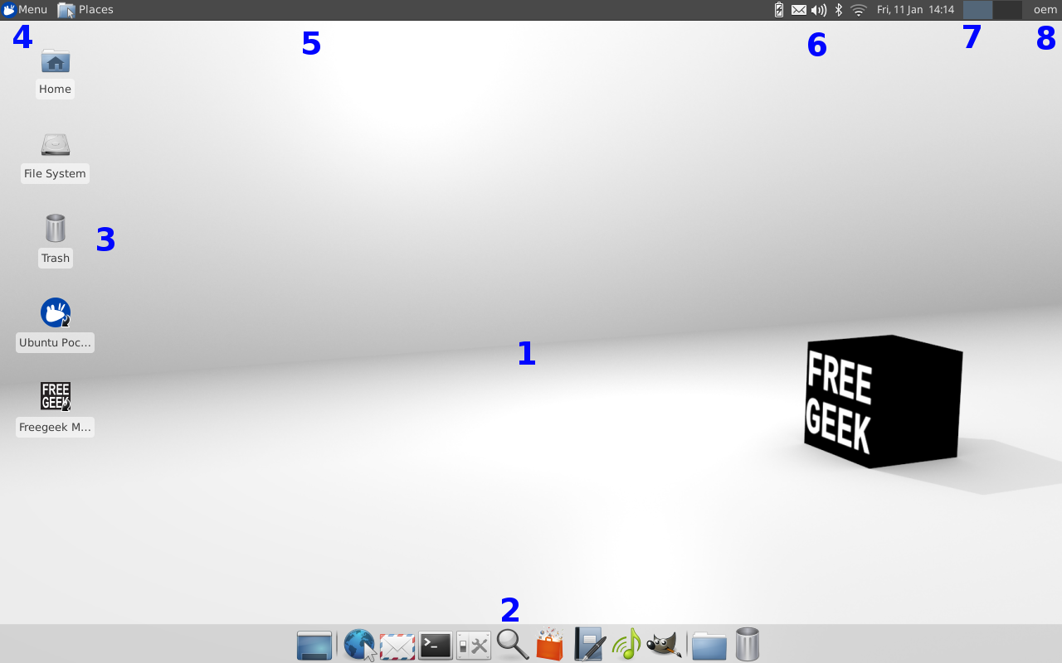

Once logged in, you'll be presented with the Xfce Desktop Environment. A Desktop Environment is a collection of programs that help you operate your computer on a day-to-day basis. This section of the user guide will briefly explain each part of your environment.

The Xubuntu desktop has three things that let you use your computer. A Panel at the top (Panel 1), a hidden panel at the bottom (Panel 2), and a desktop space that is extremely similar to that of Windows or Mac. Here is more detail on the most useful parts of your Xubuntu Desktop:

1. Wallpaper: A background image which you can choose. To set a new wallpaper, right-click on the desktop and choose "Desktop Setting," then select the “Background” tab. Select an image from the displayed backgrounds and click “Close.” You can also right click on an image file anywhere on your system and select “Set as Wallpaper.”
2. Launcher: A list of some commonly run applications. The launcher (Panel 2) only appears when you move your mouse to the bottom of the screen. You can add frequently-used applications to this panel by right clicking on it, selecting “Panel” in the menu that pops up, and clicking on “Add New Items.”
3. Desktop Icons: Shortcuts to commonly used programs. Files and launchers can be placed on your desktop for quick access. The Desktop folder stores all of these files.
4. Menu: A categorized list of all the programs currently installed, and available for use, on your system.
5. Window Buttons: After the Places icon, you will see a row of all opened applications (Panel 1).

6. The Notification Area: This area contains icons for various applications, to indicate activity in those applications. Clicking on the various icons pictured above will give these options:
- Sound – Mute, volume control, Music Player, and sound settings.
- Mail – Instant messenger (Pidgin) and email program (Thunderbird).
- Network manager (the up/down arrow icon or the wifi signal icon) - This is an applet/widget designed to help simplify connecting to the Internet.
- Notification – Any updates that are available to the installed system software.
- Date and Time – Changes the current date.
Note: the notification area may include Battery and Bluetooth notifications (on laptops) and notifications for other running applications.
7. Virtual Desktops: A configurable set of 2 “virtual desktops,” each of which can contain a separate set of running application windows. You can drag an open application, using the top bar of the application, to the right or left side of the screen. This will move that application into the adjacent virtual desktop.
(Note: If you accidently “roll up” an application so that all you can see is the top bar. Simply place your mouse pointer on the bar and roll your mouse wheel towards you.)
8. Exit Menu: This will appear as your username and is used to Lock screen, Suspend, Hibernate, Reboot, Shut down and Log out on your system. Note that suspend and hibernate will not work on all systems.

The Xubuntu Menu System
Windows users are probably used to the Start Menu. The Windows Start Menu is essentially the same as the Xubuntu Menu and Places menu. Pretty much everything that you're used to in Windows has an equivalent here, it might just be called something different.

Take a look around; make yourself at home. You'll discover lots of useful menus by right-clicking on icons. Try dragging applications from the Menu to the Desktop or to the bottom Launcher (Panel 2). If you're not sure about something, don't change it, especially if it requires your password. Remember, if it ain't broke, don't fix it!

What if There's a Problem?
Two of the common problems new users have are simply not being able to find something or not knowing what it is called on their new system. Some of these questions may be answered later in this manual. If not, you can contact Free Geek Tech Support, or explore features by searching the Internet.

IV. Connecting to the Internet

The Internet is a pretty nebulous thing - it's a world wide network of interconnected computers which share information. Most people who adopt or buy computers from Free Geek want access to the Internet, so they can check their email, browse the Web, listen to music, and watch movies.

Ways to Connect to the Internet
There are 4 ways to connect to the Internet: Dialup, Wired Broadband, Wireless Broadband, and Mobile Broadband.

Dialup
This is Internet that is delivered through a phone line. Compared to other methods of connecting to the Internet, dialup is very slow. Still, if all you want to do is check your email, and you can only afford to spend a small amount of money each month, it may be all you need. A dialup connection is generally used for only one computer.
If you wish to connect to the Internet using dialup, you should contact Free Geek Tech Support for more information (go to the last section of this manual for contact info). You will likely need
to bring your system in to Free Geek, as using dialup requires additional hardware and software to be installed on your computer. Additionally, Free Geek has a relationship with a Portland company called Whiz To Coho (www.coho.net), that allows your tech support for connection issues to be handled through Free Geek.

Broadband (a.k.a. Cable, DSL).
Broadband is a lot faster than dialup and is what you need if you want to play online games, download or stream music and movies, and move around the Internet quickly. It is more expensive than dialup. Your Free Geek computer already has all the hardware it needs for broadband Internet. Wired broadband is one of the most stable and secure ways to connect to the Internet.

Wired broadband will almost never be free. To receive this type of connection, you'll most likely need to pay for broadband Internet and transmit your Internet connection through ethernet cables, by way of a modem and possibly a router. See the section entitled Creating a Home Network for instructions on how to do this.

Ready, Set...Connect
Once you've set up your wired home network, you should be able to plug an ethernet cable directly into your computer's ethernet port, from either a modem or a router, and then be automatically connected to the Internet. Even if you have a wireless router you should do this the first tiem you use it to ensure the connection is working properly. If your system doesn't automatically connect, please check your connections and ensure that the modem and router are on. If you still can't connect, disconnect the modem from the power source wait 15 seconds and then plug it back in. If you also have a router wait another 15 seconds and do the same to the router. When these steps are completed reboot your computer. If this does not work please contact Free Geek Technical Support. If you have a wireless router you wish to use see the next section.

Wireless Networking
Many people chose to install a wireless router with their broadband connection, in addition wireless connections can be found in places like the library or in coffee shops. In many cases you will need a a passphrase or password in order to gain access to a wireless network. You should note it can be hard to access a consistent, strong wireless connection using free or public connections.

Wireless Adapters
Most people use wireless broadband by paying for the broadband connection and then purchasing hardware to transmit their Internet connection wirelessly. The transmitter is a wireless router. The receiver is a wireless adapter or wireless card (most laptops have this adapter built in already).

What the wireless adapter on your computer looks like depends on whether you've got a desktop computer or a laptop computer. A desktop will usually allow a card that is installed internally (a PCI wireless adapter). If you bought a wireless card from Free Geek's Thrift Store and you have a Free Geek computer, our Tech Support department will be happy to install it for free.

A laptop uses either an internal card or one that plugs into a port on the side of the laptop. Alternatively, both laptops and desktops can use wireless adapters that plug into a USB port. These are handy because they're easy to use on more than one computer, but can be harder to get working and may not work as well.

Will My Wireless Adapter Work with Xubuntu?
Some wireless adapters work with Xubuntu and others don't. Tested wireless adapters from Free Geek's Thrift Store will always work with Xubuntu. Some tested wireless adapters require software to work. You can usually get this software by connecting to the Internet with an ethernet cable and then going to Menu>Settings>Additional Drivers and selecting the circle next to the wireless adapter driver you want to enable. After doing this, select the “Activate” button (near the bottom right corner of the dialog box) to install the driver. You may have to reboot to activate the driver. If you do not see this option or you still have issues, please contact Free Geek Technical Support. Once the software is installed, you will usually not need to do anything else to make your wireless adapter work.

Ready, Set...Connect
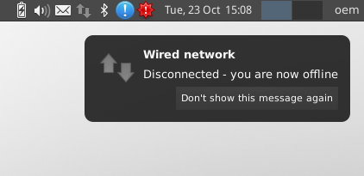
Once you have a wireless adapter and have found a place to connect to the Internet wirelessly, you'll need to tell your computer to connect to the wireless signal. Xubuntu includes an applet called the Network Manager to help with this. The Network Manager applet is an icon that changes depending on whether you're connected to the Internet and whether you're connected wirelessly or with an ethernet cable. In the picture to the left, the Network Manager applet icon is the up/down arrow icon in the upper right corner.

An exclamation mark means an update is required or something needs your attention. Click on it to read the message or update your operating system. Updates are good; they keep the system secure.
To connect to a wireless network, click on the Network Manager applet and click on the wireless network you wish to connect to..

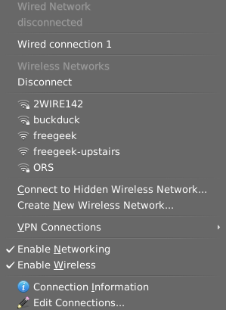
Pictured to the left is a list of available wireless networks. A lock icon means the network requires a password or passphrase. Password-protected networks require you to enter a password or passphrase before you can connect to them.

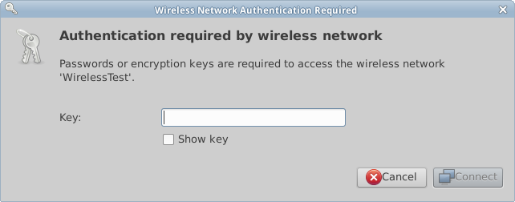
If you select a network with a lock icon, you'll be shown a window that resembles the one pictured to the left. Enter the required password in the Key text box. If you click on the Show key box near the bottom of the window, you'll see the password you are typing instead of generic dots. This will make it so you can be sure you're entering the correct characters. Once you're connected to a wireless network, the Network Manager applet will indicate wireless signal strength.

Mobile Broadband (WiMax/3G/4G and Others)
Mobile broadband is a reasonably fast Internet connection that works by using a cell phone network. It’s cost and speed are between dial-up and traditional broadband. Most mobile broadband devices should be recognized automatically when you connect them to your computer. To help configure your device, the New Mobile Broadband Connection Wizard will open automatically when you connect the device. Here's what to enter:
- Click “Forward” or “Continue” and insert your details, including the country where you bought your device (probably the United States), your network provider's name (Sprint, Verizon, Cricket, etc.), and type of connection (Contract or Pre-pay).
- Give your connection a name (it's up to you what name you choose) and click “Apply.” Your connection is now ready to use.
- To connect, click the Network Manager applet in the top right of your screen and select your new connection. To disconnect, click the Network Manager applet in the top right of the screen and click “Disconnect.”

If you are not prompted to configure the device when you connect it, you may still be able to
add the connection manually.
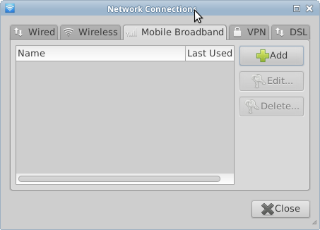
- Click the Network Manager applet in the
system notification area and click “Edit Connections”.

- Select the “Mobile Broadband” tab.
- Click “Add.”

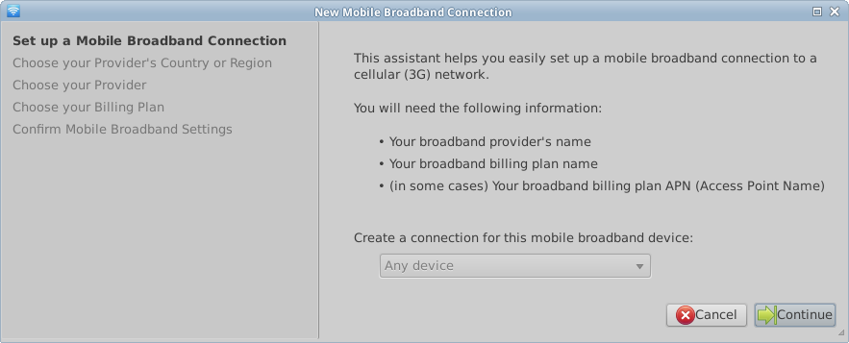
This will open a New Mobile Broadband Connection Wizard, such as the one seen above. Click “Continue” and insert your details.

If you're still having problems after you've tried the steps above, please contact Free Geek Tech Support.

Creating a Home Broadband Network
So, you've taken the plunge and paid for broadband Internet. Now you'll need a cable or DSL modem to receive the signal from your Internet provider. If you want to share your broadband connection with more than one computer, you'll also need a router.

Setting Up a Modem and Router for a Wired Home Network
This is how hardware is generally set up for sharing wired broadband Internet at home:
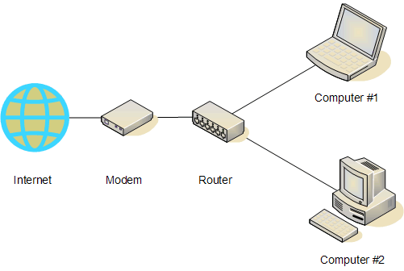

The physical wire that connects the wall to the modem depends on what type of Internet connection you bought. You may have a coaxial cable (a thick cable with a round end and a pin sticking out of it, like what you'd use if you paid for cable TV), or a DSL cable, which is like a phone cable and connects to your phone jack. If you're trying to buy a modem from Free Geek, the type of modem you need depends on whether you will use a coaxial cable or a DSL line. Your best bet is to get a modem from your provider as they only provide phone support for certain models.

The modem's job is to turn whatever signal you're getting from your Internet provider into one that your computer can understand and respond to. From there on, everything is connected together with an ethernet cable (the modem to the router, the router to your computers, etc.) You can get cheap ethernet cables from the Free Geek Thrift Store.

What if There Are Problems?
Usually this kind of setup is plug-and-play. In other words, you plug everything in, turn everything on, and it should work. Please wait a minute or so after hooking everything up for your Internet connection to work. If all the pieces are connected correctly, but you still can't connect to the Internet, try unplugging your router from the wall for 10 seconds, and then plugging it back in. If you are still experiencing issues, please contact Free Geek Technical Support.

Setting Up a Modem and Router for a Wireless Home Network
Setting up a wireless network can be a little tricky. Because all wireless routers are a bit different, we can't give precise instructions. What follows is a general overview explaining how to setup a wireless network.
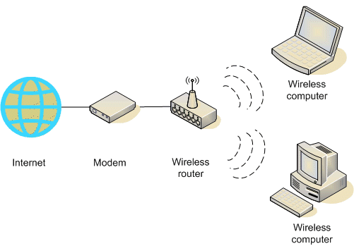
The connection going from the wall (in the picture above, "Internet") to your router is the same as if you were using a wired connection. You will connect an ethernet cable from your cable or DSL modem to your wireless router. The wireless router is a special kind of router that sends radio signals to computers that have wireless adapters, which can receive and translate these signals. Most wireless routers look like little boxes with one or two antennae on them, however, there are some that have internal antennae. One nice thing about wireless routers is that they usually also have extra ethernet ports, to allow you to connect to them with a wire. You can also configure your wireless router through these ports. This is a nice option if you get frustrated with setting up the wireless network and need to get on the Internet for some answers.

Configuring a Wireless Router
Configuring a wireless router is slightly different for each router model. For this reason, your best bet is to read the manufacturer's instruction manual for your router. If you do not have the manufacturer’s manual, you can usually find it by going to www.google.com, and searching for your router's make and model number (usually on a sticker on the bottom of the device) and the word "configure." For example, "configure linksys wrt54g." The instructions from manufacturers are written for beginners, so they should help most users configure their routers. If you are setting up a wireless connection at home you should generally set it up as an encrypted network in order to protect the data traveling across it. Always use the newer WPA standard as the old WEP standard is not secure.

V. Browsing the Web

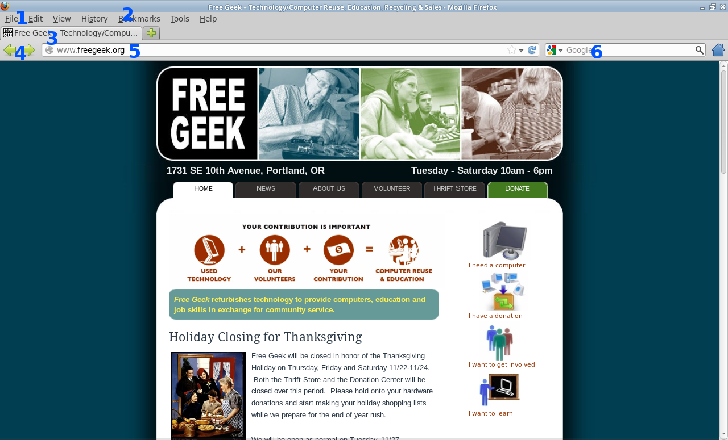

1. Firefox Menu Bar: Use this to print web pages and adjust Firefox's settings. Click on Edit>Preferences to change your homepage, edit online password preferences, edit popup preferences, and more.
2. Bookmark Toolbar: Here you can store frequently visited web sites. To add a bookmark to this toolbar, simply click on “Bookmarks” and click “Bookmark This page.” To edit this toolbar, go to Bookmarks>Show All Bookmarks or View>Sidebar>Bookmarks.
3. Tabs: Tabs can be used to browse multiple web pages at the same time. To open a new tab, click on the plus sign to the right of your right-most open tab, or hold the “Ctrl” key and press “T” on your keyboard.
4. Navigation: go Back (left arrow), go Forward (right arrow), Refresh the page (blue curved arrow), Stop loading (red stop sign), take me to my Homepage (blue House).
5. Address Bar: If you want to visit a specific website, such as www.freegeek.org (www. is assumed if you just type freegeek.org), you would enter it here, then press “Enter” on your keyboard.
6. Search: For searching the web. Type the terms you'd like to use in your search, and then press “Enter.”

Being Safe Online
One common question new users ask is “What about virus protection?” Currently viruses and spyware are limited to Microsoft's Windows operating systems. This is partly because Xubuntu is designed to be less vulnerable to these types of attacks. While there are no viruses that work on Xubuntu, you should still be aware of a few basic security steps to take while browsing the web. This will ensure your personal information stays safe and your computer remains secure.

● It is best to visit websites directly rather than clicking on a link from an email or other webpage. For example, if you receive an email from facebook.com asking you to log in by clicking on a link, type "facebook.com" into your web browser address bar, instead of clicking on the link.
● NEVER submit serious personal information such as tax or bank account information to a web page that does not start with "https://" (the “s” after the http indicates secure).
● Never open email attachments from people or organizations you do not know (no matter how tempting).
● On occasion, you may receive emails or Facebook messages offering free ipods/ ipads/laptops etc. in exchange for your time filling out surveys. These offers are scams. Do not click on these links.
● Update your software regularly (see section VIII. Managing Updates for information on how to do this).
● Occasionally, a website will present you with a popup window that insists that you have a virus on your computer. Remember, there are no viruses for Xubuntu! These sites are scams that will attempt to obtain your personal information if you click on them. Exit out of these windows.
●Be wary of file sharing and downloading from sources that seem too good to be true.

Improving Readability
To make text larger while using your web browser, press “Ctrl,” then “+” on your keyboard. To make text smaller, press “Ctrl,” then “-”. You can also press and hold the “Ctrl” key, then use your mouse wheel to zoom in and out.

Web Media
Some web media (usually music and video) requires the installation of software in order to make it work. Please see section VIII. Installing New Software for more information on getting this software.

VI. Email
Email is now a standard communication tool. The email messages you receive in your inbox actually "live" on a computer that belongs to someone else. If you use a web browser to check email, you are using webmail (e.g., Gmail, hotmail), and your email "lives" on the computers belonging to your email provider (e.g., Google, Microsoft). If you use a program on your computer, such as Thunderbird, to retrieve and organize your email, you are using a mail client.. In both cases, you must be connected to the Internet to get new mail.

When surfing the web, the first time you click on a link to send someone an email the window seen below will pop up:

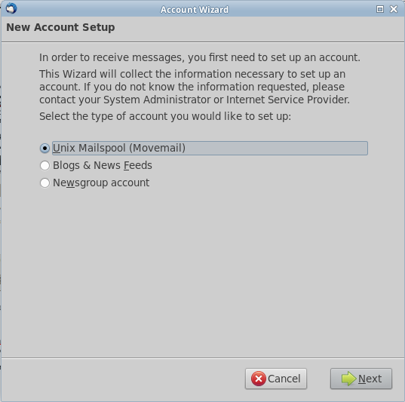

Clicking the “Next” arrow and filling in the text boxes that follow will setup your email account in Thunderbird. Thunderbird is a third-party mail client to used download and display emails. You may have used programs similar to Thunderbird in the past, such as Outlook or Evolution. Click “Cancel” if you do not wish to set up Thunderbird, and wish to only use webmail. Please contact technical support if you wish to use a mail client and are unable to configure it.
There are many email providers to choose from for email service, such as Gmail and Yahoo! Mail. If you have used email in the past, Free Geek recommends using the email service that you're already comfortable with. If you're new to email or want a new email provider, we recommend Gmail. Gmail is easy to learn and use for both new and experienced users.

For more information on email visit:

Gmail Help: http://mail.google.com/support/
Thunderbird User Guide: https://support.mozillamessaging.com/en-US/home

VII. Audio & Video
Xubuntu comes with software for playing videos and managing a digital music collection. Unfortunately, many of the most popular media formats, including commercially-available DVDs, require software that isn't possible for Free Geek to distribute. Don't fear, though; there's hope! You can individually install this special software on your computer. To learn how to do this, read the topic Xubuntu Restricted Extras in section IX. Installing New Software.

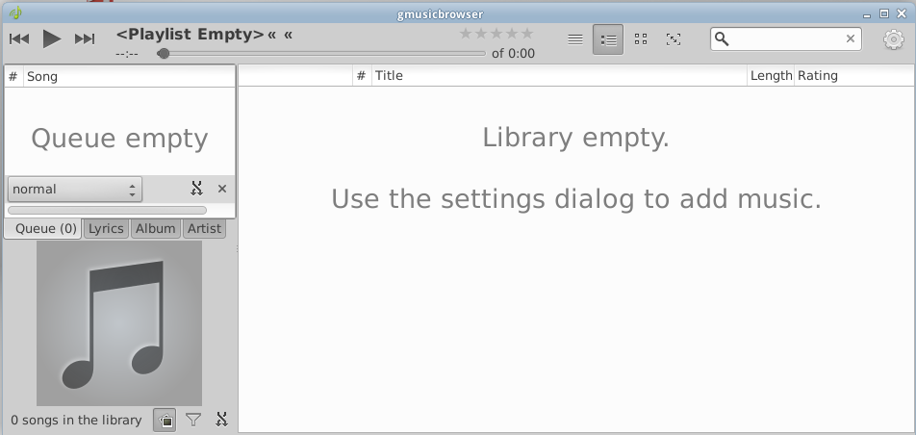

Audio
You can use gmusicbrowser Music Player (Menu>Multimedia>gmusicbrowser) and Parole Movie Player (Menu>Multimedia>Parole) to listen to music on your computer. Audio files will be opened in Parole Movie Player when double-clicked.

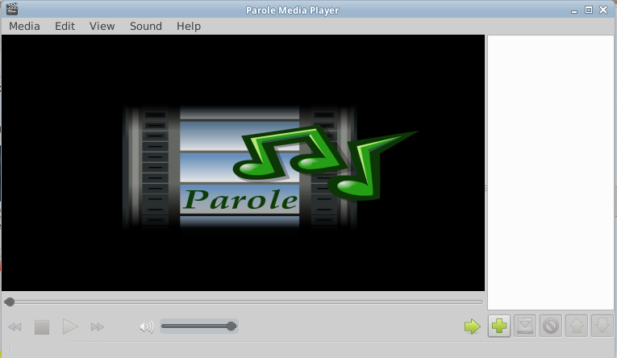

Video
You can watch movies, DVDs, and video clips with the Parole Movie Player (Menu>Multimedia>Parole).

A Note About Speakers
If you can't hear any sound, check that:
● Your speakers are plugged into the green port on the back of your computer (or the headphone jack if you have a laptop),
● The speaker power cord is plugged into the wall
● Your speakers are turned on with the volume up. Check the volume icon on the desktop and make sure it’s not muted or turned down.

VIII. Managing Updates
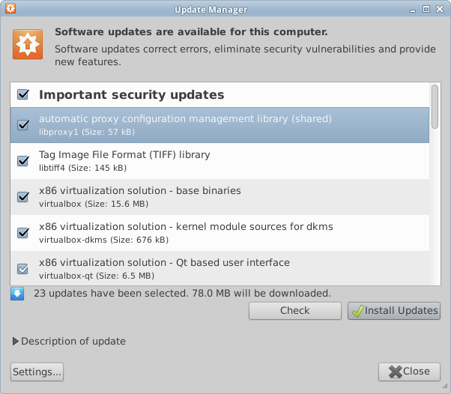

When important updates are available for your system, an Update Manager window will pop up on your desktop. If the update window does not pop up, but you see an exclamation mark pop up, click on this exclamation mark to view updates. Then, click “Install Updates.” This is a good thing to do! Installing these updates eliminates security flaws and keeps applications installed on your system current working.

IX. Installing New Software
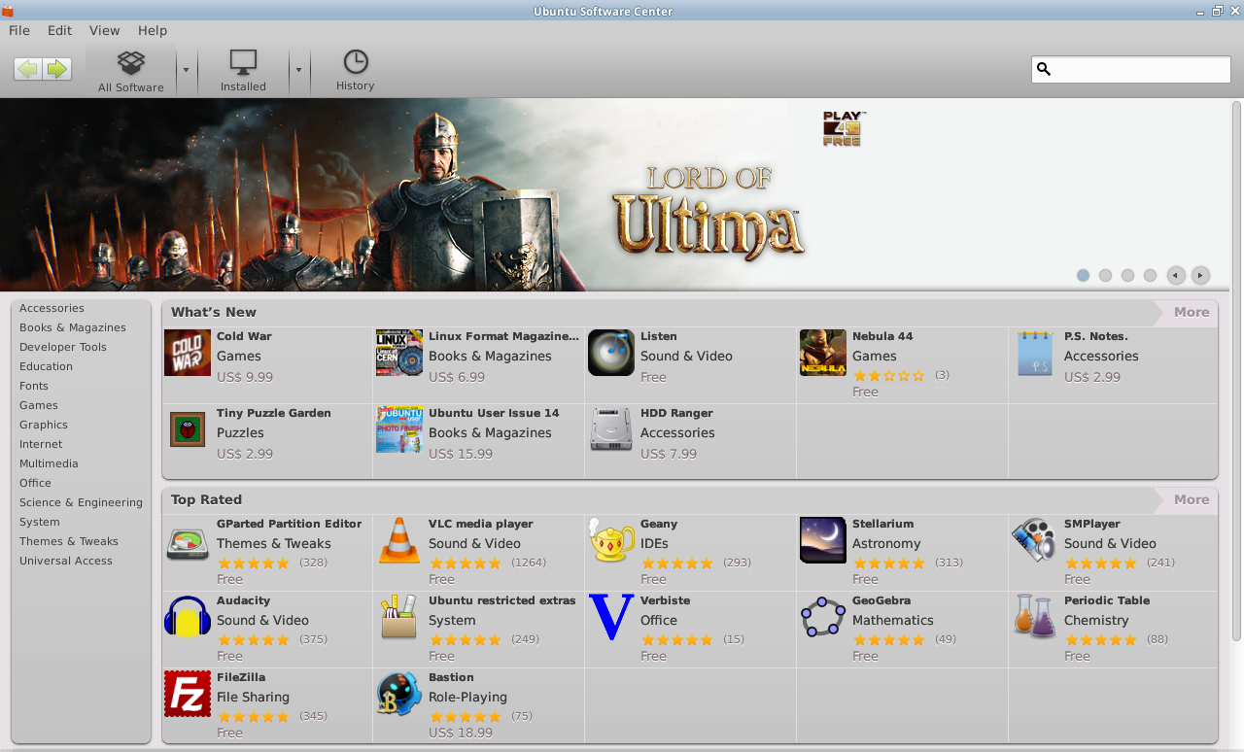
Xubuntu includes the Ubuntu Software Center to make installation and removal of software
easier. You can browse categories to discover new applications, or use the search feature.
Remember that you need to be connected to a working Internet connection to download software.

If you don’t like the programs your Freekbox came with, launch the Ubuntu Software Center, and try some of the other programs. There are a bunch of awesome (and let’s not forget free) music and video players, office tools, and web browsers out there just waiting to be installed!

Xubuntu Restricted Extras
Just like Windows and Mac computers, some media formats won't automatically play on your
Free Geek computer. Thankfully, Xubuntu has created an easy way of installing the software
necessary to enable playback of flash videos, MP3s, and many more commonly-used media
formats. To install this software, follow these steps:

- First, we need to tell the software to look in the right place. Open the Menu and click on Ubuntu Software Center. Now go to the Edit->Software Sources menu and check the option “Software restricted by copyright or legal issues (multiverse)." , enter your password when prompted.

- When it’s done close the software, then open up your web browser and go the URL tinyurl.com/fgclass or http://wiki.freegeek.org/index.php/Getting_Started_Class_Teacher%27s_Outline#Flash.2C_Java.2C_and_DVD_Software and copy the line of code found on that page: sudo apt-get install -y vlc xubuntu-restricted-extras libdvdread4 && sudo /usr/share/doc/libdvdread4/install-css.sh
- Go to Menu->Accessories->Terminal Emulator and type or (preferably) paste the above exactly as it appears and hit enter. Enter your password (note that it will not look like you're typing anything) and hit enter.
- After going through some processes a blue screen will require your input. Hit the “tab” button to get to “OK” and then hit enter. On the next blue screen hit tab again to get to “Yes” and hit enter.

X. Getting Help
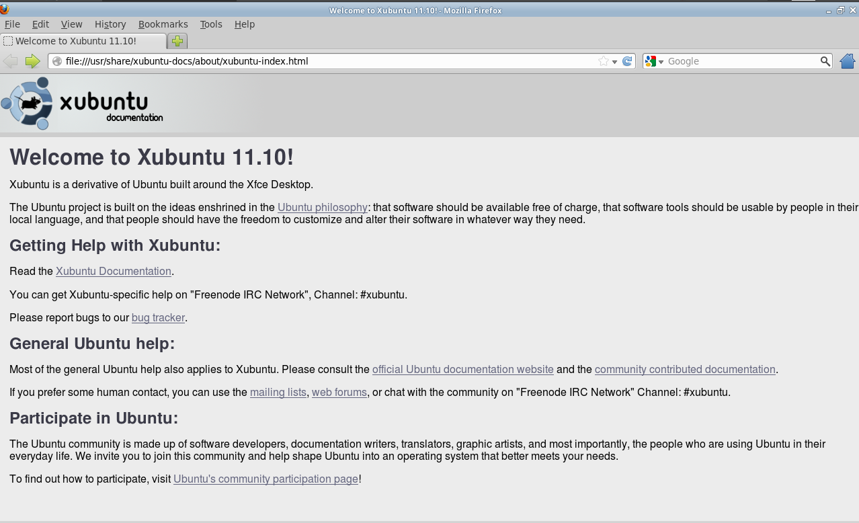

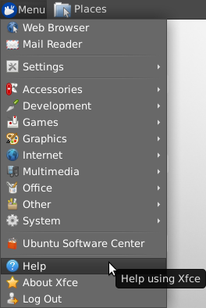
The Xubuntu community has created many resources to help both new and experienced users learn more. Use the built-in help features by going to Menu>Help .

Official Xubuntu Documentation
Xubuntu provides and maintains an up-to-date set of how-tos and manuals. They can be found by going to the website http://www.xubuntu.org and clicking on the “Help & Support” link.

Taking Classes at Free Geek
Free Geek offers a range of classes for beginners and intermediate users alike. These classes are free. If you learn well in a classroom environment and are interested in taking a class at Free Geek, please call 503-232-9350.

Contacting Technical Support
Free Geek offers technical support services for users of our products. If you purchased this system form the Thrift Store it come with six months free tech support. After the warranty period has run out Tech Support will still fix your computer for a further year at $10 an issue plus the cost of parts if works needs to be done. After this year they may still fix it at their discretion. The purpose of technical support is to repair or replace hardware that breaks and provide basic end-user support of Xubuntu and the applications included on it.

Free Geek Technical Support
Noon to 1 pm, 1:30-5:45 pm, Tuesday through Saturday
Telephone: 503-232-9350
Email: support@freegeek.org

In order to get the best help from our technicians, in your email, be sure to include what is not working (for example, "I can't get on the Internet" or "I can't log into my computer"). If an error message appears and you do not understand it’s meaning, you can take a screen shot of it to ensure that tech support has specific information about your issue. You can take a screen shot by going to Applications>Accessories>Take Screenshot. To learn how to attach the screen shot image to your email, refer to the help documentation provided by your email service provider (eg. Gmail) or mail client (eg. Thunderbird), if you are using one.
Finally, if your computer freezes (whether or not you can still move the mouse pointer) please note the time this occurred. Please use the system time in the upper right corner (instead of your phone or watch). This allows our technicians to use detailed logs to determine the source of the problem.

About this Manual

This manual was written and edited by:
Ben Koenig
Larry Haugen
Tim Peterson
Tanvi Garg
Kyle Miskell
Based on the Original Ubuntu 10.04 Manual written and edited by:
Ian Young, Luiz Sudbrack, Shawn Furst Joe Sapienza & Evie Strohmeyer
Through all these bits and bytes we want you to have a great time with your new computer. May you have many hours of enjoyment and a rewarding learning experience. Please let us know how we can improve the manual to further serve new Linux users. To tell us your thoughts, please send an email to:
manual@freegeek.org

