

***PROC,ENHANCED ORT PLAN FOR NETGEAR ODM SUPPLIERS***

**Rev Date**: 03/06/2014

**Origination Date**: 11/15/2005

**Document Num**: QSP-10015

**Revision Num**: 10

**Author**: CHUN HUI MENG

# PURPOSE

Enhanced Ongoing Reliability Testing (EORT) is intended to characterize product reliability performance, to expose the weakness in design, process, material & workmanship.

# SCOPE

This procedure covers the Enhanced On-going Reliability (EORT) test at NTGR ODMs and CMs.

# RESPONSIBILITIES

The VP of Global Quality is responsible for approving initial release and updates to this document.

NTGR Quality Engineer for EORT is responsible for ensuring EORT procedure is implemented at NTGR’s ODMs and for ongoing compliance.

The ODM is responsible for ensuring the EORT is planned during product NPI, execution of EORT Test, and upload EORT test result to NTGR.

* 1. **Document Approval**

The following are responsible for approving any changes to this document.

* VP, Global Quality

# DOCUMENTATION CHANGE NOTIFICATION

## ECO Release Notification

The following notifications are required when this document is changed and are automatically issued at ECO release.

## Expert Quality Engineers

## Other Notifications

Anyone can set up their own automated notification of changes to this document by ‘subscribing’ to the document in Agile. See DOC-00037, Agile Overview for more information on Agile Subscriptions and details on how to set them up.

# REFERENCE DOCUMENTS

DOC-00124: Procedure, NPI

QSP-10016: Procedure, FAI

DOC-00033: Procedure, Deviation Orders

DOC-10189: Spec, OBIEE Production DB

# TERMINOLOGY

**AVL** – Approved Vendor List

**DUT** – Device Under Test

**FCS** – First Customer Shipment. Initial production shipment to NTGR.

**FG** – Finished Goods

**FGI** – Finished Goods Inventory

**EORT** – Enhanced On-Going Reliability Test

**New SKU** – New Store Keep Unit

**NTGR** – NETGEAR, Inc.

**NPI** – New Product Introduction

**ODM** – Original Design Manufacture

# GENERAL REQUIREMENTS

## EORT Process Summary

Each ODM will generate an EORT PLAN during New Product Introduction (NPI). The NTGR QE will work with each ODM to review & approve EORT PLAN during First Article Inspection (FAI). EORT testing is to start after NPI but before Mass Production.

The EORT chambers are fully populated with DUTs and run through the test protocol described below. Once the test cycle is completed, the chamber is reloaded with new DUT and the test cycle is repeated until the product is taken end of life.

DUTs that fail during the test cycle are inspected and taken through failure analysis. Corrective actions are taken depending on failure analysis results.

## EORT Application

### NPI Products

ODM is to plan EORT as part of the New Product Introduction (NPI) process, so EORT Plan will be ready for review & approval during FAI . EORT must begin after NPI but before Mass Production.

### Mass Production Products

For current shipping products, EORT should be implemented based on the chamber capacity. ODM to consult with NTGR EORT QE to optimize EORT test methodology and improve EORT test frequency. Testing is continuous so long as the SKU is production released.

### Exceptions

Any exception to the above, the ODM needs to check with NETGEAR Quality Engineer and obtain the consensus.

## Sample Method

The DUT for EORT shall be selected randomly from FGI or may also be finished goods pack-out at production line.

Note: EORT Sampling Plan is generated by ODM based on the Chamber capacity and production schedule, NTGR QE will review/approve the EORT Plan with ODM, ODM should have EORT chamber fully populated with DUTs.

## EORT Test Details

### EORT Test items

The purpose of this test is to measure product operating characteristics in various environmental combinations of temperature and humidity. The test includes:

* Thermal Shock Test
* Dynamic/Static Operation
* Temperature/humidity Cycling
* Power On/Off Test
* Vibration test (with 2nd generation EORT Chamber)

### Test conditions:

* Test Temperature range: -25 Degree C ~ 65 Degree C
* Test Humidity range: 0 RH ~ 95 RH

### Test Procedures:

|  |  |  |  |  |
| --- | --- | --- | --- | --- |
| **Step** | **Time** | **Status** | **Temp (C)** | **Humidity (R.H.)** |
| Initialization | 22 min | Power On/Dynamic (>=80% loading) | 25 | 50 |
| 0’ - > 0’1’’ | 1 min | Power On/Dynamic (>=80% loading) | 25 - > 45 | 50 - > 95 |
| 0’1’’ -> 1’1’’ | 1 hour | Power On/Dynamic (>=80% loading) | 45 | 95 |
| 1’1’’ -> 1’2’’ | 1 min | Power off | 45 -> 65 | 95 |
| 1’2’’ -> 2’2’’ | 1 hour | Power off / Static Operation | 65 | 95 |
| 2’2’’ -> 2’3’’ | 1 min | Power off / Static Operation | 65 -> 45 | 95 |
| 2’3’’ -> 2’8’’ | 5 min | Power off / Static Operation | 45 | 95 |
| 2’8’’ -> 2’13’’ (hot start) | 5 min | Power On/Dynamic (>=80% loading) | 45 | 95 |
| 2’13’’ -> 3’3’’ | 50 min | Power On/Dynamic (>=80% loading) | 45 | 95 |
| 3’3’’ -> 3’5’’ | 2 min | Power On/Dynamic (>=80% loading) | 45 -> -5 | 95 -> 0 |
| 3’5’’ -> 4’5” | 1 hour | Power On/Dynamic (>=80% loading) | -5 | 0 |
| 4’5’’ -> 4’6’’ | 1 min | Power off | -5 -> -25 | 0 |
| 4’6’’ -> 5’6” | 1 hour | Power off / Static Operation | -25 | 0 |
| 5’6’’ -> 5’7’’ | 1 min | Power off / Static Operation | -25 -> 10 | 0 - 50 |
| 5’7’’ -> 5’17’’ | 10 min | Power off / Static Operation | 10 | 50 |
| 5’17’’ -> 5’22’’ (cold start) | 5 min | Power On/Dynamic (>=80% loading) | 10 | 50 |
| 5’22’’ -> 6’17’’ | 55 min | Power On/Dynamic (>=80% loading) | 10 | 50 |
| 6’17’’ -> 6’18’’ | 1 min | Power On/Dynamic (>=80% loading) | 10 -> 45 | 95 |

### EORT Temperature Profile (1st Generation EORT)

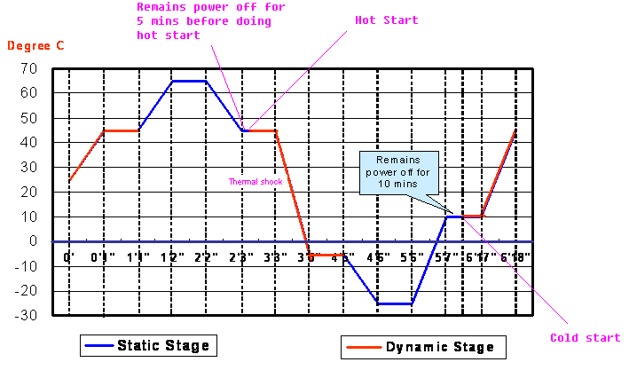

Note: 4 cycles for each DUT under EORT test.

### Power On/Off Cycling Profile (at last cycle, duration 1 hour)

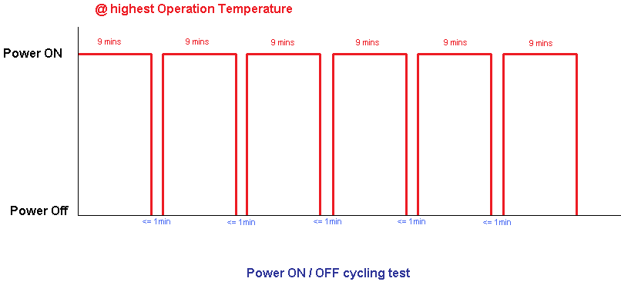

### EORT profile with Vibration function (2nd Generation EORT Chamber)

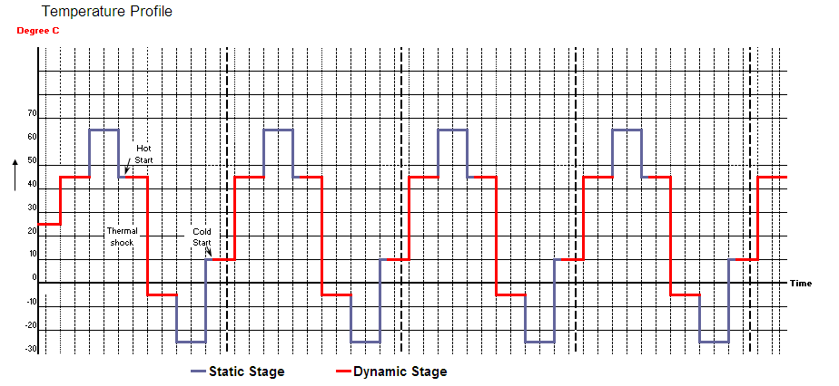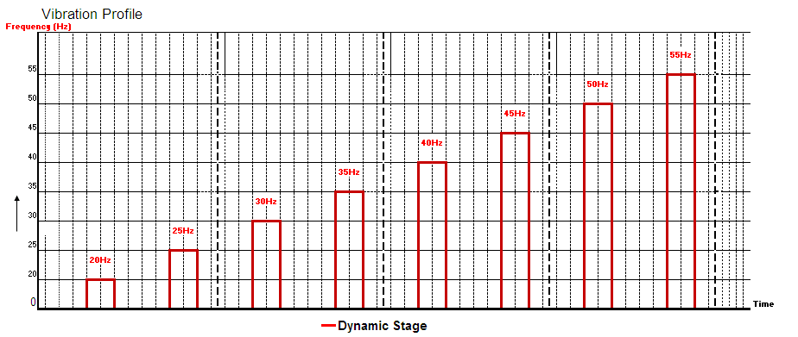

Note: Please refer to specific Product Specification to determine highest Operation Temperature. Normally:

* High temp in Dynamic Stage (45℃) – home products, and CBU products released before Middle of 2006
* High Temp in Dynamic Stage (50℃) – POE related CBU products
* High Temp in Dynamic Stage (55℃) – New designed CBU products (non-POE CBU products)

### Pass / Fail Criteria

1. All units must go through the standard setup process to place the unit in operation. Any error found during the standard setup process is considered a failure and not acceptable.
2. All units must pass system test under the testing process, and any function error cannot be allowed
3. All units should not have electrical or mechanical malfunction or damage phenomenon under or after testing

# EORT Test Results

Any test item with abnormal performance is considered as a failed unit. ODM and NTGR Engineering may need to be involved to explain or verify the test result. More samples may be required for re-testing.

## Function Test

Function will be performed after completion of EORT cycle. Use the right FQA Test Program as specified in the NTGR Agile System. Refer to Appendix for EORT Performance Summary report format and Pass/Fail criteria.

# Failure Analysis and Corrective Actions

If a change to the standard setup process is required to operate the units then the ODM must submit an Agile Deviation before proceeding. No email deviations are accepted.

The ODM is responsible for performing root cause analysis of all failures. After diagnosis and repair of the failure, the repaired unit will complete the EORT cycle to ensure the corrective action was effective.

If more than one DUT fails with the same failure, it will be considered a chronic failure. Root cause analysis will be performed to and a product change will be implemented. The NTGR QE responsible for EORT may issue a stop ship until the corrective action is implemented.

# EORT Test Reports

The ODM is responsible for delivering EORT test reports as described in NTGR DOC-10189.

# REVISION HISTORY

|  |  |  |  |
| --- | --- | --- | --- |
| **Rev** | **DATE** | **COMMENTS** | **Appvd** |
| 1 | Nov 15, 2005 | First Draft | CP Lim |
| 2 | Nov 2, 2006 | Modified on ORT procedures | CP Lim |
| 3 | Aug 1, 2007 | 1. In Section 6.3, Adding wait time (5 minutes) before doing hot start.  2. Adding Appendix - EORT report form with standards. | CP Lim |
| 4 | Aug 5, 2010 | Format update refer to NTGR requirement of procedure documents  Clarify the test criteria for Wireless products  Adding Power On/Off cycling test | CP Lim |
| 5 | Jan 5, 2011 | Per ISO requirements:  Modified item 6 - General Requirements  Modified item 7, and merged item 7 into item 6.  Deleted item 8 – Roles and Responsibilities  Modified item 9  Modified Appendix – the format of “EORT performance Summary Report” | CP Lim |
| 6 | Feb 25, 2011 | 1. Modified 6.1 EORT Frequency  2. Modified 6.2 Sample Method  3. Modified 6.3 EORT Test Details  4. Modified Appendix: EORT Performance Summary Report | CP Lim |
| 7 | 8/24/2011 | 1. Added section 9 EORT test reports. 2. Added section 8 failure analysis. 3. Added section 6.3 sample size and duration. 4. Added section 6.1 process summary. 5. Edited to support new draft of MPA. | CP Lim  T.Stover |
| 8 | 12/16/2011 | Add section 4 DOCUMENT CHANGE NOTIFICATION | CP Lim |
| 9 | 07/05/2013 | 1. Modify the Scope 2. Modify the Responsibilities 3. Clarify EORT Sampling Plan 4. Modify the profile with Vibration function | CP Lim |
| 10 | 3/6/2014 | Sec 5 add Deviation procedure DOC-00033. Modify 7.4.7 to add setup process to pass/fail criteria. Modify Sec. 9 to document method for handling setup failures.  Add section 3.1 and correct job title. | CP Lim  D. Leong |

**APPENDIX 1** - **EORT** **Report Form**

**EORT Performance Summary Report**

ODM: ______

Week: ______

|  |  |  |  |  |  |  |  |  |  |  |  |  |  |
| --- | --- | --- | --- | --- | --- | --- | --- | --- | --- | --- | --- | --- | --- |
| Test Date | Model Name | Serial Number | Initiation Cycle (22mins@25C) | Failure % during rapid temp.ramp up | Peak Operation Temp | Hot Start @ 45C | Failure % during rapid temp.ramp down to -5C | Lowest Operation Temp | Cold Start @ 10C | 10℃ @ 45 mins at each cycle | Performance of Thermal Cycling (consist or decreased) | Performance of Power Cycling | EORT Result |
|  |  |  |  |  |  |  |  |  |  |  |  |  |  |
|  |  |  |  |  |  |  |  |  |  |  |  |  |  |
|  |  |  |  |  |  |  |  |  |  |  |  |  |  |
|  |  |  |  |  |  |  |  |  |  |  |  |  |  |
|  |  |  |  |  |  |  |  |  |  |  |  |  |  |
|  |  |  |  |  |  |  |  |  |  |  |  |  |  |
|  |  |  |  |  |  |  |  |  |  |  |  |  |  |

***Notes:***

**1. Refer to the EORT profile for the stage explanation**

25℃: Initial period in the first Cycle, 22 minutes

10℃: 55 minutes at each cycle

Highest Operation Temp: need exactly follow up with the **Product Specification**, normally:

* 45℃ - for home used products, and products (SMB products) released before mid of 2006
* 50℃ - for POE products (SMB products)
* 55℃ - For new designed SMB products (non-POE SMB product)

Lowest Operation Temp: Set as -5℃ by default

Hot Start: Test duration (5 minutes), after temperature down from 65℃ & stable in hot operating temp

Cold Start: Test duration (5 minutes), after 10 minute stabilization at 10℃

Failure percentage in Thermal Shock: number of failure during Thermal Shock/testing times during Thermal shock

* Minor issue found, if 0% ≤Failure percentage in Thermal Shock" ≤ 20%
* Issues need to be investigated, if Failure percentage in Thermal Shock ≥ 20%

Performance of Thermal Cycle: described as "Consist" or "Decreased"

**2. Standards for EORT results**

a. For Switch Product

* No Major Issue Found, if
  + There is NO "CRC" error, and
  + The packet loss/gain is less than 1%, and
  + There is NO continuously abnormal symptom (≤5 times), such as Link failure, Alignment, oversize, undersize, etc
* Minor issue found, if
* There is ≤ 10 CRC errors, or
* The packet loss/gain is 1% ≤ Packet loss ≤5 packet, or
* There is Continuous abnormal symptom, 5 times ≤ continuous abnormal ≤ 15 times
* Issues need to be investigated
* There is more than 10 CRC error, or
* The packet loss/gain is 5% ≤ Packet loss, or
* There is Continuous abnormal symptom, 15 times ≤ continuous abnormal

b. For Wireless Product

* + No major issue found, if
    - 11b autorate: Average TCP throughput ≥ 3.5 Mpbs; and Failure rate (% of throughput less than 3 Mpbs) ≤0.3%
    - 11g autorate: Average TCP throughput ≥ 18 Mpbs; and Failure rate (% of throughput less than 15 Mpbs) ≤0.3%
    - 11 SuperG, Pre-N, etc no 11N: Average TCP throughput ≥ 30 Mpbs;

and Failure rate (% of throughput less than 26 Mpbs) ≤0.3%

* + - 11n (HT20) atuorate: Average TCP throughput ≥ 40 Mpbs;

and Failure rate (% of throughput less than 35 Mpbs) ≤0.3%

* + - 11n (HT40) autorate: Average TCP throughput ≥ 70 Mpbs;

and Failure rate (% of throughput less than 60 Mpbs) ≤0.3%

* + Minor issue found (non-stable, wobble), if
* 11b autorate: 3.5Mpbs > Average TCP throughput ≥ 3 Mpbs;

and 3% ≥ Failure rate (% of throughput less than 3 Mpbs) >0.3%

* 11g autorate: 18Mpbs > Average TCP throughput ≥ 15 Mpbs;

and 3% ≥ Failure rate (% of throughput less than 15 Mpbs) >0.3%

* 11 SuperG, Pre-N, etc no 11N: 30Mpbs > Average TCP throughput ≥ 26 Mpbs;

and 3% ≥ Failure rate (% of throughput less than 26 Mpbs) >0.3%

* 11n (HT20) autorate: 40Mpbs > Average TCP throughput ≥ 35 Mpbs;

and 3% ≥ Failure rate (% of throughput less than 35 Mpbs) >0.3%

* 11n (HT40) autorate: 70Mpbs > Average TCP throughput ≥ 60 Mpbs;

and 3% ≥ Failure rate (% of throughput less than 60 Mpbs) >0.3%

* Issue need to be investigated, if
  + - * 11b autorate: Failure rate (% of throughput less than 3 Mpbs) >3%
      * 11g autorate: Failure rate (% of throughput less than 15 Mpbs) >3%
      * 11 SuperG, Pre-N, etc no 11N: Failure rate (% of throughput less than 26 Mpbs) >3%
      * 11n (HT20) autorate: Failure rate (% of throughput less than 35 Mpbs) >3%
      * 11n (HT40) autorate: Failure rate (% of throughput less than 60 Mpbs) >3%
      * Or the connect lost