The Staircases
Time Limit: 2 second
Memory Limit: 1000K
One curious child has a set of N little bricks (5 <= N <= 500). From these bricks he builds different staircases. Staircase consists of steps of different sizes in a strictly descending order. It is not allowed for staircase to have steps equal sizes. Every staircase consists of at least two steps and each step contains at least one brick. Picture gives examples of staircase for N=11 and N=5:
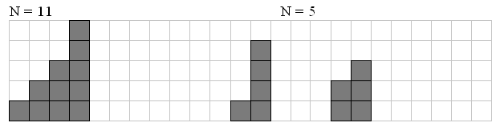
Your task is to write a program that reads from input file one number N and writes to output file the only number Q — amount of different staircases that can be built from exactly N bricks.

Input
Number N

Output
Number Q

Sample Input
212

Sample Output
995645335

Problem Source: Ural State University Internal Contest '99 #2

