Integer Percentage
Time Limit: 1 second
Memory Limit: 1000K
Applying for a new job, programmer N. Smart required that his new salary (in rubles, positive integer) would be greater than his previous salary by integer percentage. What could be the highest possible number of previous jobs for mister Smart, if his latest salary did not exceed n rubles and his first salary was exactly s rubles?
Example
Let n=10, s=2, then m=5. The sequence 2, 4 (+100%), 5 (+25%), 8 (+60%), 10 (+25%) is the longest (although not unique) sequence that satisfies to the problem statement. Salary increase percentage is written inside the brackets.
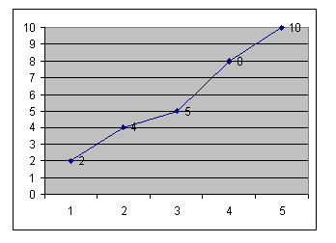

Input
Two integer numbers n and s separated by one or more spaces.
1 <= n, s <= 10000

Output
A single integer m – the maximum number of N. Smart’s previous jobs.

Sample Input
10 2

Sample Output
5

Hint
if n=s, the answer is 1.

Problem Source: Quarterfinal
Central region of Russia
Rybinsk, October 17-18 2001

