Kind spirits
Time Limit: 1 second
Memory Limit: 1000K

Ivanushka the Fool lives at the planet of 0-level. It's very unpleasent to live there. An awful climate, 80 hours working week, ugly girls... He, as well as every inhabitant of his planet, dreams to get to a planet of N-th level. To the paradise.
At each of the i-th level planets there are several hyperspace transfers to some of the (i+1)-st level planets (but there are no reverse ways). Every transfer is guarded by a spirit. The spirits are usually evil: they demand many galactic bank-notes for each transfer. You know, everyone wants to go to a higher level planet. And one has to pay for the pleasure. More than Ivanushka can even imagine. However, extraordinary situations like a lack of a labor-force at one of the higher level planets sometimes happen, and then the spirits - the guards of the transfers - become kind. Sometimes they give galactic bank-notes themselves if only someone goes to their planets.
In order to embody his dream of heavenly planet Ivanushka has done two things. First of all, he has borrowed a complete map of the Universe. It's written on the map how much the spirits demand or give for a transfer from this or that planet to another one of the next higher level. Secondly, he has hired a staff of young talanted programmers in order that they will help him to draw the way on the map from his planet to the one of Nth level so that he would spend for the spirits as little money or even earn as much as it is possible.

Input
The first line contains an integer N (0 < N < 30) - an amount of levels of the planets on Ivanushka's map. Then follow N blocks of information that describe interlevel transfers. More precisely, the ith informative block describes the scheme of transfers from (i-1)-st level planets to the ones of ith level. Those blocks are separated with a line that contains the only symbol "*". Planets of each level are numbered with sequential positive integers starting from 1. Each level contains not more than 30 planets. There is the only planet of 0-level: the one that Ivanushka lives at. The first line of a block contains a number K_{i} - an amount of planets of the ith level. Then follow K_{i} lines - one for each planet of the ith level. Every line consists of numbers of planets separated with a space of the previous (i-1)st level that one can get from them to the current planet, and the corresponding fees. A fee for each transfer is an integer number from -32768 to 32767; a negative fee means that the kind spirit is ready to pay for such a transfer. Each description line is ended by zero.

Output
should contain the only number - the minimal fee that Ivanushka might pay for a transfer to some planet of the Nth level. The answer may be negative: it means that Ivanushka will not only get to a heavenly planet, but will earn some galactic bank-notes. It's known that there exists if only one way from Ivanushka's planet to the one of Nth level.
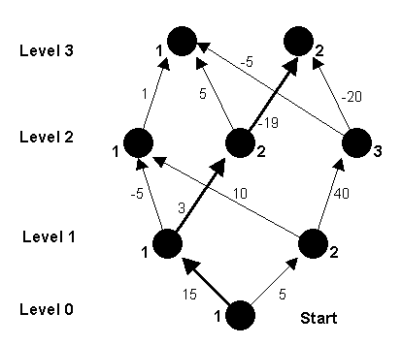

Sample Input
3
2
1 15 0
1 5 0
*
3
1 -5 2 10 0
1 3 0
2 40 0
*
2
1 1 2 5 3 -5 0
2 -19 3 -20 0

Sample Output
-1

Problem Source: The Sixth High School Collegiate Programming Contest
Author: Leonid Volkov

