City Blocks
Time Limit: 1 second
Memory Limit: 1000K
The blocks in the city of Fishburg are of square form. N avenues running south to north and M streets running east to west bound them. A helicopter took off in the most southwestern crossroads and flew along the straight line to the most northeastern crossroads. How many blocks did it fly above?
Note. A block is a square of minimum area (without its borders).

Input
The input contains N and M separated by one or more spaces.
1< N, M < 32000

Output
The number of blocks the helicopter flew above.

Sample Input
4 3

sample input2:

3 3

Sample Output
4

sample output2:

2

Hint
Images for samples :
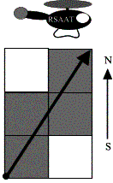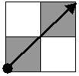

Problem Source: Quarterfinal
Central region of Russia
Rybinsk, October 17-18 2001

