Maximum Sum
Time Limit: 1 second
Memory Limit: 1000K
Given a 2-dimensional array of positive and negative integers, find the sub-rectangle with the largest sum. The sum of a rectangle is the sum of all the elements in that rectangle. In this problem the sub-rectangle with the largest sum is referred to as the maximal sub-rectangle. A sub-rectangle is any contiguous sub-array of size 1x1 or greater located within the whole array. As an example, the maximal sub-rectangle of the array:
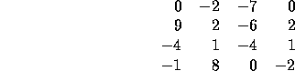
is in the lower-left-hand corner:
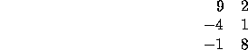
and has the sum of 15.

Input
The input consists of an NxN array of integers. The input begins with a single positive integer N on a line by itself indicating the size of the square two dimensional array. This is followed by N² integers separated by white-space (newlines and spaces). These N² integers make up the array in row-major order (i.e., all numbers on the first row, left-to-right, then all numbers on the second row, left-to-right, etc.). N may be as large as 100. The numbers in the array will be in the range [-127, 127].

Output
The output is the sum of the maximal sub-rectangle.

Sample Input
4
0 -2 -7 0
9 2 -6 2
-4 1 -4 1
-1 8 0 -2

Sample Output
15

