Flags
Time Limit: 1 second
Memory Limit: 1000K

On the Day of the Flag of Russia a shop-owner decided to decorate the show-window of his shop with textile stripes of white, blue and red colors. He wants to satisfy the following conditions:
- Stripes of the same color cannot be placed next to each other.
- A blue stripe must always be placed between a white and a red or between a red and a white one.
Determine the number of the ways to fulfill his wish.
Example. For n=3 result is following:
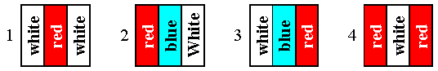

Input
n – the number of the stripes, 1 <= n <= 45.

Output
m – the number of the ways to decorate the shop-window.

Sample Input
3

Sample Output
4

Problem Source: 2002-2003 ACM Central Region of Russia Quarterfinal Programming Contest, Rybinsk, October 2002

