Bricks
Time Limit: 1.0 second
Memory Limit: 1 000 КБ
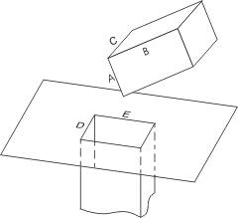
The prisoner of the "IF" castle has decided to run away by disassembling the brick wall in his prison cell. To hide his work from his jailors he shall get rid of the bricks that he removes from the wall. All bricks have a shape of rectangular parallelepiped with the size of A × B × C inches and are so strong that they are impossible to break. However, there's a small rectangular sewer hole in the cell's floor with the size of D × E inches that goes deep down as a rectangular well of the same size (so deep it is, that its depth could not be measured and can be neglected). The prisoner have precisely (up to a tenth of an inch!) measured all the sizes A, B, C, D, E and wants to know if it is possible to dispose of the castle's bricks through the hole in the floor. Please, answer this question for him.

Input
The input file consists of a single line with 5 numbers A, B, C, D, and E separated by spaces. A, B, C are the lengths of brick's sides, and D, E are the lengths of hole's sides. All lengths are at least 1 and at most 10 inches and have at most 1 digit after decimal point.

Output
Write to the output file a single word YES if it is possible to dispose of the bricks through the hole or NO otherwise.

Sample Input
Sample input #1
1.0 2.0 1.5 1.4 1.0

Sample input #2
1.0 2.0 1.5 1.5 1.0

Sample Output
Sample output #1
NO

Sample output #2
YES

Problem Author: Elena Andreeva
Problem Source: 2002-2003 ACM Northeastern European Regional Programming Contest

