jACOB

QBE Expression Description
Version 1.0

QBE Expression Description
Since QBE (Query By Example) feature allows to use any input field as search criteria, the search result set can be filtered efficiently. Nevertheless, strings entered as search criterias for text, numerical and datetime data fields are treated as QBE expressions in case they contain QBE modifiers and/or QBE keywords. These modifiers and keywords will be described in the following to enable advanced users to perform more powerful and target-oriented (e.g. for reports) search queries.
Common modifiers
Common modifiers can be used to build QBE expressions for text, numerical and datetime fields. There it makes sense QBE modifiers could be combined.
NULL
The keyword NULL (or null) is used to identify empty data fields.
Examples:
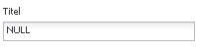
NULL
Get any users with no title.
Logical NOT
A logical not is represented by a ! character.
Examples:
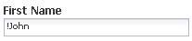
!John
Get any users with first name not containing John.
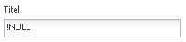
!NULL
Get any users with any title.
Logical OR
A logical or is represented by a | character.
Examples:
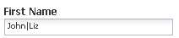
John|Liz
Get any users with first name containing John or Liz.
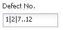
1|2|7..12
Get the defects with number 1 or 2 or 7 to 12.
Logical AND
A logical and is represented by a & character.
Examples:
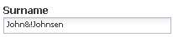
John&!Johnsen
Get any users with surname containing John but not Johnsen.
Greater than, greater or equal than, less than, less or equal than
Examples:
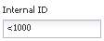
<1000
Get any data records with an internal id below 1000.
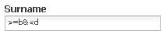
>=b&<d
Get any users with surname starting with b or c.
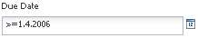
>=1.4.2006 (or >=4/1/2006 to use american notation)
Get any defects with due date of the 1. April 2006 or after.
Text modifiers
Text modifiers can be used to build QBE expressions for text fields only. There it makes sense text modifiers could be combined with other QBE modifiers.
Exact match
A leading = character is used to query for text fields which exactly match a given string.
Examples:
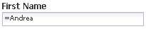
=Andrea
Get any users with first name Andrea (but not Andreas, etc.).
Wildcards
The character ? is used as a placeholder for a single character, there as the character * is used as a placeholder for any character sequence (or no character).
Examples:
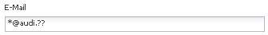
*@audi.??
Get any Audi users with a German (.de), an Austrian (.at), or any other 2 character country domain email address (we do not want .com email addresses).
Alignment
A leading ^ character is used to left align a text sequence, there as a trailing $ character is used to right align a text sequence.
Examples:
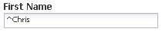
^Chris
Get any users with first name staring with Chris.
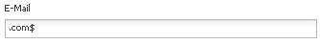
.com$
Get any users with a .com email address.
Escaping character sequences
Since the characters |, &, ! and so on are interpreted as QBE modifiers, they can not be used within normal text sequences. Therefore these text sequences have to be escaped. This is done by means of bracketing a text sequence with two “ characters. The “ character itself is escaped by two “ characters within an escaped character sequence, e.g. “I said “”No”” to him”.
Examples:
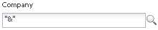
“&”
Get any companies containing a & character, e.g. Rohde & Schwarz.
Range modifiers
Range modifiers can be used to build QBE expressions for numerical and datetime fields only. There it makes sense range modifiers could be combined with other QBE modifiers.
Range
A range is indicated by two . (dot) characters.
Examples:
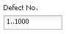
1..1000
Get the defects with number between 1 and 1000
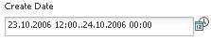
23.10.2006 12:00..24.10.2006 00:00 (or 10/23/2006 12:00 PM..10/24/2006 12:00 AM to use American notation)
Get any defects which have been created within the second half of 23. October 2006.
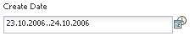
23.10.2006..24.10.2006 (or 10/23/2006..10/24/2006 to use American notation)
Get any defects which have been created either on 23. October 2006 or 24. October 2006.
Datetime keywords
Datetime keywords can be used to build QBE expressions for date, time and timestamp fields only. Datetime keywords could be combined with datetime modifiers (as described below) and, if it makes sense, with other QBE modifiers as well.
TODAY
The keyword TODAY (or today) is used to represent the current day.
Examples:
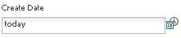
today
Get any defects which have been today.
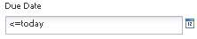
<=today
Get any defects which are overdue.
NOW
The keyword NOW (or now) is used to represent the current timestamp, i.e. the current day and current time.
Examples:
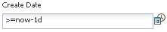
>=now-1d
Get any defects which have been created within the last 24 hours.
THISY
The keyword THISY (or thisy) is used to represent the current year, i.e. the range of this years 1. January to this years 31. Dezember.
Examples:
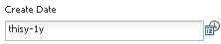
thisy-1y
Get any defects which have been created within the previous year.
THISQ
The keyword THISQ (or thisq) is used to represent the current quarter, e.g. if today is the 4. May, THISQ represents the range of this years 1. April to this years 30. June.
Examples:
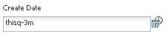
thisq-3m
Get any defects which have been created within previous quarter.
THISM
The keyword THISM (or thism) is used to represent the current month, e.g. if today is the 4. May, THISM represents the range of this years 1. May to this years 31. May.
Examples:
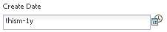
thism-1y
Get any defects which have been created within the same month of previous year.
THISW
The keyword THISW (or thisw) is used to represent the current week, i.e. the range of Monday (or Sunday depending on the locale setting) of this week to Sunday (or Saturday) of this week.
Examples:
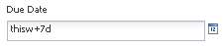
thisw+7d
Get any defects which will overdue next week.
YTD
The keyword YTD (or ytd) is used to represent the current year to date range, e.g. if today is the 4. May, YTD represents the range of this years 1. January to this years 4. May.
QTD
The keyword QTD (or qtd) is used to represent the current quarter to date range, e.g. if today is the 4. May, QTD represents the range of this years 1. April to this years 4. May.
MTD
The keyword MTD (or mtd) is used to represent the current month to date range, e.g. if today is the 4. May, MTD represents the range of this years 1. Mai to this years 4. May.
WTD
The keyword WTD (or wtd) is used to represent the current week to date range, e.g. if today is Friday, WTD represents the range of this weeks Monday (or Sunday depending on the locale setting) to this weeks Friday.
WEEK[n]
The keyword WEEK (or week) combined with an unsigned decimal number (e.g. WEEK12) is used to represent the designated calendar week of the current year.
Datetime modifiers
Datetime modifiers can be combined with datetime keywords to build QBE expressions as follows:
keyword[+-][n]modifier
There [n] is an unsigned decimal number and modifier one of the following:
Modifier | Description
y or Y | years
m or M | months
d or D | days
h or H | hours
min or MIN | minutes
sec or SEC | seconds

Examples see above.

