
US Market Entry

MBA 741
Tony Chase
Megan Parmelee
Shakira Pena

EXECUTIVE SUMMARY
Main Facts and Figures:
The current over-arching market that the Free Joint Motion products fall under is the Rehabilitation Equipment Market. The global market is expected to reach $19.8B by 2027 with a growth rate of 5.9%, in which the United States is expected to be a “medium” growth rate region, per the below data from Mordor Intelligence. This shows great promise for Motion’s ultimate plans to enter the US market.
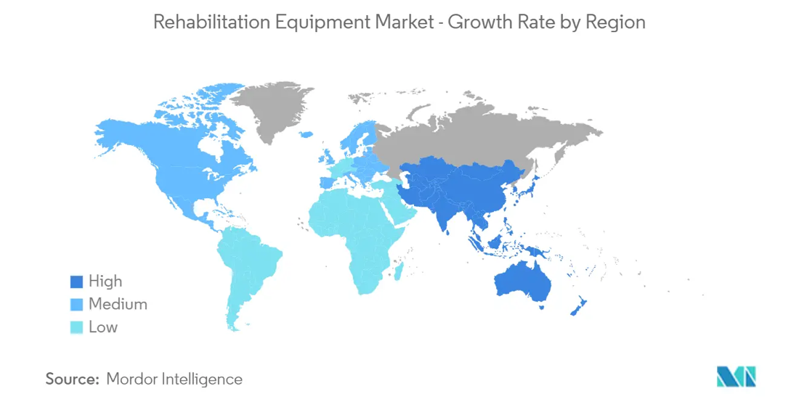
Source: https://www.mordorintelligence.com/industry-reports/rehabilitation-equipment-market
Recommendations and Key Take-Aways:
Our final recommendation consists of three steps:
- Prepare for the meeting with the FDA to understand the medical device classification. It will be key to ensure that the team strategically chooses the claims that you plan to make about the product. The main purpose of these claims should be to place the product in a differentiated category in the market, while also ensuring that proper classification will be provided in the initial process with the FDA. For this meeting, all necessary research, testing and protocols should be prepared and presented to the FDA.
- The price point that this product should be offered at is $15,000, to ensure the value of the product is understood in the marketplace, while also placing Free Joint Motion in a competitive position with their current competitors. Our team also suggests identifying a way to obtain recurring streams of income from one of two options: providing an option to lease the equipment and/or adding a subscription service to the software that will be provided with the product. It is imperative to ensure there is a way to bring back customers and keep them engaged in purchasing additional products from Free Joint Motion.
- The market that Motion should enter in the Professional Sports space is the New York Market. With 5 teams partnered with the Hospital for Special Surgery, coupled with their Research Institute funding and growth opportunities, this could be a partnership that would allow the Free Joint Motion product to make its way into many Professional Sports Teams buildings in a short amount of time.
BACKGROUND
Free Joint Motion is an ankle rehabilitation medical device company, that currently employs three people part time; their inventor, Luis Commisso, their biomedical engineer, Luis Ayet Blanchard and their software engineer, Federico Commisso. They have not yet entered any market; however, they are looking to enter the US market soon.
The mission of Free Joint Motion is to help people recover from their ankle injuries and allow them to function as independently as possible. They are dedicated to reducing the risk of re-injury as well as preventing them. This patented solution promotes healing by providing exceptional and innovative technology.
MARKET SIZE AND COMPETITOR OVERIVEW
There are a variety of market segments that Motion products could fit under, but we felt it best fit under the Rehabilitation Equipment Market, based on the data previously provided by Motion. The global rehabilitation equipment market is currently at $14.9 billion in 2022, and is expected to reach $19.8 billion by 2027, which is a growth rate of about 5.9^{%16.} This market is a great mix of well-established, larger companies, and many smaller, newer entrants into the market. With the lack of very strong incumbent companies, it leaves plenty of room for Motion to penetrate the market, especially with a well-differentiated product.
One important aspect of understanding the market is understanding the major competitors. The first competitor is Biodex Medical Systems, which was founded in 1949, and is headquartered in the United States. They were purchased by Marion Technologies on September 1, 2020³. They have a variety of product offerings in the categories of physical medicine, nuclear medicine, and medical imagining. For the purposes of comparison to Free Joint Motion, we will focus on the products that are direct competitors for the Motion products. The Biodex Gait Trainer, in conjunction with the Biodex Unweighing system support their gait evaluation testing. The Biodex Gait Trainer claims to “yield audio cueing and visual biofeedback and objective documentation.” This product allows them to measure the progress that a consumer is making and can therefore track the progress and the timeline surrounding the full rehabilitation process. It does appear however that Biodex is marketing this $22,000 product more towards inpatient and outpatient physical therapy centers who are treating people with Parkinson’s disease.
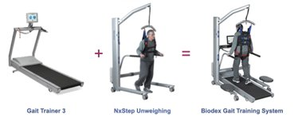

The next competitor we will discuss is Medisport Italy, which was founded in 1991, and is currently selling their portfolio of over 400 products, in over 30 countries around the world¹⁴. Their main competing product with Free Joint Motion, is their Medislipper 1000, as shown in the photo below. According to the Medisport team, this product’s main use is to treat injuries in a variety of phases. First, in the active phase, they will use this product for “dynamic stabilization”, in the passive phase they will use it for “static stabilization”, and they will also use it for evaluation of treatment plans. This product can be used through the power of the patient themselves, or through the power of the machine, depending on which type of treatment the patient is looking to obtain¹⁵.
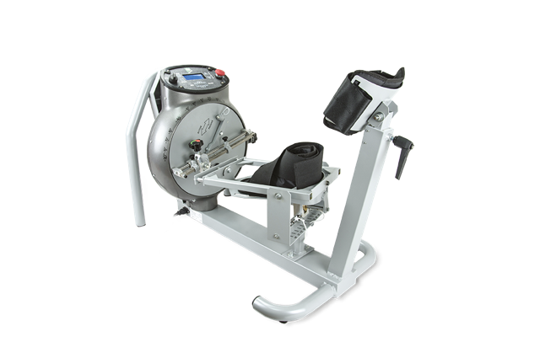
The last competitor we will touch on is Elgin Division, which is the oldest rehabilitation equipment company in the United States⁷. Elgin Division sells a variety of rehabilitation products from cardio machines, weights, pulley systems, stretch straps and finally, ankle exercisers. For the sake of this report, we will focus on the leg/ankle exerciser, as shown in the picture below. They market this product as the “ultimate progressive resistance exerciser for ankles”. They also go on to state on their website that “The "Elgin" is the industry standard for both preventative-injury ankle exercise and rehabilitative ankle exercise” ⁷. The major difference between this product and the motion product is the lack of power and automation that other competitors and Motion have in their products. This product, however, is still noted to be used by a trained medical professional and can be used in a variety of settings such as schools, sports teams and physical therapy clinics.
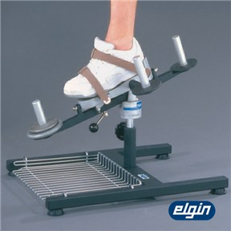

As you can see, there are products in the market that are similar to the motion product, but there are none that we were able to identify that provide the exact same benefits as the Free Joint Motion Product. This differentiation should allow Motion to set themselves apart when entering a market against these companies who have 30-60 years of experience.
CERTIFICATION PROCESS
In the research conducted for Motion and its product, it became clear early on that the scope and deliverables of the device was the type of tool utilized best by medical practitioners due to the suggested benefits offered in the initial presentation. What this meant from our respective backgrounds was the understanding that any effort to market this product would inevitably run its course through the FDA and its regulations, the United States’ method of ensuring that all products that intend to improve the livelihood of individuals had the necessary qualifications and support to back up its claims. The problem became that going through the FDA is a difficult process that requires several layers of data and research to be presented to the board. Schematics, trials, and claims would all need to be backed up by Motion because of this. There can be no ‘claims’ with the FDA, only facts and deliverables about the risks and intended benefits of the product, all of which can be proven. This would naturally bolster the product’s marketability with the right certification with access to extremely niche markets that have little space for competition due to guidelines, but to get there the markets need proof the product works. This would mean work to gain approval with the FDA under the correct medical classification and clinical trials as validation for the product deliverables. The more info and in control you are regarding the information you provide the FDA, the more relaxed they are with you; first impressions are important.
Leveraging connections with regulatory affairs, we acquired contact with Donna Haire, CEO of The Eriah Group which delves into Global Regulatory, Quality, Clinical, & Medical Affairs Consulting. Donna, who frequently works with the FDA, was curious about the product and found the concept to be a well thought out one. What was identified under guidelines was how the product fell under an ‘electrical, mechanical, software’ medical device classification. Due to the measurement capabilities of the device, her initial evaluation suggested that the FDA would most likely group this as a Class II Medical Device, the same classification as an Apple Watch which measures biological data of your body. Even if the initial evaluation from the client side served to suggest a Class I classification, post-market regulatory compliance for any medical device is best done right the first time as the answer will dictate the regulatory path the device will take. We started with the FDA section: Quality system regulations 21 CFR Part 80020 in order to understand the facets Donna had described which led us to recommending the 510K and De Novo processes, both of which enable the selling of medical devices with specialized controls. Under the process outlined, we agreed that this was the best path to take in order to position the product.
As an additional facet to consider when approaching the FDA, it is important to consider the aspects prior companies have taken when approaching the appropriate certification steps with the FDA. As we explored pricing and clinical trials, what became evident was that there are no clinical trials that would be free in the United States. In addition to the fee to conduct a trial, there is also the consideration that as a group, Motion would require funding in order to attract investors as well as a regulatory presentation to present to the FDA when the time comes. Given that our group was unable to acquire a line with investors nor sites that offer clinical trials in a week’s time, it is suggested that work be conducted sooner rather than later to synthesize results and prepare a think tank of sorts in order to assist with your endeavors from a clinical and regulatory perspective.
SWOT ANALYSIS
A SWOT analysis is a great strategy to understand the strengths, weaknesses, opportunities, and threats in an organization that is trying to enter a specific market. It helps Free Joint Motion discover its strong and weak points and whether it is strong enough to survive in the environment.
Free Joint Motion has several strengths within its business that will aid in its development. First, the founders have extensive knowledge in the arena and one can say they are considered experts in the field. Luis Commisso is an inventor who has over 30 years of experience in rehabilitation and sports medicine. Luis Ayet Blanco is a medical engineer who also has over 30 years of experience in the medical field. Finally, Federico Commisso is a software engineer and IoT specialist who did tremendous work in developing the ankle therapy product. Upon doing their own research, they had already gotten approval to do clinical trials from two universities in the United States which is a major milestone because there are products that do not make it that far in the journey. They also have a very clear value proposition which is to reduce the risk of ankle re-injury.
Although the strengths are fruitful, Free Joint Motion is a small startup company that does have some weaknesses. For instance, they have a high-cost structure with no funding because it is a family-owned business and everything they have raised so far is out of pocket. Since they are in the beginning phase of getting their product out there, they have very little brand awareness, and the niche market makes it difficult to generate publicity. The current competitive landscape is also very strong which includes products in the Biodex Medical Systems with prices ranging from $22,000, the Medislipper 1000 and the very similar Elginex Elgin Leg and Ankle Exerciser which retails at about $1,500. Free Joint Motion does not have any product range unlike the Biodex Medical Systems which currently has three on the market. They also have no certificates or sense of FDA requirements in the US which can be a major hurtle to get this product on the market.
The opportunities Free Joint Motion possesses to enter the market are very beneficial. It is a niche market meaning there are not a lot of products currently that do the same exact thing. For example, there are several coffee shops that must have some type of differentiation to attract customers, but ankle therapy medical devices are a bit scarce, which makes it a great opportunity to price it a bit higher because of the value it brings the specific industry. Another opportunity this company has is venturing into various industries such as the sports industry, rehabilitation centers or even gym and training facilities. The sports industry in the US is a vast market that ranges in multiple states. Like our team mentioned in our final presentation, New York is a major state that is huge in sports and many teams partner with hospitals, which would be a great way to enter the market. There is always great opportunity in technology because it is constantly advancing.
As a business it is important to determine any external threats that could result in failure. Therefore, because we are entering a recessionary environment there could be economic downturn that would impact the sales of Free Joint Motion. Customers could always change their attitude towards the industry or the company itself. Given that this is considered a medical device, it would need to have FDA approval. A threat that could occur in this sense is the regulatory environment change that could jeopardize the product staying in the market.
Overall, it is a very strong product that has a lot of potential to be successful in the American market.

PORTER’S FIVE FORCES
Porter’s Five Forces model assesses an organization’s industry based on five components that include threat of new entrants, threat of substitutes, bargaining power of customers and suppliers, and competitive rivalry.
As mentioned in the SWOT analysis, Free Joint Motion is a niche market therefore it would be difficult for new businesses to sort of set up shop. The FDA requirements alone as well as finding adequate engineers, the funding and produce clinical trials are all long processes so it is challenging. The ankle therapy medical device Free Joint Motion developed is an advanced equipment that has very smart technology. This kind of equipment belongs in a facility rather than in someone’s home, therefore the threat of substitutes is very likely because of how bulky the product is and the lack of convenience. People would need to travel to use this machinery, which could be substituted by an ankle brace, a band or even something as simple as an ice pack. However, because this product is so unique it is very unlikely others will clone it. The bargaining power of customers solely depends on the usability of the product and the supplier power would depend on the speed and cost of production. The intensity of the competitive landscape exists. There are currently other similar products on the market that range from $1,500 to $22,000, one has a range of products in their stack. The rehab equipment market is also growing which is currently at $14.9 billion dollars and projected to be at $19.8 billion dollars in 2027.

FINAL RECOMMENDATIONS
Recommendation Step 1: Pre-Market Process
Recommendation Step One can be boiled down to preparing for the meeting with the FDA and assembling the necessary resources in preparation. This includes acquiring all the necessary research, testing, protocol, and data regarding the product and assembling additional resources (including manpower along with funding). The FDA is notorious for first impressions and going in on the right foot ensures a smoother meeting. Initial suggestions from the client indicated that their sources believed Motion’s product to fall under the Class I Medical Device classification, but it is our recommendation that the company also prepare for a Class II classification just in case the FDA does not agree with the evaluation provided. To that end, Motion is suggested to acquire more funding from investors through an investor pitch deck and utilize the funds to prepare a regulatory presentation with the FDA including bring on board a regulatory + quality expert and a clinical expert to assist with the trial and FDA meeting. Donna Haire has indicated that her firm is a great example of a partner group for the undertaking and has offered to connect. The suggested clinical trial location will be recommended to be in one of the medical institutions suggested in Recommendation 3
Recommendation Step 2: Identification of Price Point and Recurring Streams of Income
As we move into the second step of our final recommendation, we want to focus on the price point to enter the market, as well as the need for recurring streams of income for the longevity of Free Joint Motion. First, when looking at the price point, we understand from our conversations with the team that it costs about $1,000 to produce one piece of equipment. In the original documentation that your team provided us with, you mentioned the idea of charging around $6,000 per piece. However, when looking at your competitors, we believe that will severely underprice you in the market. Pricing should provide your value proposition to the marketplace and when you add in the fact that you are providing a product that you believe is not currently on the market, it is important to price at a point that the market will understand this. When you dive into competitors' pricing, as we did previously in the report, you will find the Biodex Gait Trainer at around $22,000. On the other end of the spectrum in the Elgin Division Leg and Ankle Exerciser for only $1,500. We believe that Free Joint Motion should focus in a around $15,000 price point to sit right between these two competitors, while allowing the consumer to get a differentiated product at a slightly reduced price than competitors. This will also allow for an incentive of distributors to be willing to sell your product, as the commission on a higher priced product will be more appealing to them. The last point in the pricing strategy is to ensure you understand your target market, which will be professional sports teams, who will be buying this as capital equipment, and therefore will have the funds to purchase such a product at a $15,000 price point.
Next, we propose an idea to introduce recurring streams of income to the business model of Free Joint Motion. If you simply focus on selling your products at around $15,000, it will be difficult to grow your business beyond the initial sale, as these are large pieces of equipment that ideally won’t need to be replaced for 20 plus years. Therefore, we suggest introducing one of the following two recurring streams of income. The first option would be to provide leasing opportunities for your equipment. This opportunity may be a good option for the beginning of your business to not only allow customers to try your product through yearly or monthly leases, but it can also produce more income than a straight buy out of a product would. Depending on your financial standing when you being to offer this, you may need to consider a financing partnership to fund this operation, but it could provide an opportunity for new customers to try your product, while also bring in additional streams of income.
The second idea we would like to introduce would be a software subscription service for your product. During the presentation you mentioned additional accessories that will be available to track the productivity of the equipment and the progress that users are making. We believe that you should sell this software as a subscription service, in which you collect the data from the machines and then are able to provide this aggregated data back to the customer in a way that they are able to clearly see the improvements that are being made on this equipment. By having a subscription-based service, like companies like Peloton or Nordic Track currently have, you will be able to continue to collect revenue on existing customers and ensure that this is not just a one-time purchase. This data will then also allow you to show new, potential customers the value that your product could provide to them as well.
Recommendation Step 3: Market Entry in NY Professional Sports Market
The last piece of our recommendation will be step 3, and the mode of entry into the US market. We believe that Free Joint Motion should enter the New York professional sports market as the first market entry point in the US. There are 5 markets in the US that have all 5 professional sports leagues with teams present in their cities. We identified that in New York, there is the most overlap with the orthopedic and hospital partnerships with these teams. This was an important finding because, if Free Joint Motion can partner with the Hospital for Special Surgery, they will not only have found a partner that will give them access to “funding and friends” that you currently didn’t have access too, but you will also have access to five professional sports teams in one single market. There are no other markets in the US that we were able to locate in which this would be the case. The Hospital for Special Surgery is a major partner with 5 teams: The Mets, Knicks, Nets, Red Bulls and Liberty¹². The NY Presbyterian Hospital is partnered with 3 teams: the Yankees, The Giants and NYC FC²⁰ . The Hospital for Special Surgery is ranked the #1 Orthopedic Residency Hospital in the US, while the New York Presbyterian Hospital is ranked number 7 in the same ranking²³.
We have chosen to focus our attention on the Hospital for Special Surgery, as we believe a partnership with them would not only provide entry into the NY Professional sports market, but they also have a variety of programs to help Motion grow your product and even find access to funding. The Hospital for Special Surgery has 3 major programs: the Educational Institute, the Research Institute and the Innovation Institute¹¹ . We believe that Motion could find a partnership and growth opportunity within the Research Institute. This institute has over 300 employees with a focus on identifying effective approaches for prevention, diagnosis and treatment of a variety of issues, including musculoskeletal. They have a $60m federal grant portfolio, $35m in industry funding and have published 1305 articles in just 2021 alone¹¹. We believe that this partnership could allow you to not only continue to grow your product, but also find clinical trials that will help through the FDA process as well.

REFERENCES
¹ Atlantic Health. (n.d.). New York Jets Partnership - Atlantic Health. Retrieved June 17, 2022, from https://www.atlantichealth.org/about-us/partnerships/ny-jets-partnership.html
² Atlantic Yards Report. (2020, November 11). The Barclays Center, the Brooklyn Nets, and three hospitals pursuing sponsorships. Retrieved June 14, 2022, from https://atlanticyardsreport.blogspot.com/2019/12/the-barclays-center-brooklyn-nets-and.html
³ Biodex Medical Systems Inc. (n.d.). Balance SystemTM SD - Balance - Physical Medicine | Biodex. Biodex Medical Systems. Retrieved June 15, 2022, from https://www.biodex.com/physical-medicine/products/balance/balance-system-sd
⁴ Center for Devices and Radiological Health. “QS Regs for Device Good Manufacturing Practices.” U.S. Food and Drug Administration, FDA, https://www.fda.gov/medical-devices/postmarket-requirements-devices/quality-system-qs-regulationmedical-device-good-manufacturing-practices.
⁵ “CFR - Code of Federal Regulations Title 21.” Accessdata.fda.gov, https://www.accessdata.fda.gov/scripts/cdrh/cfdocs/cfcfr/CFRSearch.cfm?CFRPart=890&showFR=1&subpartNode=21%3A8.0.1.1.32.6.
⁶ Chase, Tony, and Donna Haire. “Interview with Donna Haire; CEO, The Eriah Group - Global Regulatory, Quality, Clinical, & Medical Affairs Consulting.” 27 June 2022.
⁷ Elgin Division. (n.d.). Replacement Components for Elgin Leg/Ankle Exerciser | Elgin Division. Retrieved June 10, 2022, from https://www.elgindivision.com/replacement-components-for-elgin-leg/ankle-exerciser/
⁸ ESPN. (n.d.). WNBA Teams. ESPN.Com. Retrieved June 4, 2022, from https://www.espn.com/wnba/teams
⁹ Gotham FC. (n.d.). Partners. Retrieved June 15, 2022, from https://www.gothamfc.com/partners
¹⁰ Health Products For You. (n.d.). Home Health Care Products & Medical Supplies. Retrieved June 20, 2022, from https://www.healthproductsforyou.com/error404
¹¹ Hospital for Special Surgery. (n.d.). Your Partner in Musculoskeletal Health. Retrieved June 21, 2022, from https://www.hss.edu/professional.asp
¹² Hospital for Special Surgery. (2019, September 5). The New York Knicks and Hospital for Special Surgery Announce Renewed and Expanded Multi-Year Marketing Partnership. Retrieved June 15, 2022, from https://news.hss.edu/the-new-york-knicks-and-hospital-for-special-surgery-announce-renewed-and-expanded-multi-year-marketing-partnership/
¹³ “Industry Market Research, Reports, and Statistics.” IBISWorld, https://www.ibisworld.com/industry-statistics/market-size/colleges-universities-united-states/.
¹⁴ Major League Baseball. (2019, April 18). The New York Mets extend partnership with Hospital for Special Surgery to be the presenting partner of the Mets Academy in the Dominican Republic. MLB.Com. Retrieved June 18, 2022, from https://www.mlb.com/press-release/mets-extend-partnership-with-hospital-for-special-surgery
¹⁵ Medisport. (n.d.). MEDISLIPPER 1000 ACTIVE/PASSIVE. Retrieved June 17, 2022, from https://www.medisport.it/site/en/MedisportElettromedicale?sku=EL202
¹⁶ MLB. (n.d.). The Official Site of Major League Baseball. MLB.Com. Retrieved June 2, 2022, from https://www.mlb.com/
¹⁷ Mordor Intelligence. (n.d.). Rehabilitation Equipment Market Size, Trends, Analysis (2022 - 27). Retrieved June 2, 2022, from https://www.mordorintelligence.com/industry-reports/rehabilitation-equipment-market
¹⁸ National Women’s Soccer League. (n.d.). National Women’s Soccer League Official Site | NWSL. Retrieved June 5, 2022, from https://www.nwslsoccer.com/
¹⁹ NBA. (n.d.). NBA.com | The official site of the National Basketball Association. Retrieved June 1, 2022, from https://www.nba.com/
²⁰ New York Presbyterian. (n.d.-a). About Us | NewYork-Presbyterian. Retrieved June 19, 2022, from https://www.nyp.org/about
²¹ New York Presbyterian. (n.d.-b). NewYork-Presbyterian Sponsorships | NYP. Retrieved June 10, 2022, from https://www.nyp.org/sponsorships
²² “Procurement.” University of North Carolina at Chapel Hill - Knowledge Base, https://policies.unc.edu/TDClient/2833/Portal/KB/?CategoryID=21547.
²³ RyOrtho. (2009, July 21). The Best Orthopedic Hospitals in America. Orthopedics This Week. Retrieved June 16, 2022, from https://ryortho.com/2009/07/the-best-orthopedic-hospitals-in-america/
²⁴ Stadium Maps. (2021, July 9). A breakdown of all 151 Major League Sports franchise locations by city. Retrieved June 3, 2022, from https://www.stadium-maps.com/facts/sports-franchises.html

