Freek Hens, 08-09-2025
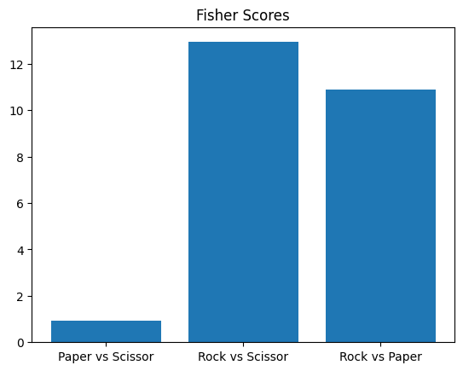
Figure 1: baseline result; i.e. no sensors have been ablated here.
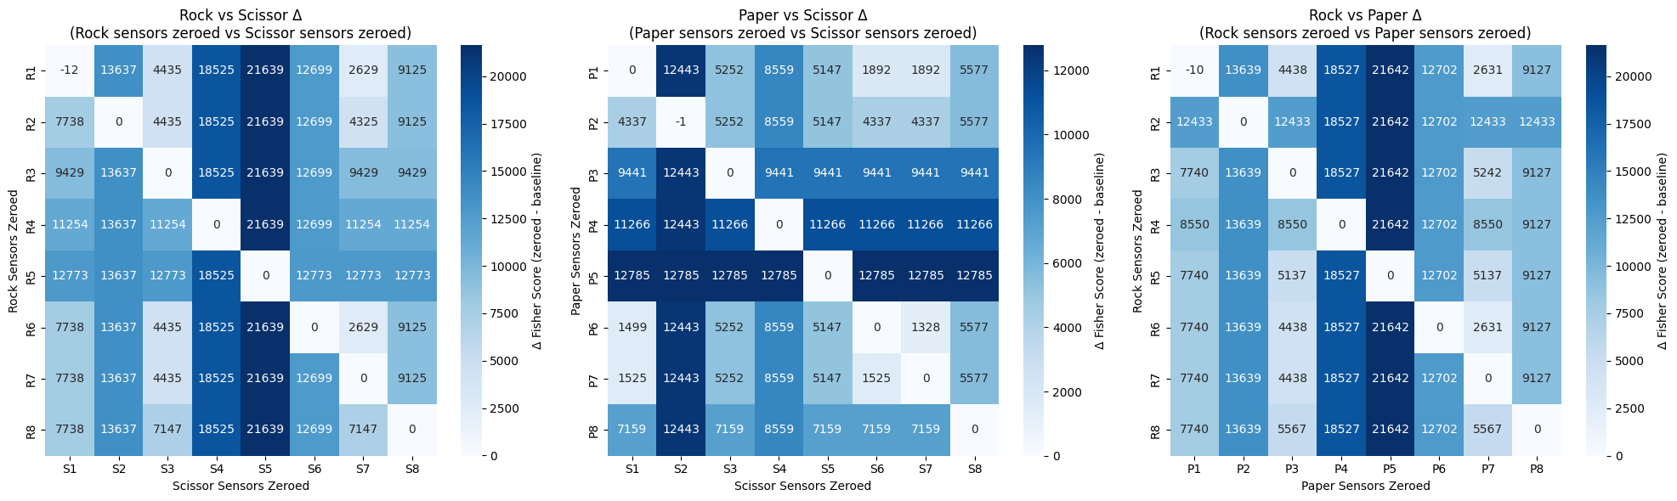
Figure 2: results, for your convenience. E.g. cell R1-S5 indicates the deltaF when sensor 1 of Rock and sensor 5 of Scissor have been ablated.
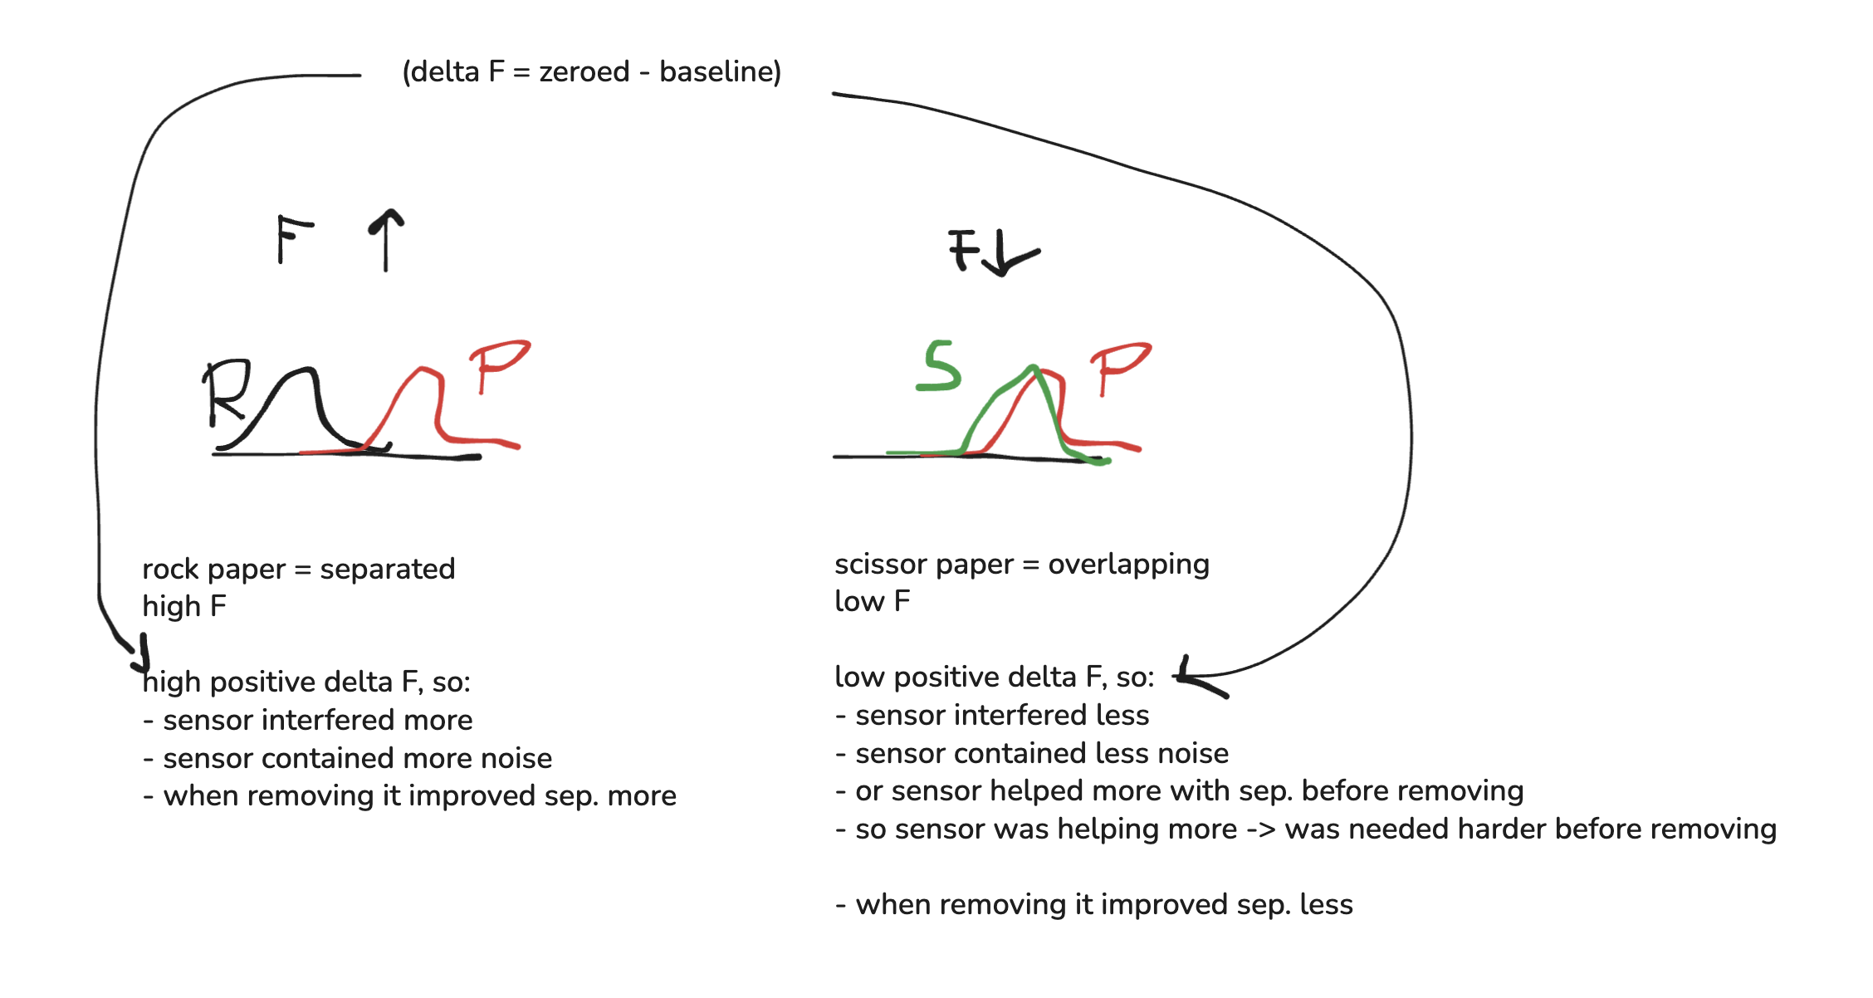
Figure 3: my explanation for finding 4, in keywords.
Background:
The way I saw it was that a negative deltaF (=zeroed-baseline) means that the Fscore is lower after ablating this sensor, thus the overlap got more, thus the separanility was worse after removing. So the sensor contributed positively to the separabiltiy before removing.
Conversly, a positive deltaF means that the sensor that is removed that created a positive deltaF makes the separabniltiy better, so it was 'messing' with the separbailtiy befroe removing. It was providing noise or was somehow disturbing the goal of separating the distributions (for downstream task [we are task-agnostic]).
Start of explanation:
The thing is, that the data shows that, that F(r,p) and F(r,s) are higher than F(p,s) before ablating anything (See figure 1). So finding 1 is that paper and scissor are harder to separate, which we verify using Roshambo paper results + physiological evidence (see overleaf).
Now, in the ablation study, we find that the diagonal values (e.g. R1,P1 or P4,S4) have near 0 or slightly negative deltaF (see figure 2). This I explain by saying that when we remove the same features, the effect of deltaF cancels, since both distributions change by a similar/nearly the same amount. This is the only case where we find (small) negative deltaFs (again, negative deltaF is good, since it worsens the separablity after ablation, so the sensor was crucial before removing). This is finding 2.
Finding 3 is, from figure 2, we see the following:
- all off-diagonals are positive deltaF, meaning they make the separability better after ablation.
- BUT the magnitudes differ.
- paper,scissor matrix has lower positive deltaFs (maximum and avg) than rock,paper and rock,scissor.
- in fact, the magnitudes scale similarly to the magnitudes in F found in finding 1. (backup of credibility of our method: it is consistent)
- now, why are deltaFs higher positive for rock,paper and rock,scissor than for paper,scissor?
This is finding 4 (^{needs most feedback}):
In the class separated scenario (rock,paper and rock,scissor) the deltaF is higher positive when ablating. This would mean that the sensor interfered more, contained more noise, because when removing it, it improved the separability. But we can also look at it the other way around.
The positive deltaF is less high in the unseparated scenario (paper,scissor). This means that the sensor interfered less, or contained less noise. OR (third perspective): it helped more with classification before removing. I.e. the sensor was less redundant (though it simply did not work provide enough useful information to make the classes separated [see finding 1, low F]). It does say, however, that the sensor was needed harder before removing RELATIVE to the class-separated scenarios (involving rock). This makes sense, since the classes are overlapping in scissor-paper, so the sensors contain information 'working at their limit', so to say. At least more so than in the rock scenarios, where redundancy might occur, since the classes are well separated.
Figure 3 may aid with this idea visually. I used it to think of the explanations, but I can imagine they are not very helpful for others. No worries if they are not useful, but maybe they can be.

Feedback:
Can you follow this reasoning?
Do you agree with the steps I made getting there?
I hope the idea somewhat came across to you. IF they are correct, what spots/topics do we need to emphasise to get this across optimally for the HCI crowd?

