Insider Dealings

Home Dashboard Analytics Brokers Stocks Foreign Money Flow Insider Dealings Ai Analysis Screener User Profile

Space for ADS

Ticker: User will input Insider Title  
Transaction Type: Check box – CEO Check box – CFO Check box – Director Check box – 10% owner  
 Check box – Acquired (A) Check box – Pres Check box - VP Check box – Officer Check box – Other We may add more insider title depending on the data  
 Check box – Disposed (D)

By default the page will show the latest insider trading for the past week.  
  
Parent Table

|  |  |  |  |  |  |  |  |  |  |  |  |
| --- | --- | --- | --- | --- | --- | --- | --- | --- | --- | --- | --- |
| Reference Number | Filling Date | Date of Announcement | Ticker | Company | Insider Name | Title | Transaction Type | Ave. Price | Qty | Value | Ttl number of shares after transactions |
|  | Date | Date | Stock Code | Company Name | Name of the Insider | Title | A or D |  |  |  |  |

Sub table when blue arrow above is expanded

|  |  |  |  |  |  |  |
| --- | --- | --- | --- | --- | --- | --- |
| Type of Security / Stock Symbol | Date of Transaction | Number of Shares | Acquired or Disposed | Price per share | Ownership From Direct (D) or Indirect (I) | Nature of Indirect Beneficial Ownership |
|  |  |  |  |  |  |  |

This page is intended to Insider Trading

We need a script that converts pdf to text and extract some information and put in the DB. There are 3 PDF templates so we will go over them one by one.

**How to Scrape data as per Template name** [**Acquisition or Disposition of Shares by Subsidiaries/Affiliates**](https://edge.pse.com.ph/announcements/form.do#viewer)  
  
This information is only being extracted from web.

Script visits, <https://edge.pse.com.ph/announcements/form.do> and in the Template name, enter [**Acquisition or Disposition of Shares by Subsidiaries/Affiliates**](https://edge.pse.com.ph/announcements/form.do#viewer)**.**

It will then click on the template name column and go over each row. At the time of setup, needs to get all data way back in Jan 1st, 2020. After all the data is up to date, it should run the script twice 3 times a day. 9:00 AM GMT+8, 12:30 PM, GMT +8, 5:30 PM GMT+8.  
  
Please refer to this link to see what data needs to extract from PDF and put in the DB. <https://1drv.ms/u/s!AqC9FHiTnP5i3WwabpJOZRDp1JGa?e=OfbhQK>

From the information that we extracted, we don’t have the average price and quantity and value, hence we need to compute it.

Example data

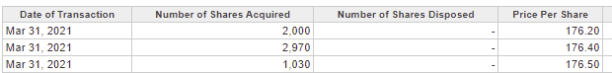

**How to get Qty**

Add number of shares per reference/circular number.  
  
Example from above.

QTY is 2,000 + 2,970 + 1,030 = 6,000

**How to get value**  
  
Example from above

Value is   
  
Transaction row 1 = 2,000 * 176.20 = 352,400  
Transaction row 2 = 2,970 * 176.40 = 523,908  
Transaction row 3 = 1,030 * 176.50 = 181,795  
  
Hence VALUE is transaction row1 + row 2 + row 3 = 1,058,103

**How to Average price**  
  
TOTAL VALUE 1,058,103 / TOTAL QTY 6,000 = AVE PRICE 176.3505

**How to Scrape data as per Template name** [**Change in Shareholdings of Directors and Principal Officers**](https://edge.pse.com.ph/announcements/form.do#viewer)  
This information is only being extracted from web.

Script visits, <https://edge.pse.com.ph/announcements/form.do> and in the Template name, enter [change in Shareholdings of Directors and Principal Officers](https://edge.pse.com.ph/announcements/form.do#viewer).  
It will then click on the template name column and go over each row. At the time of setup, needs to get all data way back in Jan 1st, 2020. After all the data is up to date, it should run the script twice 3 times a day. 9:00 AM GMT+8, 12:30 PM, GMT +8, 5:30 PM GMT+8.  
  
Please refer to this link to see what data needs to extract from PDF and put in the DB. <https://1drv.ms/u/s!AqC9FHiTnP5i3WulFLuus25GANNa?e=5Sr6E4>   
  
From the information that we extracted, we don’t have the average price and quantity and value, hence we need to compute it. Formula is the same as above.

However, for this template you need to get the Ttl number of shares after transactions column by adding the direct and indirect shares

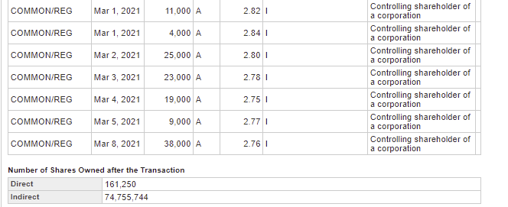

**How to Scrape data as per Template name Statement of Changes in Beneficial Ownership of Securities**

Script visits, <https://edge.pse.com.ph/otherReports/form.do> and in the template name enter **STATEMENT OF CHANGES IN BENEFICIAL OWNERSHIP OF SECURITIES.**

It will then click on the template name column and go over each row and download the pdf. Open pdf extract data and put in DB.  
  
At the time of setup, needs to get all data way back in Jan 1st, 2020. After all the data is up to date, it should run the script twice 3 times a day. 9:00 AM GMT+8, 12:30 PM, GMT +8, 5:30 PM GMT+8.  
  
Please refer to this link to see what data needs to extracted.  
  
<https://1drv.ms/u/s!AqC9FHiTnP5i3W2uc62ahSHQA3L1?e=YVtSSG>

Leave TTL Number of shares after transactions to NULL and for the value column, same computation as above.

In the event that the pdf file has a different value other than A or D, ignore and do not add in DB as per below.

