TERMINAL COMMAND STRUCTURE

command -options arguments

options can be long format with -- preceding ( --reverse)

options can be short format with - precending ( -l )

shorthand options can also be struing together ( -lt )

BASIC TERMINAL COMMANDS

date display current date time

cal display date on calendar

df show disk free space

free how memory free space

exit terminate terminal sessino

UNDERSTANDING THE FILE TREE SYSTEM

- organized in hierarchical directory structure

- unliked windows -- linux has one file system for all storage devices rather than individual file systems for each unit

- ## root directory

- located in /usr/bin which is where most programs are installed

NAVIGATING TERMINAL COMMANDS

pwd print name of current working directory

cd change directory

- "." refers to the current working directory

- ".." refers to the cwd parent directory

Shortcut Result

- cd Changes the working directory to your home directory.
- cd - Changes the working directory to the previous working directory.
- cd ~username Changes the working directory to the home directory of sername. For example, cd ~bob changes the directory to the home directory of user bob.

ls list directory contents

ls -a will show all folders/files including hidden folders/files

ls /Documents will show all contents of Documents folder without entering Documents folder

ls -l will change format to the long format

ls -lt will provide long format (l) and then (t) to sort the result by file's modification time

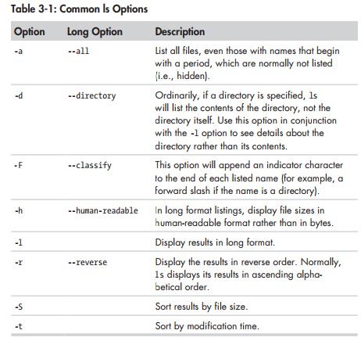
long format
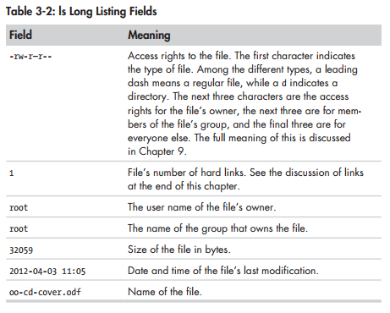
file determine file type – print brief description of the file

less view file contents of text files

Q to exit the less view

/characters to seach for characters in less

n – search for next occurencee of previous search

MANIPULATING FILES AND DIRECTORIES

COMMON MANIPULATION COMMANDS

cp copy files and directories

mv move/rename files and directories

mkdir create directories

rm remove files and directories

ln create hard and symbolic links

WILDCARDS FOR SELECTING GROUPS OF FILENAMES

* select any characters - (*.html)

? any single characters

[characters] any character that is a member of the set characters

[!characters] any character that is not a member of the set characters

[[:class]] any character that is a member of the specified class

Commonly used Character Classes

[:alnum:] any alphanumeric characters

[:αlpha:] any alphabetic characters

[:digit:] any numerical characters

[:lower:] any lowercase letter

[:upper:] any uppercase letter

WildCard Examples

* all files

g* any file beginning with g

b*.txt any file beginning with b and ending with .txt

Data??? any file beginning with Data followed by exactly three characters

[abc]* any file beginning with either a, b, or c

BACKUP.[0-9][0-9][0-9] beginning with ‘BACKUP’ followed by three numerals

[[:upper:]]* any file beginning with an uppercase

[![:digit:]]* any file beginning with a numerals

*[[:lower:123] any file ending with a lowercase or the numerals 1, 2 or 3

mkdir – CREATE DIRECTORIES

mkdir `dir` this will make a directory

mkdir `dir1 dir2` this will make mulitple directories

cp – COPY FILES AND DIRECTORIES

cp item1 item2 copy single file or directory to file item1 or file/dir item2

cp item… directory copy multiples items (either files or dirs) into a directory

CO OPTIONS

-a, --archive copy the files and irs and all of their attributes, ncluding ownership
and permissions. Normally copies take on the default attriburtes
of the user performing the acopy

-i, --interactive before overwriting file, prompt user for confirmation

-r –recursive recursively copy dirs and their contents (required when copying dir)

-u, --update when copying files from one dir to another copy only files which dont
exist or are newer than the corresponding in destination directory

-v, --verbose display informative messages as the copy is performed

mv - MOVE AND RENAME FILES

mv is used in the same was as cp

mv item1 item2 move or rename file or directory item1 to item 2

mv item… directory move oneor more items from one directory to another

mv OPTIONS

-i, --interactive before overwriting existing file, prompt the user to confirm

-u, --update when moving files from one dir to another, move only files
that either don’t exist in the destination dir or are newer than
the corresponding files in the destination directory

-v, --verbose display informative messages as the move is performed

rm – REMOVE FILES AND DIRECTORIES

rm is used to delete files and direcotires

rm item… (can list multiple items or directories)

WHEN USING WILDCARDS WITH RM DOUBLE CHECK FIRST WITH LS

RM OPTIONS

-i, --interactive before deleting a file, prompt the user for confirmation

-r, --recursive recursively delete directories. This means that if a dir
being deleted has subdirectories, delete them too

-f, --force Ignore nonexistent files and do not promprt. This overrides
the –interactive optional

-v, --verbose dipslay informative messages as the deletion is performed.

ln—CREATE LINKS

ln file link creates a hard link

ln -s item link creates a symbolic link

HARD LINKS

- every file has a single hard link that gives the file its name
- a hard link cannot reference a file outside its own file system – this means a link cannot reference a file that is not on the same disk aprtition as the link itself
- a hard link cannot reference a directory
- modern practice prefers symbolic links
- hard links are indistinguishable from the files themselves

SYMBOLIC LINKS

- special file that creates a text pointer to the referenced file or directory similar to a windows shortcut
- file and link are distinguishable from each other – if files are deleted then the link points to an empty space
- created to overcome the shortcomings of hard links
  - hard links cannot reference directories
  - hard links cannot span physical devices

When creating hard links we basically create additional titles directed towards the same data contents

ls -i this will show the file reference of each file in a directory

WORKING WITH COMMANDS

What Exactly are Commands??……… it is one of these four things

- An executable program – programs in /usr/bin – scripts written in python
- a command built into the shell itself – cd is a bash builtin command
- a shell function – miniature scripts incorporated into the environment

Common Commands
type – indicate how a command name is interpreted
which – display which executable program will be executed
man – display a commands manual page
apropos – display a list of appropriate commands
info – display a commands info entry
whatis – display a very brief description of a command
alias – create an alias for a command

Identifying Commands – there are a couply of ways to do this : )

- type command – indicate how a command name is interpreted
  - type ls ls is aliased to ‘ls –color=’auto’ – this is why dit displays in color :)
  - type cd cd is a shell built in
  - type cp cp is hashed (/bin/cp)

- which command
  - only works for executable programs – not built-ins or aliases
    - which ls /bin/ls
    - which cd error – because cd is a shell built in

Getting a Commands Documentation

- help function – retrives the documentation for the function in question
  - help cd
  - when squar brackets appear in help notation – that indicates the arg is optional
  - an vertical bar between args in brackets indicates args that are mutually exclusive

- man function – retrieves alternative documentation to help function
  - man ls
  - layout of a manual ( we can specify a number ex – man 3 ls to retrieve section 3 of ls
    - user commands
    - programming interfaces for kernel system calls
    - programm interfaces to the c library
    - special files such as device nodes and drivers
    - file formats
    - games and amusements such as screensavers
    - miscellaneous
    - system admin commands
- apropos – search the list of man pages for possible matches based on term
  - apropos floppy – searches for floppy in command documentation

- whatis – shows a very brief description of the function

aran@lexce:~$ whatis ls
ls (1) - list directory contents

- info – an alternative to the manual pages – ordered by links
  - info ls

Documentation beyond info and man pages

- documentation for commands stored in /usr/share/doc directory
- use less to view the documentation and zless for zipped document in gz file

CREATING YOUR OWN COMMANDS USING ALIAS

alias ls=’cd /usr/bin; ls -l; cd -’
unalias ls

REDIRECTION

What is Redirection?

- Redirection is the ability to redirect the input and output of a command to different files
- By default output is linked to stdout & stderr which are files linked to the screen
- By default many programs take input from a file called stdin which is linked to keyboard but with I/O direction we can change stdout & stderr & stdin

Common Redirection Commands

- cat concatenate files
- sort sort lines of text
- uniq report or omit repeated lines
- wc print newline, word, and byte counts for each file
- grep print lines matching a pattern
- head output the first part of a file
- tail output the last part of a file
- tee read from standard input and write to standard output and files

Redirecting Standard Output

- ls -l /usr/bin > ls-output.txt
- when directing to a text file it rewrites the file each time
- if an error is thrown – it will show the error because errors are sent to stderr not stdout
- to truncate or create an empty file we can use “ > ls-output.txt ”
- to append / not overwrite a logging file we can simply use two arrows

Redirection Standard Error

- to redirect standard error we must refer to its file descriptor
- stdin, stdout, stderr are referenced as file descriptors 0, 1, 2 respectively
- ls -l 2> ls-error.txt – this will redirect the std error

Redirecting Standard Output and Standard Error to One File

- Two ways to do this
  - old way
    - ls -l /bin/usr > ls-output.txt 2>&1
    - must redirect error with 2>&1 after redirecting standard output
  - new way
    - ls -l /bin/usr &> ls-output.txt
    - this redirects both standard output and well as stderr to the specified file

Disposing of Unwanted Output

- to suppress error messages we direct output to /dev/null – which is a special file which accepts input but does nothing with it
  - ls -l /bin/usr 2> /dev/null

Redirecting Standard Input

cat – Concatenate Files

- cat [file . . .]
  - this will copy whichever file you pass to output
  - often good for displaying short text files
  - cat can accept more than one file – so it can be used for joining files together
- cat movie.mpeg.0* > movie.mpeg
  - this will take pieced files such as ( movie.mpeg.001, movie.mpeg.002 and concat )

- In the absence of filename arguments cat copies stdin to stdout
  - Below will create a lazy_dog.txt file with the contents specified
  - cat > lazy_dog.txt → The quick brown fox jumped over the lazy dog
  - then we can use the same cat command to copy the file to std output again!
  - Using < operator we can change the source of stdin from keyboard to lazy_dog.txt

Pipelines

- ability of commands to read data from stdin and send to stdout is utilized by pipelines
- using the pipe operator “|” the std output of one command can be piped into the std input of another
  - ex. ls -l /usr/bin | less

Filters

- often-times pipeliens are referred to as filters – they take input, change it, then output it
  - ex. ls /bin /usr/bin | sort | less ( combine list of all executable programs from dirs)
Uniq – Report or Omit Repeated lines
  - ls /bin /usr/bin | sort | uniq | less
  - ls /bin /usr/bin | sort | uniq -d | less ( passing -d will show you duplicate values)
wc—Print Line, Word, and Byte Counts
- wc ls-output.txt
- ls /bin /usr/bin | sort | uniq | wc -l

grep—Print lines matching a pattern
- ls /bin /usr/bin | sort | uniq | grep zip
- options -i (ignorecase) & -v ( print lines that do not match )

head / tail—Print First / Last Part of Files

- -head prints the first 10 lines of text, tail prints last 10 lines – can be adjusted with n
- head -n 5 ls-output.txt
- head / tail can be used in pipelines as well
- ls /usr/bin | tail -n 5
- using -f function on tail it allows us to view files in real time

tee-- Read from Stdin and Output to Stdout and Files

- tee function allows for us to read stdin and copy to both stdout and a file
- ls /usr/bin | tee ls.txt | grep.zip

SEEING THE WORLD AS THE SHELL SEES IT

echo – display a line of text

EXPANSION – the processes BASH carries out on command text b4 processing

- echo * - displays all files / dirs in pwd
  - before echo receives * – * is expanded into the file names within the pwd
- echo D* - will display all directories which start with D
- echo *s – will display all directories which end with ‘s’
- echo [[:upper:]]* – will display all directories beginning with a capital lettter
- echo /usr/*/share – will display all dirs within usr dir which contain a share dir

ECHO WITH HIDDEN FILES . \

- echo respects . Hidden file syntax
- echo .* will almost display all hidden files – but also includes “.” and “.” which are pwd and parent directories
  - echo -d [.!]?* is a specific pattern which will return exactly what we need :)

TILDE EXPANSION

- ~ expands to the home dir of the current user – or of the specified user
  - echo~ → /home/aran
  - echo ~foo → /home/foo

ARITHMETIC EXPANSION

- echo $((2+2)) → 4
  - must have the dollar sign along with ((..)) to do
- Spaces are insignificant in arithmetic expansion
  - echo $(($((5**2)) * 3))
- Single expressions can be grouped in parentheses
  - echo $(((5**2) * 3 ))
- Arithmetic can be embedded into text
  - echo with $((5%2)) left over.

BRACE EXPANSION

- You can create multiple text strings from a pattern containing braces
  - echo Front-{A,B,C}-Back (CANNOT CONTAIN SPACES IN BRACES)
- You can use double dot notation to span integers and letters
  - ech Number_{1..5} – Number_1 Number_2 Number_3 . . .
  - echo {Z..A} – Z Y X W V U T S R Q P O . . .
- Brace expansions may be nested
  - echo a{A{1,2},B{3,4}}b
    - aA1b aA2b aB3b aB4b
- Most common use is to create a list of directories for organizational purposes
  - mkdir {2009..2011}-0{1..9} {2009..2011}-{10..12}

PARAMETER EXPANSION

- Capabilities have to do with system to store chunks, variables available for examination
  - $USER → aran
- To see a list of variables use printenv
  - printenv → list of global variables
- More useful in shell scripts than directly in the terminal

COMMAND SUBSTITUTION

- allows us to use the output of a command as an expansion
  - ls -l $(which cp) → we get list of cp command without having to know full pathname
- entire pipelines can be used with command substitution
  - file $(ls /usr/bin/* | grep zip)
- alternative syntax allows for back ticks `` rather than () in command substituion
  - ls -l `which cp`

QUOTING

- white spacee will be removed when using echo due to word splitting
- when using $100 it replace $1 with an empty string because it is a non-existant variable

Double Quotes

- All special characters placed inside double quotes lose their special meaning with the exception of $ \ and ` (arithemetic, parameter expanison, and command subs are supressed)

Single Quotes

- All expansions are suprressed when placed in single quotes
- echo 'text ~/*.txt {a,b} $(echo foo) $((2+2)) $USER' → returns string value

ESCAPING CHARACTERS

- To escape single characters use the \ symbol
  - echo “The balance for user $USER is: \$5.00” → escapes $ special meaning
- You can escape special characters in file names as well
  - mv bad\&filename good_filename
- To allow backslashs to appear use “\\”

Backslash escape sequences

- /a bell (“alert” --causes the computer to beep)
- /b backspace
- /n Newline(on unix-like systems it produces a linefeed)
- /r carriage return
- /t tab

ADAVNCED KEYBOARD TRICKS

clear clear the screen
history display the contents of the history list

COMMAND LINE EDITING

- bash uses the library Readline – a shared collection of routines that diff programs can use
- CURSOR MOVEMENT COMMANDS

  - ctrl-a move curosr to the beginning of the line
  - ctrl-e move cursor to the end of the linefeed
  - alt-f move cursor forward one word
  - alt-b move cursor back one word
  - ctrl-l clear the screen and move to the top left corner

- TEXT EDITING COMMANDS
  - ctrl-d delete the character at the cursor location
  - ctrl-t transpose the character at the cursor location with the one preceding it
  - alt-t transpose the word at the cursor location with the on preceding it
  - alt-l convert the chars from the cursor location to the end of the word to lc
  - alt-u convert the chars from the cursor loc to the end of the word to uppercase

- CUT & PASTE COMMANDS
  - ctrl-k kill text from the cursor location at the end of the linefeed
  - ctrl-u kill text from the cursor location to the beginning of the linefeed
  - alt-d kill text from the cursor location to the end of the current word
  - alt-backspace kill text from the cursor location to the beginning of the currrent word
  - ctrl-y yank text from the kill-ring and insert it at the cursor location

COMPLETION

- using tab can autocomplete for directory names and for global variables
  - alt-? Display list of possible completions (also double click tab will do this)
  - alt-* insert all possible completions

USING HISTORY

- history is kept in a file called bash_history
- history | less → will view command history using less
- history } grep /usr/bin → will return all commands in history with /usr/bin
- to use a numbered line from history we can use !####
- ctrl+R + typing - will search incrementally when entering each character in
  - to quit search press ctrl – C or ctrl – G

HISTORY COMMANDS

- ctrl-p move to the previous history entry. Same action as up
- ctrl-n move to the next history entry. Same action as down arrow
- alt < move to the beginning of the history list
- alt > move to the end of the history list
- ctrl r reverse incremental search.
- Alt p reverse search, non incremental.
- Alt-n forward search non incrementally
- ctrl o execute the current item in the history list and advance to the next one handing if you are trying to re-execute a sequence of commands

HISTORY EXPANSION

- !! repeat the last command. It is probably easier to press the up arrow
- !number repeat history list item numbere
- !string repeat last history list item starting with string
- !? repeat last history list item containing string

PERMISSIONS

COMMON COMMANDS

- id display user identity
- chmod change a files mode
- umask set the default file permissions
- su run a shell as another user
- sudo execute a command as another user
- chown change a file’s owner
- chgrp change a file’s group ownership
- passwd change a user’s password

OWNERS, GROUP MEMBERS, AND EVERYBODY ELSE

- /etc/passwd user accounts are defined – super user and other system users defined
- /etc/group groups are defined – super user and other system users defined as well
- /etc/shadow passwd infomration
- /etc/passwd user name, uid, gid, accounts real name, home directory, login shell

READING, WRITING, AND EXECUTING
- -rw-rw-r--
  - - ( precursor ) file type
  - rw (section 1) owner permissions
  - rw (section 2) group permissions
  - r (section 3) world permissions ( everyone else )

- File types (precursor )
  - - a regular file
  - d a directory
  - l a symoblic link ( dummy variable is listed rwxrwxrwx → real value is with the file which the link points to
  - c a character special file → devicce that handles stream of bytes ( modem )
  - b a black special file → device that handles data in blocks (hard- drive / cd)

- Permission Attributes
  - r
      - allows files to be open and read
      - allows a dirs contents to be listed if the execute attribute is also set
  - w
      - allows a file to be written or truncated – cannot be renamed or deleted that is defined by the permissions of the directory
      - allows files within a directory to be created, deleted, and renamed if the execute attribute is also set
  - x
      - allows a file to be treated as a program and executed. Program fiiles written in scripting languages must also be set as readable to be executed
      - allows a dir to be entered; e.g., cd direcotories

- Octal Representation

  - Typically only 7, 6, 5, 4 and 0 will be of use

  - 0 000 ---
  - 1 001 --x
  - 2 010 -w-
  - 3 011 -wx
  - 4 100 r--
  - 5 101 r-x
  - 6 110 rw-
  - 7 111 rwx

- Setting Permissions w/ Octal
  - chmod 600 → will set read / write access for ownership → -rw---------

- Symbolic Representation

  - u short for user bu tmeans file or directory ownership
  - g group ownership
  - o short for others but means world
  - a short for all; the combination of u, g, o
  - none if none is specified a is assumed

- Setting Permissions w/ Symbolic
  - u + x add execute permission for the owner
  - u – x remove execute permission for the ownership
  - +x add execute permisson for ugo
  - o-rw remove read and write permission from any else but owner and group
  - go=rw set the group owner and anyone else besides the owner to have read and write permission. If t either the group owner or world previously had execute permissions remove them
  - u+x,go=rx add execute permissions for the owner and set the permissions for the group and others to read and execute. Multiple specifications may be separated by commas

umask – SET DEFAULT PERMISSIONS

- umask sets default permissions when creating a file in a given directory

- 0002 -rw-rw-r--
- 0000 -rw-rw-rw- mask is turned off with 0000

- how read / write works in binary

0000 0022
--- rw- rw- rw- --- rw- rw- r--
000 000 000 000 000 000 000 010

- umask 4000 ( setuid bit ) sets the uid of the real user to that of the program’s owner
  - allows for ordinary user to have access to root files
  - chmod u+s program – set the uid of a program
  - -rwsr-xr-x
- umask 2000 ( setgid bit ) set the gid to the gid of the file owner –
  - giving root permit
  - chmod g+s dir – SET THE GID OF A PROGRAM
  - drwxrwsr-x
- umask 1000 (sticky bit)
  - linux ignores the sticky bit for files, but if applied to a dir it prevents users from renaming or deleting files unless the user is eithe rthe owner or superuser
  - chmod +t dir – SET THE STICKY BIT TO A DIR
  - drwxrwxrwt

CHANGING IDENTITIES

SU – SUPER USER

su—Run a Shell with Subsitute User and Group IDs

- su [-[l]] [user]
  - results in a login shell for the specificed user – home directory changed to users home
  - if user is not specified superuser is assumed
- su -
  - start a shell for superuser
- su – c ‘command’
  - run a single command with superuser privilege

SUDO – SUPER USER ACCESS CONFIGURED BY SU

- allow an ordinary user to execute commands a different user (usually the superuser)
  - can restrict to specific commands
- sudo does not require access to superuser’s password

chown—CHANGE FILE OWNER AND GROUP

- chown [owner][:[group]] file…

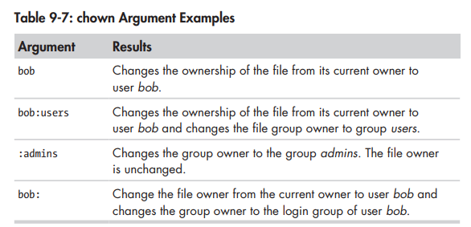

chgrp—CHANGE GROUP OWNERSHIP

- umask must be 0002 if the directory will contain folders
  - set umask is only present until end of the session – you can make it permanent

EXAMPLE STEP-BY-STEP
- create music group with gnomes GUI user managemt tool
  - name the group music
  - add Karen and Bill as users
- create the directory for the music files
  - sudo mkdir /usr/local/share/Music
- change group ownership to created group in step 1
  - sudo chown :music /usr/local/share/Music
  - sudo chmod 775 /usr/local/share/Music
- created files + directories have karen/bill default permissions
  - to fix give group music control to Music directory & umask change to 0002
    - sudo chmod g+s /usr/local/share/Music
    - umask 0002

CHANGING YOUR PASSWORD

- passwd [user]

PROCESSES

Modern operating systems create the illusion of doing more than one thing at once switching between many different operations simultaneously – this is done through the use of processes

when a linux os starts up it initiates a few programs along with init which in turn runs a series of shell scripts locateed in /etc – many of these services implmeneted as daemon programs – which are programs which sit in the background

COMMON PROCESSES COMMANDS

- ps Report a snapshap of current processes ( most common )
- top display tasks
- jobs list active jobs
- bg place a job in the backgrounds
- fg place a job in the backgrounds
- kill send a signal to a processes
- killall kill processes by name
- shutdown shut down or reboot the system

ps—VIEWING PROCESSES

- PID is the numeric labeled provided by the kernel ( init is always provided PID 1 )
- TTY is short for teletype and refers to the controlling terminal for the processes

ps x

- show all of our processes
- ? in TTY indicates no controlling terminal

PROCESS STATES ( STAT COLUMN )
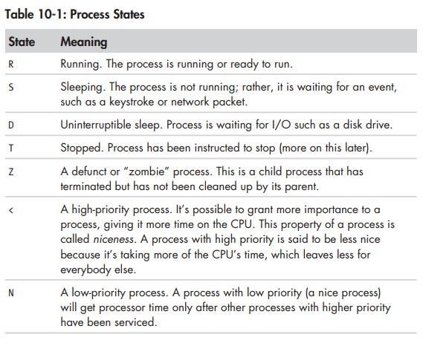
ps aux

- displays a list of processes belonging to every user

BSD-Style ps Column Headers
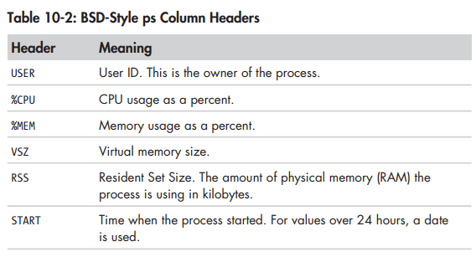

r

top—VIEWING PROCESSES DYNAMICALLY

- provides an updated list of processes in order of process activity
- top section provides system summary of usage
- use q for quitting – h for help screen

CONTROLLING PROCESSES

process & ( xlogo & )

- xlogo & will run the program in the background
- fg %1 to push process to the foreground
- bg %1 to push process to the background

jobs

- can see the working terminal processes

SIGNALS

kill

- kill [-signal] PID. . .
  - if no signal is specified then TERM signal is sent by default
- Common Signals
  - HUP used by daemon programs to cause reinitialization
  - INT interrupt (same as ctrl + c ) – will usually terminate the process
  - KILL no signal actually sent – the terminal immediately terminates the program
  - TERM default signal sent by kill – if process still alive it will terminate
  - CONT this will restore a process after a stop signal
  - STOP this will cause the process to pause without terminating
  - QUIT quitting
  - SEGV signal sent if program makes illegal use of mem – disallowed writing
  - TSTP terminal stop ( ctrl + z ) program may ignore it if it chooses
  - WINCH window change ( size ) – most commonly seen with less or top

SENDING SIGNALS TO MULTIPLE PROCESSES WITH KILLALL

- killall [-u user] [-signal] name . . .
- startup two xlogos ( xlogo & || xlogo & )
- killall xlogo – terminates all xlogo instances

OTHER PROCESS RELATED COMMANDS

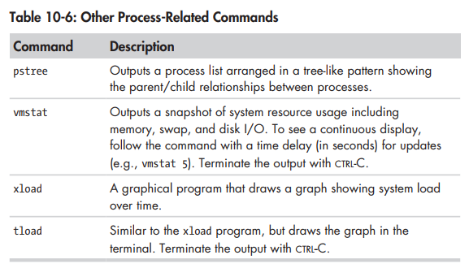

THE ENVIRONMENT

stores two variables in environment ( they are largely indistinguishable )
- shell variables added by bash
- environment variables everything else

COMMON ENVIRONMENT COMMANDS

- printenv print part or all of the environment
- set set shell options
- export export environment to subsequently executed programs
- alias create an alias for a command

EXAMINING THE ENVIRONMENT

- printenv provide a list of all environment variables
- set | less provide a list of all variables as well as functions
- echo $HOME provide the HOME variable
- alias show all alias variables

COMMON VARIABLES

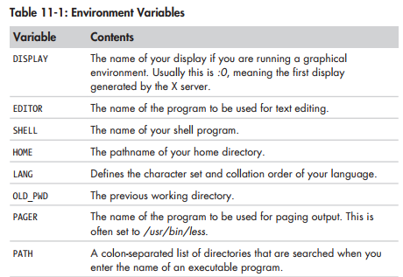

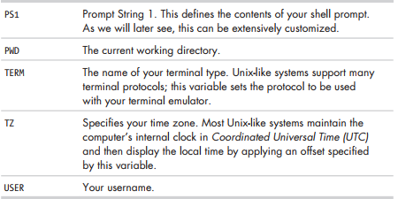

HOW IS THE ENVIRONMENT ESTABLISHED ?

Two kinds of shells

- login shell – files read in on startup
  - /etc/profile a global config script that applies to all users
  - ~/.bash_profile users personal startup – can override / extend global /etc/profile
  - ~/.bash_login if ~/.bash_profile is not found – bash attempts to read this
  - ~/.profile if ~/.bash_profile or ~/.bash_login is found, bash attempts to read

- non-login shell – files read in on startup
  - /etc/bash.bashrc global config script that applies to all users
  - ~/.bashrc users personal config can be used to override /etc/bash.bashrc

WHAT IS IN A STARTUP FILE

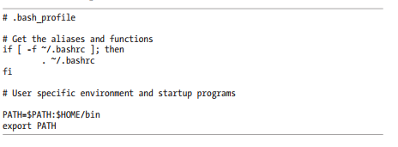

- # comments
- if [-if ~/.bashrc ]; then …. compound command
- PATH=$PATH:$HOME/bin adds HOME/bin to path – we can add custom scripts to the HOME/bin path and be set to go : )
- export PATH make PATH available to child processes of this shell

MODIFYING THE ENVIRONMENT

Unless you are sys admin you should only change bash files in your home dir. Changing files in the /etc directory is possible and does make sense in some scenarios – it is for sys admins

- .bash_profile – .profile edit to add items to path – .profile is ubuntu equivalent
- .bashrc everything else
- source .bashrc force environment to reread bashrc

TEXT EDITORS

- nano
- vi / vim
- gedit
- kate
- kwrite
- kedit

nano

- ctrl + x exit the editor
- ctrl + o save your work

VI – A GENTLE INTRODUCTION

in vim documentation command mode = normal mode and ex commands = command mode

- :q <enter> quit vim
- :q! <enter> force quit vim
- :w save work
- i (command mode) enter into insert mode
- esc (insert mode ) enter into command mode

- vi beings in command mode → press (i) to begin with insert mode

VI CURSOR MOVEMENTS

- l or right arrow right one character
- h or left arrow left one character
- j or down arrow down one line
- k or up arrow up one line
- 0 ( zero ) to the beginning of the current line
- shift-6 (^) to the first non-whitespace char in current line
- shift-4 ($) to the end of the current line
- w beginning of the next word or punctuation
- shift + w to the beginning of the next word – ignore punctuation
- B to the beginning of previous word or punctuation
- shift + b to the beginning of previous word ignore punctutation
- ctrl + f or pg down down one page
- ctrl b or pg up up one page
- number-shift-g to line number
- shift-g to the last lien of the file

VI BASIC EDITING

- u undo
- a add space and write
- shift + a jump to end of line → enter insert mode
- o insert into below line → enter insert mode
- O inert into above line → enter insert mode
- 4 x delete 4 characters at cursor location
- d general purpose delete ( followed by a movement cmd )

COMMON DELETE COMMANDS

- x the current char
- 3x the current char and next 2 chars
- dd the current linefeed
- 5dd the current line and next four lines
- dW from the current cursor location to the begin of next word
- d$ from the current cursor location to the end of the curr line
- dO from the current cursor location to the beginning of the line
- d^ from the current cursor location to the first non-whitespace charact3
- dG from the current line to the end of the filename
- d20G from the current line to the 20th line of the file

CUTTING, COPYING, AND PASTING TEXT

- d general cutting
- p general pasting
- y general copying
- yy copy current line
- 5yy copy the current line and next four lines
- yW from the current cursor location to the beginning of the next word
- y$ from the current cursor location to the end of the current line
- y0 from the current cursor location to the first non-ws char in the line
- y^ from the curr cursor location to the first non-ws char in the line
- yG from the curr line to the end of the file
- y20G from the current line to the 20th line of the filename

JOINING LINES

- shift + j delete /n character to join curr line and line below

SEARCH & REPLACE

- f searches a line and moves cursor to the next instance
- / searches entire file ( follow with n to find next instance )
- :%s/Line/line/g replace Line with line
  - : colon character starts an ex command
  - % specifies range of search (shorcut for all lines ) 1,5 – 1,$
  - s specifies the operation – s for substitution ( s & r )
  - /Line/line search pattern and the replacement text
  - g global – if omitted only the first instance of string is replaced on each line
- :%s/Line/line/gc
  - gc global – user confirmation
    - y perform substituion
    - n skip instance of the pattern
    - a perform subsitution on this and all subsequent instances of pattern
    - q quit substituting
    - l perform this lsat substitution then quit
    - ctrl-E / Y scroll down and scroll up, respectively
EDITING MULTIPLE FILES

- :n move from one file to the next
- :N move back to previous filen
- :n! switch files and abandon changes
- :buffers view all open files
- :buffer within buffers → :buffer[ file number ]
- :r [filename] insert file into other file
SAVING OUR WORK
- :w save our work
- ZZ save and exit our work
- :wq save and quit
- :w foo1.txt save the file as foo1.txt

I LOVE TO WRITE CODE IN LINUX IT IS VERY FUN !!

DIRECTORIES FOUND ON A UNIX/LINUX MACHINE

/ the root directory, where everything begins
/bin contains binaries that must be present for system to run

/boot contains the linux kernel, initial ram disk image and boot loader

Intersting files:
- /boot/grub.conf or menu.lst – used to configure boot loader
- /boot/vmlinuz, the linux kernel

/dev contains device nodes – devices are files as well (‘everything is a file’)

/etc contains all system wide configuration files – it also contains a collection
of shell scripts that start each of the system services at boot time. Everything
in this directoyr should be readable text

Intersting files:
- /etc/crontab, a file that defines when automated jobs will run
- /etc/fstab, a table of storage devices and their associated mount poitns
- /etc/passwd, a list of the user accounts

/home where all base-users folders are held – users can only modify files in their folder

/lib contains hard library files used by the core system programs (DLLS in win10)

/lost+found all formatted partitions have this directory – used in case of a partial recovery from filesystem corruption event – will stay empty unless something bad happens

/media contains the mount points for all removable media such as USB, CD-ROMS
that are mounted automatically when used – on modern linux systems

/mnt mount points for removable devices which are mounted manually old linux

/opt used to install optional commercial software products

/proc a special library which keeps virtual files maintained by the linux kernel –
these act as peepholes into the linux kernel and cann allow you to see how the
linux kernel sees your computer

/root home directory for the root accounts

/sbin contains system binaries. Programs that preform vital tasks, typically
reserved for a super user

/tmp used for storage of temporary transient files created by various programs –
some configurations have it emptied everytime comptuer is rebooted

/usr largest directory – contains all programs and support files used by reg users

/usr/bin contains executable programs installed by your linux distro – not uncommon
for this directory to hold 1000’s of programs

/usr/lib the shared libraries for programs in /usr/bin

/usr/local where programs that are not included with your distro, but are intended for
system wide use are installed. Programs compiled from source code typically
installed in /usr/local/bin – will be empty until system admin puts something

/usr/sbin contains more system administration programs

/usr/share contains data used by programs in /usr/bin. Default config files, icons, screen
backgrounds, sound files etc.

/usr/share/doc documentation files on installed programs organized by package

/var where dynamic data (data likely to be changed) is stored – databases, spool
files, email etc

/var/log contains records of various system activity – very important and should be
monitored from time to time – most useful is ( var/log/messages ) – in some
systems may need superuser priveleges to view

# SYMBOLIC LINKS
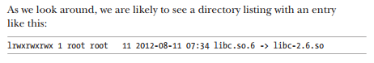

symbolic link files can be useful in terms of version control

helps to make version upgrades easier – we can delete old symbolic link files which point to outdated version of file and replacee with new symbolic link file pointing to new version – this also allows us to keep multiple versions on our PC : )

