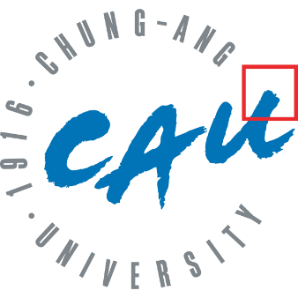

Greek Mythology Explorer – Final Report

Natural Language Processing and Information Retrieval

-

Final Group Project

Tim Leute (50251142)

Elyesa Duru

Hamidreza Rahimian

Dilara Alkanalka -50251145

Content

1 Introduction 3

1.1 Motivation 3

1.2 Project goals and use case 3

2 Data Acquisition and Graph Modelling 4

2.1 Data source: Wikidata and SPARQL 4

2.2 Graph construction: Nodes, edges and relationships 4

3 System Architecture 4

3.1 Technology stack overview 4

3.2 Web integration and interface 4

3.3 Migration from early prototypes 4

4 Core Features 4

4.1 Interactive graph exploration 4

4.2 Shortest path queries 4

4.3 Character similarity matching via vector comparison 4

5 Evaluation 4

5.1 Evaluation setup and methodology 4

5.2 Relevance metrics: Precision@K, MAP, NDCG 4

5.3 Results and Interpretation 4

6 Conclusion and Outlook 4

7 References ………………………………………………………………………………………………..4

# Introduction

## Motivation

Greek mythology encompasses a vast network of characters—such as gods, deities, titans, and heroes—connected by complex familial and social relationships. Understanding these connections can be challenging when relying solely on traditional text-based resources or websites, the information is often spread out and must be gathered and connected by the reader. Given the relational structure of mythological characters, using a graph data to represent and explore the information is a natural and effective approach by modeling the characters as nodes and relationship as edges. nodes and relationship. This data structure makes it possible to explore connections interactively and visualize the mythological universe in a way that highlights structure and complexity. Our project leverages these strengths of graph-based modeling to offer a more accessible and intuitive way to study and navigate Greek mythology.

## Project goals and use case

The primary goal of this project is to develop an interactive and informative platform for exploring Greek mythological characters and their relationships through graph-based data representation. By leveraging structured data and graph analysis, the tool enables users to intuitively search for characters, visualize connections such as family ties or rivalries, and better understand the intricate narratives of Greek Mythology. Additional features such as shortest path queries and a preference-based character matching quiz make the platform both informative and engaging. The project serves educational and exploratory purposes by simplifying access to complex mythological networks.

# Data Acquisition and Graph Modelling

## Data source: Wikidata and SPARQL

Wikidata is a structured knowledge base where entities (items) are assigned unique identifiers starting with "Q" (e.g., Zeus is represented by Q34201), and relationships (properties) are denoted by identifiers starting with "P" (e.g., "father" is represented by P22). These identifiers enable precise and language-independent querying across domains such as mythology[1] (Pastor-Sánchez et al., 2021).

To extract relevant data, the Wikidata Query Service was utilized, which supports SPARQL—a powerful query language for RDF (Resource Description Framework) data. The query was formulated to target mythological characters and their interrelations, resulting in the retrieval of a dataset containing entities labeled with names, types (such as god, deity, titan), and their corresponding relationships (e.g., mother, spouse, killed by). The query results were exported as a CSV file, serving as the raw input for the graph model.

## Graph construction: Nodes, edges and relationships

After obtaining the raw dataset from Wikidata, the next step involved modeling the data as a graph to enable structured exploration and analysis. In the constructed graph, each mythological character is represented as a node, while each relationship between characters—such as "mother," "father," "sibling," "spouse," or "killed by"—is modeled as a directed edge connecting two nodes.

The graph was built using NetworkX, a Python library designed for the creation, manipulation, and analysis of complex networks. This representation allows us to treat mythology as a relational graph, enabling effective traversal, visualization, and analysis of inter-character relationships. The final graph consists of 529 nodes and 1358 edges, reflecting the rich and interconnected nature of Greek mythology.

# System Architecture

## Technology stack overview

## Web integration and interface

## Migration from early prototypes

# Core Features

## Interactive graph exploration

## Shortest path queries

## Character similarity matching via vector comparison

# Evaluation

**Note on Sources**  
The theoretical foundations and evaluation methodology in this section are based on materials from the course lecture (*Lecture 04, 2025, Chung-Ang University*) as well as the following standard IR textbooks: *Introduction to Information Retrieval* by Manning, Raghavan, and Schütze (2008), and *Modern Information Retrieval* by Baeza-Yates and Ribeiro-Neto (1999, 2011).

## Evaluation setup and methodology

To evaluate the effectiveness of our character matching system, we follow standard IR evaluation methodology. Since direct user satisfaction is hard to measure, we use **relevance** as a proxy.[2] A result is considered relevant if the suggested character meaningfully matches the user-defined profile.

Our setup includes:

* A set of **test queries** based on user-defined slider inputs.
* **Manual relevance judgements** for the top-k results per query, using binary and graded scales.[3]
* Evaluation using standard IR metrics.

This approach aligns with the classic IR evaluation framework: a document collection, a set of information needs, and relevance assessments.[4]

## Relevance metrics: Precision@K, MAP, NDCG

We apply three widely used IR metrics:

* **Precision@K**: Measures the proportion of relevant results in the top K[5]. It reflects how well the system ranks relevant characters at the top.
* **Mean Average Precision (MAP)**: Averages the precision at each relevant result position, then across all queries.[6] It rewards systems that rank relevant results higher.
* **Normalized Discounted Cumulative Gain (NDCG)**: Accounts for graded relevance and discounts lower-ranked results logarithmically.[7] It is especially useful when not all relevant results are equally important.

These metrics allow us to compare different configurations of our matching algorithm and assess ranking quality in a structured way.

## Results and Interpretation

To evaluate the effectiveness of our character matching system, we conducted five test queries using different slider configurations. Each query returned a ranked list of mythological characters based on Euclidean distance to the input profile. As an example, the screenshot below shows one such query and its top results:

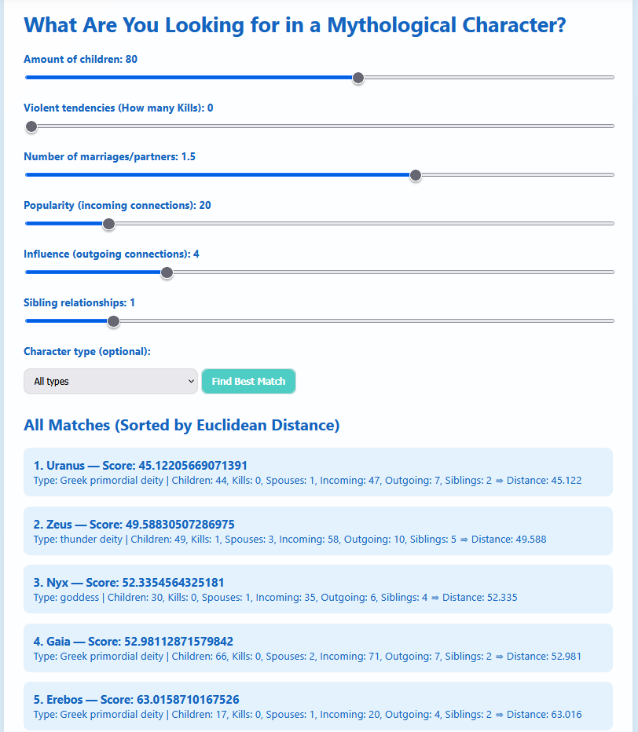

To assess the quality of these results, we manually assigned graded relevance scores (0 = not relevant, 1 = somewhat relevant, 2 = highly relevant) to the top 5 matches for each query. Based on these judgments, we computed three standard IR metrics: **Precision@5**, **Mean Average Precision (MAP)**, and **Normalized Discounted Cumulative Gain (NDCG@5)**. The following table summarizes the results:

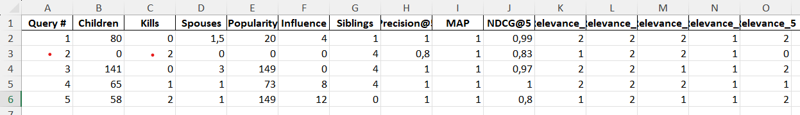

* **Key Observations:**
* **Precision@5** was **1.0** for 4 out of 5 queries, indicating that most top-ranked results were relevant.
* **MAP** reached the maximum value of **1.0**, showing that relevant characters were consistently ranked at the top across all queries.
* **NDCG@5** values ranged from **0.80 to 1.00**, reflecting that highly relevant characters were generally placed in higher positions, with minor variations in ranking quality.

These results suggest that our system is effective at identifying and ranking mythologically similar characters based on user-defined traits. The combination of graph-based data modeling and vector similarity appears to yield meaningful and interpretable results.

# Conclusion and Outlook

# Refereces

Pastor-Sánchez, J., Kontopoulos, E., Saorín, T., Bebis, T., & Darányi, S. (2021). Greek Mythology as a Knowledge Graph: From Chaos to Zeus and Beyond. Semantic Web Journal. Retrieved from <https://www.semantic-web-journal.net/system/files/swj2754.pdf>

1. Pastor-Sánchez, J., Kontopoulos, E., Saorín, T., Bebis, T., & Darányi, S. (2021). Greek Mythology as a Knowledge Graph: From Chaos to Zeus and Beyond. Semantic Web Journal.
2. Chung-Ang University. (2025). *Lecture 04: IR Evaluation Measures*. Natural Language Processing and Information Retrieval, p.3.
3. Chung-Ang University. (2025). *Lecture 04: IR Evaluation Measures*. Natural Language Processing and Information Retrieval, p.4, 17; Manning, C. D., Raghavan, P., & Schütze, H. (2008). *Introduction to Information Retrieval*. Cambridge University Press.
4. Chung-Ang University. (2025). *Lecture 04: IR Evaluation Measures*. Natural Language Processing and Information Retrieval, p.4.
5. Chung-Ang University. (2025). *Lecture 04: IR Evaluation Measures*. Natural Language Processing and Information Retrieval, p.10; Baeza-Yates, R., & Ribeiro-Neto, B. (2011). *Modern Information Retrieval: The Concepts and Technology behind Search* (2nd ed.). Addison-Wesley. (Original work published 1999)
6. Chung-Ang University. (2025). *Lecture 04: IR Evaluation Measures*. Natural Language Processing and Information Retrieval, p.13, 16.
7. Chung-Ang University. (2025). *Lecture 04: IR Evaluation Measures*. Natural Language Processing and Information Retrieval, p.21.