**AGING OF RECEIVABLES**

**Accounts Receivable Aging** is the process of distinguishing open *accounts receivables* based on the length of time an Invoice/AR has been outstanding. Accounts Receivable Aging is useful in determining the allowance for doubtful accounts. Listed in the *Figure 1* are the Outstanding Receivables from Customers which are categorized by *length of* *time*.

**Figure 1**

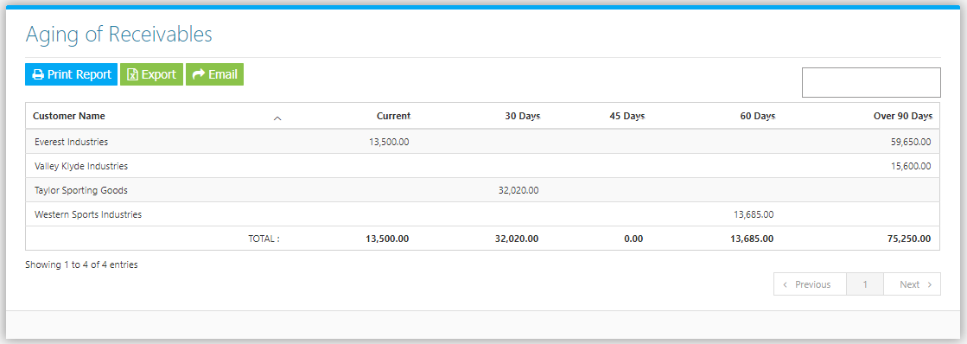

**Figure 2**

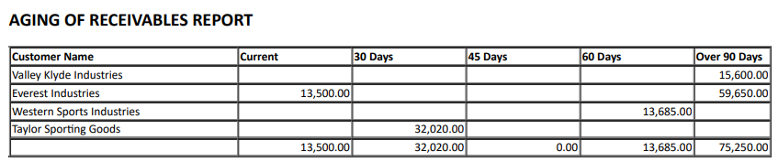

**Figure 3**

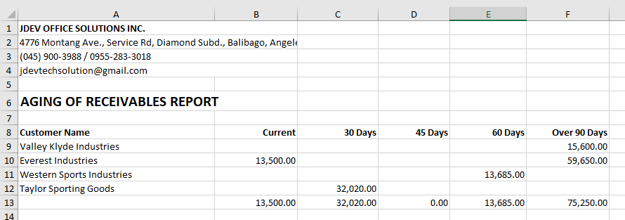

The System computes the balances by getting **Accounts Receivables Entries** from the *Sales / Accounts Receivable Module* in the Financing Modules and **Collections** from the *Collection Entry Module* in the Sales Module. To check the Accounts Receivable **Account Titles** *(Chart of Accounts)* included in the computation of the Report, Go to **Settings -> SOA Settings**

**STATEMENT OF ACCOUNTS SETTINGS / Accounts Receivable Settings**

Check the appropriate accounts to be included in the Computation of **Customer** **SOA Report** and **Aging of Receivables Report**. This is also used to compute and filter **Receivables** from Customer (A/R) in the **Sales ->** **Collection Entry Module** when recording payment. Click **Save Account Changes Button** to save *(Figure 4)*.

**Figure 4**

