**STATEMENT OF ACCOUNT**

A Statement of Account is a *detailed* report of the contents of an account or Customer. A statement is usually sent to a customer, showing *billings* and *payments* from the customer during a specific time period, resulting in an ending **balance**. The purpose of the statement is to remind a customer of sales on credit that have not yet been paid. Click the **Print Report Button** to print *(Figure 2)*, **Export Button** to save the report to an Excel File *(Figure 3)*, and **Email Button** to email the excel file to the designated address in the **Settings -> Email Report Settings**.

**Figure 1**

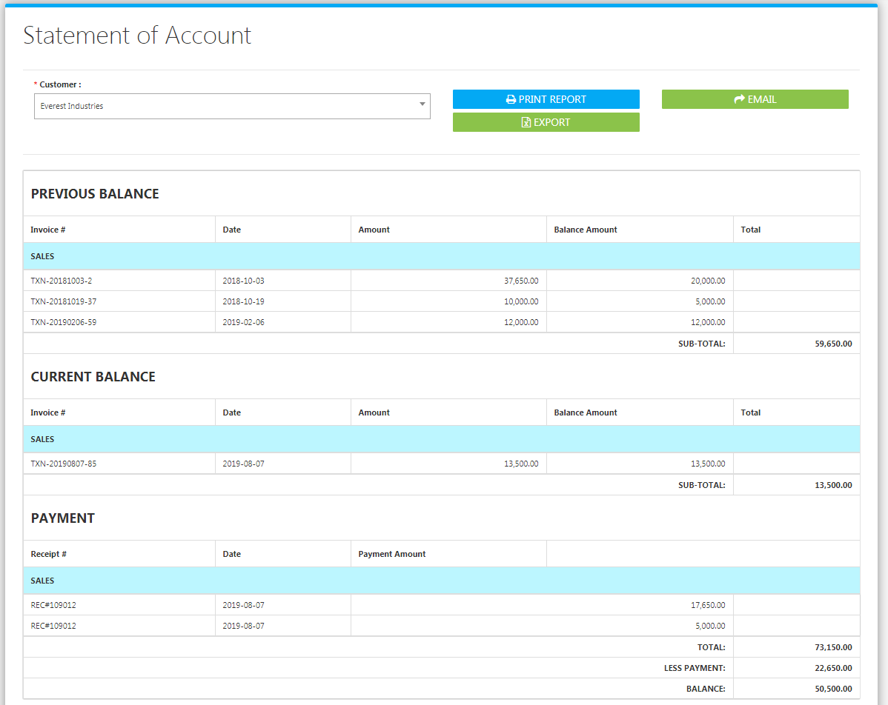

**Figure 2**

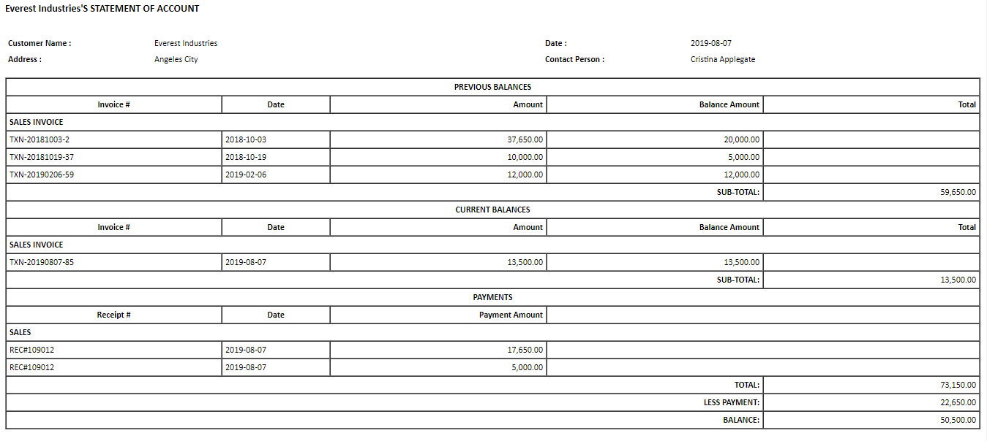

**Figure 3**

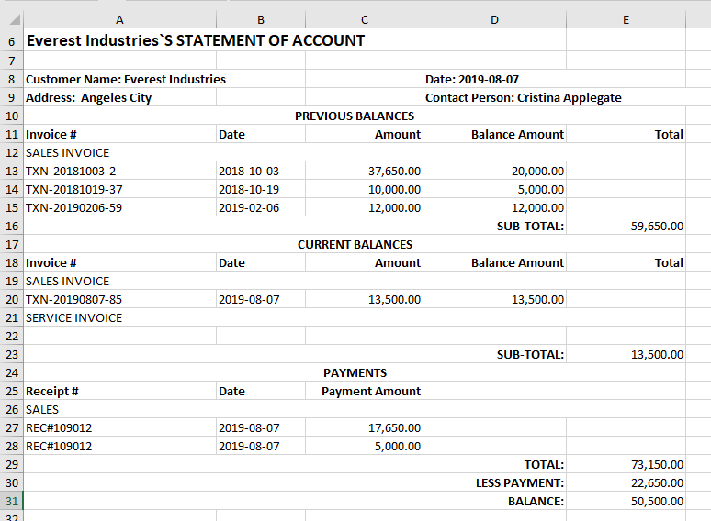

The System computes the balances by getting **Accounts Receivables Entries** from the *Sales / Accounts Receivable Module* in the Financing Modules and **Collections** from the *Collection Entry Module* in the Sales Module. To check the Accounts Receivable **Account Titles** *(Chart of Accounts)* included in the computation of the Report, Go to **Settings -> SOA Settings**

**STATEMENT OF ACCOUNTS SETTINGS / Accounts Receivable Settings**

Check the appropriate accounts to be included in the Computation of **Customer** **SOA Report** and **Aging of Receivables Report**. This is also used to compute and filter **Receivables** from Customer (A/R) in the **Sales ->** **Collection Entry Module** when recording payment. Click **Save Account Changes Button** to save *(Figure 4)*.

**Figure 4**

