**COST OF GOODS SOLD**

**Cost of Goods Sold** is the accumulated total of all *costs* used to create a product or service, which has been sold. In a periodic inventory system, the cost of goods sold is calculated as *beginning inventory + purchases - ending inventory*. The assumption is that the result, which represents costs no longer located in the warehouse, must be related to goods that were sold. Change the **Department**, **Date Range** *(Start Date and End Date)* as filters for the report *(Figure 1)*. Click the **Print Report Button** to print *(Figure 2)*.

**Figure 1**

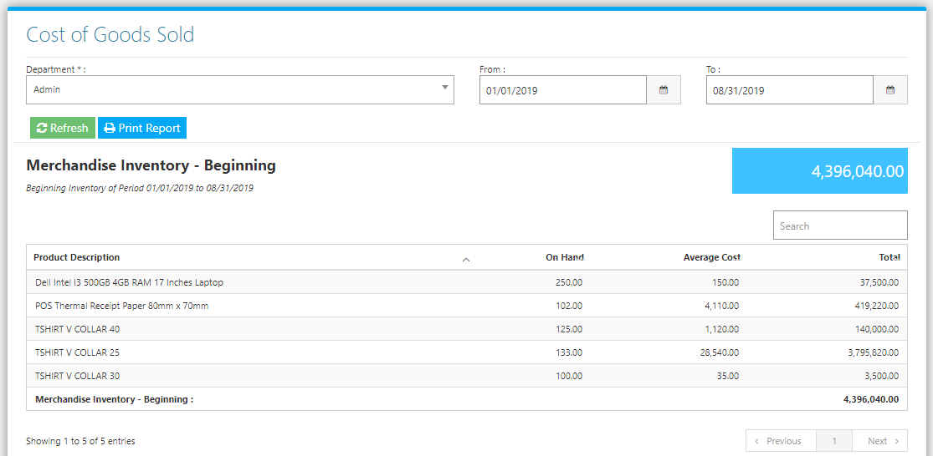

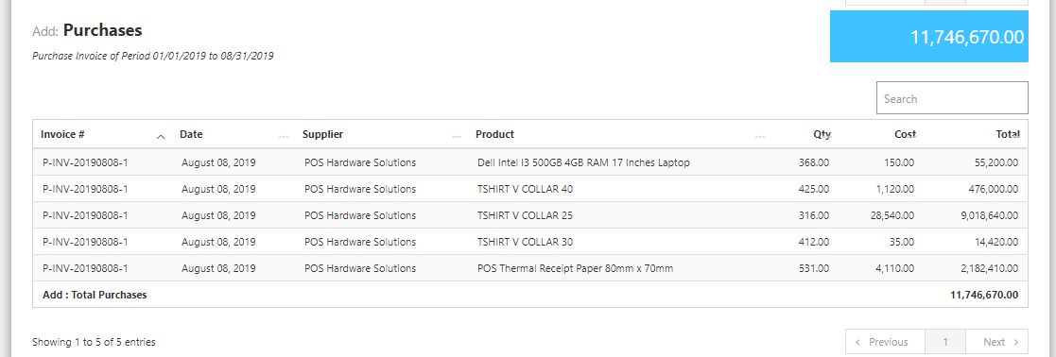

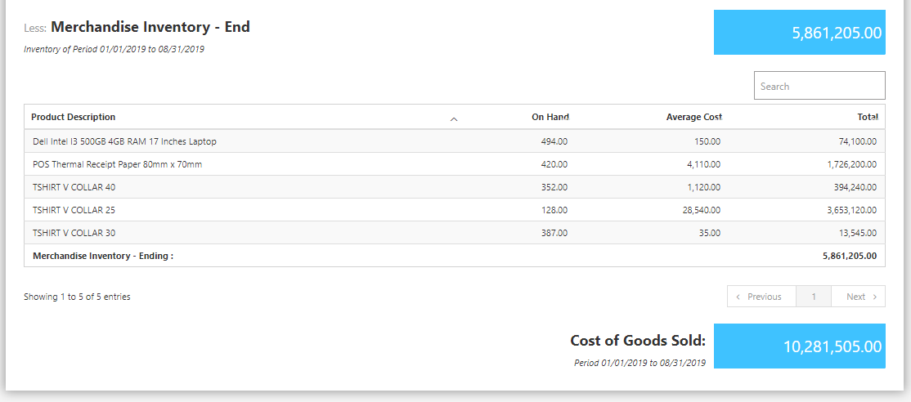

**Figure 2**

