**VAT RELIEF REPORT**

Listed in *Figure 1* are the **Vat Totals** for every *Purchase Invoice* record from the Purchases Module. Only Suppliers which were setup as **Vatted** *(Figure 2, from the Supplier Management)* will be included in the Report. Click the **Print Report Button** to print *(Figure 3)*, **Export Button** to save the report to an Excel File *(Figure 4)*, and **Email Button** to email the excel file to the designated address in the **Settings -> Email Report Settings**.

**Figure 1**

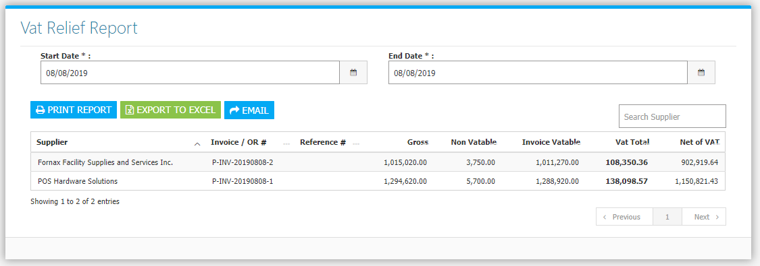

**Figure 2**

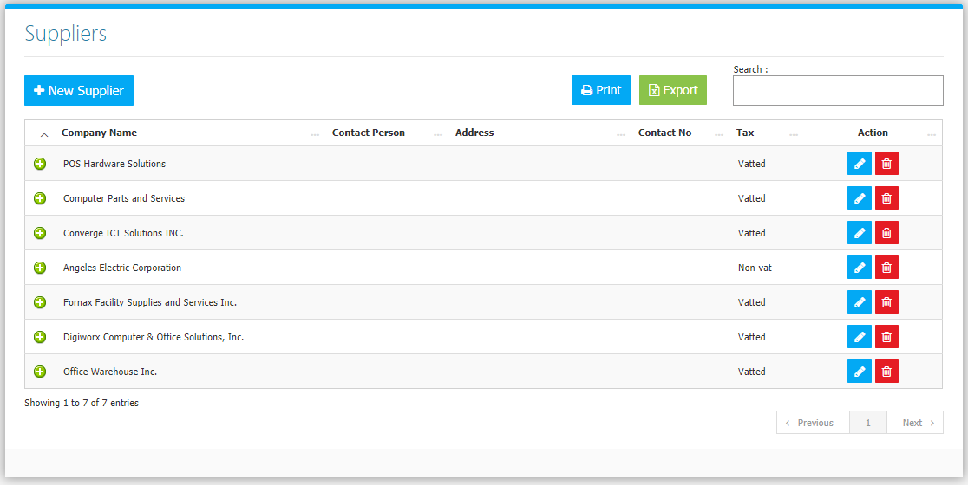

**Figure 3**

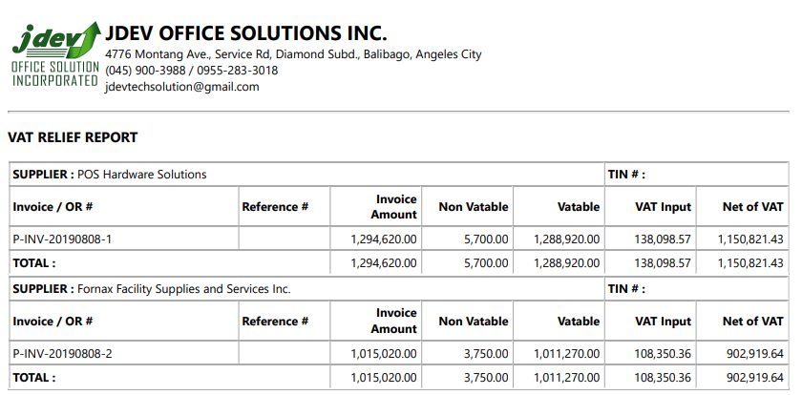

**Figure 4**

