**ANNUAL INCOME STATEMENT**

Listed in the *Figure 1* is the Annual Income Statement. The Report Shows the *Profit and Loss Report* computation for each month of the Current Year. Click the **Print Report Button** to print *(Figure 2)*, **Export Button** to save the report to an Excel File *(Figure 3)*, and **Email Button** to email the excel file to the designated address in the **Settings -> Email Report Settings**.

**Figure 1**

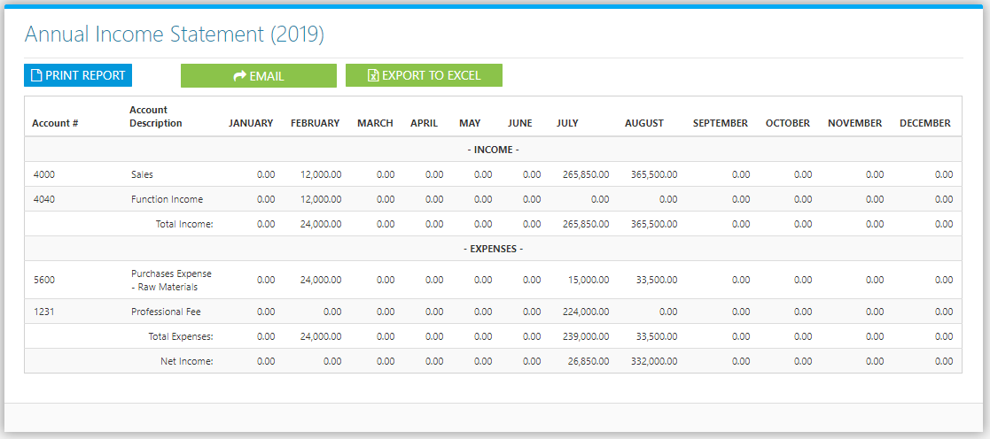

**Figure 2**

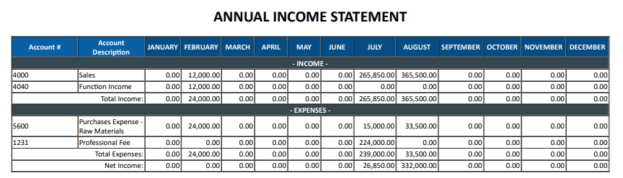

**Figure 3**

