**BALANCE SHEET**

A **balance sheet** is a financial statement that reports a company's assets, liabilities and shareholders' equity at a specific point in time, and provides a basis for computing rates of return and evaluating its capital structure. It is a financial statement that provides a snapshot of what a company owns and owes, as well as the amount invested by shareholders. Change the **Branch**, and **as of Date** as filters for the report *(Figure 1)*. Click the **Print Report Button** to print *(Figure 2)*, **Export Button** to save the report to an Excel File *(Figure 3)*, and **Email Button** to email the excel file to the designated address in the **Settings -> Email Report Settings**.

**Figure 1**

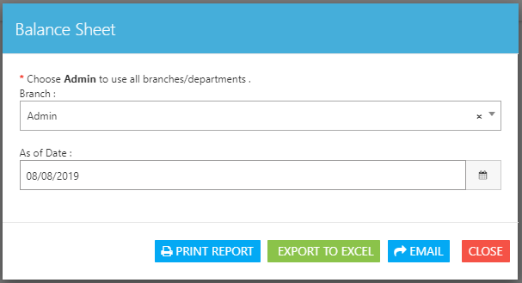

**Figure 2**

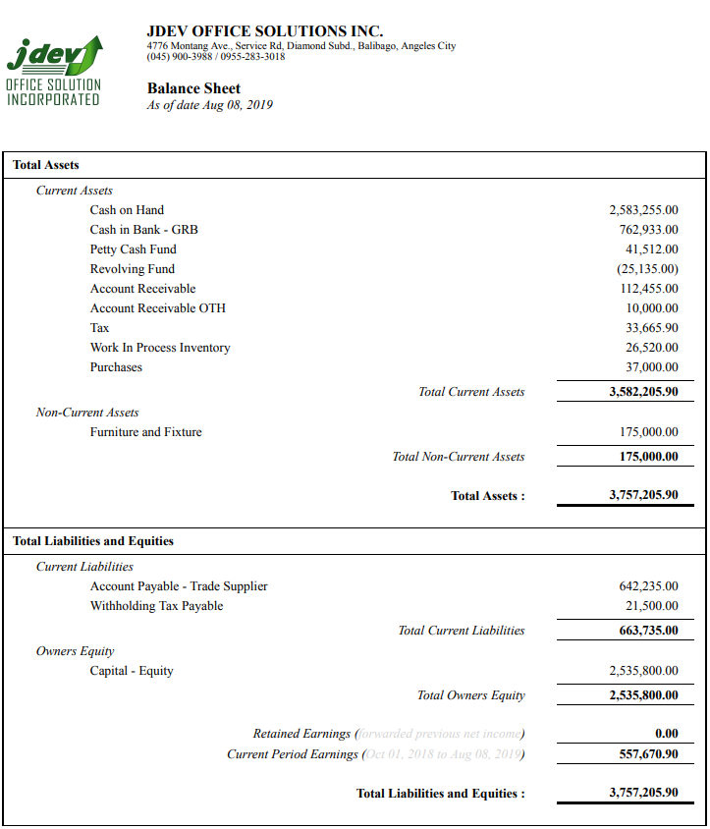

**Figure 3**

