**TRIAL BALANCE**

A Trial Balance is a bookkeeping or accounting report that lists the balances in each of an organization's general ledger accounts. A listing of the accounts in the general ledger along with each account's balance in the appropriate *debit* or *credit* column. The *total* of the amounts in the debit column should equal the total of the amounts in the credit column. Change the **Branch**, **Date Range** *(Start Date and End Date)* as filters for the report *(Figure 1)*. Click the **Export Button** to save the report to an Excel File *(Figure 2)*, and **Email Button** to email the excel file to the designated address in the **Settings -> Email Report Settings**.

**Figure 1**

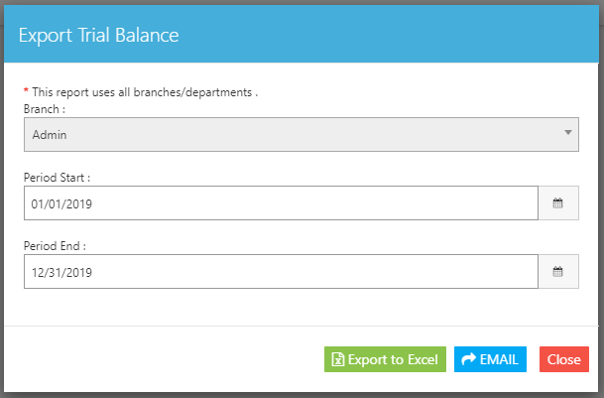

**Figure 2**

