**ACCOUNT SUBSIDIARY**

A **Subsidiary Account** is an account that is kept within a subsidiary ledger, which in turn summarizes into a control account in the general ledger. A subsidiary account is used to track information at a very detailed level for certain types of transactions, such as accounts receivable, and accounts payable. Change the **Account Title**, **Transaction Type**, **Date Range** *(Start Date and End Date)* as filters for the report *(Figure 1)*.

Two options are available for **Transaction Type**:

*Selected Account Only –Transactions of the Account.*

*Include Transactions of Main Account – Transactions of the Account with the Transactions of its* ***Parent*** *or* ***Child***.

Click the **Print Report Button** to print *(Figure 2)*, **Export Button** to save the report to an Excel File *(Figure 3)*, and **Email Button** to email the excel file to the designated address in the **Settings -> Email Report Settings**.

**Figure 1**

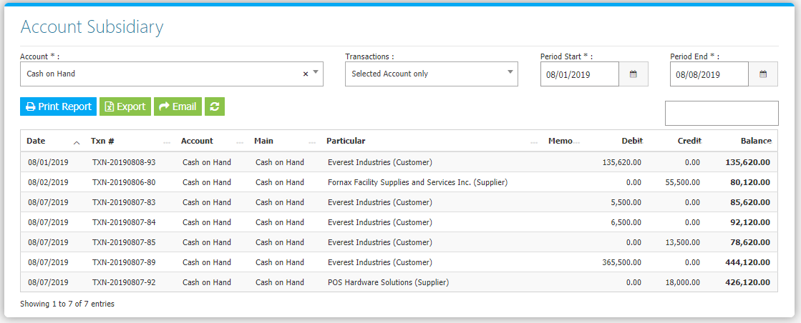

**Figure 2**

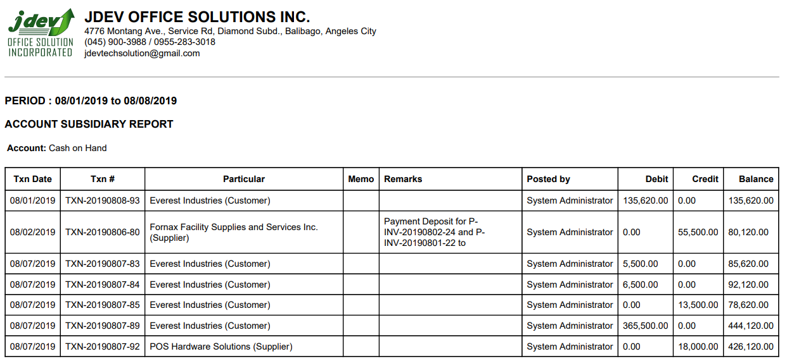

**Figure 3**

