**GENERAL LEDGER**

The General Ledger is the principal and controlling ledger of a business enterprise containing individual or controlling accounts for all assets, liabilities, net worth items, revenue, and expenses. Change the **Date Range** *(Period Start, and End)* to filter the shown transactions *(Figure 1).* Click the **Print Report Button** to print *(Figure 2)*, **Export Button** to save the report to an Excel File *(Figure 3)*, and **Email Button** to email the excel file to the designated address in the **Settings -> Email Report Settings**.

**Figure 1**

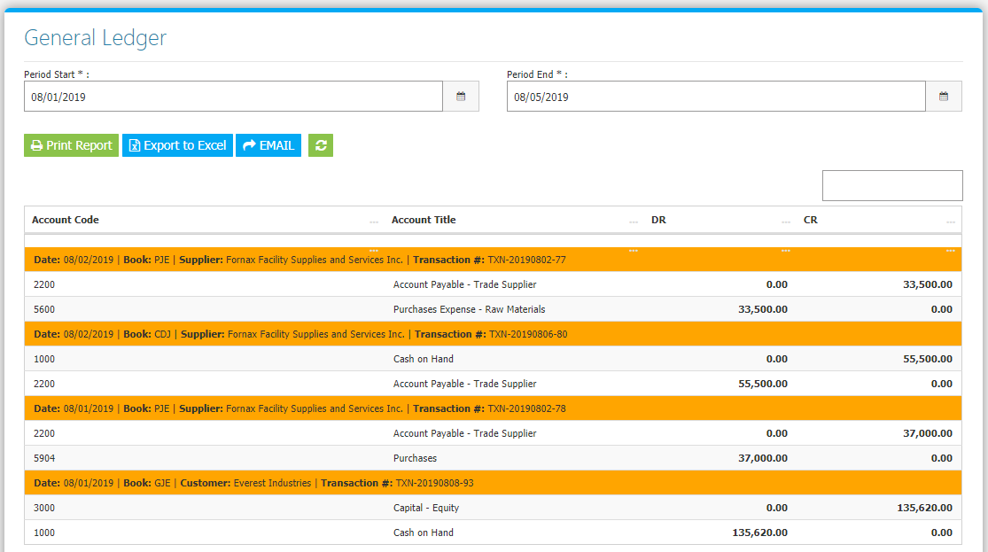

**Figure 2**

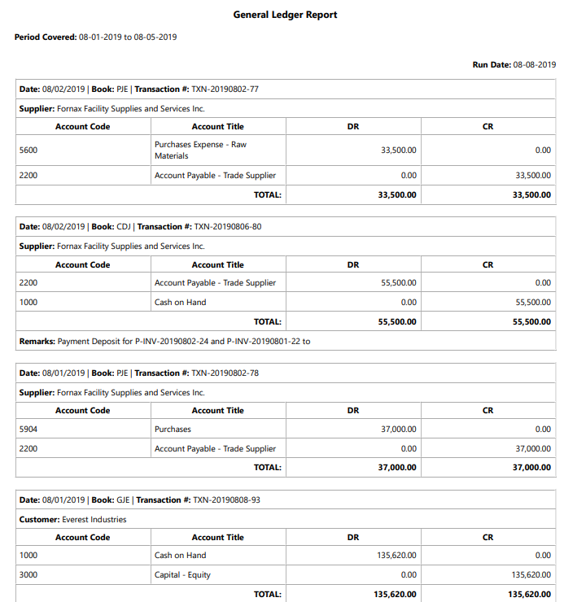

**Figure 3**

