**REPLENISHMENT BATCH REPORT**

Listed in *Figure 1* are the **Replenished Petty Cash Journal** Transactions. The Report will contain Petty Cash Entries based on the chosen *Batch Number*. Click the **Print Report Button** to print *(Figure 2)*, **Export Button** to save the report to an Excel File *(Figure 3)*, and **Email Button** to email the excel file to the designated address in the **Settings -> Email Report Settings**.

**Figure 1**

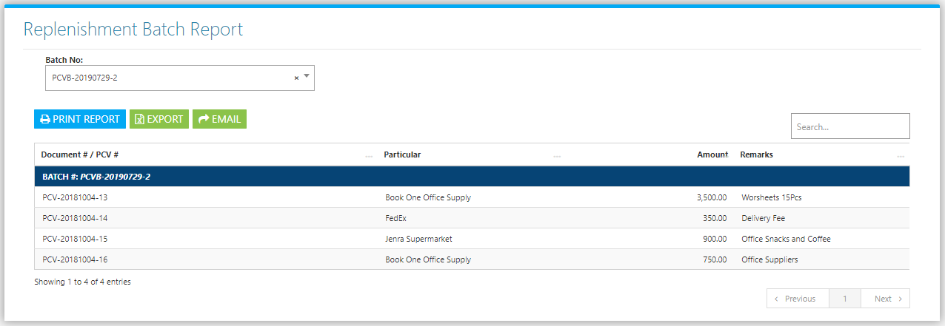

Figure 2

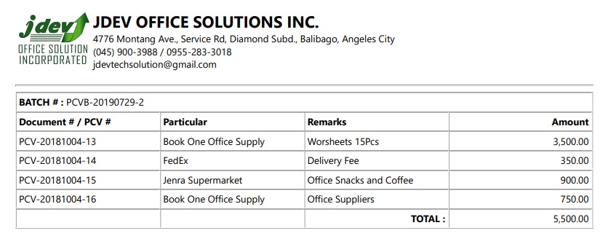

Figure 3

