**REPLENISHMENT REPORT**

Listed in *Figure 1* are the **Replenished Petty Cash Journal** Transactions. The Report will contain different *batches* from the Beginning of up to the chosen *as of Date*filter. Click the **Print Report Button** to print *(Figure 2)*, **Export Button** to save the report to an Excel File *(Figure 3)*, and **Email Button** to email the excel file to the designated address in the **Settings -> Email Report Settings**.

**Figure 1**

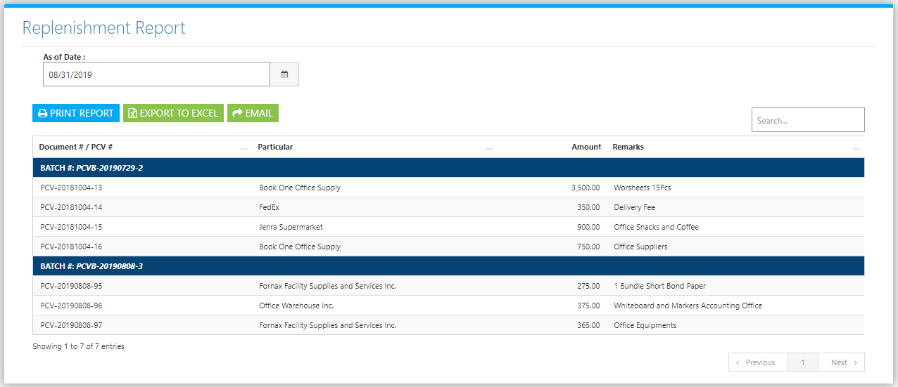

**Figure 2**

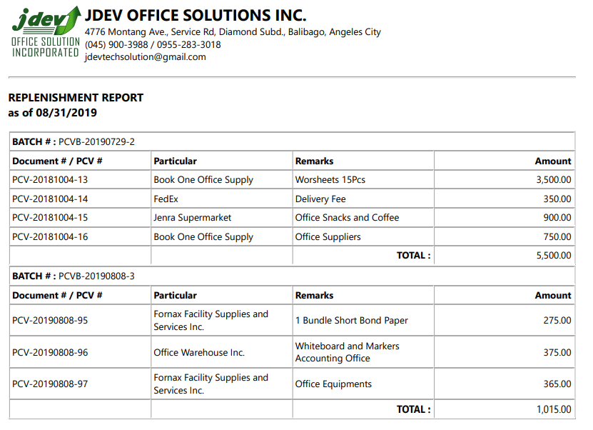

**Figure 3**

