**T ACCOUNTS**

The T Accounts report shows the transactions of an account represented in a company’s general ledger. A T-account allows an accounting professional to manually calculate the balance of a specific account in a quick and efficient manner. Change the **Date Range** *(Start Date and End Date)* as filters for the report *(Figure 1)*. The report is categorized based on the **types of book** the records namely: *General Journal, Cash Disbursement, Purchase Journal, Sales Journal, Petty Cash Journal, and Cash Receipt Journal*. There are two types of generated reports: ***detailed***, and ***summary****.* The **Detailed** contains the detailed debit and credit entries for each transaction, while the **Summary** sums the amounts of the same Account Titles.Both of these can be *printed*, *exported* to excel file, and *emailed* to the designated address in the **Settings -> Email Report Settings**.

**Figure 1**

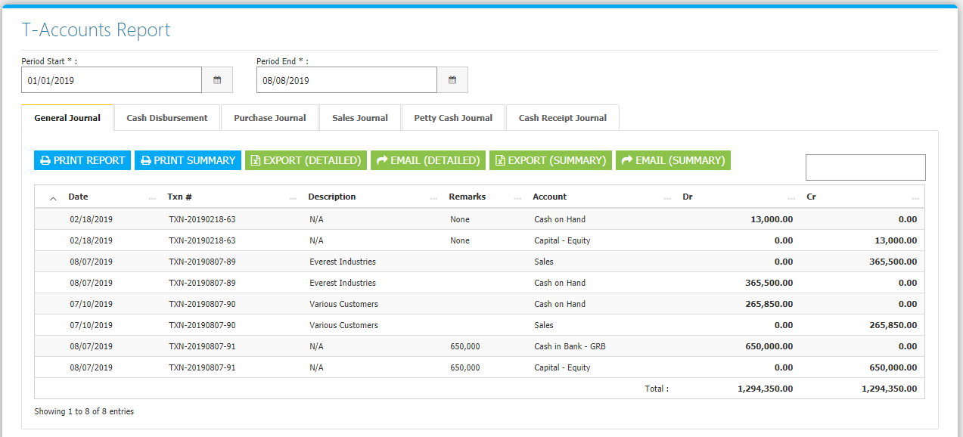

**Figure 2** *Detailed Report – Print*

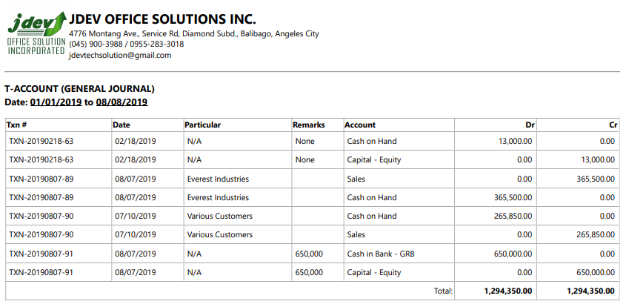

**Figure 3** *Detailed Report – Exported to Excel*

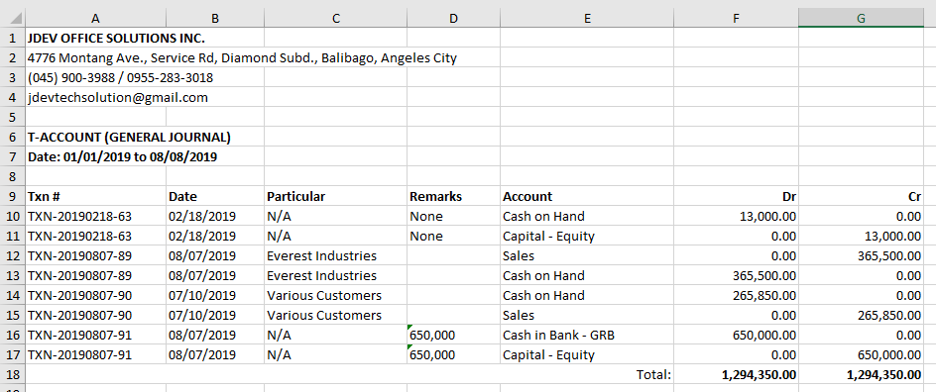

**Figure 4** *Summary Report – Print*

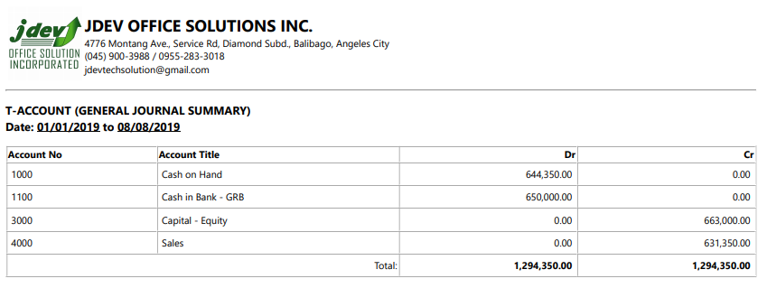

**Figure 5** *Summary Report – Exported to Excel*

