**ACCOUNTS PAYABLE ENTRIES / AP SCHEDULE**

Listed in *Figure 1* is the **Accounts Payable Schedule Report**. The Report **sums** up the Accounts Payable Balance of each *Suppier (if any).*Choose the **Account Title**, and **as of Date** as per your preference to filter the shown suppliers, and compute the *running balance*. Click the **Print Report Button** to print *(Figure 2)*, **Export Button** to save the report to an Excel File *(Figure 3)*, and **Email Button** to email the excel file to the designated address in the **Settings -> Email Report Settings**.

The **Previous** section of the report shows the Accounts Payable Balance of all previous AP transactions up to the previous month of the **as of Date Filter,** thus *all previous transactions* up to July 31, 2019 (07/31/2019). The **This Month** section of the report shows the Accounts Payable Balance from the *First day* *of Month* of the **as of Date Filter** up to the **as of Date Filter**, thus all transactions from August 1,2019 (08/01/2019) to August 07, 2019 (08/07/2019).

**Figure 1**

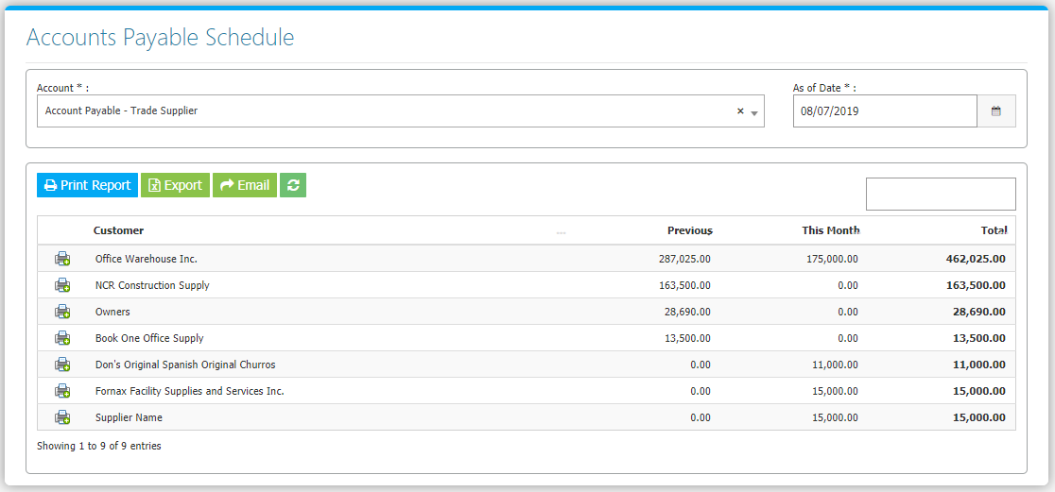

**Figure 2**

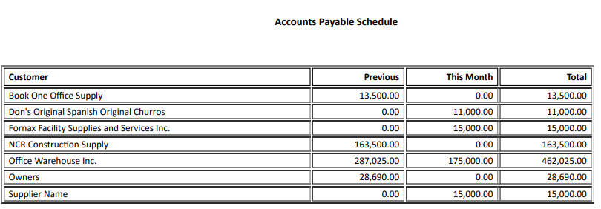

**Figure 3**

