**AGING OF PAYABLES**

**Accounts Payable Aging** is the process of distinguishing open *accounts payable* based on the length of time an Invoice/AP has been outstanding. Listed in the *Figure 1* are the Outstanding Payables to Suppliers which are categorized by *length of* *time*.

**Figure 1**

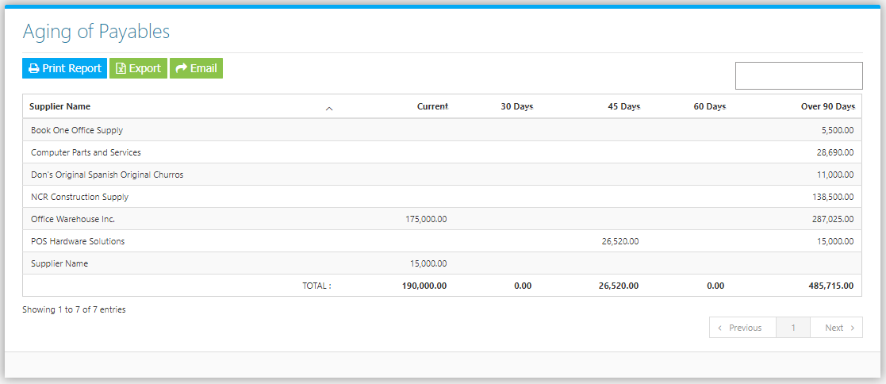

**Figure 2**

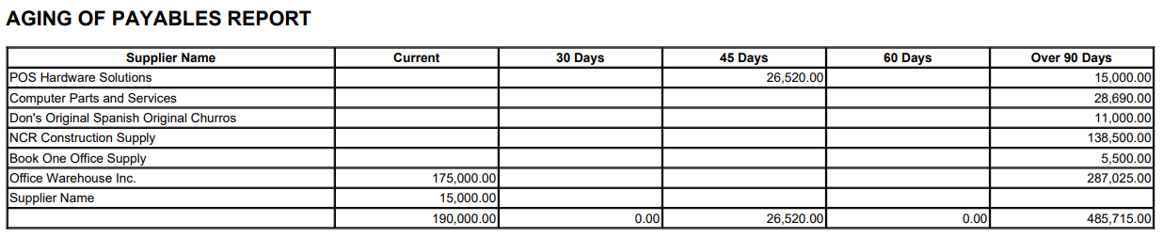

**Figure 3**

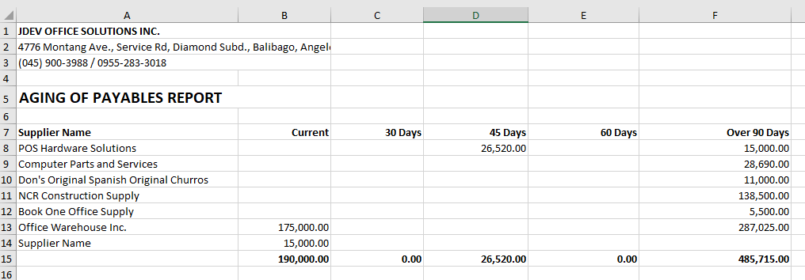

The System computes the balances by getting **Accounts Payable Entries** from the *Purchase / Accounts Payable Module* in the Financing Modules and **Payments** from the *Record Payment Entry Module* in the Purchases Module. To check the Accounts Payable **Account Title** *(Chart of Accounts)* included in the computation of the Report, Go to **Settings -> General Configuration -> Supplier *-> Payable to Supplier*** *(Figure 4).*

**Figure 4**

