**SUPPLIER SUBSIDIARY**

Listed in *Figure 1* is the **Supplier Subsidiary Report**. The Report holds more specific information about the *supplier* and the *accounts* that make up the General Ledger. Choose the **Supplier**, **Account Title**, and **Date Range** as per your preference to filter the shown transactions, and compute the *running balance*. Click the **Print Report Button** to print *(Figure 2)*, **Export Button** to save the report to an Excel File *(Figure 3)*, and **Email Button** to email the excel file to the designated address in the **Settings -> Email Report Settings**.

**Figure 1**

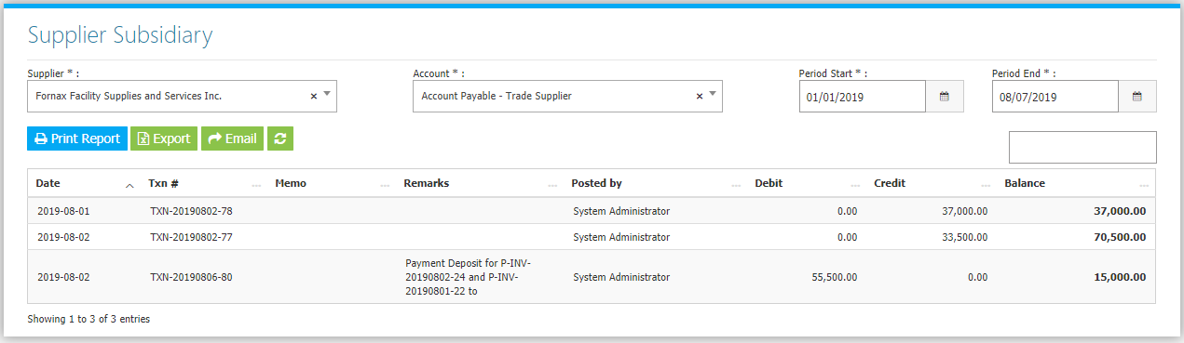

**Figure 2**

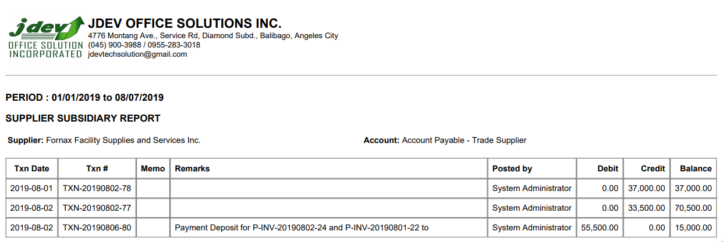

**Figure 3**

