**BANK RECONCILIATION**

A Bank Reconciliation is the process of matching the balances in an entity's accounting records for a cash account to the corresponding information on a bank statement. The goal of this process is to ascertain the differences between the two, and to book changes to the accounting records as appropriate. Listed Below in the *Figure 1* is the **1st Step: Outstanding Check**.

**Figure 1**

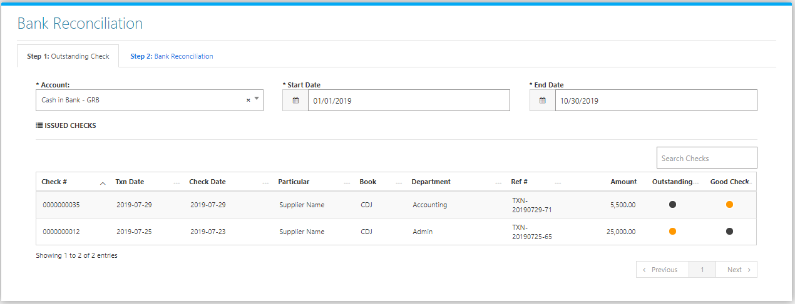

Change the **Date Range** (from and to), and the **Bank Account Title** to your preference to filter the shown Journal (Check) Transactions. Then **Tick** which Checks are **Outstanding** and which are **Good Checks.** Then go to **Step 2: Bank Reconciliation** (Figure 2).

**Figure 2**

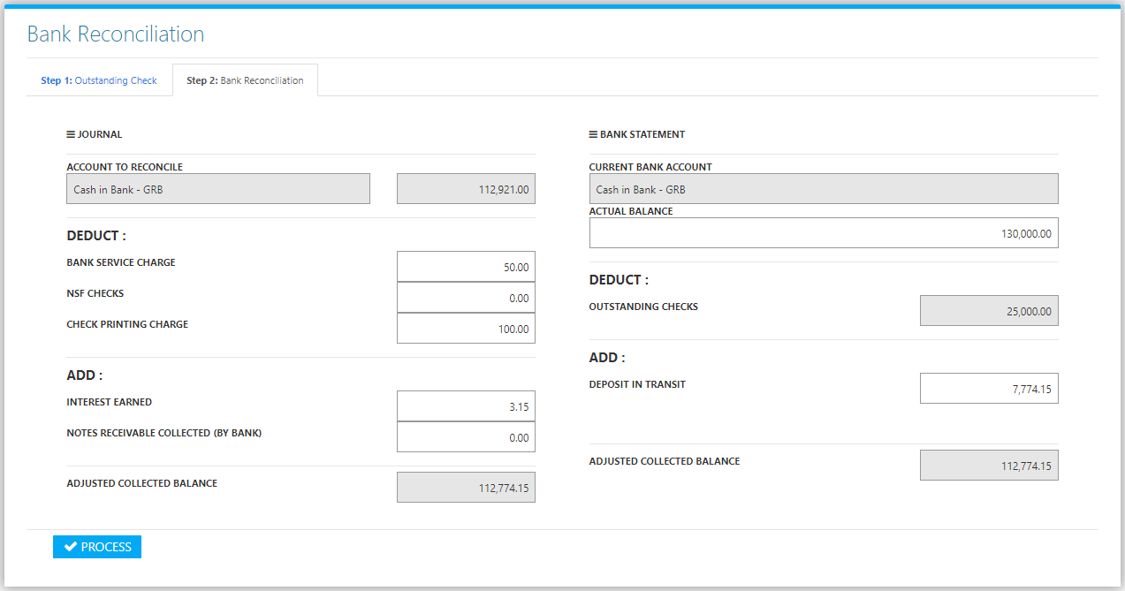

Adjust the **Journal Details:** Bank Service Charge, NSF Checks, Check Printing Charge, Interest Earned, Notes Receivable Collected, and the **Bank Statement Details**:Actual Balance, and Deposit in Transit. Adjusted Collected Balance from both **Journal** and **Bank Statement** must be equal to Process (Click the Process Button) the Bank Reconciliation.