**RECONCILIATON HISTORY**

A **Bank Reconciliation** is the process of matching the balances in an entity's accounting records for a cash account to the corresponding information on a bank statement. The goal of this process is to ascertain the differences between the two, and to book changes to the accounting records as appropriate. Listed Below in the *Figure 1* are the processed Bank Reconciliations.

**Figure 1**

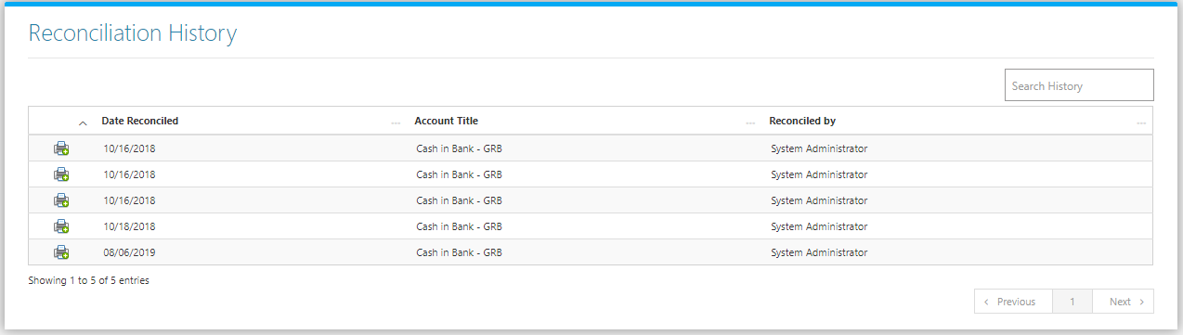

Clicking the **Print Button** will open the transaction/Bank Reconciliation as shown in *Figure 2.* It can be printed and downloaded as pdf.

**Figure 2**

