**CERTIFICATE OF CREDITABLE TAX – BIR FORM 2307**

To use the BIR FORM 2307, first setup the Withholding Tax Account *(Figure 1)* from the **Settings -> General Configuration -> Supplier**

**Figure 1**

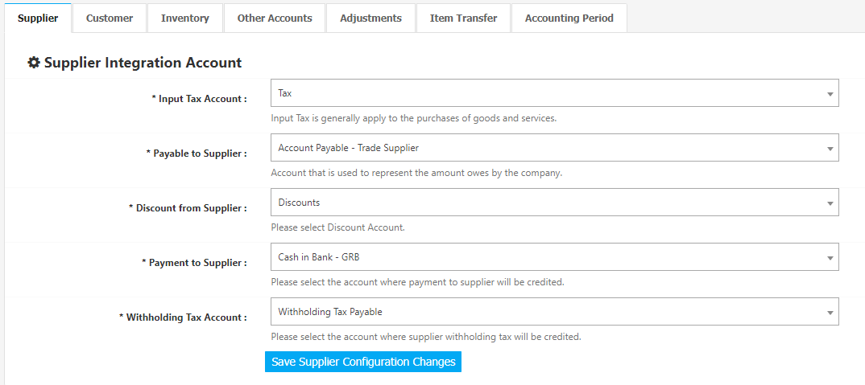

When creating a Cash Disbursement Journal *(Figure 2)*, click *Apply 2307 Form*, Enter the ATC, and Remarks details. Use the **Withholding Tax Account** as *Credit* in the entry. The system will then get the *credit amount* as the withholding amount in the BIR 2307. Adjust the details to your preference then click **Finalize and Post this Journal** **Button** to post the Transaction to Accounting.

**Figure 2**

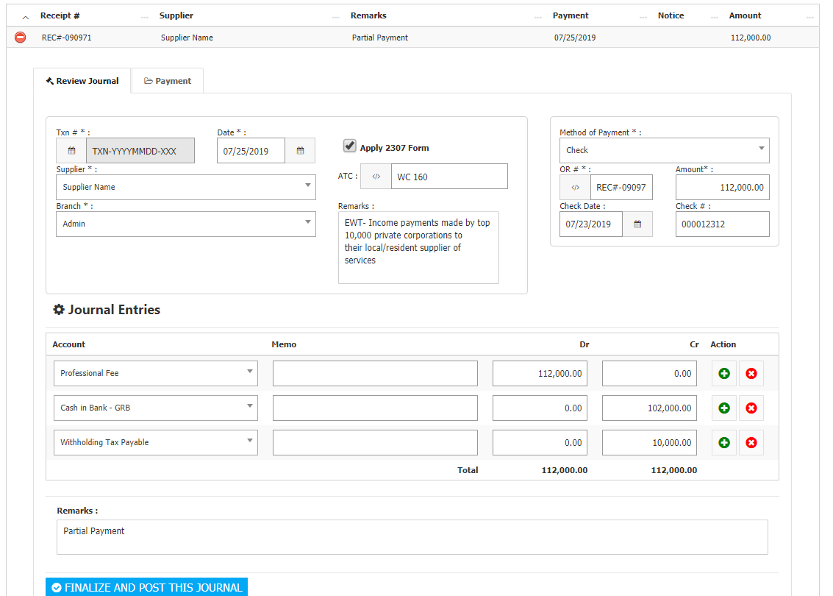

Listed in Figure 3 are the BIR FORM 2307 created from the **Cash Disbursement Journal** in the Financing Module. Choose desired **Month** and **Year** to filter the shown list *(Figure 3)*.

**Figure 3**

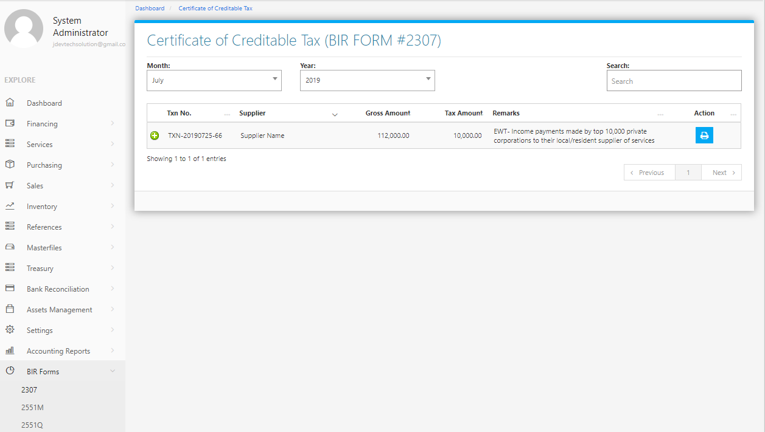

Clicking the **+ Button** will open the Transaction/Voucher as shown in *Figure 4.* TheVoucher can be printed.

**Figure 4**

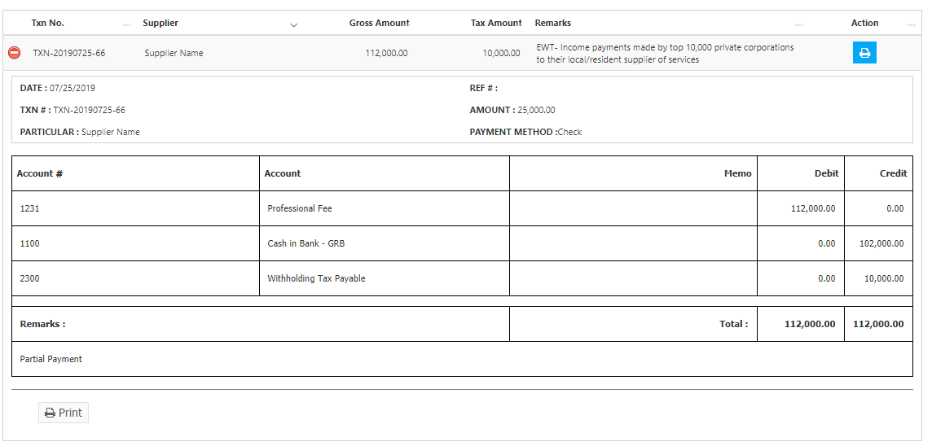

Clicking the **Print Button** located at the right side will print the 2307 Form together with the details of the transaction as shown in the *Figure 5* which can be printed and saved as a PDF File.

**Figure 5**

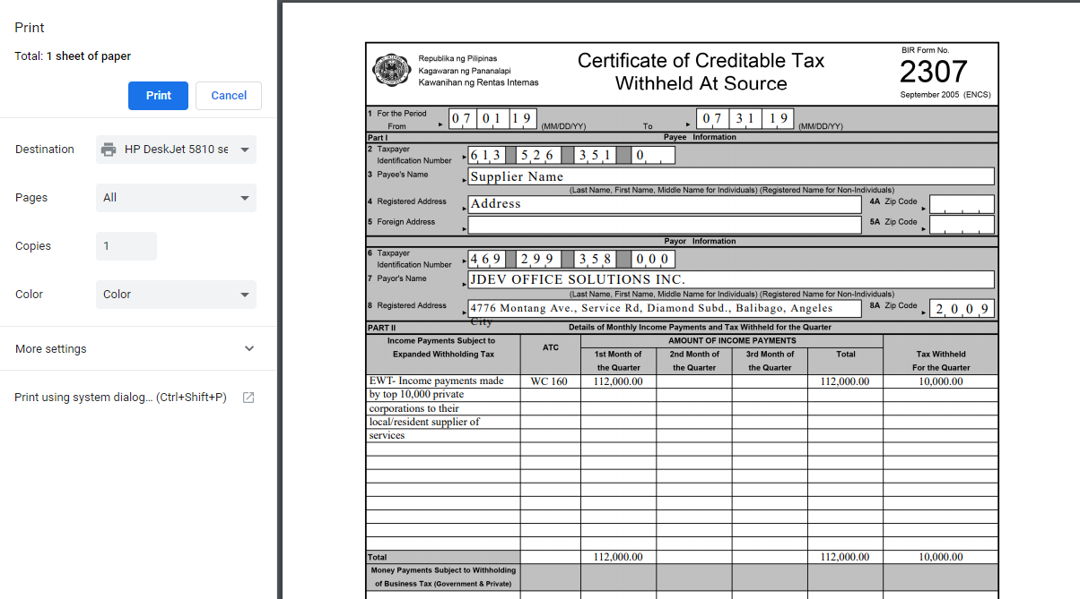

The **Taxpayer Details** **of the Payee** *(TIN, Payee’s Name, Registered Address)* will come from the Supplier Management in the **Supplier Masterfile Module** *(Figure 6)*. The **Taxpayer Details of the Payor** *(TIN, Payor’s Name, Registered Address, and Zip Code)* will come from the Company Setup in the **Settings** *(Figure 7)***.**

**Figure 6**

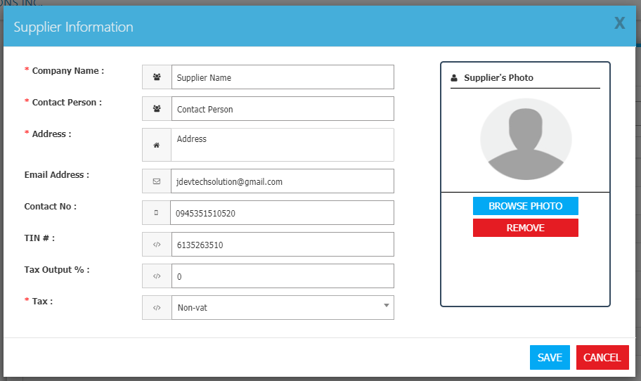

**Figure 7**

