**MONTHLY PERCENTAGE TAX RETURN - BIR FORM 2551M**

Listed in the *Figure 1* are the Monthly Percentage Tax Returns created. Change the **Year** filter the list. Click the **+ Button** to show the details of the sales *(Figure 2).* Click the **Print Button** *below* to print the sales details *(Figure 3).* Click the **Print button** located at the *right corner* to print the form together with the details of the sales as shown in the *Figure 4* which can be printed and saved as a PDF File.

**Figure 1**

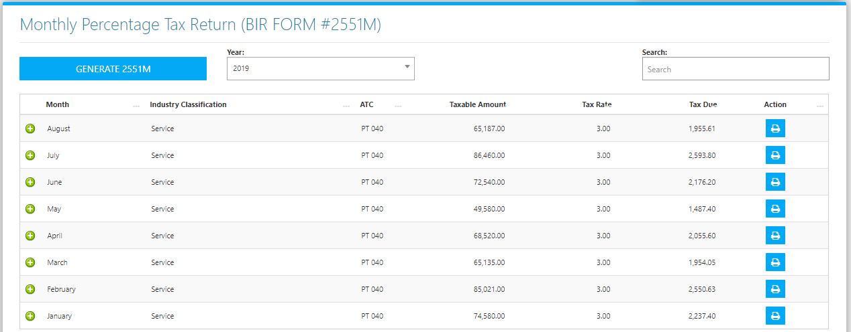

**Figure 2**

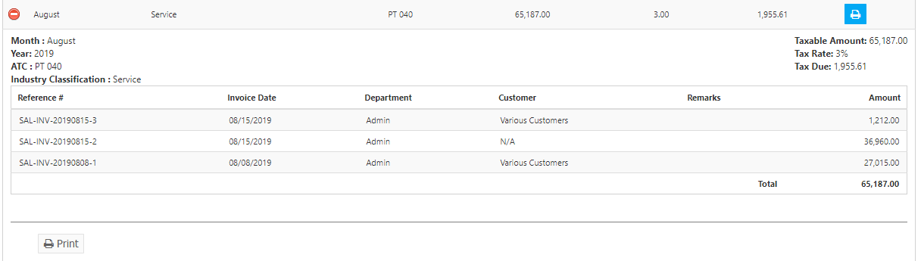

**Figure 3**

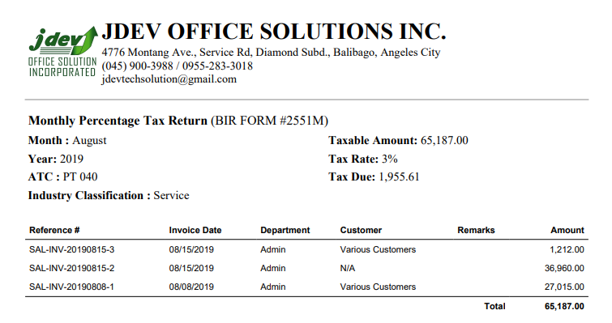

**Figure 4**

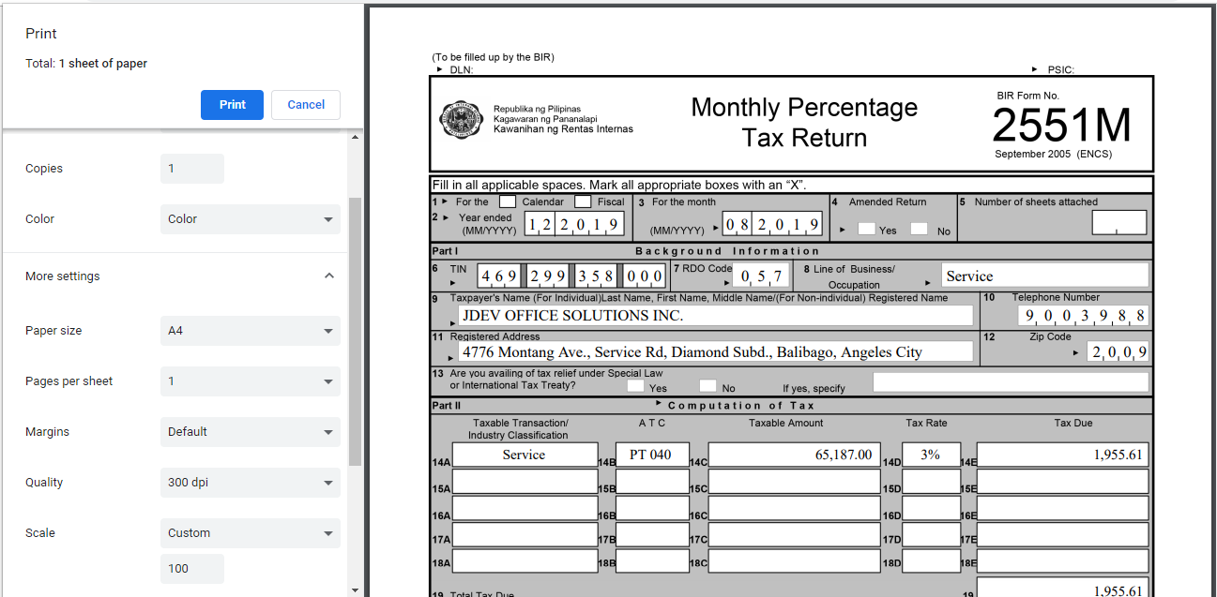

Click the **Generate 2551M Button** to create new. Change the **Month** and **Year** to your preference, then Invoices from Sales, and Cash Invoices that are *already finalized and posted in the Accounting* will be listed to compute the *Taxable Amount*, and *Taxable Due*. Click the **Save Button** when finished.

