**QUARTERLY PERCENTAGE TAX RETURN - BIR FORM 2551Q**

Listed in the *Figure 1* are the Quarterly Percentage Tax Returns. Change the **Year** filter the list. Click the **+ Button** to show the details of the sales *(Figure 2).* Click the **Print Button** *below* to print the sales details *(Figure 3).* Click the **Print button** located at the *right corner* to print the form together with the details of the sales as shown in the *Figure 4* which can be printed and saved as a PDF File.

**Figure 1**

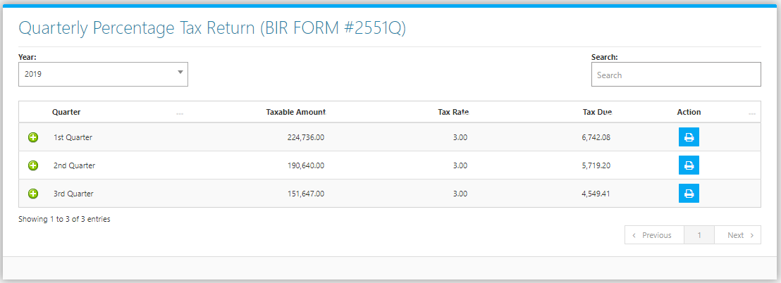

**Figure 2**

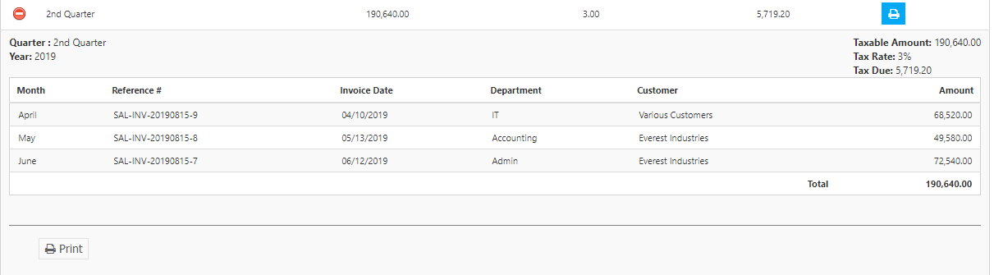

**Figure 3**

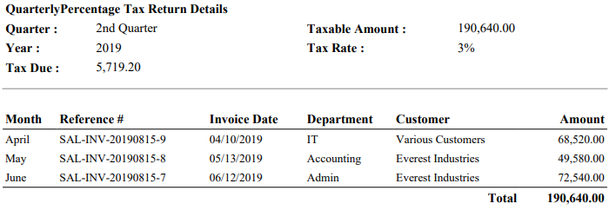

**Figure 4**

