**Cash Disbursement Journal**

Listed in the *Figure 1* are the Cash Disbursement Entries Posted in the Accounting System. The **Cash Disbursement** is the master journal to where all the company expenses are recorded such as *Electric and Water Consumption*, *Professional Fees*, *Salaries and Wages, Payment to Suppliers, Legal Expenses, and other expense transactions of the Company.*

**Figure 1**

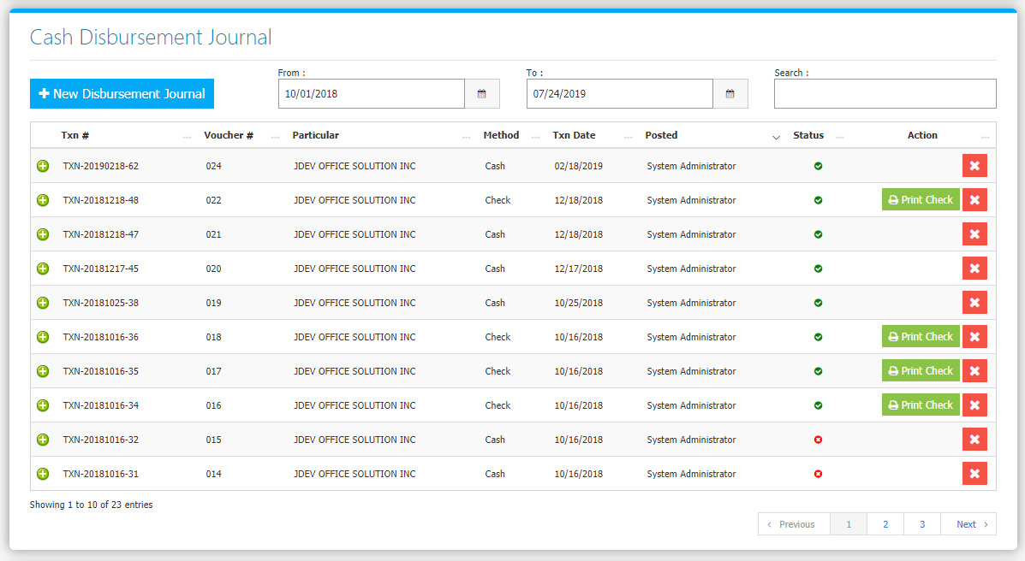

Change the **Date Range** (from and to) to your preference to filter the shown Journal Transactions. Use the **Search Field** to search for the information from inside the table. Clicking the **X Button** will mark the Journal either cancelled or active. Click the **New** **Disbursement Journal Button** to create. Fill the form *(Figure 2)* then click **Save and Post Button** to save.

**Figure 2**

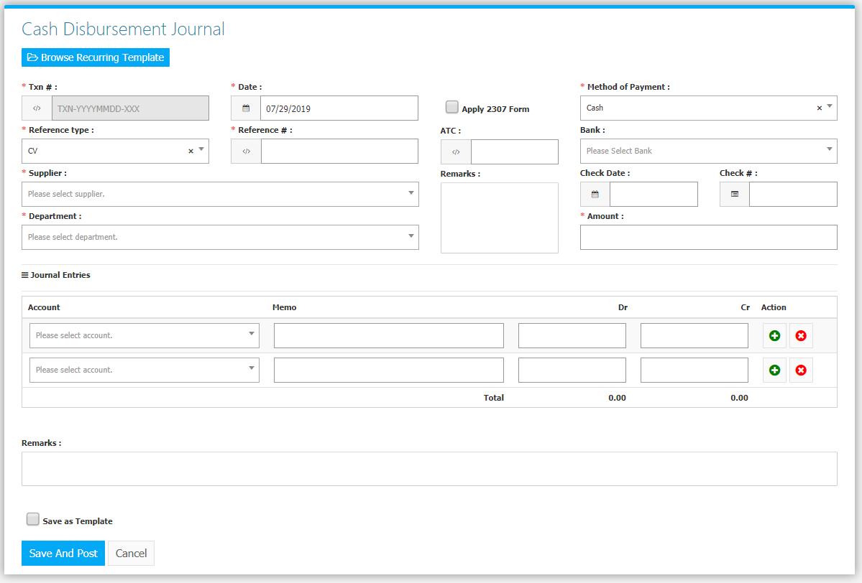

Clicking the **+ Button** will open the transaction/voucher as shown in *Figure 2.* Thevoucher can be printed.

**Figure 2**

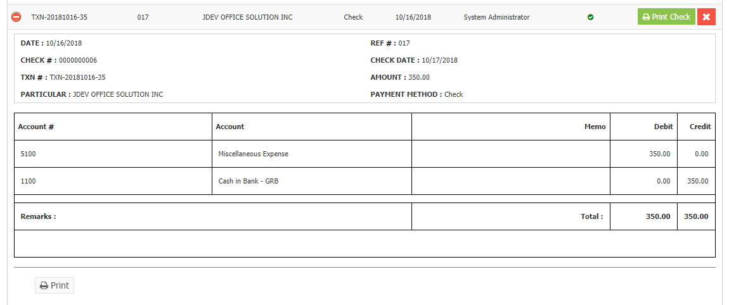

Clicking the **Print Check Button** will show a list of available check layouts *(Figure 3)*. Choose a layout then click the **Preview Check Button** to Print *(Figure 4 and 5)*.

**Figure 3 Figure 4**

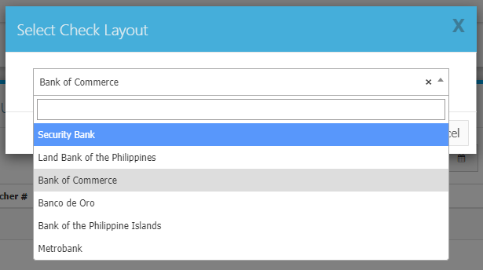 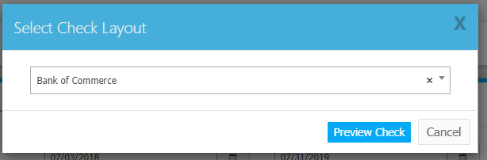

**Figure 5**

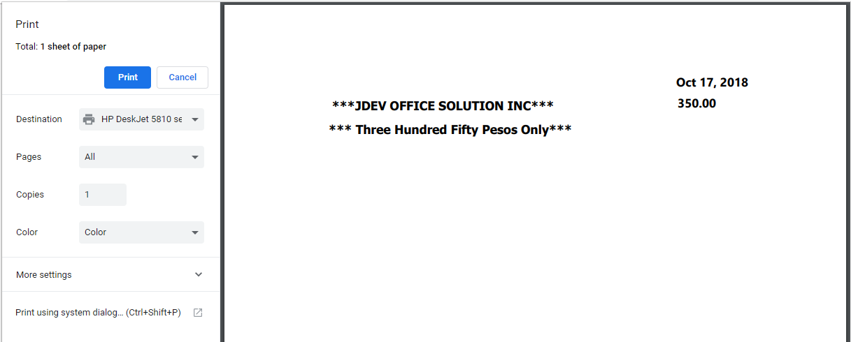

The List of Check Layouts *(Figure 6)* can be found in the **Settings Menu -> Setup Check Layout**.

**Figure 6**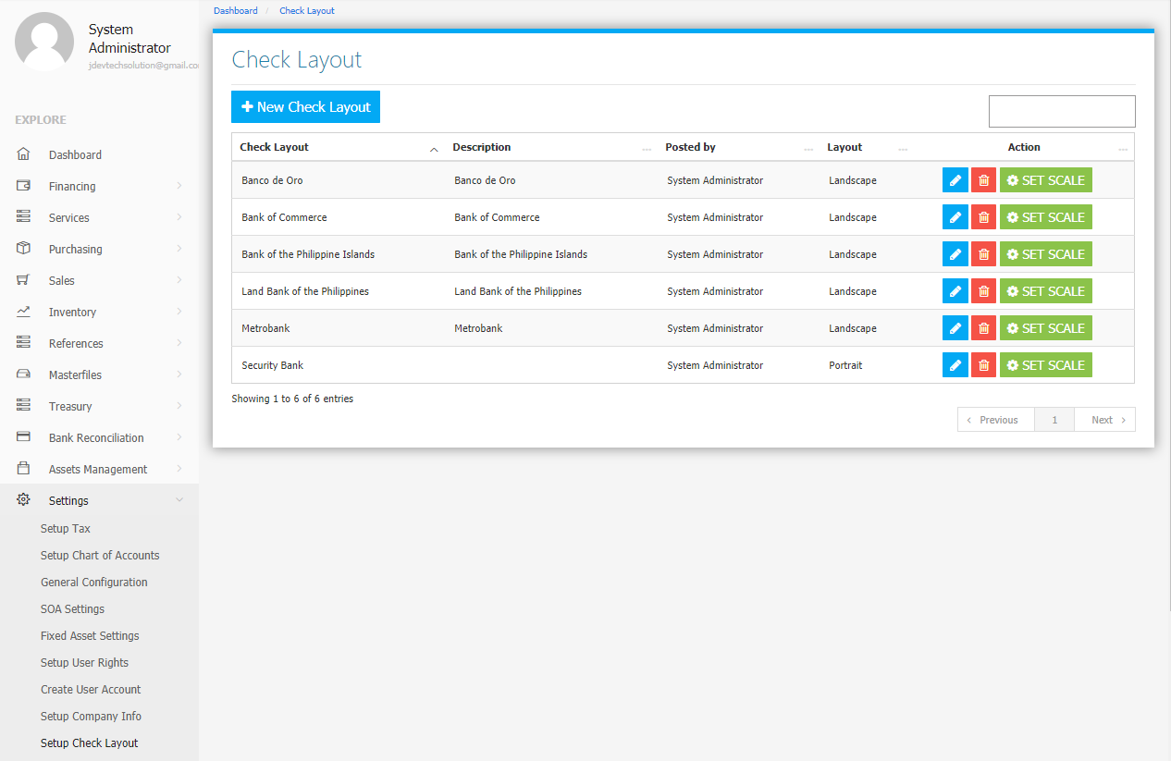

Use the **Search Field** to search for the information from inside the table. Click the **Pencil Button** to edit the layout information, and **Trash Button** to delete the layout. Click the **New** **Check Layout Button** to create a new *layout (Figure 7).* Fill the required fields then click the **Save Check Layout Button** to save.

**Figure 7**

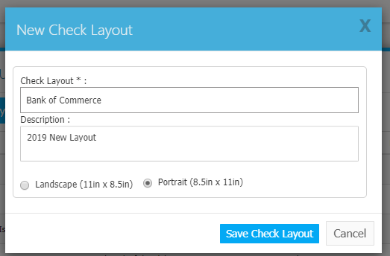

Click the **Set Scale Button** to show the current check layout positions *(Figure 8)*. Reposition *(Drag and Drop)* the check details such as Particular, Date, Amount in Words, and the Amount to your preference. Click the **X Button** at the top right corner to save and exit.

**Figure 8**

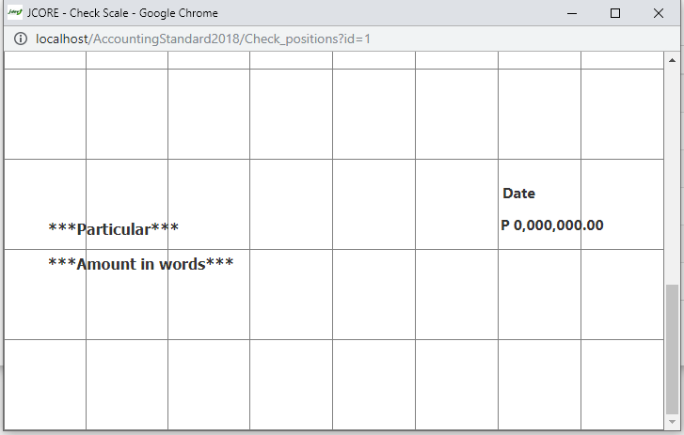

**RECURRING TEMPLATES**

Certain Transactions repeat themselves on a regular basis. You can create or use templates for such recurring transactions. The template contains the *Particular*, *Debit* and *Credit Accounts* together with the *amounts*, and *Remarks*. To create a recurring template **inside** the **Cash Disbursement Module**, click (put a check mark) on the **Save as Template Check Box** before savingto also save the current filled form as a new template *(Figure 9)*.

**Figure 9**

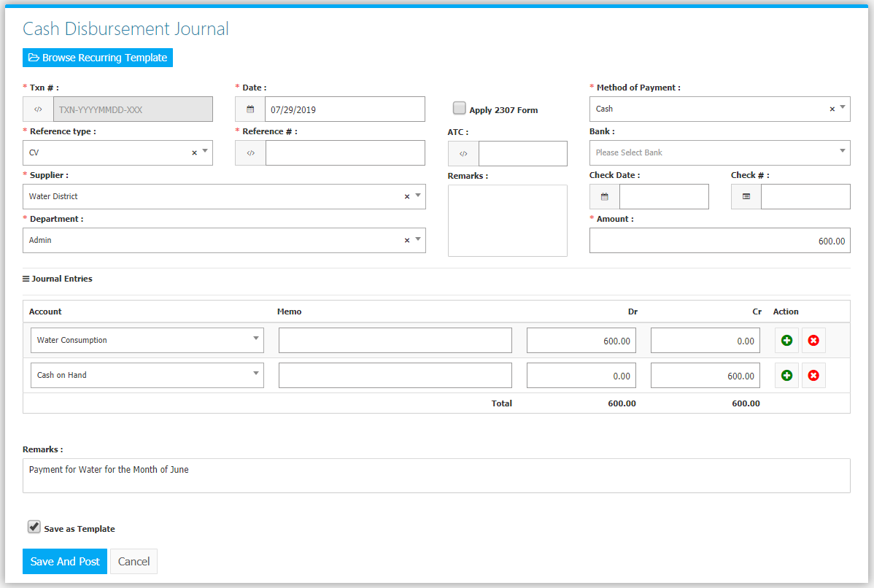

To use an existing template, click **Browse** **Recurring Template Button** upon creating a new Cash Disbursement *(Figure 9)*.

**Figure 9**

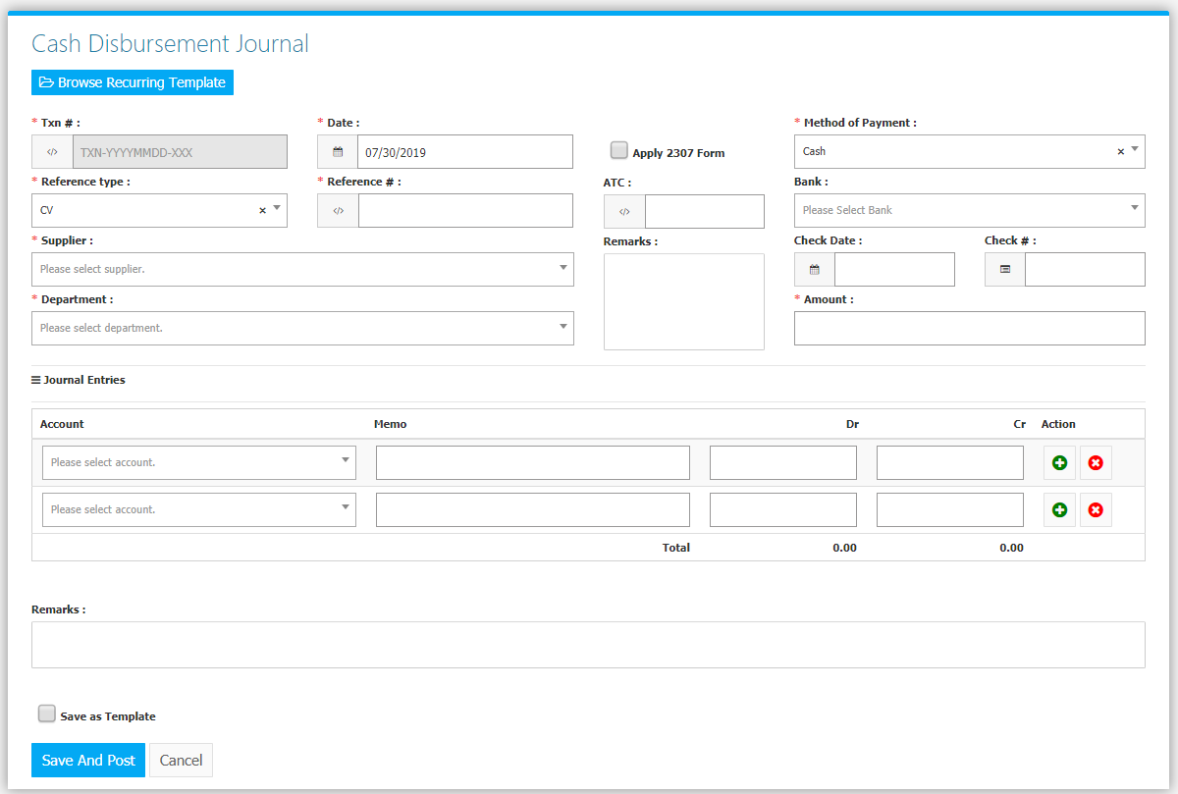

Upon clicking, it will show a list of existing Templates *(Figure 10)*. To use, click the **Check Button**, and the details of the template will automatically fill the form *(Figure 11).*

**Figure 10**

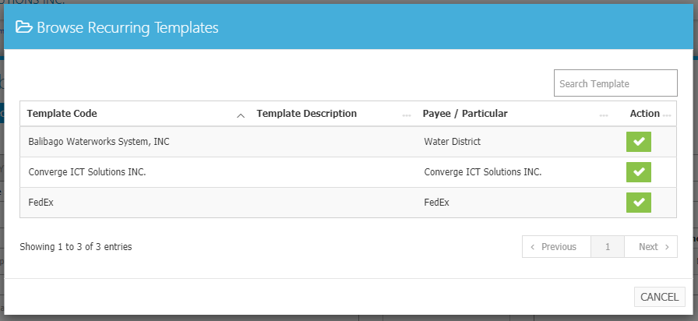

**Figure 11**

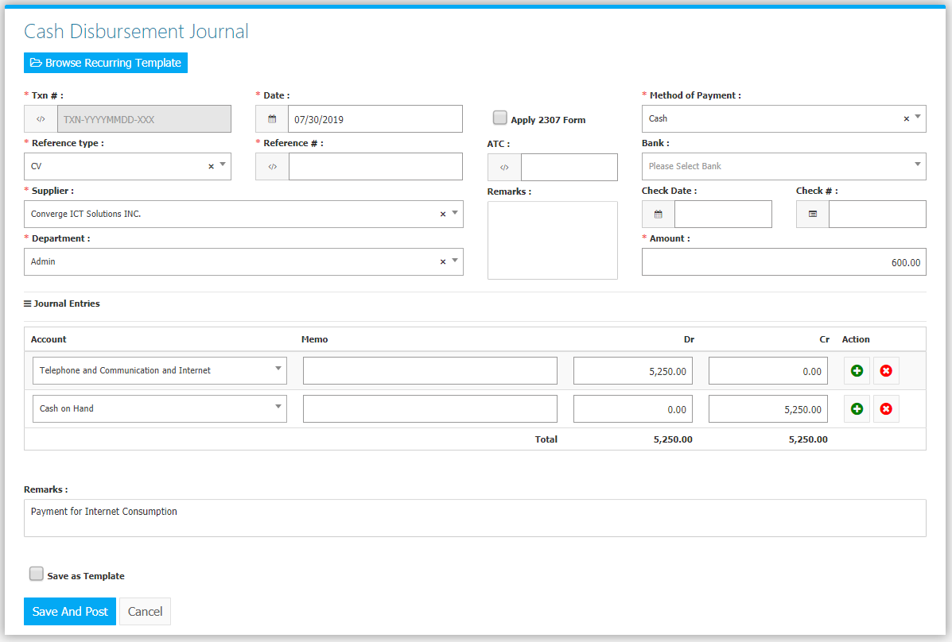

The list of **Recurring Templates** *(Figure 8)* can be found in **Settings -> Recurring Templates**.

**Figure 8**

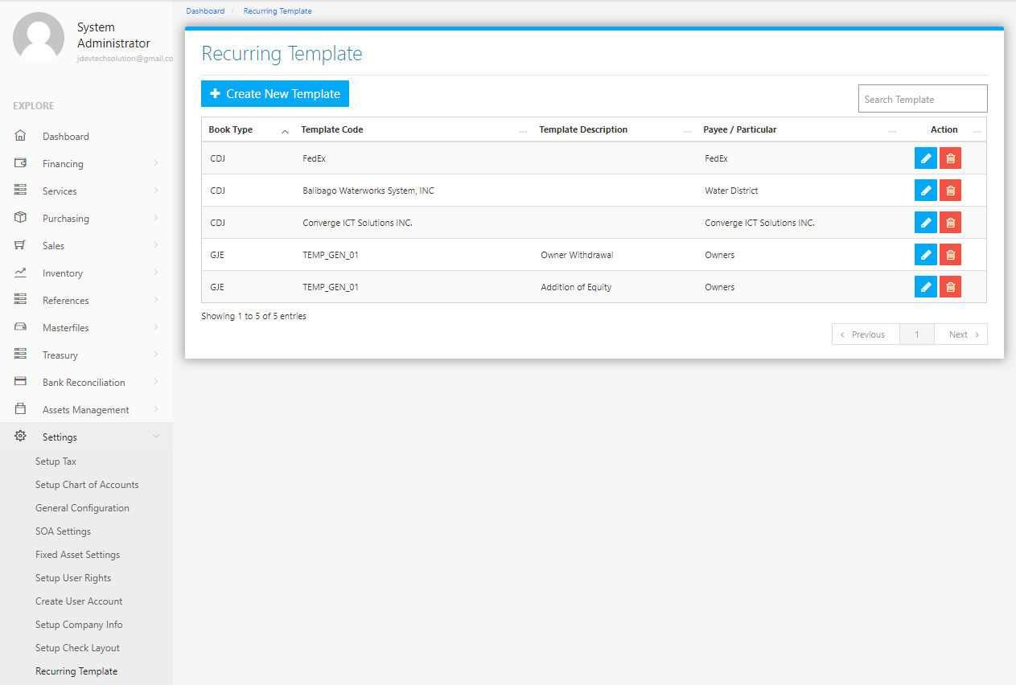

Use the **Search Field** to search for the information from inside the table. Click the **Pencil Button** to edit the template information, and **Trash Button** to delete the template. Click the **Create New Template Button** to create a new template*.* Select a Book Type and Accept *(Figure 9),* fill the form *(Figure 10)* then click the **Save Changes Button** to save.

**Figure 9 Figure 10**

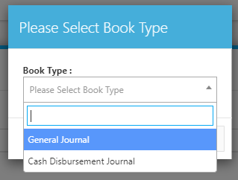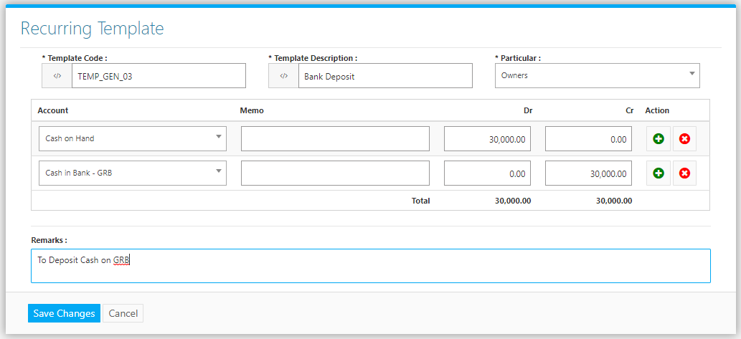

**Purchasing Flowchart**

