**CASH RECEIPT JOURNAL**

Listed in the *Figure 1* are the Cash Receipt Journal Posted in the Accounting System. The **Cash Receipt Journal** is the master journal to where all the collections of the company are recorded in such as *payments from customers, or investors.*

**Figure 1**

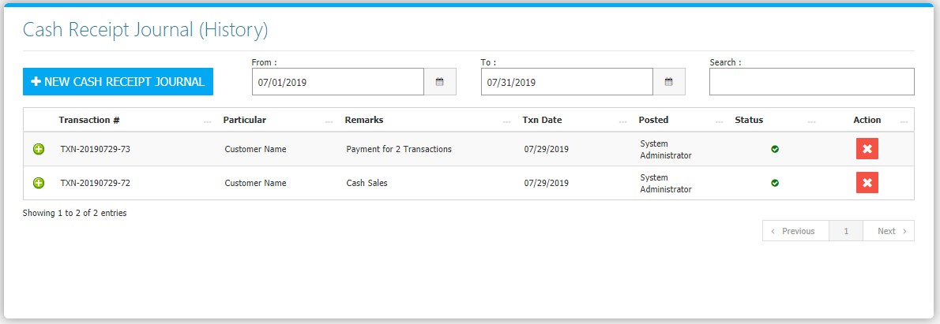

Change the **Date Range** (from and to) to your preference to filter the shown Journal Transactions. Use the **Search Field** to search for the information from inside the table. Clicking the **+ Button** will open the transaction/voucher as shown in *Figure 2.* Thevoucher can be printed and downloaded as a PDF File. Clicking the **X Button** will mark the Journal either cancelled or active.

**Figure 2**

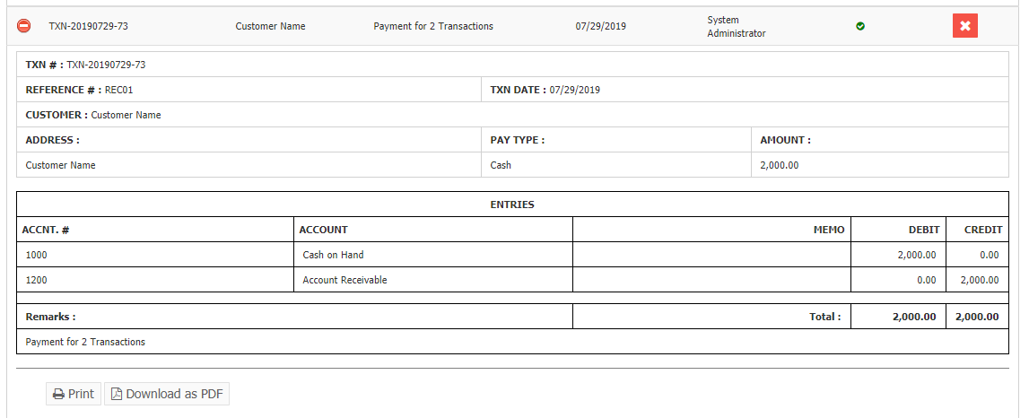

Click the New **Cash Receipt Journal Button** to create. Fill the form *(Figure 3)* then click **Save and Post Button** to save.

**Figure 3**

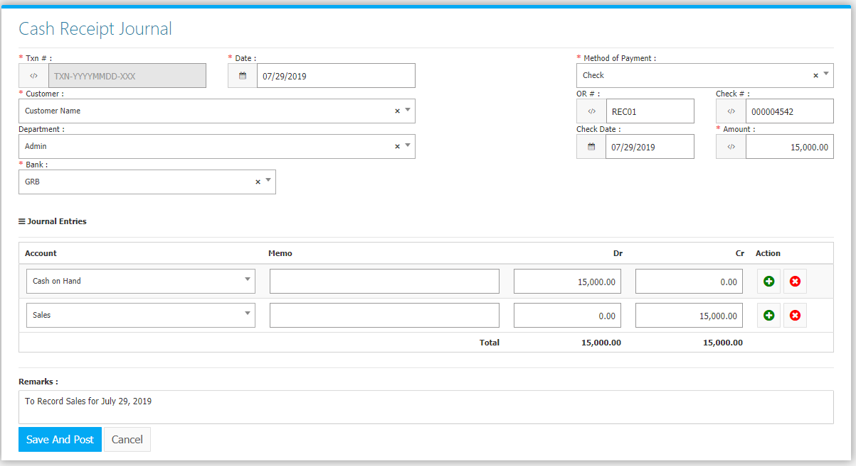

**Sales Flowchart**

