**GENERAL JOURNAL**

Listed in the *Figure 1* are the General Journal Entries Posted in the Accounting System. The ***General Journal*** is the master journal to where all the general transactions or entries of the company are recorded in such as *Addition of Capital Investments, Cash withdrawal of Company owners, Adjusting Entries, Deposits to banks, and other General Transactions of the Company.*

**Figure 1**

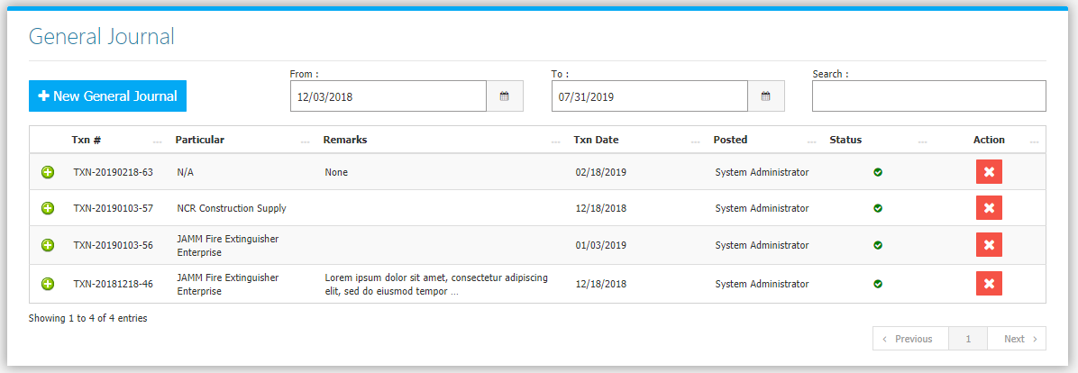

Change the **Date Range** (from and to) to your preference to filter the shown Journal Transactions. Use the **Search Field** to search for the information from inside the table. Clicking the **+ Button** will open the transaction/voucher as shown in *Figure 2.* Thevoucher can be printed and downloaded as a PDF File. Clicking the **X Button** will mark the Journal either cancelled or active.

**Figure 2**

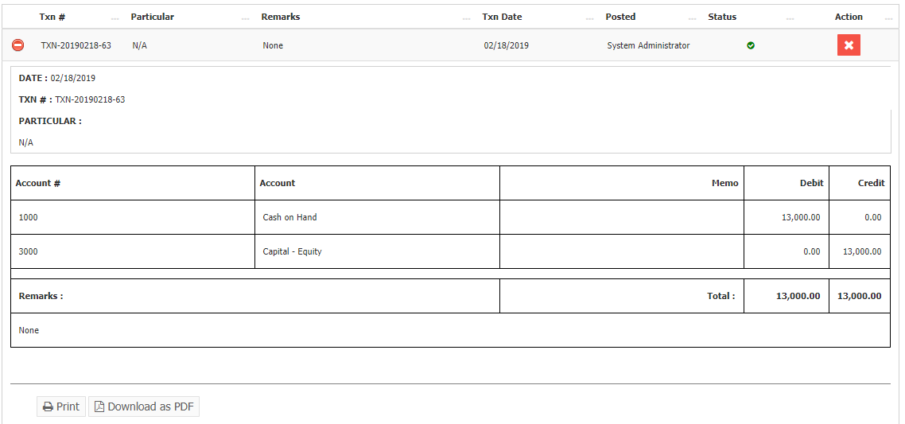

Click the **New** **General Journal Button** to create. Fill the form *(Figure 3)* then click **Save and Post Button** to save.

**Figure 3**

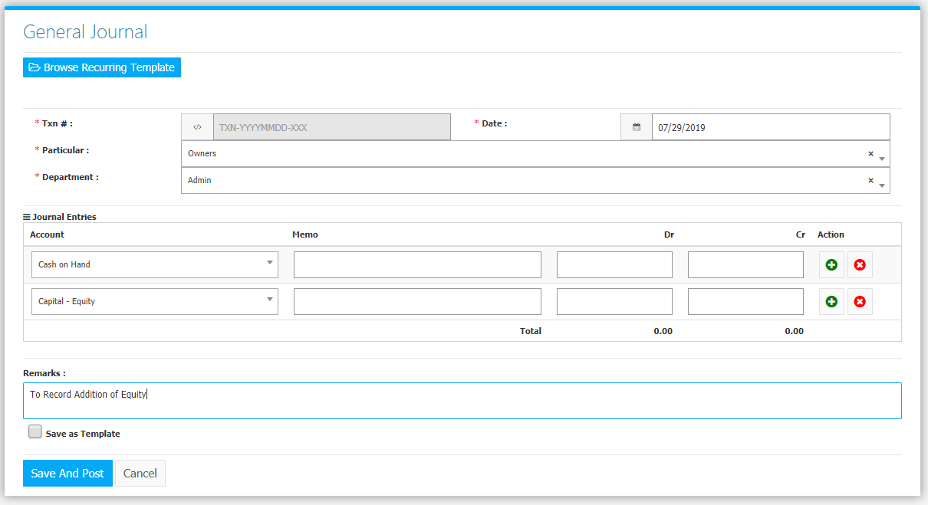

**RECURRING TEMPLATES**

Certain Transactions repeat themselves on a regular basis. You can create or use templates for such recurring transactions. The template contains the *Particular*, *Debit* and *Credit Accounts* together with the *amounts*, and *Remarks*. To create a recurring template **inside** the **General Journal Module**, click (put a check mark) on the **Save as Template Check Box** before savingto also save the current filled form as a new template *(Figure 4)*.

**Figure 4**

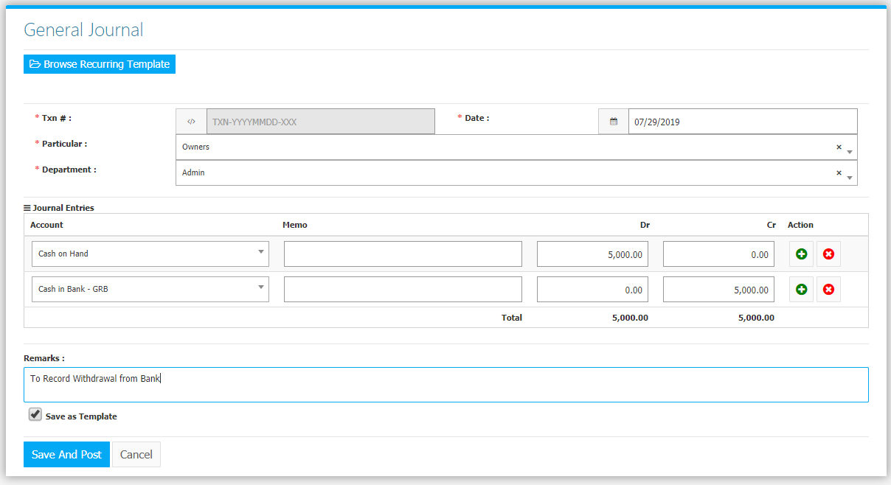

To use an existing template, click **Browse** **Recurring Template Button** upon creating a new General Journal *(Figure 5)*.

**Figure 5**

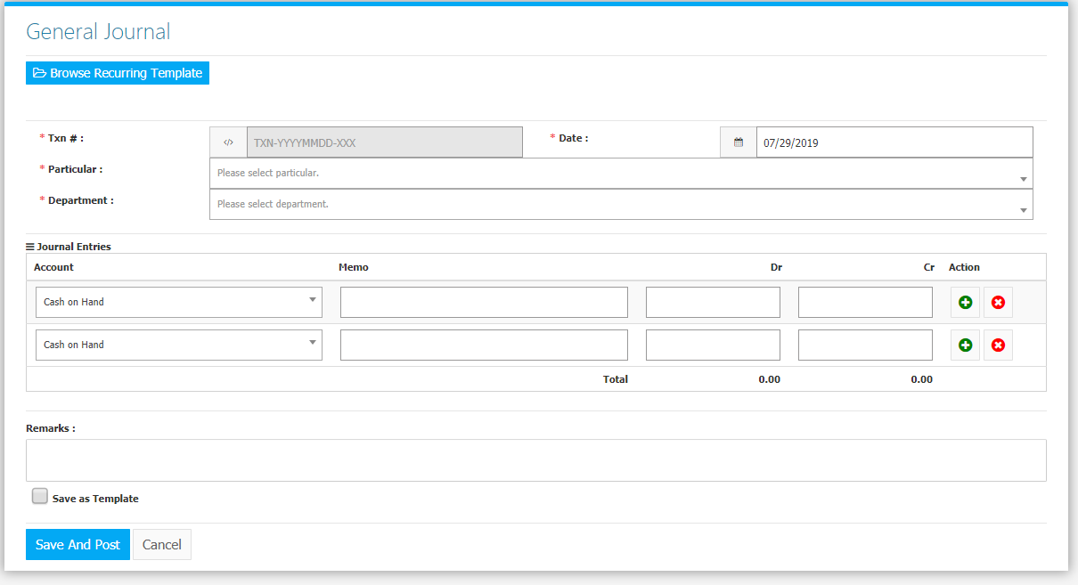

Upon clicking, it will show a list of existing Templates *(Figure 6)*. To use, click the **Check Button**, and the details of the template will automatically fill the form *(Figure 7).*

**Figure 6**

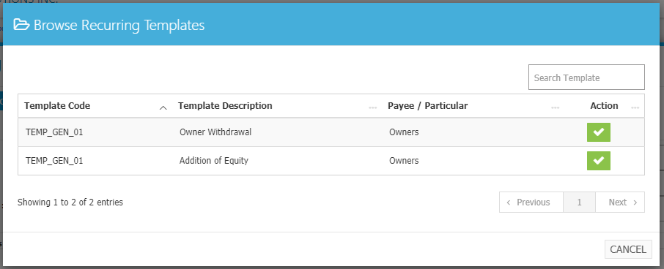

**Figure 7**

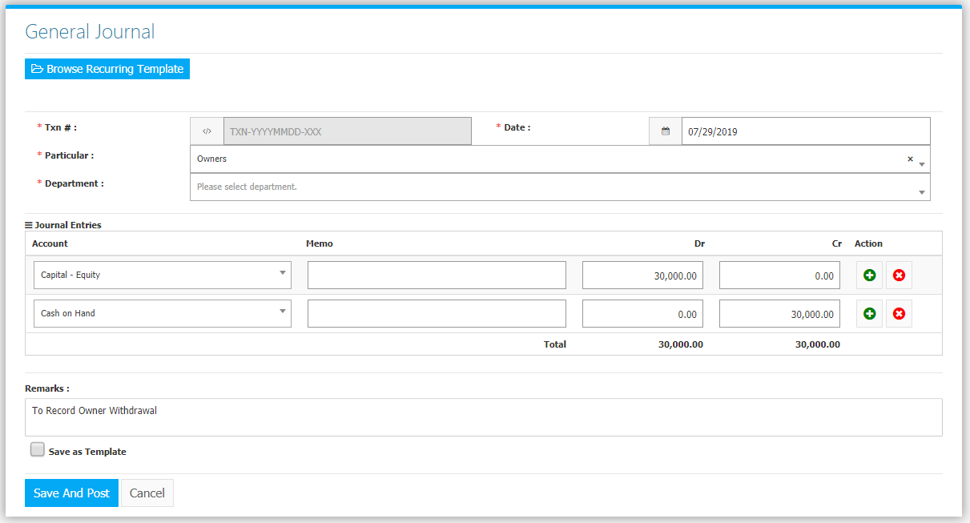

The list of **Recurring Templates** *(Figure 8)* can be found in **Settings -> Recurring Templates**.

**Figure 8**

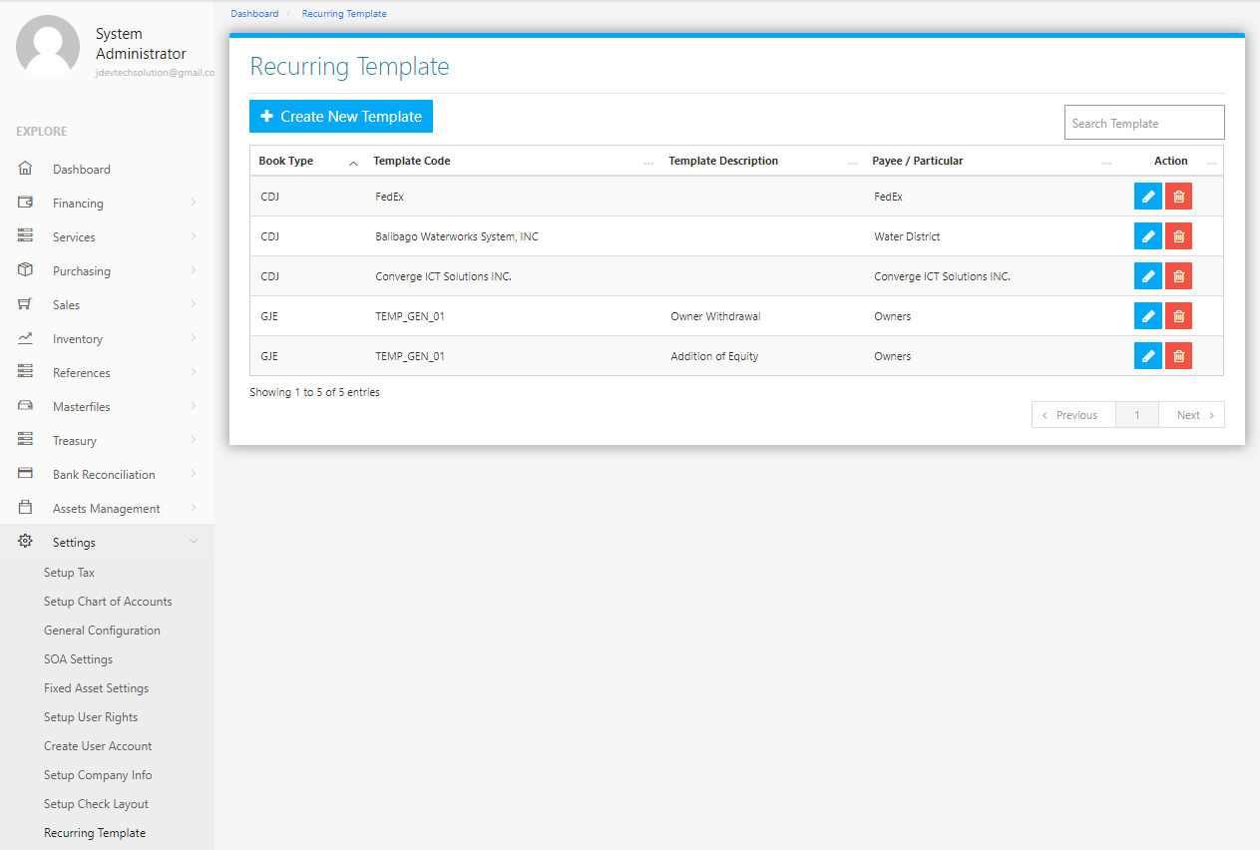

Use the **Search Field** to search for the information from inside the table. Click the **Pencil Button** to edit the template information, and **Trash Button** to delete the template. Click the **Create New Template Button** to create a new template*.* Select a Book Type and Accept *(Figure 9),* fill the form *(Figure 10)* then click the **Save Changes Button** to save.

**Figure 9 Figure 10**

