**PETTY CASH JOURNAL**

The **Petty Cash** is the master journal to where all the minor expenses are recorded such as *Office Supplies*, *Postage and Handling*, *Stationery, Daily Wages, and other small expenses.* To begin, Choose the Appropriate Petty Cash Account Title from the **Settings -> General Configuration-> Other Accounts** *(Figure 1)*

**Figure 1**

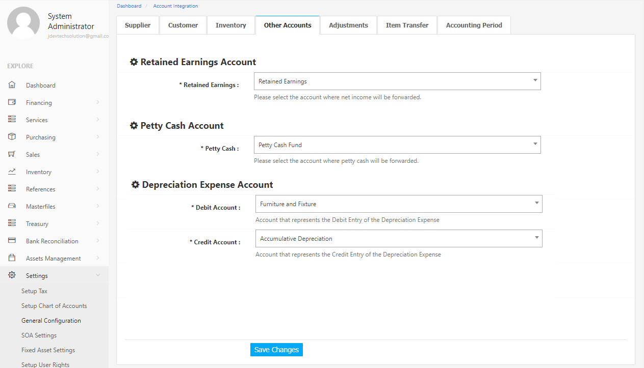

Then *Establish*, *Add*, or *Deduct* Petty Cash by creating a **Cash Disbursement Journal** in the Cash Disbursement Module located in **Financing Menu -> Cash Disbursement** *(Figure 2)*

**Figure 2**

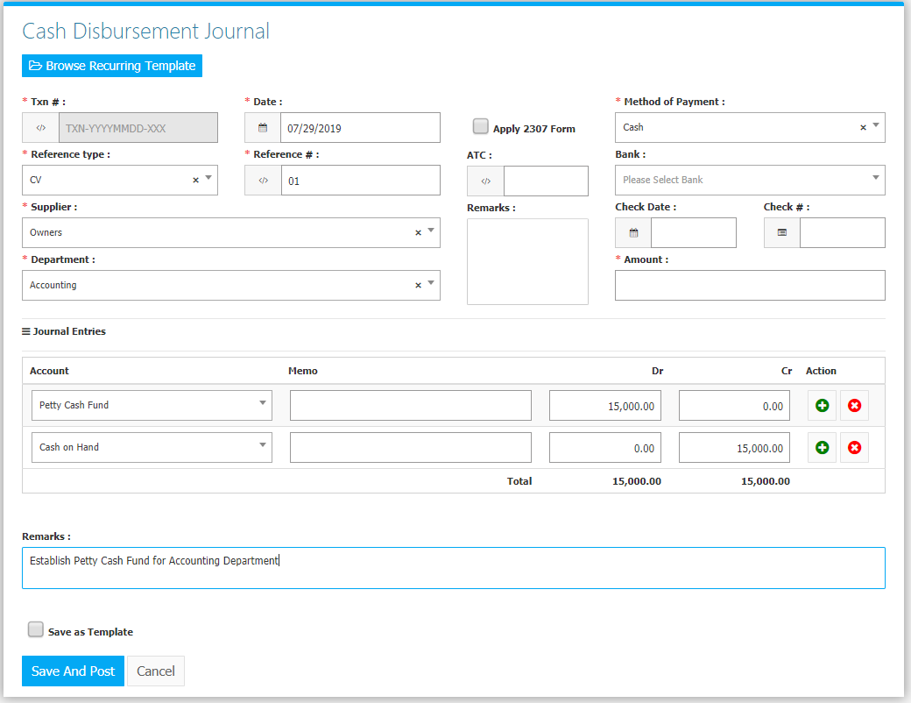

Then Go to **Financing-> Petty Cash Journal** to check the Remaining Amount of the petty cash which can be used for transactions *(Figure 3).* Choose Appropriate *as of date* and *department.*

**Figure 3**

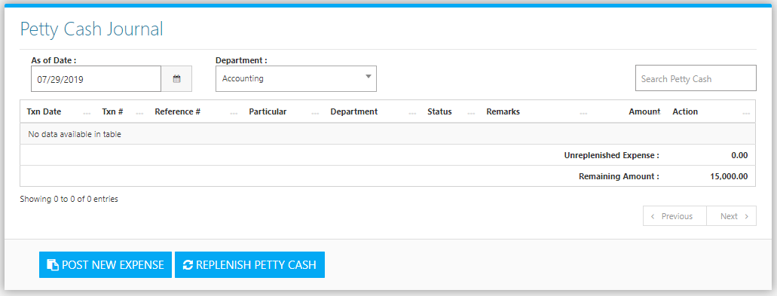

Click the **Post New Expense Button** to create new. Fill the form *(Figure 4)* then click the **Save Button** to save the transaction.

**Figure 4**

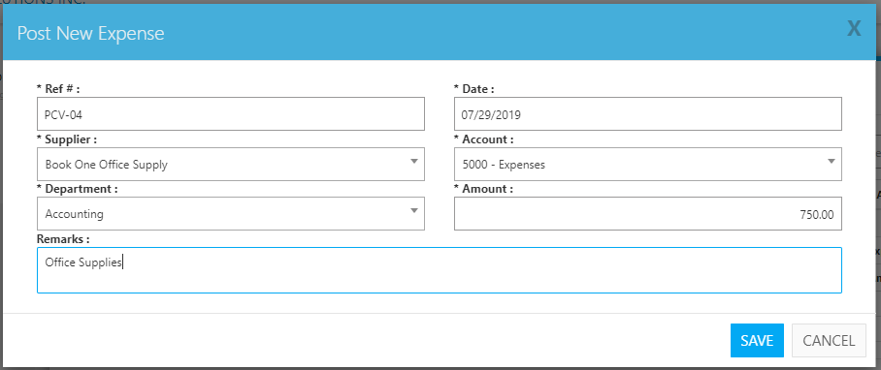

Change the **Date** (as of date) and the **Department** to your preference to filter the shown *Transactions*, *Unreplenished Expense*, and *Remaining Amount (Figure 5)*. Use the **Search Field** to search for the information from inside the table. Clicking the **🛇 Button** will cancel the transaction. Click the **Pencil Button** to edit the transaction.

**Figure 5**

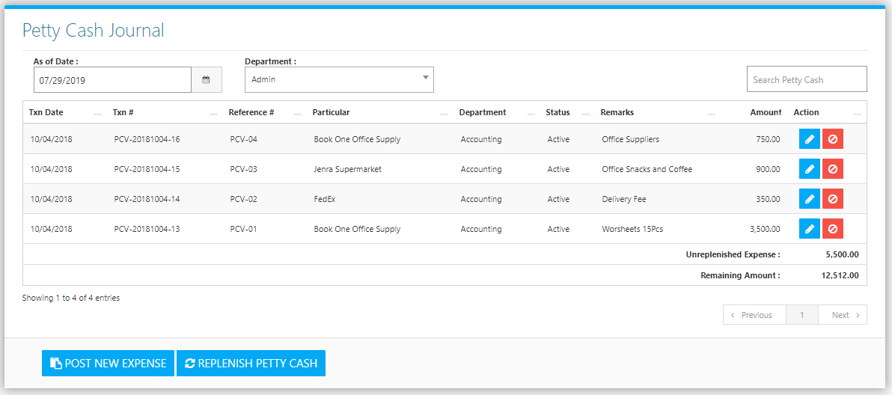

Click **Replenish Petty Cash Button** to replenish, confirm replenishment by choosing *Mode of Payment* and an *Account for Credit Entry (Figure 6)*, then the system will generate a Cash Disbursement Journal to replenish the expense amount which is **5,500.00** *(Figure 7)*. The Unreplenished Amount will go back to its original amount which is **15,000.00** *(Figure 8)***.**

**Figure 6 Figure 7**

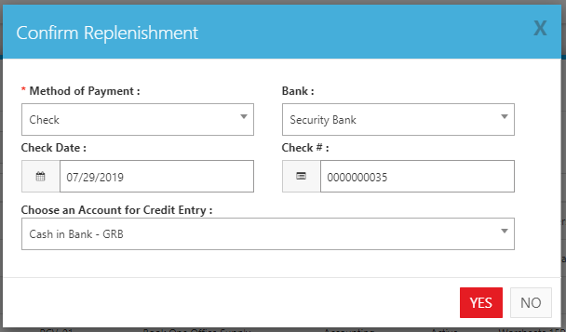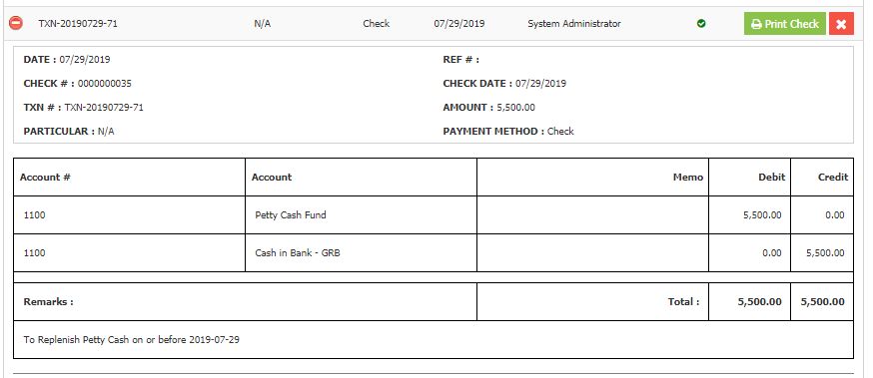

**Figure 8**

