**PURCHASE JOURNAL**

Listed in the Figure 1 are the Purchase Journal Entries posted in the Accounting System. The ***Purchase Journal*** is the master journal where all the *Purchases, and Accounts Payables* of the Company are recorded.

**Figure 1**

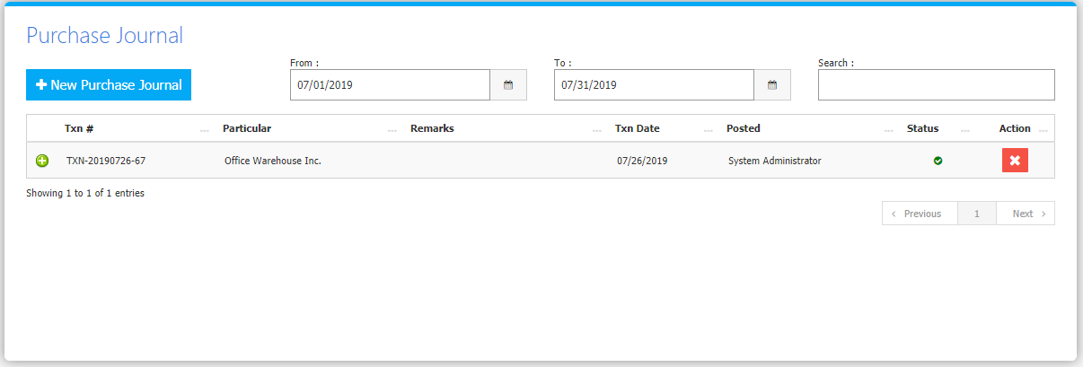

Change the **Date Range** (from and to) to your preference to filter the shown Journal Transactions. Use the **Search Field** to search for the information from inside the table. Clicking the **+ Button** will open the transaction/voucher as shown in *Figure 2.* Thevoucher can be printed and downloaded as a PDF File. Clicking the **X Button** will mark the Journal either cancelled or active.

**Figure 2**

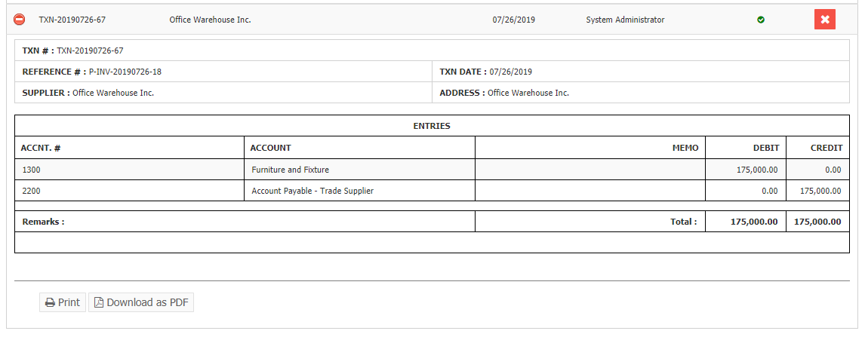

Click the New **Purchase Button** to create. Fill the form *(Figure 3)* then click **Save and Post Button** to save.

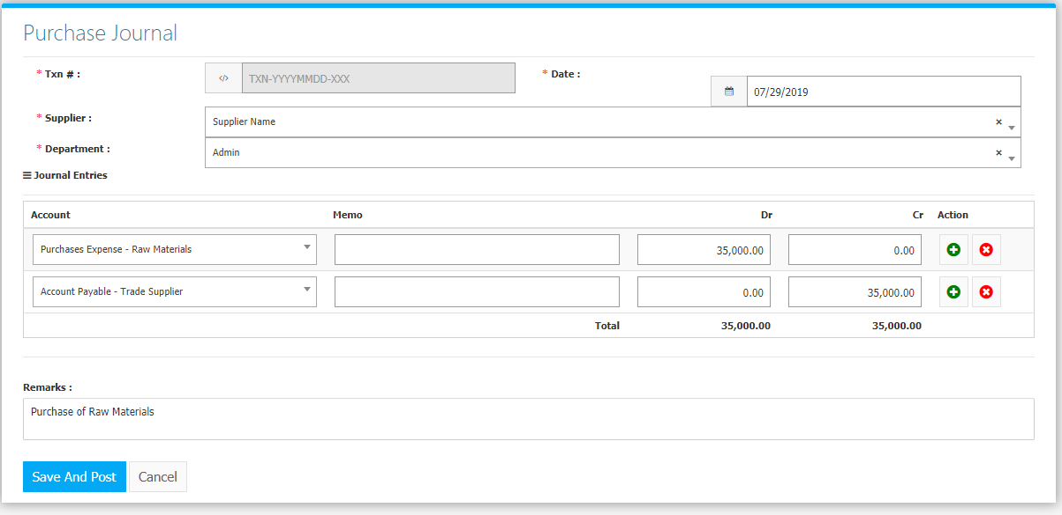

**Purchasing Flowchart**

